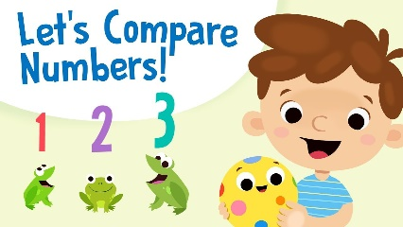
Circle The Number

Here are some worksheets for you to compare numbers. For the first worksheet you need to look very carefully at each set of two numbers and circle the largest number within each pair of numbers. In the second worksheet, you need to circle the smallest number within each pair of numbers.
Please let me know if you enjoy doing these and I can provide you with some more.
Also, please let me know if there is something in particular that you would like me to try and find for you.
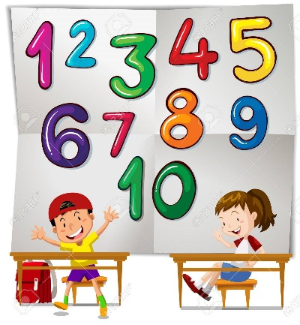
Have fun and stay safe!!
Ms Lennon

