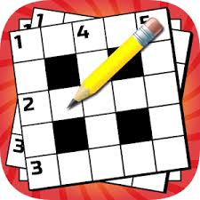

**Crossword Puzzle**

Here is a crossword based on **ou** words. Can you solve the clues correctly?

If you are unsure what to do, ask an adult to see if they can help you and try to solve the crossword together.

Please let me know if you enjoy doing this crossword puzzle and, if so, I can provide you with some more.

Also, please let me know if there is something in particular that you would like me to try and find for you.

Have fun and stay safe!!

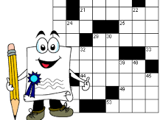Ms Lennon

