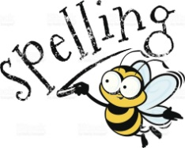
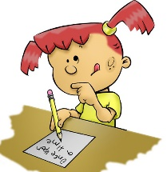
Five Minute Box 2 Activities –Term 4
I hope that this information will be helpful and useful to you during these strange and difficult times, if your child receives the ‘Five Minute Box 2’ intervention.
The children work through the cards in order starting with Consonant Digraphs. I am afraid that the cards are not the exact same as we have in school but are the best that I could make under the present circumstances. I hope the children won’t mind or be too disappointed.
In Box 1, the children need to be able to say, read, write and spell each word on each card before they can move onto the next card. Box 2 works in a similar way except that it focuses on sounds (phonemes) and blends, rather than whole words. It is always best to keep revising sounds that the children have already covered first, so you can easily start back at consonant digraphs and move forward.
If the children are up for a challenge feel free to try any or all of the following: -
- Identify one word for each sound before reading the words in the word lists
- Write each sound in a word then use that word in a sentence or use several of the words to make up a funny story
- Take a word, rearrange the letters, then ask your child to try to work out what the word is
- Write out the words using fancy coloured pens, chalks or paints, using magnetic letters, playdoh, sand, flour, rice or lentils if you have any of these to hand
- Choose an age appropriate book and try to find some of the words within the book. You could either write down the page number the word is on or keep a tally chart
All of the 5 Min Box children have been working on vowels and consonants so it is good to remind them about these. How many vowels are there? What are the vowels? You could then say random letters and ask them to tell you if the letter is a vowel or consonant.
As an extra challenge you could play a simpler version of ‘Countdown’ and ask the children to choose (for example) 3 consonants and 2 vowels. How many words can they make using only these letters? As an example, if they chose b, g, t, a and i, they might write big, at, bag, tig, it. Challenge them to beat their own score. For older or more confident children, they could use more vowels and consonant and play it more like ‘Countdown’ where they have a set time limit to make up a list of words. You can play this with them too!
I hope that this information makes sense and is helpful to you. Please do not panic and think that you need to do all of this – you definitely don’t! Please keep reading with your children and use this unprecedented time to help them realise that books are great fun – it is just a matter of finding a book that you like. Play board games, sing songs, do jigsaws (amazing for problem solving skills and developing concentration), crossword puzzles and wordsearches too.
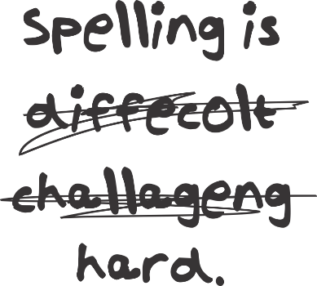
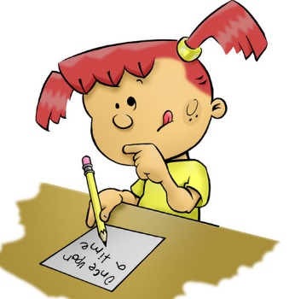
I have also uploaded some worksheet tasks that you may enjoy. Please let me know if there are any that you particularly like, and would like me to provide more of, or if there is something else that you would like me to try to find for you.
Please stay safe and take care,
Ms Lennon
Five Minute Box 2– Consonant Digraphs (Yellow Card)

sh | ch | th
ph | wh | qu
Five Minute Box 2 – Vowel Digraphs 1 (Green Card)

oo | ay | ou
ee | ow  how | or
ai | ea  each | ar
Five Minute Box 2 – Vowel Digraphs 2 (Red Card)

oa | er | ow  snow
oi | ur | ea  head
oy | ir | igh
Five Minute Box 2 – Triple Blends (Purple Card)

 | thr | spl
str | scr | shr
spr | squ
Five Minute Box 2 – Split Vowel Digraphs (Blue Card)

a-e | e-e | i-e
 | o-e | u-e
Word Lists
Consonant Digraphs
sh | ch | th | ph | wh | qu
shop | chop | think | photo | where | queen
wash | chip | this | graph | when | quiet
cash | chew | then | phone | why | quite
ship | much | moth | elephant | what | quit
mash | each | with | alphabet | which | quiz
show | match | tooth | sphere | white | quick

Vowel Digraphs 1
oo | ee | ea | ou | ow | ai | ay | or | ar
moon | feet | read | out | down | rain | play | torn | hard
room | tree | cream | shout | how | wait | day | sort | dark
cool | keep | meat | round | brown | sail | stay | form | park
soon | seen | seat | house | town | train | may | sport | card
pool | sleep | each | found | frown | paint | way | storm | part
spoon | need | teach | mouth | clown | tail | tray | horse | farm
Vowel Digraphs 2
oa | oi | oy | ur | ir | igh | ow | ea | er
boat | boil | boy | church | girl | light | flow | head | mother
soap | spoil | toy | nurse | sir | sight | blow | bread | father
toast | coin | joy | purse | stir | night | throw | tread | sister
float | foil | enjoy | turn | first | bright | grow | thread | brother
coat | point | annoy | burn | shirt | might | slow | dead | teacher
moan | join | royal | hurt | skirt | tight | show | instead | jumper

Triple Blends
thr | spl | str | scr | shr | spr | squ
throw | splash | straw | scrap | shriek | sprint | squeak
throat | splendid | strong | scratch | shred | spray | squiggle
thrash | splint | strawberry | scrape | shrimp | sprinkle | squelchy
three | splinter | string | scream | shrink | spread | squash

Split Vowels (Magic e)
a-e | e-e | i-e | o-e | u-e
race | here | mice | home | rule
make | eve | spice | phone | sure
take | these | nine | cone | flume
made | theme | time | Rome | tune

