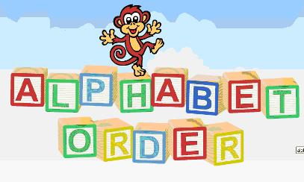

Alphabetical Order

Have fun trying some of these alphabetical order worksheets. Remember that you might need to look at the second or third letters of each word too! Let me know if you enjoy doing them and I can provide some more.

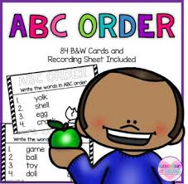Have lots of fun and stay safe!!

Ms Lennon

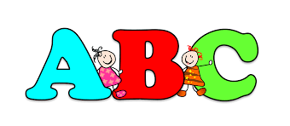

**Alphabetical Order**

1. Put each line of words into alphabetical order.

Look at the **first** letter.

1. dog   you   bean   animal   lion

2. just   grab   kneel   cat   east

3. hay   out   island   queen   farm

B) Look at the **second** letter of each word when arranging these words alphabetically.

1. plank    press    panic    punch    perch

2. clever    crisp    centre    candle    cheat

3. grape    geese    guilty    garden    goose

C) Look closely at the **third** letter of each word this time.

1. decide    demand    deadly    defeat    debt

2. harmful    habit    has    hatch    hamster

3. prune    prepare    produce    price    prank



Description: C:\Documents and Settings\miss stone\Local Settings\Temporary Internet Files\Content.IE5\3P2SPEYY\MC900358163[1].wmf

**Alphabetical Animals**

Put these animals into alphabetical order. Be careful! You might need to look at the second letter too!

Description: C:\Documents and Settings\miss stone\Local Settings\Temporary Internet Files\Content.IE5\Y75RUJSY\MC900338008[1].wmf1) dog, cat, mouse, horse

2) goat, pig, chicken, sheep

3) horse, zebra, hare, cat

4) snake, dog, spider, giraffe

5) lion, rat, goldfish, lemur, lizard

6) toad, ant, tiger, tarantula, ape

7) bear, armadillo, aardvark, baboon, anteater

Description: C:\Documents and Settings\miss stone\Local Settings\Temporary Internet Files\Content.IE5\7ZS2KRZU\MC900324464[1].wmf8) shark, dog, snail, dingo, dragon

9) monkey, whale, worm, manatee, mink

10) cheetah, cat, clam, crab, cobra

Challenge :- When you are finished you could look up some of the animals that you are not sure of and find out some more about them. You could even try to draw a picture of them.

Description: C:\Program Files\Microsoft Office\MEDIA\CAGCAT10\j0304933.wmfDescription: C:\Program Files\Microsoft Office\MEDIA\CAGCAT10\j0149627.wmf

Description: C:\Documents and Settings\miss stone\Local Settings\Temporary Internet Files\Content.IE5\17W1SFTE\MC900356123[1].wmf

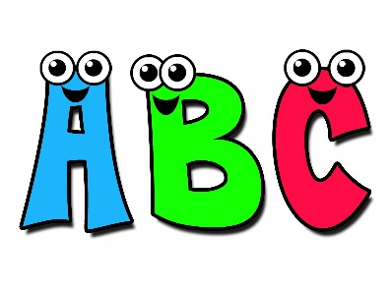

Description: C:\Documents and Settings\miss stone\Local Settings\Temporary Internet Files\Content.IE5\3P2SPEYY\MC900358163[1].wmf

**Alphabetical Animals 2**

Put these animals into alphabetical order. Be careful! You might need to look at the second or third letter too!

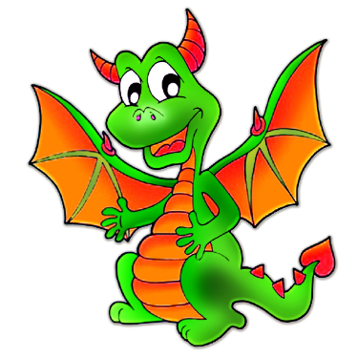

1) dog, cat, mouse, dragon

2) horse, zebra, hare, cat

3) shark, dog, snail, dolphin, dragon

4) monkey, whale, worm, manatee, mouse

5) hamster, hare, bat, beetle, bear

6) goat, koala, polar bear, kangaroo, giraffe, pig

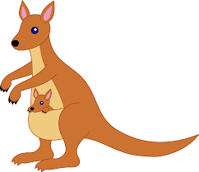7) cheetah, cat, crocodile, clam, cobra

8) lion, leopard, lizard, lemur, lynx

9) horse, hamster, hare, hog, hawk

10) bear, baboon, bat, bee, badger

Challenge :- When you are finished you could look up some of the animals that you are not sure of and find out some more about them. You could even try to draw a picture of them.

