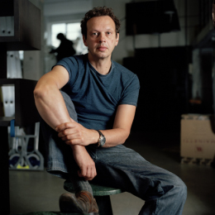
New Fluoro Shade 2009/2010
Design task

Tom Dixon

”..commitment to innovation and a mission to revive the British furniture industry.”

Use the materials supplied to create your own product model inspired by Tom Dixon’s designs.

Look at style, shape, colour, materials, influences, function, construction, ergonomics, environment, target audience etc.

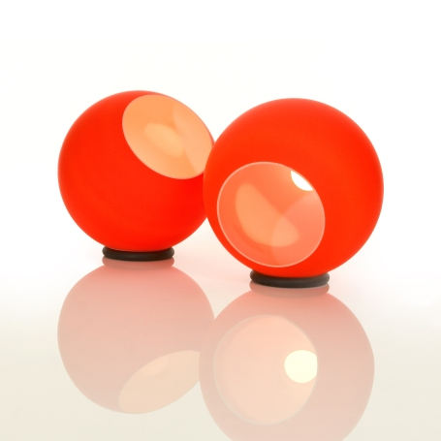
Tom Dixon was born in Tunisia and moved to England in 1963.
Tom rose to prominence in the mid 1980's as "the talented untrained designer with a line in welded salvage furniture".

By the end of the 80's, he was designing chairs for powerhouse Italian brands like Cappellini; by the mid-nineties, he had created his own company, 'Eurolounge', to make and sell his work.

In 2002 by Tom Dixon and David Begg, established the Tom Dixon brand, a British design and manufacturing company of lighting and furniture.

With a recognised commitment to innovation and a mission to revive the British furniture industry, the Tom Dixon brand is inspired by the unique heritage, the individualistic innovation and the robust, no nonsense engineering.
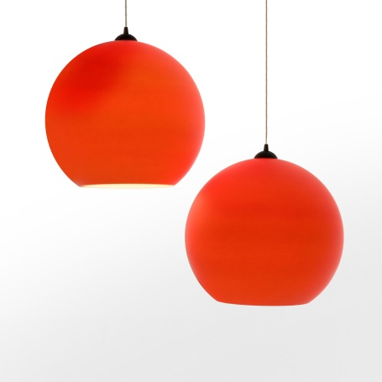

Other Tom Dixon designs

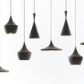

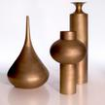
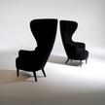
Wingback Chair

Beat Light
Info, photos and images www.tomdixon.net
Fluoro Shade Pendant Fluoro Shade
Made from white polycarbonate with a matt fluorecent orange coating. Available as a pendant and floor light
Diameter: 45cm/300cm white fabric cable with foot switch

Beat Vessels

