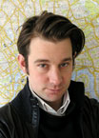
‘Sweet Dreams Security’ 2003
Design task

Matthias Megyeri

His design of ... "socially critical objects", forces us to confront a pervasive, yet often neglected aspect of contemporary life.’

Use the materials supplied to create your own product model inspired by Matthias Megyeri’s designs.

Look at style, shape, colour, materials, influences, function, construction, ergonomics, environment, target audience etc.

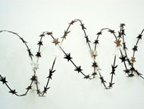
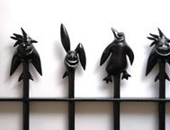
Matthias Megyeri was Born in Stuttgart in 1973. He studied visual communication in Karlsruhe before enrolling on the design products course at the Royal College of Art in London, where he applied his graphic sensibility to the customisation of security products.
Matthias Megyeri has carved an exciting new niche market for products that respond to what he sees as an uncomfortable balance between the growing demand for security
products and an over-saturation of the kitsch, the ‘cute’, the garden gnomes and the frilly curtains.

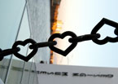

Other Matthias Megyeri designs

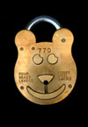

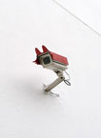

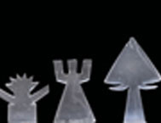
‘CityCatTV’

‘Billy B’
Padlock
Info, photos and images www.designmuseum.org + www.sweetdreamssecurity.com/
R. Bunnit , Peter Pin & Didoo Security railings
Unique railing-top characters by Sweet Dreams Security™.
This contemporary take on traditional Victorian street furniture injects a sense of energy into often-lifeless urban landscapes. The jagged but friendly little creatures guard your home with a warm smile.

‘Glass Objects’

