
Julia Lohmann

Cow Benches 2004

Design task

”..transforms the practice of product design into a rich
and complex medium of social investigation.” Design Museum

Use the materials supplied to create your own product model inspired by Julia Lohmann’s designs.

Look at style, shape, colour, materials, influences, function, construction, ergonomics, environment, target audience etc.

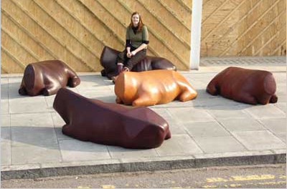
Julia Lohmann Born in Hildesheim, Germany in 1977, Lohmann became interested in design on childhood walks with her father when they collected abandoned objects to create strange creatures.

After graduating in graphic design from the Surrey Institute, she studied design products at the Royal College of Art, London

She uses her work to explore provocative contemporary issues such as our relationship to animals

Lohmann began her investigation into the contradictions in our relationship to animals as sources of food and materials at the RCA. By working with offal, off-cuts of leather and other meat industry waste products, she probes those contradictions while “giving value to leftovers”

Other Lohmann designs

Cow Benches
Rosel, Belinda, Raul, Eileen, Carla, Elsa, Radia
A leather bench or bovine memento mori.
The ‘cow-bench’ explores the threshold between animal and material.

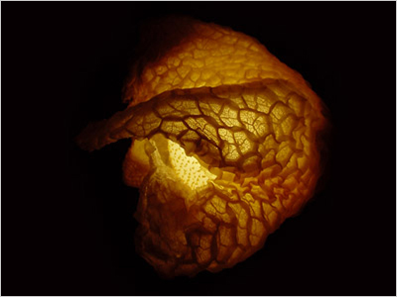
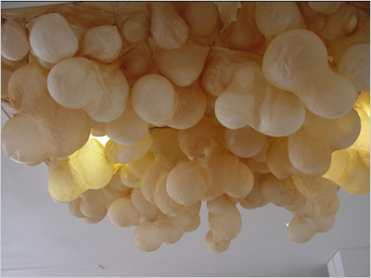
Flock
A light-ceiling made
preserved sheep-stomachs.

Ruminant Bloom
Lamps made from preserved sheep-stomachs.

Info and images www.julialohmann.co.uk and www.designmuseum.org
+

