MARKS
SECTION 2 – DESIGN STUDIES (continued)
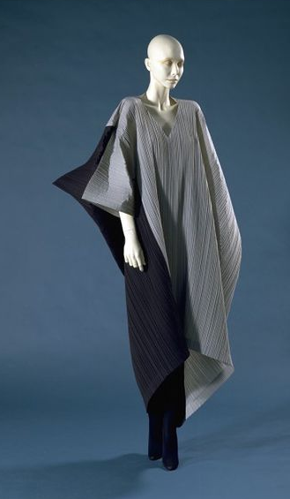
Image for Question 2

Dress designed by Issey Miyake (1990)
Materials: grey and black pleated polyester

2. Analyse the following elements of this fashion design
- materials
- function
- target market
You must fully justify each point you make.

10
MARKS
SECTION 2 – DESIGN STUDIES (continued)
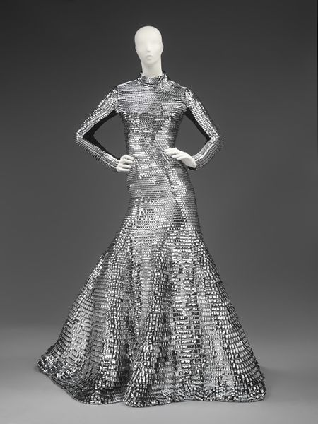
Image for Question 3

Full length fitted evening dress designed by Gareth Pugh (2011)
Materials: machine stitched cut vinyl

3. Analyse the following elements of this fashion design
- visual impact
- function
- target market
You must fully justify each point you make.

10

MARKS
SECTION 2 – DESIGN STUDIES (continued)
Image for Question 4
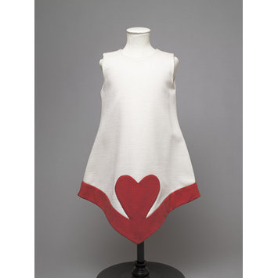

Girl’s Dress designed by Pierre Cardin for Neiman Marcus Luxury Department store (1960s)
Materials: cream and red coloured cotton

4. Analyse the following elements of this fashion design
- sources of inspiration
- style
- target market
You must fully justify each point you make.

10
MARKS
SECTION 2 – DESIGN STUDIES (continued)
Image for Question 5
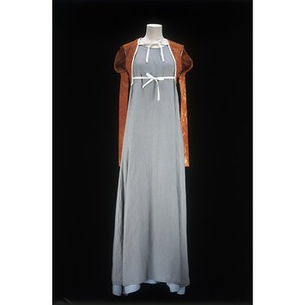

.
Dress and Jacket designed by Hussein Chalayan (1995)
Materials: (Jacket) Cotton coloured by rusted metal (Dress) pale blue linen

5. Analyse the following elements of this fashion design
- materials
- colour
- decoration
You must fully justify each point you make.

10
MARKS
SECTION 2 – DESIGN STUDIES (continued)
Image for Question 6
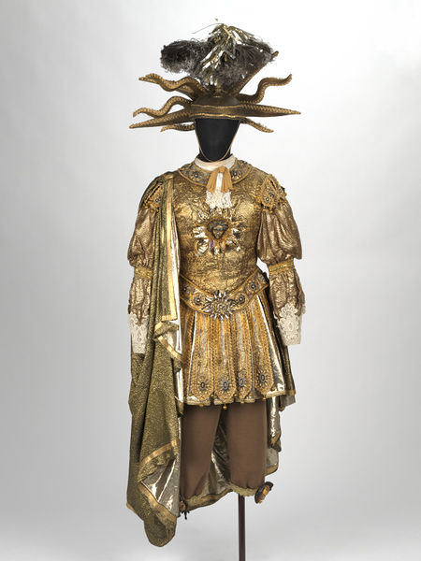

.
Recreation of a 17th Century ballet costume worn by the French King Louis XIV (1638-1715),
Materials: Cotton, lace, broiderie anglaise, organza, lamé, metal, cord, gold braid, tape, Lurex, plastic, paint, thread

6. Analyse the following elements of this fashion design
- visual impact
- fitness for purpose
- shape and/or form
You must fully justify each point you make.
10
MARKS
SECTION 2 – DESIGN STUDIES (continued)
Image for Question 7
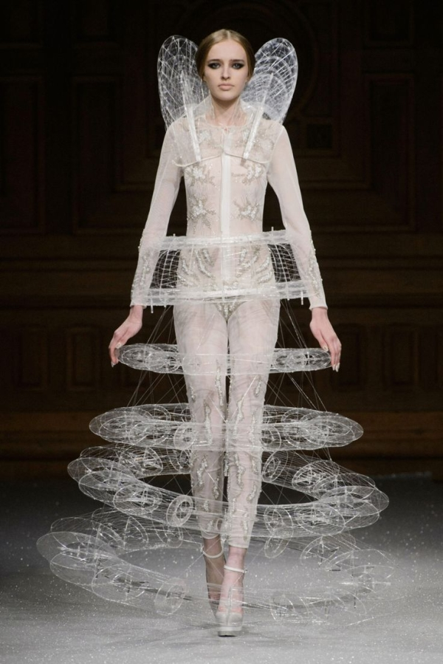
Floating Ring Illusion Dress (2015) by Oscar Carvallo
Materials: Silk Lace, silk thread and nylon
7. Analyse the following elements of this fashion design
- shape and/or form
- fitness for purpose
- materials and/or techniques
You must fully justify each point you make.
10

MARKS
SECTION 2 – DESIGN STUDIES (continued)
Image for Question 8
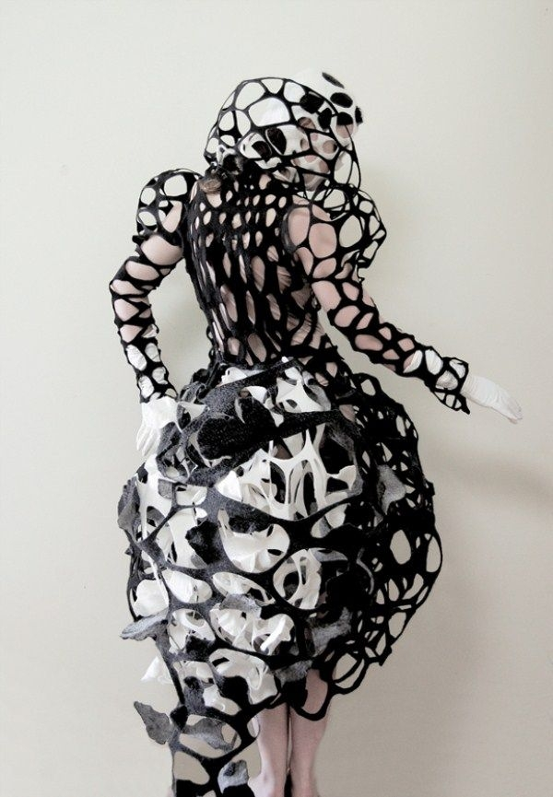
Layered Black and White Felt Dress (2012) by Catherine O’Leary
Materials:Felt

8. Analyse the following elements of this fashion design
- shape and/or form
- pattern
- materials and/or techniques
You must fully justify each point you make.
10

