National 3 Critical Questions-

Expressive

Answer the following in FULL sentences:

1. What is the name of the painting you are studying?
2. Who was the artist that painted this work?
3. What year was it painted?
4. What is the subject matter of the painting?
5. What is the composition of this painting? Describe what you see in the picture.
6. What media was used to create this piece of work?
7. What kind of brush strokes have been used in this painting? Where have they been used?
8. Describe the main colours in this painting and where they were used.
9. Why do you think the artist chose these colours?
10. Has the artist used hot or cold colours?
11. What do you think the mood of this painting is? How does it make you feel?
12. Why do you think this is the mood of the painting?
13. What is the most important visual element of the painting?
14. Why is this the most important visual element? Give 2 Reasons.
15. Where/ why did the artist paint this?
16. What/ who were the influences of this painting?
17. Give one more fact about this painting.
18. Do you like this painting? Why/ why not?

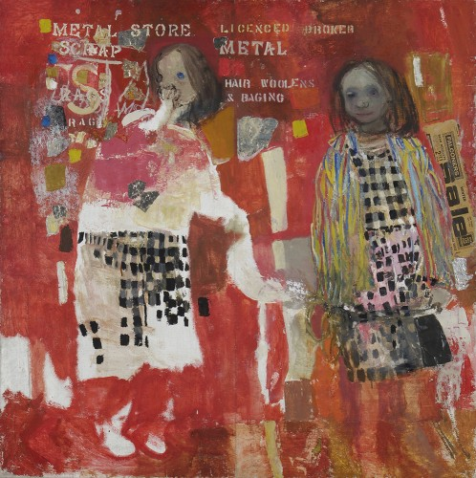

135cm x 135cm

Joan Eardley – Two Children 1963

**Social, cultural and/or other influences**

1. **Real situations** – Eardley has been compared with her London contemporary ‘Kitchen sink’ painter.
2. **Local children** – Eardley often painted the children who lived beside her from the Town Head area of Glasgow, in particular the Sampson family.
3. **Social living conditions** – people living in 1950’s slums.
4. **James Cowie** – her Art School tutor encouraged her to portray the everyday.
5. **Kelvingrove Art Gallery** – where she would often visit to take inspiration from artists such as Van Gogh.

Two Children 1963

**Materials and techniques**

* Oil paint on canvas
* Collage – foil and newspaper
* Stencils
* Unfinished/lacking in detail

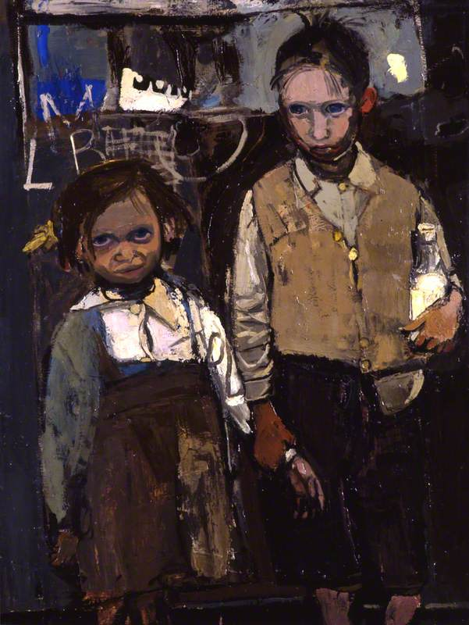

102cm x 77cm

Brother and Sister by Joan Eardley 1955

Joan Eardley

Social, cultural and/or other influences

1. **Real situations** – Eardley has been compared with her London contemporary ‘Kitchen sink’ painter.
2. **Local children** – Eardley often painted the children who lived beside her from the Town Head area of Glasgow, in particular the Sampson family.
3. **Social living conditions** – people living in 1950’s slums.
4. **James Cowie** – her Art School tutor encouraged her to portray the everyday.
5. **Kelvingrove Art Gallery** – where she would often visit to take inspiration from artists such as Van Gogh.

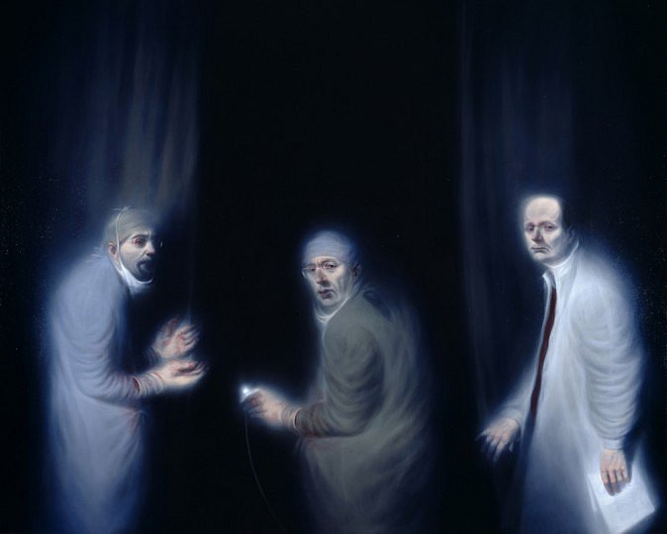 196cm x 245cm

**The Three Oncologists by Ken Currie 2002**

**Ken Currie**

**Social, cultural and/or other influences**

1. **‘School of London’ artist, Francis Bacon and Lucien Freud**
2. **Industrial Glasgow – both past and present (poverty)**
3. **Political and Humanitarian events**
4. **Death and mortality**
5. **The Three Oncologists – this painting was inspired by the exceptional and challenging work undertaken by the surgeons.**

**Materials and techniques**

* **Oil paint on canvas**
* **Dark background**
* **Luminous blue tones**
* **Detailed brushwork**

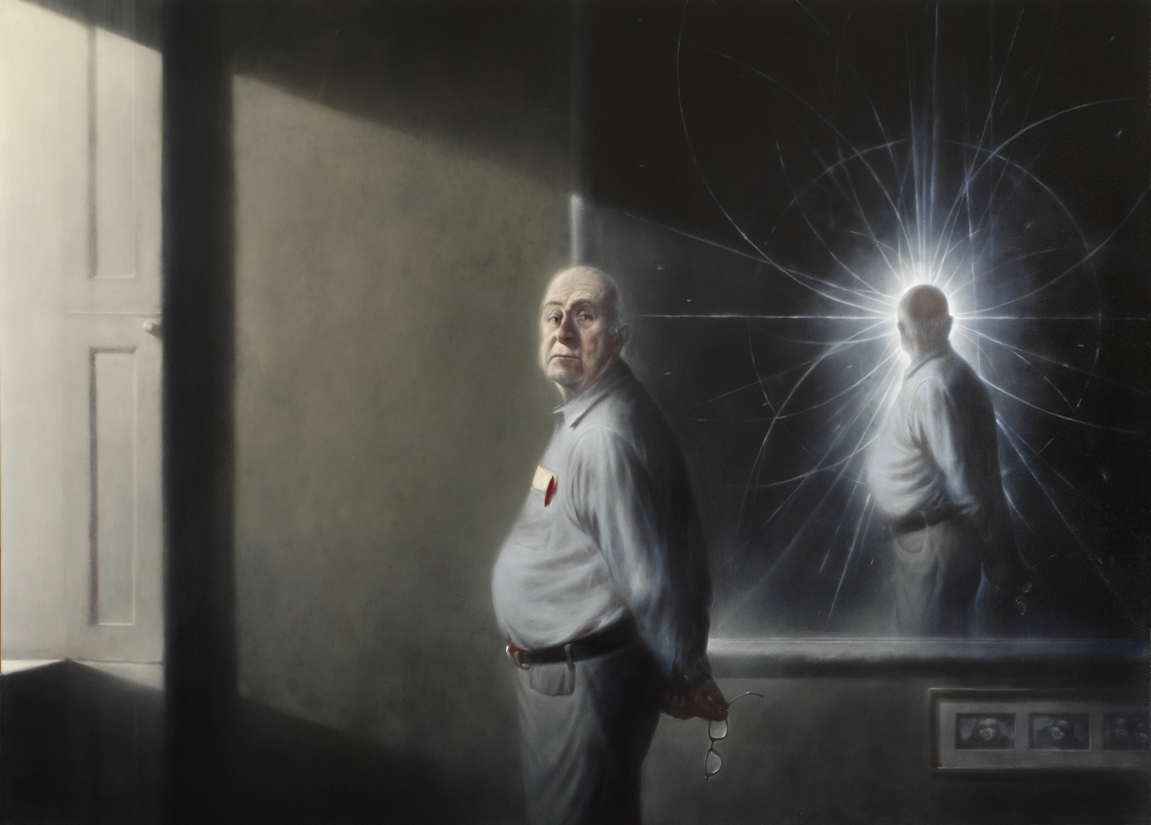180cm x 220cm

**Portrait of Peter Higgs by Ken Currie 2008**

**Ken Currie**

**Social, cultural and/or other influences**

1. **‘School of London’ artist, Francis Bacon and Lucien Freud**
2. **Industrial Glasgow – both past and present (poverty)**
3. **Political and Humanitarian events**
4. **Death and mortality**
5. **Portrait of Peter Higgs– this painting was inspired by the famous discovery of ‘the God particle’ and the physicist who found it.**

**Materials and techniques**

* **Oil paint on canvas**
* **Realistic colour**
* **Detailed brushwork**

**Visual reference to the ‘God particle’ in mirror reflection**