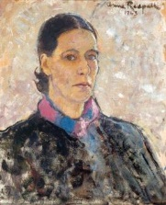  Anne Redpath  Social and Cultural Influences | Biography  - 1895–1965  - Scottish  - Studied at Edinburgh College of Art  - Best known for domestic still lives
*Warning* the paintings on this page are NOT by Redpath. They are examples of what inspired her.
Travelling  Post-graduate study led to a scholarship which allowed her to travel on the Continent in 1919, visiting Bruges, Paris, Florence and Siena  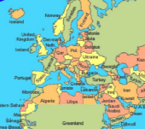  In the 1950s and early 1960s, she also travelled in Europe, painting in Spain, the Canary Islands, Corsica, Brittany, Venice and elsewhere. | 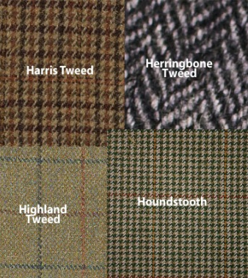  Family  Redpath’s Father was a Tweed designer in the Scottish borders. Redpath was inspired by his use of colour:  "I do with a spot of red or yellow in a harmony of grey, what my father did in his tweed."
Religion  Whilst travelling in she was inspired by Catholic Church architecture, usually the interiors. She enjoyed the highly decorative exoticism and richness of Baroque ornament in the churches of Catholic countries on the Mediterranean. They were very different from her strict Presbyterian upbringing in the Borders.  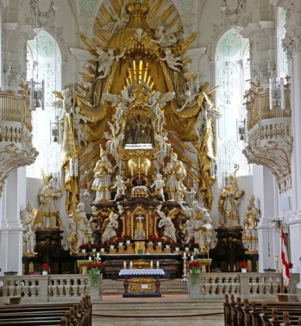  Catholic Church Alter | Other Artists - Matisse  During her years in France (1920–1933) Redpath became heavily influenced by Matisse’ use of pattern within pattern to add detail and visual impact.  Matisse's influence is clear in these bold, flat-surfaced interior arrangements.  Redpath used textiles - a printed tablecloth, a spotted scarf - to add pattern.  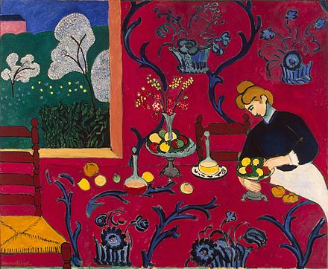  Matisse The Red Room 1909
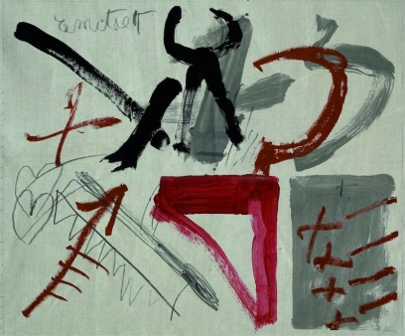  Other Artists – Antoni Tapies  In the her work from the1950’s and 60’s Redpath was inspired by the loose brushstrokes, impasto paint and semi abstract forms of Antoni Tapies.  Antoni Tapies | Other Artists - Medieval Artists from Siena  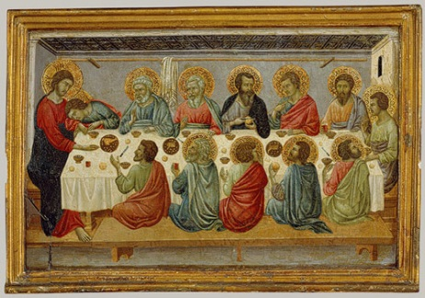  Redpath was inspired by medieval paintings from Siena in Italy on her first trip abroad. Redpath liked the distorted perspectives as can be seen in the tipped table in The Last Supper.  Ungolio de Nerio The Last Supper 1325
Other Artists – The Scottish Colourists  Redpath and a group of her contemporaries are sometimes called The Edinburgh School. They were inspired by The Colourists.  The Colourists were four painters, S. J. Peploe, J. D. Fergusson, G. L. Hunter and F. C. B. Cadell who worked in Scotland in the 1920s and 1930s. The Colourists painted many domestic still lives using bold strong colours.  Redpath was inspired by the natural compositions of everyday objects placed in domestic interiors. | 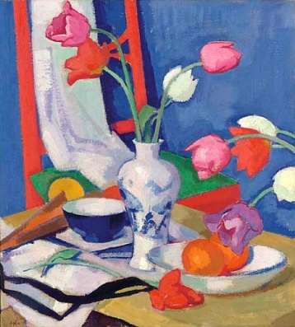  S J Peploe Red Chair and Tulips 1919 | 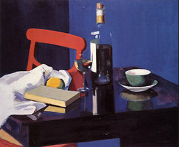  F Cl B Cadell Still Life and Rosechatel 1924
C Gordon 2016
Artist Gallery
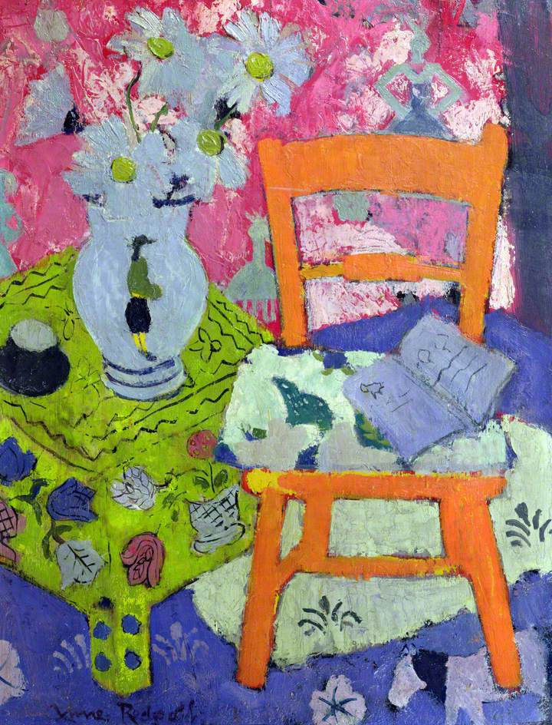  Anne Redpath - The Orange Chair - 1944 | 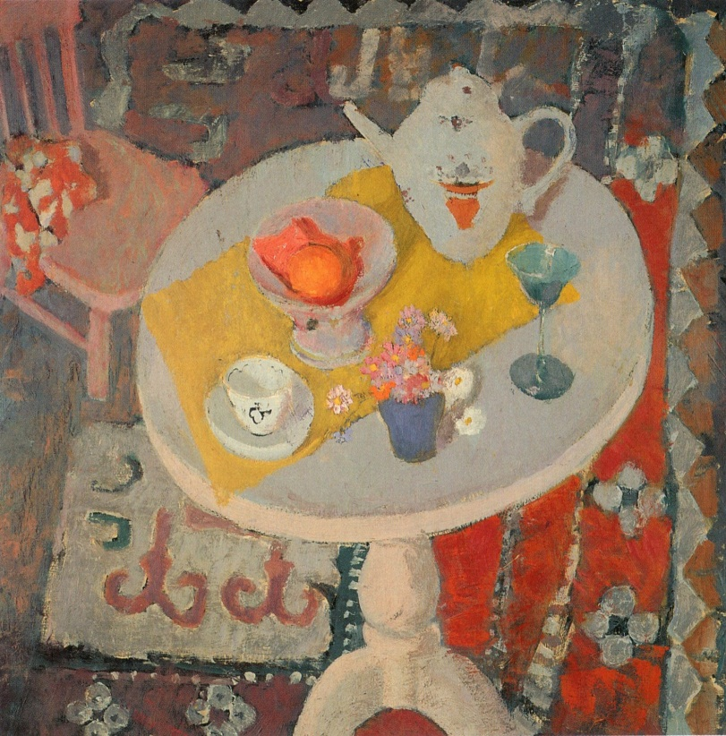  Anne Redpath – Still Life With Teapot on Round Table - 1945
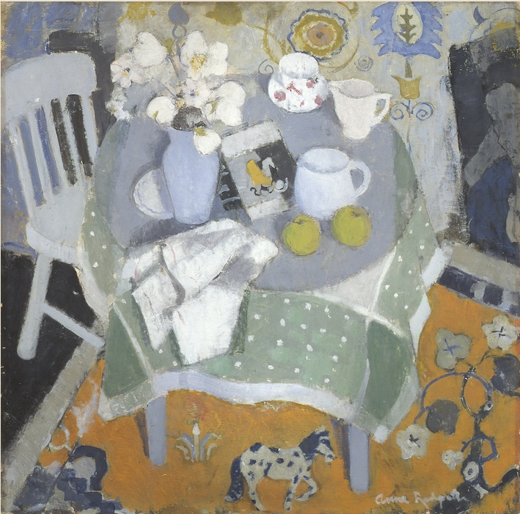Anne Redpath – The Chinese Rug – 1944 | 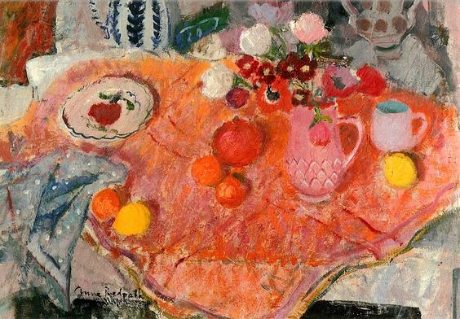  Anne Redpath – Pinks - 1948

