Art & Design Studies
Design

Learners
Booklet

Analyse the factors influencing designers and design practice by
1.1 Describing how designers use a range of design materials, techniques and technology in their work

1.2 Analysing the impact of the designers’ creative choices in a range of design work

1.3 Analysing the impact of social and cultural influences on selected designers and their design practice.

Fashion

A study of

Alexander McQueen

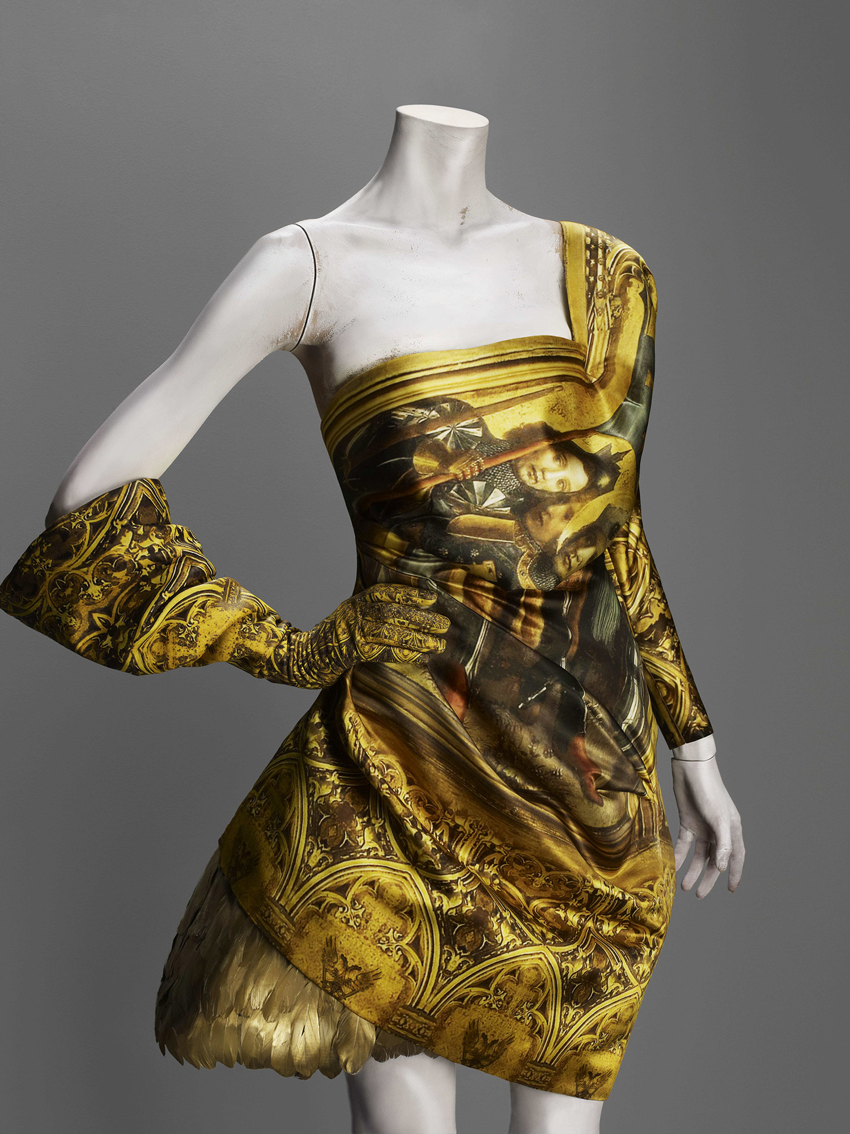
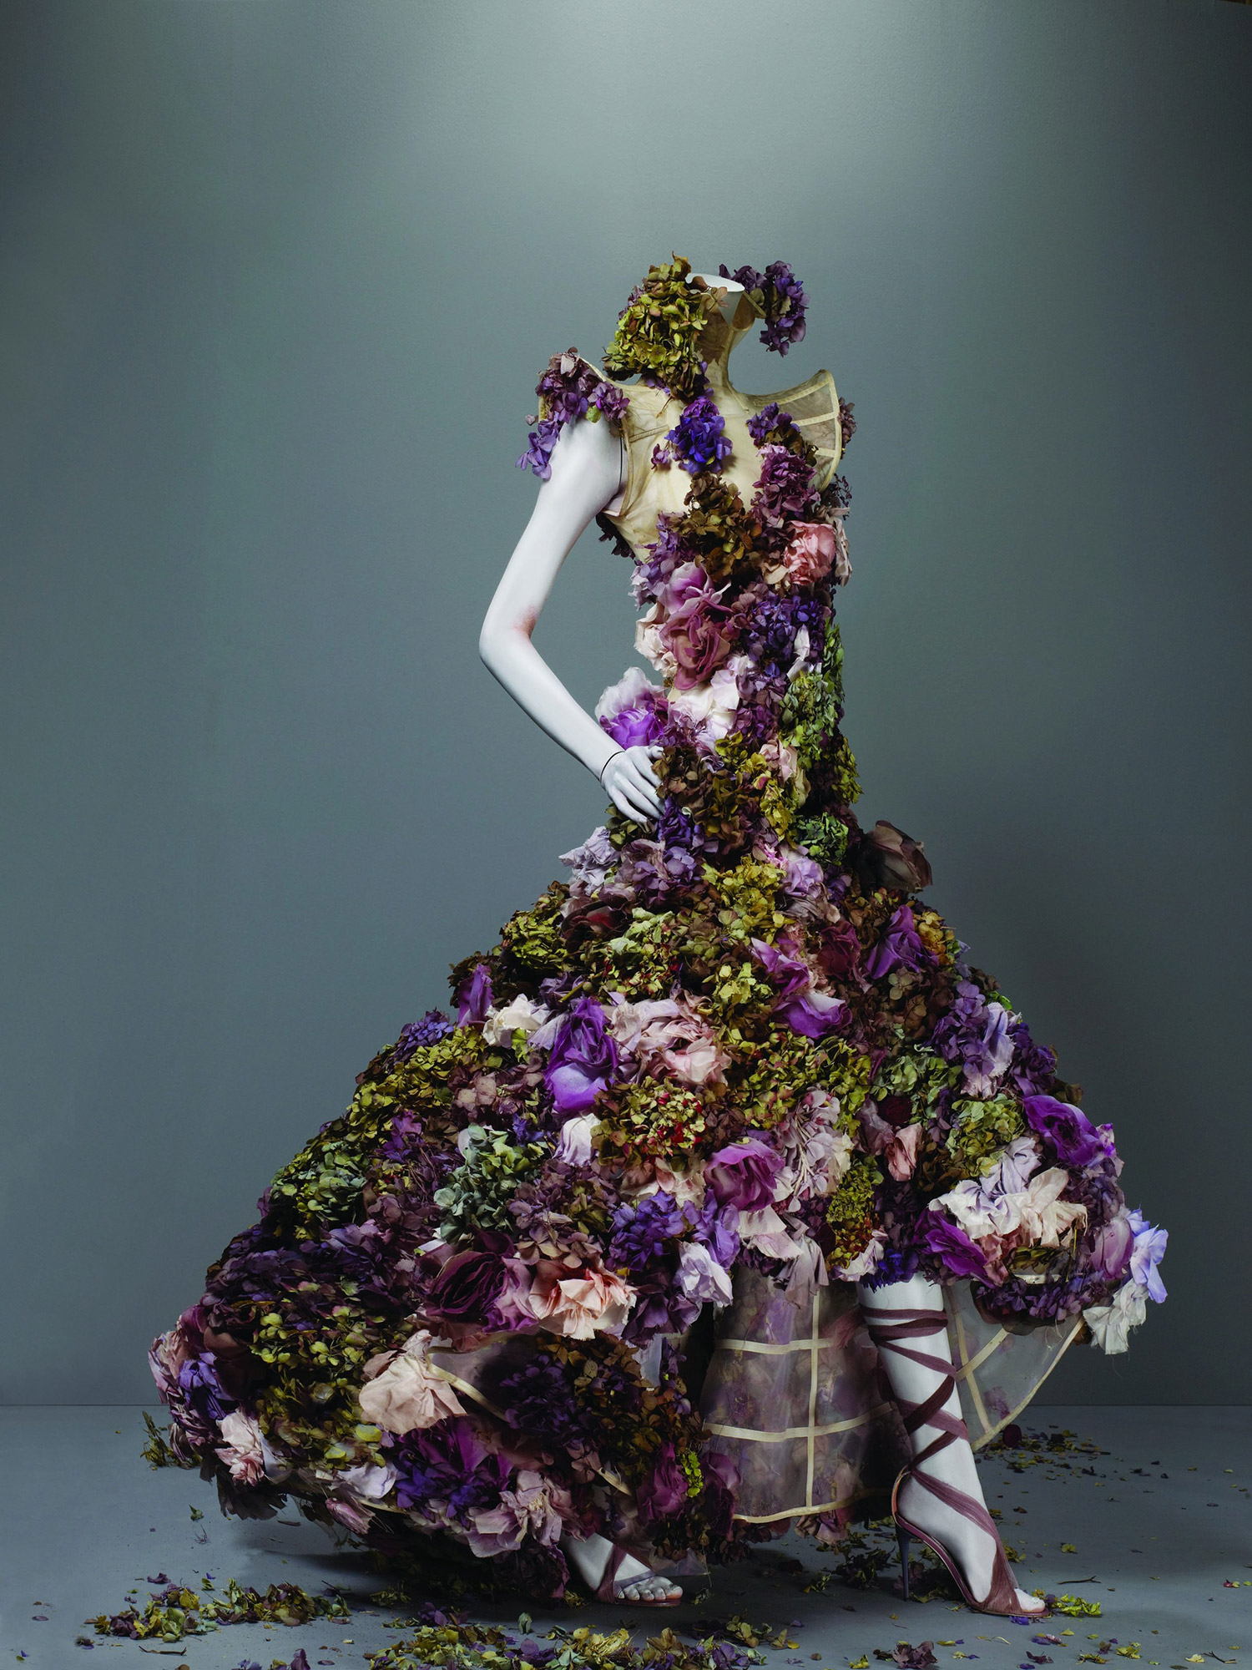
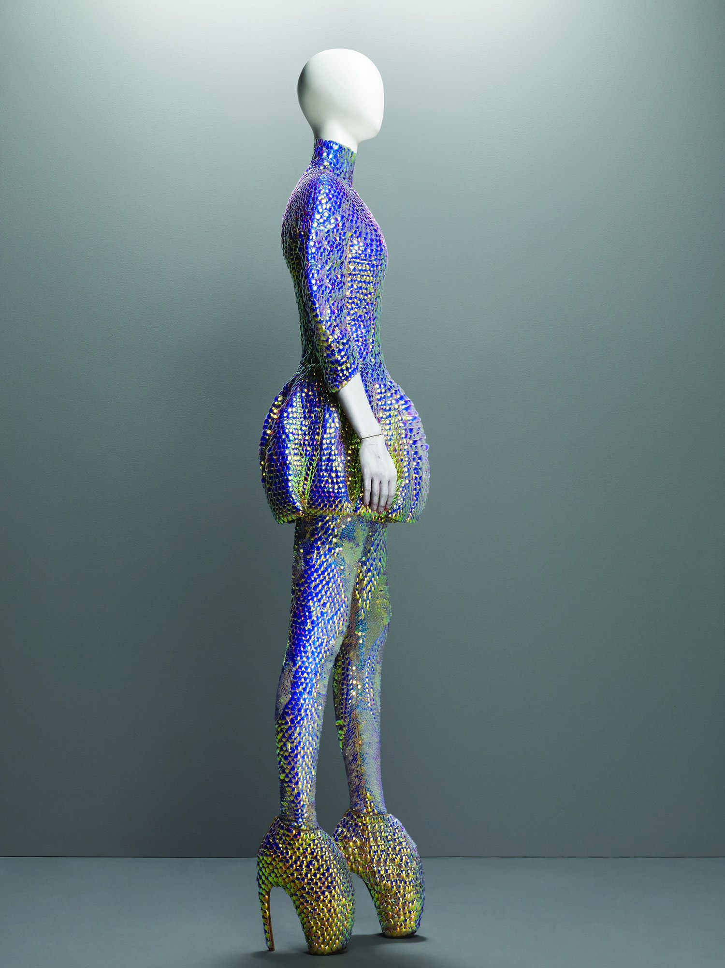

“Jellyfish” Ensemble Plato’s Atlantis, spring/summer 2010 Dress, leggings, and “Armadillo” boots embroidered with iridescent enamel
Ensemble Autumn/winter 2010–11 Dress and glove of printed silk satin; underskirt of duck feathers painted gold
Dress Sarabande, spring/summer 2007 Nude silk organza embroidered with silk flowers and fresh flowers

What is Fashion Design?

Fashion design is a form of art dedicated to the creation of clothing and other lifestyle accessories. Modern fashion design is divided into two basic categories: haute couture and ready-to-wear. The haute couture collection is dedicated to certain customers and is custom sized to fit these customers exactly. In order to qualify as an haute couture house, a designer has to be part of the Syndical Chamber for Haute Couture and show a new collection twice a year presenting a minimum of 35 different outfits each time. Ready-to-wear collections are standard sized, not custom made, so they are more suitable for large production runs. They are also split into two categories: designer/creator and confection collections. Designer collections have a higher quality and finish as well as a unique design. They often represent a certain philosophy and are created to make a statement rather than for sale. Both ready-to-wear and haute-couture collections are presented on international catwalks.
The first fashion designer who was more than a simple seamster was Charles Frederick Worth, in the 19th century. Before he set up his fashion design house in Paris, clothing was made by anonymous dressmakers and fashion standards were derived from the styles worn by royalty. Worth was the first designer to actually dictate to his customers what to wear rather than following their demands.

His fashion house became so famous that people were able to attach a face and a name to designs when they knew they were from the House of Worth. This was the beginning of the tradition to have a designer of a house not only create clothing, but also represent the symbol of the brand.

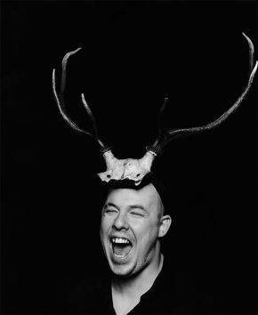
Portrait of Alexander McQueen, 1997 photographed by Marc Hom
'I'm a romantic schizophrenic'
- Lee Alexander McQueen (1969 - 2010)
Alexander McQueen's dashing creativity was expressed through the technical artistry of his designs and the dramatic intensity of his fashion shows. Drawing on avant-garde installation and performance art, these were also definitely autobiographical. McQueen fearlessly challenged the conventions of fashion. Rare among designers, he saw beyond clothing's physical constraints to its conceptual and imaginative possibilities. Over and again, McQueen's spectacular catwalk presentations unleashed powerful feelings as compelling sources of aesthetic experience. In the spirit of Romanticism, unrestrained emotionalism sustained his profound appreciation of beauty. Evoking the feelings of shock and awe associated with the Sublime, his dark imaginings elicited an uneasy pleasure that merged wonder and terror, incredulity and revulsion. McQueen's romantic sensibility propelled his creativity and advanced his fashion in directions both unimagined and unprecedented. His individualistic and defiant vision was augmented by an acute sense of time and place, and a preoccupation with the exotic and the untamed. Filtered through a powerful modernity McQueen's work was, above all, driven by his fascination with the beauty and savagery of the natural world.

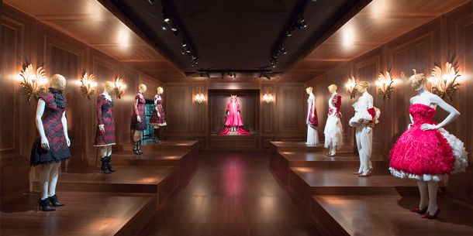
Romantic Nationalism

'The reason I'm patriotic about Scotland is because I think it's been dealt a really hard hand. It's marketed the world over as haggis and bagpipes. But no one ever puts anything back into it.'
- Alexander McQueen
Alexander McQueen’s collections were fashioned around elaborate stories that were profoundly autobiographical, often reflecting upon his ancestral history, specifically his Scottish heritage. Indeed, when he was once asked what his Scottish roots meant to him, the designer responded, “Everything.” McQueen’s national pride is most evident in The Widows of Culloden (Autumn/Winter 2006) which was based on the final battle of the Jacobite Risings in 1745. The collection was wistful, featuring the McQueen tartan, lace and exaggerated silhouettes inspired by Victorian styles. A grand collection, it presented a fresh look to the public against the anti-romanticism of his earlier, Highland Rape collection of 1995. McQueen’s message, however, remained defiantly political: ‘What the British did there was nothing short of genocide.’ The McQueen tartan reappears in this later collection Widows of Culloden (autumn/winter 2006–7). Here he revisited the earlier anger of Highland Rape, referencing the doomed Jacobite Rebellion that ended on the bloody field of Culloden, as well as more recent conflicts such as World War II—some models wore battle dress jackets with model Spitfire airplanes in their hair. But the resistance to violation evident in the former collection gives way in Widows of Culloden to a more wistful interpretation of the period; the tartan's reappearance is a comment, from a designer at the height of his fame who could have used a range of couture techniques, on the inevitable triumph of fashion. In this collection, models appeared in every variation of traditional Scottish dress, from a traditional draped and belted plaid, or fhéilidh Mor, to the fhéilidh beag, the shortened, tailored kilt we are familiar with today. McQueen used his tartan to suggest how the traditional dress of the Highlander had become commodified and Anglicized as fashion, a point he drove home by presenting in the same collection bustled Victorian ball gowns, 1940s suits and dresses, and skinny trouser suits all in McQueen tartan.
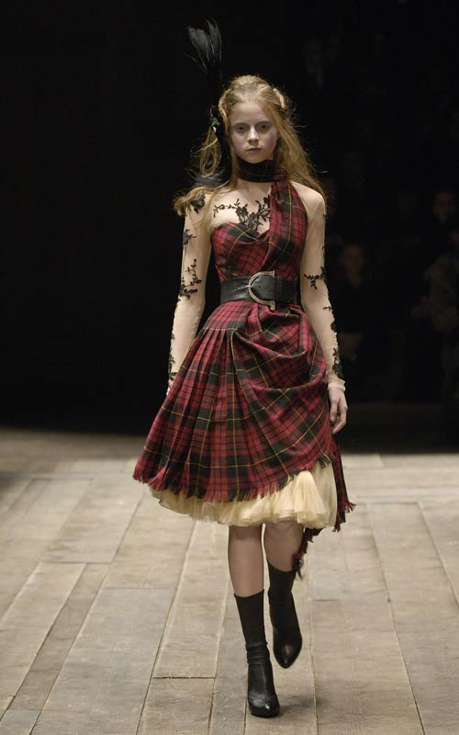
While Widows of Culloden seems especially concerned with loss and the ghosts of the past unable to contend with the march of fashionable progress—after all, the show ended with a spectral hologram of Kate Moss—McQueen was able to use it as the basis for one of his most flamboyant appearances. For the Metropolitan's gala benefit dinner to celebrate the opening of the 2006 exhibition Anglo Mania: Tradition and Transgression in British Fashion, McQueen and the actress Sarah Jessica Parker arrived together in matching tartan finery. Their outfits, hers a belted plaid dress from Widows of Culloden, and his an approximated fhéilidh Mor teamed with tailcoat, oversized badger sporran, and American West–inspired silk satin tie, stunned both guests and the fashion world at large. The transatlantic fashion bricolage, and the union of British and American fashion "royalty" under the banner of McQueen tartan, was a testament to his talent not only to create enduring fashion, but to make fashionable history.
Widows of Culloden, Autumn/Winter collection 2006/2007 Dress made of McQueen Wool Tartan; top of nude silk net appliqued with black lace; underskirt of cream silk tulle.
Some design issues to consider:
Function: McQueen’s work often pushed boundaries, combining art and fashion, his work while always provoking at first, his work always ended up becoming part of main stream fashion. Sarah Jessica Parker wore this very dress to the opening of the Savage Beauty exhibition at the Met.
Aesthetics / Style: A tartan dress draped over one shoulder and around the neck in traditional Scottish style but accompanied by a tulle underskirt and a top of flesh-coloured net appliquéd with black lace. A black belt with Celtic buckle cinched the waist to emphasize the female form.
Materials / Technique:
The collection was made using traditional Scottish tartan wools, lace, tulle and featured the layering of materials to make the whole piece.
Outcome 1
Learners
Help sheet

Fashion Design

Analysis

Materials

What is the piece made of? How does this affect the look, feel, and overall function?

Consider…
- Working methods
- Fit
- Textures
- Functionality of materials
- Feel of material
- Comfort for wearer
- man-made or natural fibres
- Unusual materials
- Recycled materials
- Dyed or natural colours

Inspiration & Influence

Answer:
Where did the designer get ideas from? How have these been developed?
Consider…
- Theme (nature, architecture etc.)
- Concepts (ideas, e.g. the future)
- Work of other designers
- Narrative (story)
- Culture/society of the time (N5)
- Choices the designer made and the results/impact of these (N5)
Process and Techniques
Answer:
How has the designer made this piece of clothing?

Consider…
- How it is put together
- Traditional or untraditional techniques
- Machine made or hand made
- Sewing techniques
- Knitting techniques
- Woven
- Any embellishments

Style & Aesthetics

Answer:
What historical period or design movement does the designer/ design belong to?
Does it reflect the time, place,
Social/cultural events? (N5)

How would you describe it? Elegant? Fun? Sophisticated? Sleek? Quirky? Kitsch? Fun? Futuristic? Retro? Etc.

Form & Shape

Consider…
- Volume & solidity, is the garment soft and flowing or rigid and hard in places?
- three dimensional structure
- symmetry, A line
- What kinds of shapes are used to give form?
- Sources of shapes, soft or rigid material?
- stylisation of shape
- angular, geometric
- curved, rounded
- simple, intricate
- flow & movement
- Stick a colour printed copy of your selected design in the middle of your sheet.
- Add a caption with the name of the designer, her/his life dates; Name of the design; date; dimensions.
- Respond to whichever prompts (Consider…Answer…) seem appropriate for the work you are studying. Your teacher will guide you in this.

Ergonomics

Consider…
- safety issues: wearability and dimensions
- size and weight
- How should it be worn?
- How is it worn?

Answer:
Is the piece wearable? Would it be comfortable? Why?

Other Visual Elements

Answer:
What other visual elements feature?

Consider…
- line: structure, framework, edges
- pattern: surface design, repeats
- texture: surface quality, feel

Colour

Answer:
- Do colours come from materials used?
- How is colour added to the piece?
Consider…
- warm & cold
- contrasts
- colour-tone
- subtle/bold
- complimentary
Function & Purpose

Answer:
What is the piece of clothing for?
Where and when would it be worn?

Consider…
- Target market: gender/age group
- Target market: social class/wealth
- Wear-ability
- Occasion: costume/theatre or specific event
- Part of a wider collection of clothes?
- Where was it shown, what season?

Facts & Opinions: Say WHAT you think, but also WHY: give your opinions with some explanation and reasons!
Cost & Market

Consider…
- Target market: for whom?
- hand-made/mass produced
- types/costs of materials
- time taken to create one piece

