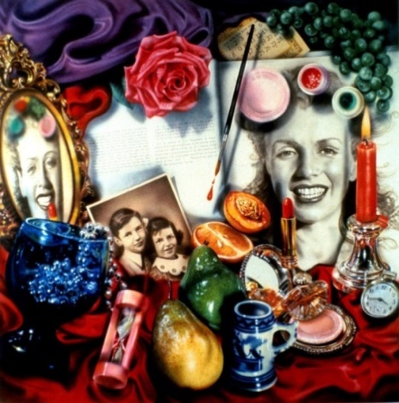

**Scale**

* The painting is large scale at 244cm x 244cm square. This creates a powerful painting to support both its powerful message of life and death as well as its message about the life of Marilyn Munroe.
* Being so large means that all of the subject matter is easier to take in for a viewer, meaning they can engage with the painting and its subject better.
* Combined with the vivid use of colour, the large scale of the painting creates a strong visual impact.

**Mood and Atmosphere**

* A very distinct, thought provoking painting due to the objects included
* Idolisation of celebrity and vanity.
* Life and death / Life is short (time pieces, calendar, burning candle)
* Despite the use of everyday subject matter and bright colours, this painting has a morbid atmosphere.
* Bright vivid colours create a visually interesting piece however, along with very busy composition, this can be quite over-whelming for the viewer.

**Subject Matter or imagery**

* Feminine subject matter which such as flowers and pearls represent the female icon of Marilyn Munroe.
* The subject matter has a deep meaning in this painting as they are symbols of life and death (candle = life, fruit likely to rot = death). This relates to Marilyn Munroe as a reflection of what she is remembered for; her glamorous life and untimely death.
* Looks like a dressing table or shrine (life and death)
* Reflection in mirror shows imperfections in beauty.

**Style**

* Flack paints in the photorealistic style. This helps the viewer engage with the work as it seems to be real.
* This work is created in the ‘vanitas’ style of still life where the artist creates a composition of items that represent the shortness of life such as the timer, watch and fruit.

**Media Handling and Techniques**

* The image was projected onto canvas and traced allowing Flack to ensure the desired scale and proportion of the subject matter as well as helping her to focus more on the application of media.
* Flack used acrylic paint applied in flat colour on canvas first with oil paint applied on top to create tone and glossy finish.
* Audrey Flack used photographs to create her work. This meant that she could create compositions of work that would not be affected by changing light and colour or aging subject matter.

**Visual Elements**

**Colour**

* Bright, bold, vivid, acidic, feminine colours e.g red, pinks, purples reinforces the feminine icon.
* Colour has a glossy appearance, giving the impression that objects are plastic – this emphasizes/highlights the ‘falseness’ of celebrity
* Colours too acidic to be realistic / natural

**Tone**

* High contrast creates visual interest.
* Vivid highlights give plastic feel to subject matter.
* The vivid highlights on the subject matter give the impression of staged lighting rather than natural lighting which is in reference to the staged life of Marilyn Munroe.
* Darkest tones are on the left of the painting, bringing focus to the brighter side that contains the photograph of Munroe.
* Shadows falling where objects overlap, creating realism in the painting.

**Shape and/or Form**

* Variety of shapes
* Ornate shape of mirror is a contrast to the more solid shapes of the other objects. This draws attention to the reflection as well as adding a delicate nature to the subject matter.
* Many circular objects contrasted by rectangular book
* Repetition of shape (ellipses)
* High contrast of tone emphasises form
* Repetition of ellipses emphasises 3D cylinder shapes.

**Pattern**

* Lack of pattern on fabric and subject matter balances the fact that the composition is very busy.
* Repetition of circular and cylindrical shapes create a pattern.
* Repetition of beads opposite grapes create a frame which draws connotations to celebrity life and beauty; both things that Munroe is remembered for.

**Line**

* No obvious brushstrokes to create line which is characteristic of the photorealism style.
* Subject matter creates lines of interest for example the paintbrush links the top and bottom of the composition and draws attention to the calendar at the top of the painting.
* Curved lines of fabric soften the otherwise solid subject matter of the painting and help to make the painting look realistic
* Line of book splits painting in half
* Soft lines on photo compared to harder lines of other subject matter emphasises the real-life nature of Marilyn Munroe.

**Texture**

* Due to Flack’s use of vivid highlights, the subject matter appears to be smooth and glossy but this also emphasises the feeling that the surfaces are hard and cold such as the reflections on the metal and glass objects.
* The fabric appears to be silk or satin due to the glossy appearance which creates a luxurious feeling representing Munroe’s life of luxury as a celebrity. However, these fabrics are cold by nature which could reflect the isolation of this life.
* Plastic look to subject matter

**Composition**

* Square format
* Cluttered / busy composition as well as the fact that all subject matter is arranged in the foreground gives the painting a chaotic atmosphere and makes the viewer feel claustrophobic.
* Tallest objects like the mirror and candle arranged at side of painting to create a frame around the images of Marilyn Munroe.
* Overlapping of objects
* Focal point is unclear
* Reflection creates symmetry
* Fabric at top creates an over-bearing, cumbersome feeling (top –heavy).
* Multiple viewpoints of the subject matter represents the life of Munroe as a public alter ego to her ‘regular’ self, Norma Jean and creates visual interest

Audrey Flack

‘Marilyn’

1977

**Social and Cultural Influences**

* Flack was inspired by the 17th Century Dutch still life artists such as Pieter Cleasz who specialised in ‘Vanitas’, a type of painting that contained moral meanings, usually about the shortness of life. This can be seen clearly in the painting ‘Marilyn’ as well as many other works by Audrey Flack as they contain common subject matter relating to time, decay and death.
* The Photorealism movement takes inspiration from Pop Art which sees a vivid use of colour as well as the inclusion of items from pop culture such as make-up but also reference to historical events.
* Flack is credited as the first artists of the photorealism movement to have a painting bought by the Museum of Modern Art. This brought the movement to the fore in the art world and has brought more attention and acclaim to her work
* The painting ‘Marilyn’ was inspired by the life and death of model and film star Marilyn Munroe. Munroe became famous as a pin-up girl and for her femininity however her life and fame was overshadowed by her unexpected suicide at 36 years old. She was also famous for the fact that Marilyn Munroe was an alter ego and her real name was Norma Jean Mortenson.
* Audrey Flack has since claimed that the photorealistic style was “too restrictive” and has progressed her work on to baroque-inspired sculpture that includes more ornate detailing.