National 4/5 Lois Comfort Tiffany

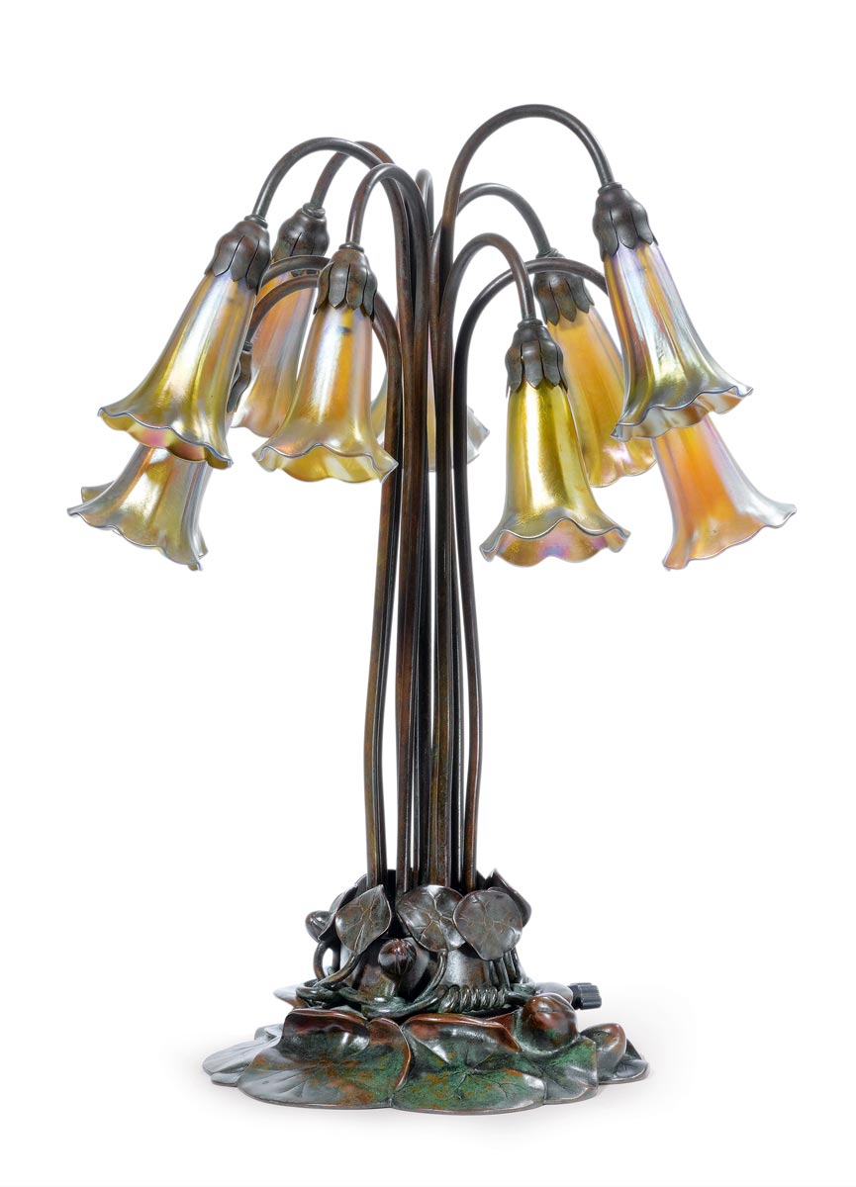

Word Bank:

* engraved in a decorative manner
* highly decorative pieces
* the surface is decorative and ornate
* work displays true craftsmanship
* motifs
* An example of technical mastery…
* High quality tailoring was evident
* Hand finished to perfection
* Uses elegant decorative art style
* Pays particular attention to finish and detail
* sinuous
* elongated and curvy lines
* the whiplash line is evident and indicates art nouveau
* stylised shapes and forms
* Exuberant
* exotic
* emotive
* expressive

Lois Comfort Tiffany (1848-1933), the celebrated glass designer, was the son of Charles Lewis Tiffany, the legendary founder of the silver and jewelry firm, Tiffany and Co. Louis chose to pursue his love of art instead of following in the family business, gaining acclaim for his oils and watercolors in the 1860s and 1870s. In the 1880s, however, he turned his attention to interior design as "a way to provide good art for American homes." His remarkable career spanned 57 years.

As one of America' s most influential artists, designers and craftsmen of the century, Tiffany wanted to bring decorative arts to the same status as fine arts. The lamps of Louis Comfort Tiffany signify this quest to bring beauty into the home. After collaborating to light the first movie theater, friend Thomas Edison suggested the idea of making electric fixtures. Tiffany soon began to create lamps as small versions of his exquisite stained-glass windows and developed the idea into a new art form. Tiffany's lamps were and still are recognized for their superior design and handcrafted details.

In addition to bringing beauty to the masses, Tiffany also made discoveries in the process for formulating glass. Tiffany developed a unique process that created bolder colors, opalescent sheens and a broader range of textures for artisans. He patented four types of glass over a period of two decades and worked with teams of craftsmen to manufacture stained-glass windows, lamps and lamp bases.

The motifs in Tiffany's elaborate lamps were inspired by his love of nature. Some patterns featured in *The Lamps of Tiffany* include: dragonflies, the tracery of spiderwebs, dogwoods, peacock feathers and peonies. Tiffany stated that his lamps allowed more people to enjoy the elements of nature, such as flowers in bloom, all year long in the beauty of his glass.

**Style:**

sinuous, elongated, curvy lines,the whiplash line,

vertical lines and height, stylized, flowers, leaves, roots, buds and seedpods, iridescent glass, silver and semi-precious stones

<http://www.tfaoi.com/aa/3aa/3aa624.htm>

*Purple-Grape Table Lamp*, 1900- leaded glass, patinated bronze, 27 1/2 x 18 inches,

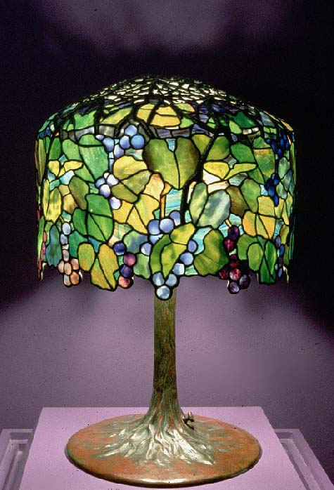

Lamp "Ten-light lily",1904.

Bronze and

Favril glass.

Art Nouveau could be said to be the first 20th century modern style. It was the first style to stop looking backwards in history for ideas, taking inspiration instead from what it saw around it, in particular the natural world

When Art Nouveau was showcased first in Paris and then in London, there was outrage; people either loved it or loathed it. Within the style itself there are two distinct looks: curvy lines and the more austere, linear look of artists such as Charles Rennie Mackintosh. Some aspects of Art Nouveau were revived again in the 1960s.