|  |  |
| --- | --- |
| **Activity** | **Score** |
| Activity 1- Star Jumps/ Burpees |  |
| Activity 2- Spoon Challenge |  |
| Activity 3- Sock/Ball throw |  |
| Activity 4-Step ups |  |
| Activity 5-Speed Bounce |  |
| Activity 6- Ball Catch |  |
| Activity 7-Water Challenge |  |

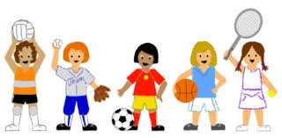Name: Class: