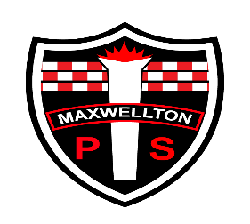**Maxwellton Primary School**

**Virtual Sports Day 2020**

**Date**: Tuesday 16th June 2020

**Time**: The demonstration videos will go live on Ms Begg’s Blog at 9am. You can choose to complete the activities at any point between Tuesday and Thursday.

**Equipment Required for Sports’ Day**

* An egg (hard boiled) or a potato
* Small ball
* Rolled up socks x 4
* A small step
* Two buckets
* A cup

**What to expect:**

* There will be 7 activities for the pupils to complete. Each activity will last 30 seconds for P1-P3 and 60 seconds for P4-P7.
* A video will be uploaded onto Ms Begg’s Blog demonstrating each activity. The link to this will be posted onto Google Classroom on Tuesday 16th June.
* Children will be provided with a score sheet. This will be uploaded on Google Classroom. This sheet can be downloaded and printed. If you don’t have a printer then copy and sketch the template. Please complete the score sheet after each activity.
* The score for each activity will be how many times your child can do that activity in the time given e.g. 20 step ups would be a score of 20 for that activity.
* For the ‘spoon race’ please indicate how many times your child had dropped the egg and we will deduct that from their overall score.
* When all activities are completed please ensure your child’s name and class are on the score sheet and email to Mrs Brown ([gw19browncarolyn@glow.sch.uk](mailto:gw19browncarolyn@glow.sch.uk))
* A photograph of the score sheet can be sent.
* The final deadline for submission is Thursday 18th June at 12noon. Ms Begg and Mrs Brown will announce the overall winners for each class on Monday 22nd June 2020.