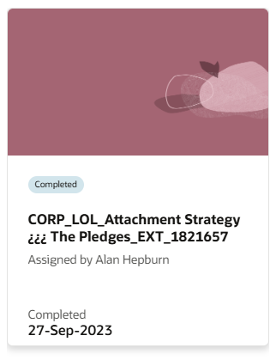
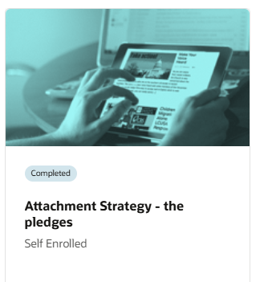

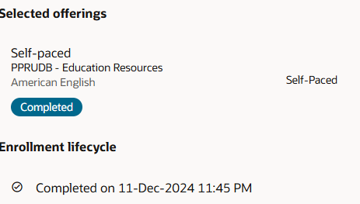
Learn Online Courses completed by all staff during the first term (either at inset or during own time, completed annually. Example from a staff member LOL Learning page.

