Kirkton Primary School
Standards and Quality Report 2022/23

Context of the school:
Our School:
Kirkton Primary is a non-denominational school within a residential area of Carluke, in Clydesdale, South Lanarkshire. Carluke is located in a semi-rural area of South Lanarkshire with good transport links. The environment is bright, spacious, modern learning environment. The roll this year was 173 children. Next session we will continue to be a single stream school. The expected role is 171 for next year.
Within Kirkton Primary we have 12 children who receive free school meals. We have 4 care experienced children. Within the school we have 10% of our children who live in SIMD 1 and 2 and receive FSM. Only 4% are living in SIMD 1 and 2.
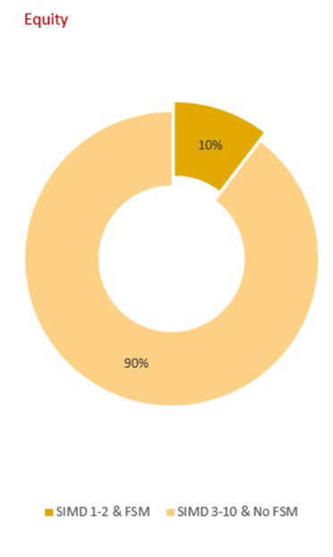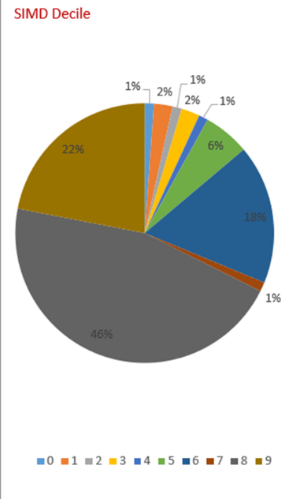

55 of the children are on staged intervention. 29% of our school role has ASN. We have 7 pupils at stage 1, 14 at stage 2, 2 stage 3 and 7 at stage 4. We have one child who has EAL. 7 of our children have an ASP. 20 Children are on Literacy Consultation pathways, 4 with health care plans. 2 children have dyscalculia and 2 with dysgraphia. 2 children have Behaviour and Support Plans. A requested ASN audit in January has now led the paperwork to be in line with SLC expectations.
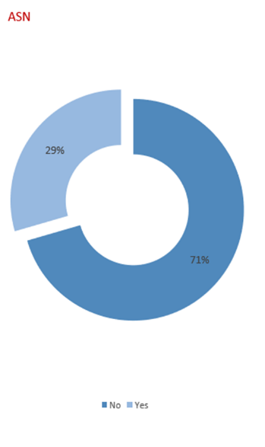
The school strives for an inclusive welcoming, diverse, nurturing environment where children are actively involved in their learning and increasingly understand the need for responsibility in achieving their personal goals. We aim to help every learner to develop knowledge and skills for learning, life, and work. The school is committed to raising attainment for all children as well as ensuring that the health and wellbeing is paramount to the development of the child. In developing the whole team/community ethos we have reflected on our values; care, trust, respect, kindness, resilience, honesty, creativity, and innovation to ensure we are clear in our vision and values each week at assembly and this is displayed in all our headed notepaper, on a wall display and followed up in class. We also strive to ensure that all child’s rights are met, and we embrace the RRSA programme, we recently achieved a silver award and have maintained our practice this year in our plans. Learning to care for the environment/sustainability is an area we are developing, and the development of our school grounds are part of that process. We are now registered for our Eco Green Flag through Beautiful Scotland for the first time since 2015. We hope to achieve this flag before May 2024.
HWB was a priority this year in our SIP as we recognised the increase in mental health needs especially amongst our P5-7 classes. There has been a wide range of after school sport clubs with 71% of our children attending them. The girls football team won the Gala Cup, with the boys as runners up. One boy won the SLC 600m and was third in the long jump. SAMH was used to support p6 and P7 pupils and parents at transition in June though a workshop experience. Play therapy and counsellors from Spark has been used along with social workers/family care workers to support our most vulnerable children. A nurture room was created for our children who were displaying high anxiety with Emotion works and emotional literacy being a support along with counselling from the HT. Boxall Profiles were screening tools to support teachers in identifying SMART targets for children who are presenting behaviours of concern. Nurture Principles were introduced at the August inset and then supported further with the Nurture Attunement Profile, observation, and assessments of classroom practice. This has created a nurturing ethos across our school and is reflected in our audited relationship policy. We intend to go forward for our Nurturing Schools UK award next year along with our Sports School Award. In our parent audit and recent emails from parents several of them have said that they think the drama, clubs and ethos has increased their child’s wellbeing positively and are strengths of the school.
The staff have a wide range of skills and are working with a distributive leadership ethic. Each member of staff has been given a leadership role linked to their strengths and children in addition have also had leadership opportunities through pupil voice groups, play leadership at P4 and P7, digital leaders, roles and responsibilities re Sustainability topics, House and Vice Captains. This has empowered staff and pupils as commented in recent audits. Our ASN audit and pupil voice said that the majority of children felt included.
We also have an active enthusiastic Parent Forum with an average of 10 parents regularly attending 6 weekly meetings and up to 20 parents who engage in fundraisers, promote the views of the parents, and support school events. Our parent forum members who have a PVG have also supported our trips, Forest Schools, and Glee Club. We have two smaller groups that have branched from the Parent Forum to create a Cost of the School Day working party and the Gala Group. These are both strong groups with 4 main members in each. We in addition this year have started an ASN parent group. The purpose is to communicate good links to agencies, supports and for parents of children with additional needs to support each other in an informal capacity. We organised and delivered sharing of the learning and teaching though class assemblies, play and stay in P1, Read, Write Count parent/child sessions p1-3, P1 induction workshops, google classrooms for parents, 3 newsletters based on SHANNARI, termly differentiated curriculum newsletters for each class, two parent’s evenings and an annual report. All parent events are well attended with 90-100% being an average.
Our curriculum is improving as it is regularly refreshed to ensure that learners benefit from challenge, enjoyment, breadth and depth, progression, relevance, coherence, personalisation, and choice in learning experiences. The aim for our pedagogy for 2022/23 was to reflect on a curriculum that was active in learning and raised engagement and motivation through Personalisation and choice. We introduced Pebl and saw significant increases in engagement at p4-7 with ICT skills being enhanced through this practice. Play was developed at P1-2 but requires further development and a clearer vision. Outdoor learning was developed in Term 4 with a particular focus to take maths outdoors. Children will continue to be coached in their learning through higher order questioning and encouraged to be more curious and inquisitive in their learning. A STEM working party developed a Discovery room after our ICT refresh in January. From our pupil’s audit of HGIOs the majority of pupils have reflected that this is an area they are finding motivating and engaging. Our P6 lead teacher has led by example in this area and SLC Raise team often compliment this practice. This area and Pebl will be further developed next year through our SLC Skills framework and IDL planners.
We have further developed the arts across the school with a P1 nativity, P4-7 School Show, 20 children learning how to play an instrument and a waiting list should any vacancies occur, 4 children chosen to attending the Glasgow Conservatoire workshops in Hamilton, an art club for p1-7 all year, an afterschool dance club, a Glee club which has sang three times to our local care homes, and a teacher enhancing the learning across the P4-7 stages each week in music and drama. We now have consistent plans in place and use Charanga as a resource. Next year we intend to continue to maintain this area but also take all children out to the theatre to see a Pantomime at Christmas and introduce an after-school show club.
Our self-evaluation takes account of current policies, guidance, tools, and examples of good practice. Self-evaluation is an ongoing process and is a key feature to the learning and teaching within Kirkton Primary. Craig Melrose from Education Scotland came to further assist the school in May with self-evaluation. This involved looking at self-evaluative language, and the importance of looking inwards, outwards and forwards pedagogy. This is an area which will continue to develop in 2023/4.

Review of progress for session Aug 2022- June 2023
School priority 1:
NIF Priority (select from drop down menus)  Improvement in attainment, particularly in literacy and numeracy.  NIF Driver  Teacher and practitioner professionalism  Assessment of children's progress | HGIOS?4 QIs (select from drop down menus)  2.2 Curriculum  2.3 Learning, teaching and assessment  - 2.4 Personalised support
Strategy
What did we set out to do?
Aim:To ensure that all children are able to access opportunities to develop a broad range of active literacy across the curriculum

Progress and Impact
What difference did we see? What did we achieve?
Outcomes/impact
- To have clear progressive planners in reading using North Lanarkshire planners as the core with support pathway and embracing the 6 reading Kirkton skills.
This year our PT was appointed in Oct but was not in place until January due to SLC HR process. This impacted on the development of this area and will be carried forward into the next session. A working party was formed and evaluated the current planners creating planners to start in August 2023. All staff felt that the current planners were overloaded and that there were important areas not being covered with depth. Writing was an area of development and PM writing was established as a focus for next year. Most staff attended a PM Writing Cat night from a HT in Blackwood Primary to reflect and support the introduction of this resource and then the working party attended a PM writing session at Blackwood Primary. In conclusion from the staff feedback, they felt we needed to further understand how to deliver a high quality writing programme to ensure we differentiate, motivate and engage our children, build on regular assessments, and use writing daily discreetly and across the BGE. Staff were also needing support to identify what PM resources would support this learning and teaching.
- To have all staff trained in active literacy approaches in spelling and reading.
Benchmarking of children across the school continued to identify the need to develop reading skills such as summarising and literal/inferential questioning. Progress in children’s reading skills from the variety of assessments used such as NGRT, benchmark, SNSA, class teacher assessments and observations indicate the need for a pacing guide and consistent reading strategies across the school. At P1 we continue to need to develop rhyme, rime in our programme along with grammar and throughout our programme we need to identify robust literacy interventions to support children who are not making progress in the core programme., especially at the end of first and second level. This year although progress has been made at P4 there was a dip from last year’s attainment. In P7 and P4 our attainment was above the national average in writing and reading but it is lower than it should be for the catchment area.
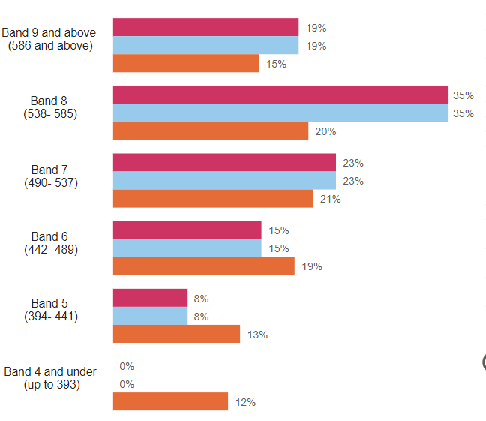

P4 reading

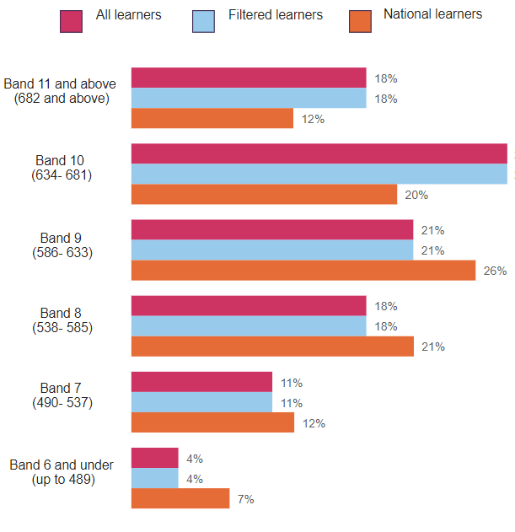
P7 Reading

Support Assistants are supported from the teacher in upleveling questions. During class observations it identified the importance of the most vulnerable children needing more time with the teacher. Intervention timetables were regularly reviewed for impact, but this needs to be more robust in implementation as due to long term illness of S/A the interventions were limited in impact.
Spelling and phonics will be carried forward to next year’s SIP due to PT not being in place until January.

- To share with parents’ strategies on how best to support their child in reading
Parents were invited to Read, Write and Count sessions from p1-3. 95-100% of parent carers attended and said they valued the sessions to inform them of the focus for reading.
Class and School Newsletters indicated links where parent/carers can support their child.
Boards displayed at the May Parents evening with strategies to support parents develop reading and on twitter were not accessed well by parents. To raise awareness, motivate and engage parents further on how to support their child with reading skills requires to be developed through reading accreditation process.

- To continue to develop the use of data to support and inform interventions, in particular the future p5 class for talking and listening and P6 writing.
This year 96% of children in reading and writing in P5 are on track. 81% in P6 for writing.
96% of children in P5 for listening and talking are on track.100% in P6
However, we now see a dip in P2. This is an area for reflection. There is wide range of abilities and the children have been regularly assessed through benchmarking to ensure we are meeting children’s needs. Children have developed better summarising skills, but inferential questioning is needing further developed.
Next year staff to further reflect on what skills they are developing and accessing in talking and listening to be able to know what children are meeting the recommended level. Most staff are giving opportunities for solo talks discreetly or through Pebl but evidence suggests skills are not explicitly taught. Wall displays do not reflect skills development in all literacy areas. Scots’ Poetry competition demonstrated low motivation and engagement. To reflect on presentation skills, motivation and engagement with Poetry and Scots language.
5 children are on Lit consultations at P5 and 4 in P6 children are on ASP with literacy interventions.
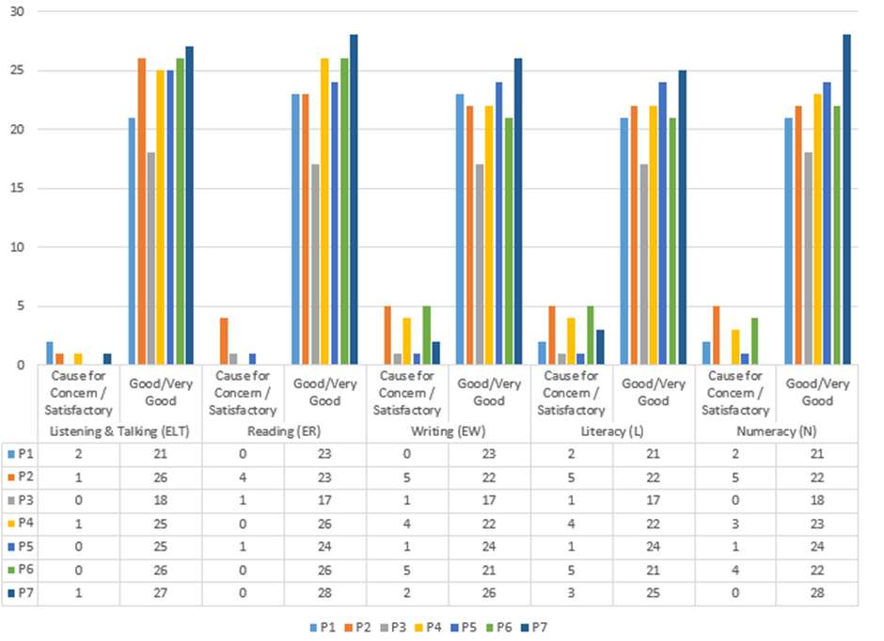
Closing the gap in literacy;(see graph below)
There is a dip in our children’s literacy skills at SIMD 1 and 2 as seen below in the graph, especially in writing and overall, in literacy. Further reflection to robust interventions for children with FSM and to attendance affecting reading and writing. Those with lower than 85% attendance are only achieving 75% in these areas. Targeted interventions are required alongside robust tracking and monitoring by all staff. From the second graph below we can identify that at P1,3 and 6 these children need to be our next focus for improvement to attendance to impact our attainment.
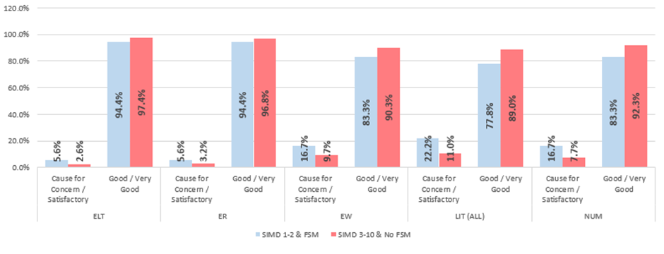
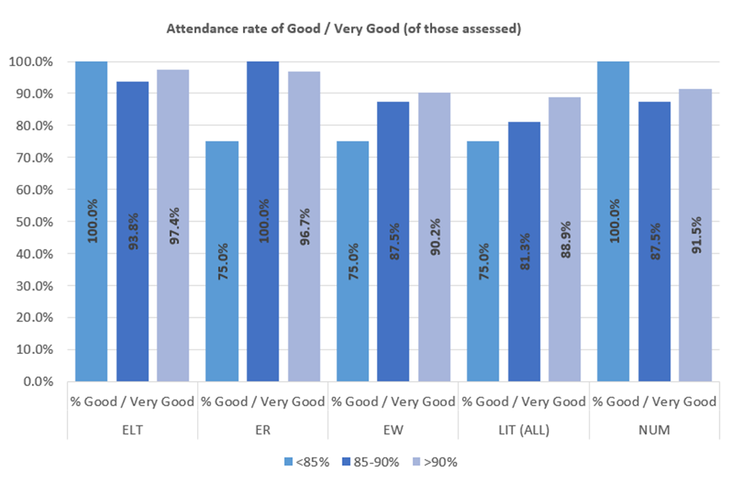
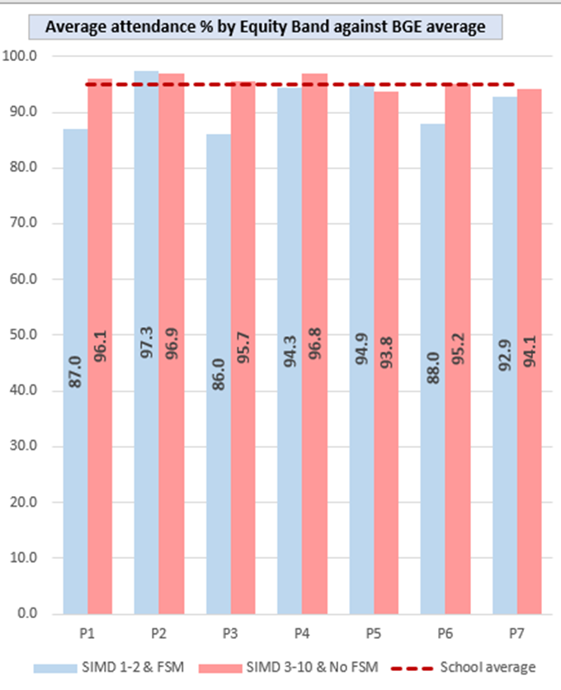
- To further develop a range of genres -poetry, plays, media in class, school library, homework to use across the curriculum
Pupil voice reported that all library areas were either good or very good. P1-2 classes reported that there is now a very good choice of genre, P3-6 said that it was good but at P7 they said that it was not very good. This is an area of development due to also dip in reading data. The P3 class reflected that they needed the library to offer more challenging material and in the upper library the classes have requested more non fiction and ‘scary’ texts. This year we focused on reading especially with males. Clearly there is improvement as we can see from the recent graph taken in June 2023. Reading now is nearly equal between sexes and the hope is to now see it impacting on our writing attainment.
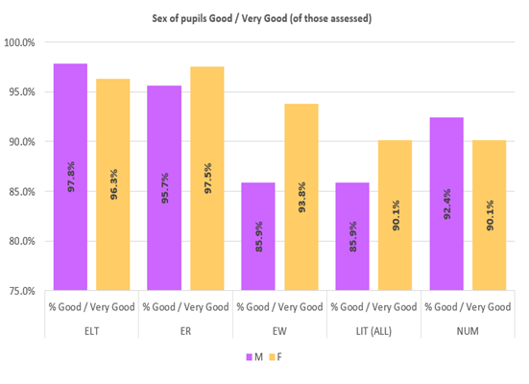
Listening centres are not being used in infant classes regularly. At P2 the teachers used it for a short spell in class. Resources are limited and need developed. QR codes are used in the upper library, but children need opportunities more regularly. All children require consistent DEAR sessions.
All classes visited the community library, but the learning intention was not explicit as when auditing the impact, the evaluation reflected on the library organisation rather than the skills. This is an area of development.
Homework is an area where there is not a high level of engagement. Further evaluation is required to motivate and engage children and parents in this area.
- To use ICT consistently as a tool and resource to reduce literacy barriers
IDL data is now used to evaluate progress and identify if the child should continue or use another intervention to support their spelling.
Most staff attended a Cat night on dyslexia supports using ICT. CALL Scotland was referred to but in class plan/staged intervention this is an area of development.
33 children with staged intervention access a Chromebook to support them with literacy however independent skills are required on how to use them independently is required due to reduced adult support.
In addition, in our upper classes the need to further develop teacher and SLT self-evaluation and data to ensure children’s learning is robustly assessed and supported. This then followed up consistently with interventions of support in and out of the class.
- To use the literacy pathway SLC to identify dyslexia and reduce barriers.
Most staff were trained in the literacy pathway and then supported from Mrs Singh the newly appointed SLC ASN teacher to begin the process of the Literacy consultation process. This area will continue to develop next session. A recording of the process was sent out to all staff to support.
20 meetings with parents of children who present themselves with literacy barriers from P3-7 took place in May to intro the process. 2 children following this process have been determined as having dyslexia.
- To train all staff further in identifying dyslexia and how to plan and support a child with this barrier
Most staff attended a CAT night in Sept 2022 but evaluated that they felt they needed further practical supports to help a child with dyslexia. 1 member of staff completed a 6 week course on dyslexia as part of her PRD.
Next Step(s) to inform SIP for 2023/2024:
- PM writing to be further developed through CLPL for all staff, lesson observations and further PM resources to increase motivation and engagement.
- Follow the reading accreditation to raise the profile with all stakeholders to ensure learning and teaching is visible and consistent.
- Introduce and develop the new literacy planners to insure consistency and progression.
- Evaluate the current talking and listening resources and skills. Identify CLPL for staff.
- Continue to develop the literacy consultation process using data to inform robust interventions and ensure children are independent in following through tasks linked to needs.
- Continue to develop supports for children with dyslexia and challenge children who present themselves with above average progress for their age in literacy.

School priority 2:
NIF Priority (select from drop down menus)  Improvement in attainment, particularly in literacy and numeracy.  NIF Driver  Curriculum and assessment  Teacher professionalism | HGIOS?4 QIs (select from drop down menus)  2.2 Curriculum  2.3 Learning, teaching and assessment  2.5 Family learning
Strategy
What did we set out to do?

To ensure that all children can access opportunities to develop maths and numeracy skills and apply across the curriculum

Progress and Impact
What difference did we see? What did we achieve?
- To develop a core plan with support pathway for mathematics and numeracy
The working party have created a new planner to be introduced to staff in August using the East Renfrewshire Programme, Crawfordyke planner and SLC planner. This planner also reflects the SEAL/Maths recovery pedagogy.
- To develop application of maths skills through identifying STEM topics and challenges across all levels
The discovery room was created by the STEM working party and introduced in April. This is being well used by classes p2-7. Resources bought by the parent forum have enhanced this area along with staff research books and model planning format for the room. The P6 teacher has led by example on how to develop maths skills through mapping, scaled drawings, creating models using junk and manmade material e.g. lego. Shared with parents re twitter. And a wall display of experiences from P1-7 continues to display experiences across all levels.
The IDL/STEM working party has now been formed and began to identify the need for a STEM/IDL planner which bundles e/o’s and reflects on the SLC skills framework.
- To use data to identify next steps for individuals and groups in particular 2nd level; P5 and P7
32 children have now been assessed through maths recovery across p2-7.
In p1 82.6, p4 84.6 and at P7 82.1% were on track.

8 children in p5 and 6 children in P7 were identified with barriers in numeracy. 96% in P5 are on track and 82.1% have achieved 2nd level in p7 from classroom observations. However, from SNSA assessments 24 P7 children did not achieve and in Malt assessments 12 children were not on track in P7 and in P5 6 children were not on track.
There was a significant number of children requesting more challenge from the pupil audit. This was also highlighted form the parent audit. In p7 children reported that they felt they needed more interactive maths. This did not reflect the planned opportunities observed. Two children have achieved 2nd level in P5.

- To create a SEAL/Maths recovery leader to support children through identifying next steps from assessments. To upskill SA in SEAL and Maths interventions to support children further with maths/numeracy barriers.
Mrs Smith has completed the purple and red training for maths recovery and has delivered 1 training session to some support assistants this past term. She has begun to discuss and work with teachers re maths recovery strategies following 32 children being assessed (19% across the school). The monitoring and tracking of children following assessment will improve next year as Mrs Smith will not be away on training and further training with staff on the inset this August will enhance the pedagogy of maths further, building on the training at our Feb inset this year. All teachers received the red and purple books. The intention is to introduce the new maths planners which will impact further the pedagogy across the school as it is in in line with maths recovery; concrete/pictorial/abstract. £2957.41 was spent in resources to increase engagement in classes. Through observations the teachers used a variety of resources to actively engage children. Children auditing HGIO maths lessons said that the lessons were good/very good. Class lesson observations of P7 children at maths, contradicted the children’s opinion about maths needing to be more interactive. During observation the children were highly engaged when the teacher was teaching but when observing the student, the children were not supported as well and key concept language was an area of development.

- To share with parents how best they can support their children with maths and numeracy
Google classroom was introduced to the parents in the upper classes following a parent questionnaire to identify what they wish support with.
At Parents evening a board which displayed how to support your child with maths strategies was not well accessed.
Parents auditing maths felt that more challenge is required, and maths recovery pedagogy is needing to be further developed across the school.
Parents have found feedback from maths recovery assessments informative and a good support but request more information for all parents on games, learning at home through play and apps. They have also requested homework to be more tailored to their children’s needs.

- To further develop parent partnership and community links through World of Work with a focus on jobs that involve maths/numeracy.
This area was not developed this year and requires to be looked at next year to increase motivation and engagement.

Next Step(s) to inform SIP for 2023/2024:
- Introduce and develop new maths planners.
- Track and monitor the children who have been assessed on maths recovery and identify if next steps are making a difference.
- At August inset further develop maths pedagogy inline with SEAL/Maths recovery for all staff
- Further develop parent partnership re information on how they can help at home through Google classroom for parents, apps, newsletters.
- Identify children who need challenged and next steps. Introducing third level planner.
- Identify STEM topics and link to World of work for all stages that will ensure children’s motivation and engagement is increased.

School priority 3:
NIF Priority (select from drop down menus)  Improvement in attainment, particularly in literacy and numeracy.  NIF Driver  School and ELC leadership  School Improvement | HGIOS?4 QIs (select from drop down menus)  3.3 Increasing creativity and employability  2.3 Learning, teaching and assessment  2.2 Curriculum
Strategy
What did we set out to do?
To increase pupil engagement in learning

Progress and Impact
What difference did we see? What did we achieve?
- P1-3 staff adopt and develop play pedagogy consistently and age/stage appropriate
Our NQT at P3 unfortunately left the course and this impacted the pedagogy in P3 at the early stages. The next teacher reflected on the needs of the class and introduced play-based learning more after Christmas when she felt that the children were clear about boundaries and expectations and were in the right place to learn through his pedagogy.
In P1 play based learning has developed over the year and in p2 play was only introduced in the afternoons due to the teacher’s developing knowledge, skills and confidence in play.
The open area was used mainly by P1 and the SA for interventions. This is an area of development and due to staff shortages, it was an area that did not progress as well as it was intended.
Both P1 and P2 teachers accessed the SLC Play Lead through meetings and discussions.
Resources were bought to enhance the environment in p1 and in the open area. Being Me in SLC was delivered to P1 staff. Further money is required to be invested in this area to motivate and engage children through play and develop staff confidence.
- Children’s engagement increases in learning and children develop independence, confidence, personalisation, and choice
Using the Leven scale through HT observations this enhanced discussion about meeting children’s needs and pedagogy. Some of the children’s engagement increased in second observations due to staff confidence increasing, increased use of data to inform next steps, resources improving and suiting various styles, and continued positive relationships with pupils. Differentiation is an area of development at some stages and feedback to identify next steps. This is an area of development.
- Children identify and plan next steps in their learning in literacy and numeracy across the curriculum
Throughout the pupil audits this year many children are not explicit in their learning of skills. Feedback from parents has also indicated that they are not familiar with the children’s next steps. Reflection on the SLC Pedagogy Palette and through SLC skills framework with the cluster for moderation will enhance this. Feedback from staff in class observations supported children in understanding concepts and LI was explicit in each class. At some stages Success criteria was not referred to by pupils to assess how well they are doing.
- Children’s questioning and curiosity has developed through enquiry-based learning across the curriculum which is relevant and progressive
- 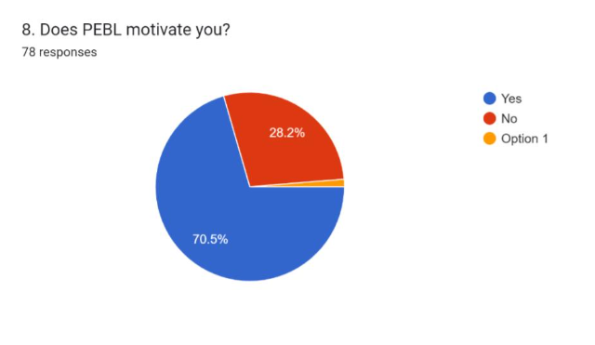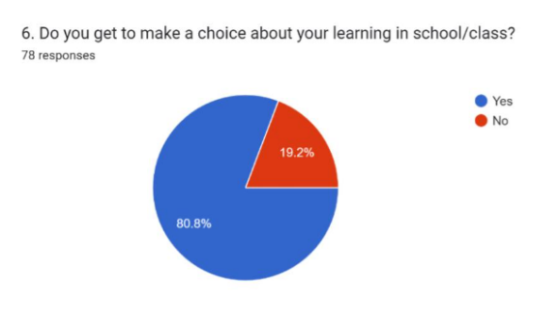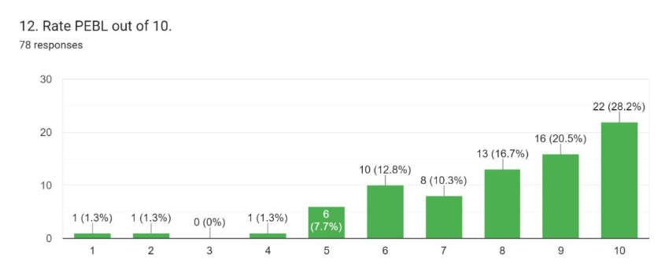
PEbl has increased children’s personalisation and choice. At p4,5 and P7 but not at P6. In the pupil audit they explicitly share that they enjoy choosing their own context/question, have developed skills in ICT, reading for information and have developed skills in resilience due to projects not quite flowing the way they expected or that they did not have the skills/resources they needed to investigate.
A Pebl pedagogy policy has been created to ensure consistency across p4-7 and stage meeting shave supported practitioner confidence to develop this new pedagogy. Expectations and lesson guides have also supported the implementation. The lead practitioner has visited and collaborates with peers across Scotland to further support staff.
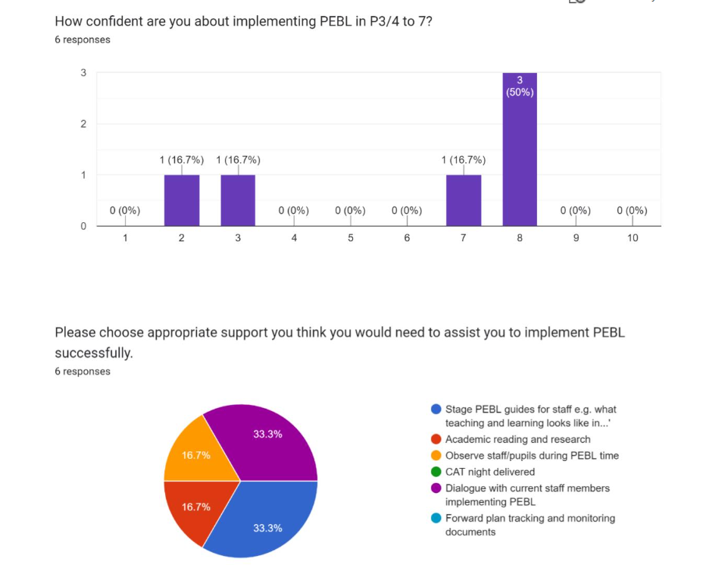
- Class environments are dynamic and demonstrate a child led pedagogy with consistent themes in HWB numeracy, literacy, and labelling.
Consistency guides were created for literacy, numeracy and wall displays. Most classes in the upper school are following these guidance’s. However further reflection is required in 2023/24 due to change in staff at stages, further development of the environment expectations in p1-2 using a play-based pedagogy and in p3 at Easter when they will be introduced to Pebl.
Improved tracking and monitoring of consistent pedagogy by peers and SLT is required to ensure consistent high-quality learning and teaching. Further planned walk rounds throughout the year would enhance this consistency.
Floor books displayed a wide variety of good experiences but in reflection across the BGE there needs to be a progression of skills and knowledge that is manageable to deliver.
Next Step(s) to inform SIP for 2023/2024:
- Clear vision of Play at P1-3.
- Further embed Pebl from P3-7 re guidelines, observation, research, stage meetings.
- Progressive IDL planners which bundle E/os and include STEM
- Moderation with cluster re pedagogy palette used by SLC

National priority: How we are ensuring Excellence and Equity?

Strategy
Brief commentary on context and identified barriers to learning which affect progress and attainment, key interventions undertaken
Progress and Impact
What difference did we see? What did we achieve?
Kirkton Primary has had 5 headteachers over 7 years. This affected the team, leadership, ethos, pedagogy, and planners and in turn has affected attainment. Consistency and expected high standards is an area of development. A change of key leaders PT and Team leader in the school this past year has had an impact as there was a gap of 4 months before a PT was in place from another PT leaving. The other PT was returning from maternity leave and therefore the SLT was only the HT and therefore the standards and quality to ensure consistency, challenge was limited due to a lack of staff. Since Christmas the distributive leadership ethic has developed a momentum of progress. Staff have also felt empowered due to working parties and clear expectations in SIP. Planners created for core areas will enhance attainment, but this will not be visible until next session. Strike action did however slow down the process.
Although most children have attained their level due to teachers planning, parental support, tutors, and home environments/experiences the attainment in comparison to a similar school in the local area is lower. In writing a local school who has higher SIMD performs better in writing. Staff using data to inform practice has developed but further work on self-evaluation to inform practice requires development. Equally drilling down on data to identify next steps in planning continues. Using benchmarks across the BGE would enhance this evaluation as well as developing staff autonomy over data.
Inwards, outwards and forwards is a pedagogy that continues to need to be supported through PRD and class evaluations. Coaching and mentoring peers to develop their own professional standards and qualities would ensure moderation across the school, motivation, engagement, and ownership of the school improvement plan. Staff should continue to liaise with other schools within and out with the cluster. This will enhance a bigger picture of education, expectations, and current educational issues.
Staff require further support in understanding play based learning. Resources in the school have been mainly paper based and motivation and engagement of pupils for some children after the pandemic in our upper classes was a concern. Teacher confidence in using consistently a wide range of resources indoors and outdoors needs supported. There are many sparkles of BGE but building on skills is an area for development.
Equally ASN interventions and paperwork has not been robust due to data not informing interventions. Nearly a third of our school has ASN needs and the limited adults to support the raising of attainment due to long term illness/or not appointed by SLC this past year has impacted attainment. Independence in some of our ICT interventions has also been a barrier.
An audit in January requested by the HT with SLC ASN team has given support for staff through meetings, CLPL, consistency in planning and assessment and in turn supporting pupils in their learning and guiding parents with supports. This has impacted positively on children’s progress although it’s at the initial stages. This will continue to in session 2023/4.
HWB mental health of some of our children in the upper school has had an impact on the classroom being a safe environment. Three of our children have had significant impact on their own health and wellbeing and their families. Play therapy and counselling, working in collaboration with outside agencies closely has increased progress however in some children they are not reaching their full potential yet.
Parent Partnership has improved as parents are reintroduced to a variety of opportunities to engage with the school; class assemblies, play and stay, P1-3 Read, Write And Count parent w/shops, school show, three Church whole school events, Parent Forum, parent consultations, open door policy, parent helpers, and fundraising events. However, parents feel they are unclear of the learning and teaching and how to support their child. They also would like more time with their child’s class teacher and for opportunities for parents and staff to work together out with the school hours due to work commitments. Informing the parents of what has been done from their viewpoints is important to continue to improve the school. You said, we did should be introduced in session 2023/4.

In conclusion Kirkton Primary has made really good progress in empowering all stakeholders and clarity of expectations and vision. Relationships are improving and the environment and ethos is right for our children to progress. High expectations are becoming clearer in policies. Stability of staff will now make a huge impact on attainment, especially in the leadership of the school. The SIP is clear and robust for all to work collaboratively to make a difference for the pupils and ensure they reach their full potential.

Next Step(s) to inform SIP/PEF Plan for 2023/2024:
- Clear consistent planners and expectations for BGE
- Mentor and coach, all staff to develop robust self-evaluation and professional development.
- Further develop pedagogy to reflect the learners needs and ensure engagement and motivation of all pupils.

