Name | Nicola McCracken
Photo
Bio | I am the Secretary of the Parent Forum. My role is to take minutes, organise meetings and coordinate some of the activities we are doing.  I am mum to 3 children two of whom are at Kirkton just now (Sam, Sophie and Finn).
Name | Kristen Dearie
Photo | 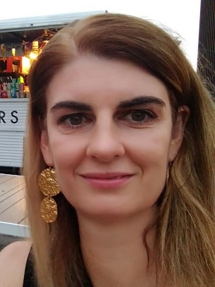
Bio | I am the Vice Chair of the Parent Forum, my role is to assist the chairperson and be a back-up if required. I am a mum to two children both of whom at Kirkton at the moment (P2 - Kelvin & P6 - Jackson) I joined the parent forum to become more involved with the school and to offer provide a parents perspective where required for any initiatives.
Name | Laura Cleland
 | Welcome to our parent forum and our Kirkton family. I am chairperson of the parent forum and I am delighted that we have such an enthusiastic group of parents volunteering their time to enhance the learning for all our children through a variety of ways. We all have our reasons to get involved, working together, will make us stronger together, to get the best possible outcomes for all our children. I currently have one girl at Kirkton, Lara P3, if you ever see me rushing into the playground at home time please come and say hi or feel free to come and chat if you would like to get involved.
Name | Carol Hunter
Photo | 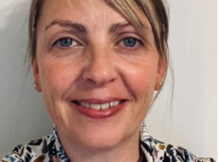
Bio | I am Carol Hunter, Parent Forum Treasurer. I'm mum to Calum and have been active with PTA since 2015. I am keen to involve more parent/carer's in the fundraising events the group hold for the children throughout the school year so please feel free to contact us or chat to me at pick up with any ideas for new events.

