Welcome To
Kirktonholme Primary School Early Learning Class 2025/26

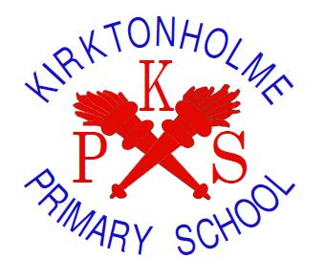

Early Learning Class Handbook


Kirktonholme Primary School
Nursery Class

Welcome
We are delighted that you have chosen Kirktonholme Primary School Early Learning Class for your child’s pre-school education. The early learning team look forward to working with your family to ensure that your child is safe, healthy, achieving, nurtured, active, respected, encouraged to be responsible and feels included in all aspects of school life.

We occupy a superb campus geared specifically to engage our children through a wide variety of learning experiences in line with Curriculum for Excellence, South Lanarkshire Council’s Together We Can and We Will document and other national guidance. Our school vision and values: Happiness, Excellence, Achievement, Respect and Teamwork are embedded in our early learning class.

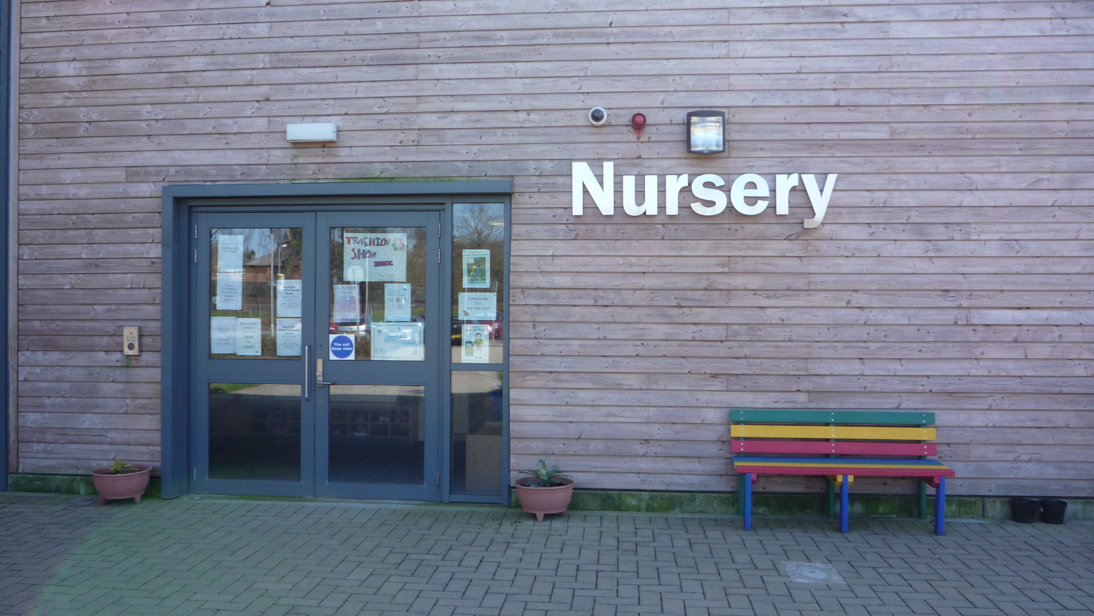

Our Staff Team

Head of Establishment – Mrs Linda Wright

Depute Head Teachers – Mrs Karen Clow (responsibility for early level)
Mrs Valerie Miller (responsibility for first level)
Mrs Samantha Souter (responsibility for second level)

Our Team Leader is Mrs Karen Moran.
Our Early Years practitioners are Mrs Fiona Thorpe, Mrs Kim Young, Miss Abby Mckendrick, Mrs Mirza Watt, Mrs Rachel Cunningham, Mrs Nicole Lynch and Ms Nicole Smith
Our support assistant is Miss Elli Athanasopoulou.

Students from secondary schools, colleges and universities may have placements within the early learning class throughout the year.

Opening Times
The Kirktonholme Primary School early learning class is located within the Kirktonholme Primary School campus building and has its own separate entrance.

We offer full day sessions and have a staggered opening between 08:45 and 08:55 and a staggered close between 14:45 and14:55.

Nursery Year
The early learning class observes the same term times as our primary school. Holiday dates are given to all families at the start of each session are also available from the school office, our own website and South Lanarkshire Council’s website (contact details can be found at the end of this handbook).

Nursery Capacity
Our nursery has the capacity for 40 pupils, which includes three, four and five-year-old learners.

Links to Schools and Community

Mrs Linda Wright, Head Teacher (HT), has overall responsibility for the whole school. Mrs Karen Clow, Depute Head Teacher (DHT), has pastoral responsibility for Nursery and Primary One pupils.
Our early learning team and primary one team work closely together to promote a smooth transition to primary schools. Our early level Principal Teacher leads transition learning opportunities March-May for all our pre-school children, and our Team Leader also runs an enhanced transition programme.

Our HT, DHT, Primary One teachers and early learning team liaise with the primary schools our children will be moving on to for primary one. All Primary One staff are invited to visit and meet the children informally and meet with our early learning team. Transition paperwork is sent to all receiving primary schools, in line with South Lanarkshire Council’s guidelines.

DHTs and Team Leaders within the Learning Community hold planned meetings to discuss the curriculum and share good practice.

Our children participate in whole school celebrations and events, such as World Book Day, COP, UNCRC showcases, assemblies, talent shows, etc.

As part of the wide range of learning opportunities on offer, our early learning class has had visits from our Oral Educator, Fire and Rescue Service, Police, Guide Dogs, Zoo Lab and Aiken Drum as well as many other specialists that have been identified by pupils and staff. If any families feel that they could offer their skills, advice or experiences at any time please contact a member of staff.

In addition to the above, we have business links with Morrisons at Lindsayfield, Gouldings Garden Centre and a community link with McKillop Gardens Care Home. We have previously organised educational outings to Low Waters Museum and Dean Castle as well as going out and about in our local community.
Snack
Our children are all offered a nutritious snack each session based upon national nutrition advice. Information regarding snack can be found daily on the door entering the playroom and from any member of the team.

Coming to school
- Entry and exit is through the main early learning class door.
- Secure entry is manned by our Team Leader, and you will be asked to give the name of the adult collecting your child when you drop them off.
- Parents/carers let the team know what their child’s lunch arrangements are at drop off time. School meals are provided free of charge.
- Children are invited to bring a change of shoes, a change of clothes and a reusable water bottle daily.
- Children should be dropped off and collected promptly. If your family require any additional supports regarding our drop off and collection times, please speak with a member of the school management team.

Clothing
Please ensure that your child is dressed appropriately for the weather conditions as the children will have many opportunities for outdoor learning throughout the session. Please note that we have wellingtons, fleeces and waterproofs for the children to use.

We have an early learning class uniform provided by Blossoms – a red polo shirt and sweatshirt with the school logo. Order forms are available online from the supplier or from their retail outlet in East Kilbride town centre. The children should be dressed in comfortable clothes, which allow them the freedom to participate in various learning activities.
Each child has a designated peg to hang outdoor jackets and bags on and a space to store their shoes.

Please label all your child’s belongings.

Our Relationship Policy
We follow an attachment informed and relationship-based approach at Kirktonholme. Within our early learning class, we encourage the children to behave with courtesy and respect towards one another and the staff. Children are encouraged to be responsible, contribute to the daily life of our nursery, communicate confidently and freely and to build their capacity to learn successfully. We focus on celebrating each child’s unique qualities.

Illness and Emergencies
If your child is ill, and therefore unable to attend, please let us know as soon as possible. Should you forget, the school will telephone you as part of our care and welfare practice. If your child becomes ill whilst at school, we need to be able to contact you as soon as possible, so please make sure we have up to date contact phone numbers where you or a nominated adult can be contacted.

In line with South Lanarkshire Council’s guidelines, if a child has had sickness or diarrhoea they must not return to school until 48 hours after the last episode of illness.

Outings
For all outings outwith our school grounds, you will be notified in writing and the appropriate consent forms will be issued.

Cost of the School Day
We are very mindful of financial demands on families and strive to minimise any additional pressures from the school. If any aspect of nursery life is a cause for financial concern to your family please contact Mrs Wright, Mrs Clow or Mrs Moran confidentially and we will do our upmost to provide support.

Learning opportunities
Our curriculum is based upon the Curriculum for Excellence and takes other national and South Lanarkshire Council documents into consideration.
Curriculum for Excellence has five levels:
Early Level
First Level
Second Level
Third Level
Fourth Level
All our children are assessed regularly, and their learning is tracked. Most pupils will be working within the early level. Learning experiences and outcomes are shared with parents/carers. Where support is required (for additional challenge, reinforcement, speech and language development, emotional regulation, etc.), the staff team will work closely with families to plan, implement and evaluate interventions. At times we may contact outside agencies for targeted support.

At all stages of learning, parents/carers are kept fully informed of their child’s progress through informal day to day feedback, end of year reports and planned parent/carer meetings. If any family would like more information about their child’s learning, they are invited to contact the school at any time.

Throughout the year the children’s learning will be linked to a wide variety of themes, information about these will be displayed in our foyer and our newsletters. Children are consulted about their learning and this information is used by our team to identify key areas for development and contexts for learning. At Kirktonholme we promote responsive planning to enable our skilled team to support personalisation and choice within our curriculum, this means that although there will always be a backdrop theme, your children will be developing their skills and learning through a wide variety of contexts. We have free flow play opportunities within our playroom and our outdoor area as well as having access to our whole school campus.

Family Engagement Opportunities
Over and above daily staff contact and our home/school partnership learning initiatives families are invited to attend; two scheduled Parents’ evenings, our new PEEP initiative led by Miss Mckendrick, termly adult stay and play events, sibling stay and play events, sports day, leavers ceremony, etc. We are also very keen to have adult helpers and appreciate any volunteers.

Parking
The central part of our car park is for staff only. If you need to bring your child to school by car, please use the parking bay opposite our entrance. Do not park in the disabled area unless you have a disabled permit, a copy of which should be emailed to Mrs Wright. This year we will be continuing our nursery parking permit scheme in our car park, as requested by our families.

Compliments and complaints
Should you have any concerns or worries the staff team are available daily to be of help.
We pride ourselves at Kirktonholme in having very positive relationships with our families and would therefore hope that any worries or concerns would be discussed together first. The Care Inspectorate Complaints Procedure and South Lanarkshire Council contact details are at the end of this handbook.
Likewise, we are very happy to hear about things you like about our early learning class. We are always looking to improve the service we provide for the benefit of our children and families and will regularly seek your feedback.

Child Protection
All staff receive training at the beginning of each session in line with South Lanarkshire Council’s procedures. Senior managers are required to attend courses to update current practice/procedures and keep staff informed of any changes.

Inspection
The Care Inspectorate and Education Scotland regulate all early learning establishments. In October 2024 we were inspected by HMIe and the very good report is available on the HMIe website.
In August 2023, Kirktonholme Primary School Nursery Class had a Care Inspectorate inspection. The inspection process looks at how we are performing in specific areas of early learning and childcare. There were no requirements or recommendations for further action. The full report is available on the Care Inspectorate website (address at the end of this handbook).

Policies and Procedures
Kirktonholme Primary School Early Learning Class’ Policies and Procedures are updated annually, or as required, and are available for parents/carers to see at any time, please ask Mrs Karen Moran if you would like any further details.

Agencies involved with our Early Learning Class can include:
- Integrated Children’s Services
- Book Bug
- English as an Additional Language Specialist support Teacher
- Libraries
- Early Years Specialist Support Teacher

- Psychological Services
- Speech and Language Therapy
- Occupational Therapy
- NHS Lanarkshire Oral Education Team
- Physiotherapy
- Social Services

Application and Enrolment Processes
All applications are completed at parents’ first choice of establishment and should be done no later than the end of February prior to the school session that your child will be eligible for a place. Application and enrolment forms are completed with a member of the school management team and appointments can be made for this through our school office. These appointments help us to get to know your family before your child start with us so that, together, we can plan for a smooth transition between home and nursery.

In the case where there are more applicants than places a ballot is held centrally and officiated by a representative from South Lanarkshire Council.

On your child’s first day at our early learning class, they will attend for one hour only and full sessions thereafter unless they need a phased settling in period. Phased settling in periods will be arranged, in agreement with families, in response to the needs of your child.

All of the above processes comply with South Lanarkshire Council’s Early Years Admissions Policy.

We hope that you found this handbook useful. If you would like any further information about any aspect of our school, please do not hesitate to get in touch.

Contact Details
Kirktonholme Primary School Early Learning Class
Dornoch Place
West Mains
East Kilbride
G74 1DJ
Telephone: 01355 222050
E-mail: gw14ktonholmeoffice@glow.sch.uk
Website: kirktonholme-pri.s-lanark.sch

Early Year Services South Lanarkshire Council
Council Offices
Almada Street
Hamilton
ML3 0AE
E-mail: earlyyears@southlanarkshire.gov.uk
Website: www.southlanarkshirecouncil.gov.uk
Telephone: 03031231023

Care Inspectorate
www.careinspectorate.com
03456009527

