

Welcome to Kirkstyle ELC
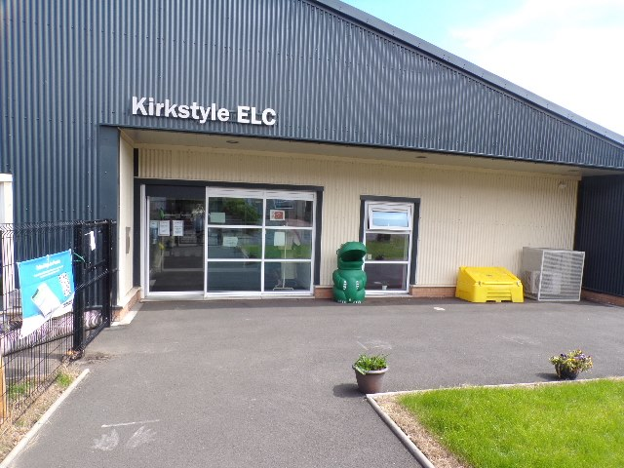

A Warm Welcome....
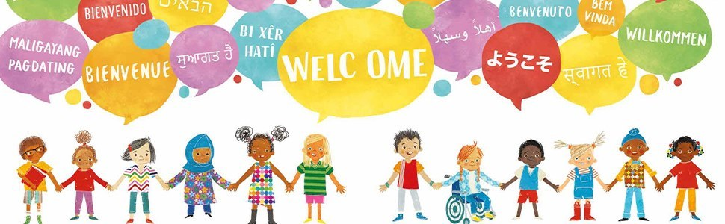
Welcome to Kirkstyle ELC. We would like to extend a warm welcome / welcome back to our new and returning families. We are confident that you will benefit from the services and quality experiences Kirkstyle ELC has to offer.
We are excited to embark on this journey with you and look forward to sharing the most precious and important early years of your child's life.
Seesaw is a communication tool we will use to share information, photos and videos of your child and experiences within the nursery (with your signed permission).
Here at Kirkstyle ELC we promote open communication and strong partnerships with our families. As such, all families are offered a communication diary as well as weekly wellbeing calls with the Keyworker. If at any time there is a matter you wish to discuss, please contact the Head of Integrated Unit (Sylvia), Deputes (Nicola and Stephanie) or Team Leader (Lynda) who will be pleased to speak with you and support you in any way we can.

Session Times
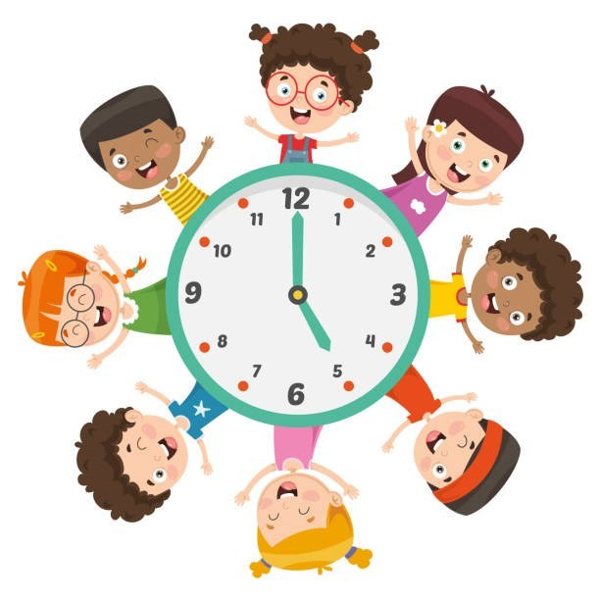
Your child has been allocated a place within our 2-3 ASN Room, also known as 'The Explorers'. Your child will attend 5 full days per week from 9am - 3pm over a 38 week period (term time). Charges may apply unless exempt at £4.32 per hour. Please see the link below for further information on charges and exemptions.
https://www.southlanarkshire.gov.uk/info/200188/secondary_school_information/1403/early_learning_and_childcare_charges_and_exemptions
Please speak to a member of the management team who will go through your contract with you.
Please contact Kirkstyle ELC if your child is going to be absent from nursery - there is an option to leave a voicemail or to speak to a member of staff.

Nursery Uniform

Nursery uniform is not mandatory but can be purchased via https://schoolwearmadeeasy.com/search?q=kirkstyle&type=product
Uniform can also be purchased from Jean Sinclair's shop in Carluke.

Snacks and Lunches

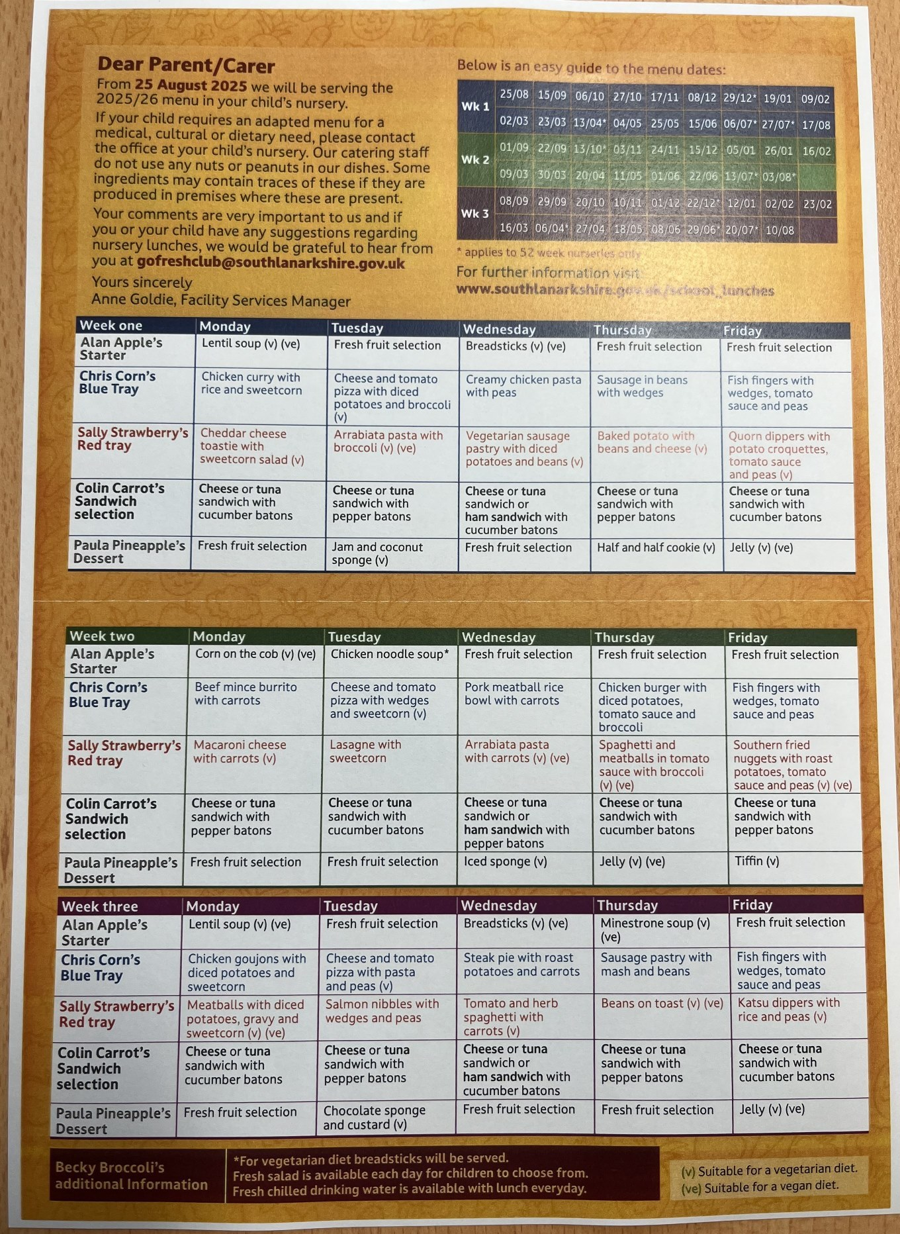
1 - Please see a copy of the current lunch menu. A new menu will commence week beginning 24th August and this will be distributed as soon as we receive it. The meals are not made on the premises and are brought to the ELC on a daily basis. Please liaise with your child's keyworker to preselect in advance the menu items you would like your child to have over the three week menu rotation.

At Kirkstyle ELC we adhere to and follow good practice guidelines from Care Inspectorate for the prevention and management of choking episodes in babies and children, and Early Years choking hazards food safety advice from the Food Standards Agency. In relation to this, we advise that small fruit and vegetables you provide within your child’s packed lunch are prepared in the following ways. *Remove any stones or pips from fruit and vegetables. * All fruit should be peeled. *Quarter (length ways) small fruit and vegetables such as cherry tomatoes, grapes, strawberries, blackberries.

Meet the Explorers Staff Team
Every child will have a member of staff who is assigned as their Keyworker and will be the main point of contact. If you have any information to pass on, or if you have any specific questions about your child, then the Keyworker is the best person to speak to. All staff members working within the playroom will get to know your child individually and will build positive relationships with them. Your child’s Keyworker will discuss their care plans and targets every three months with you.
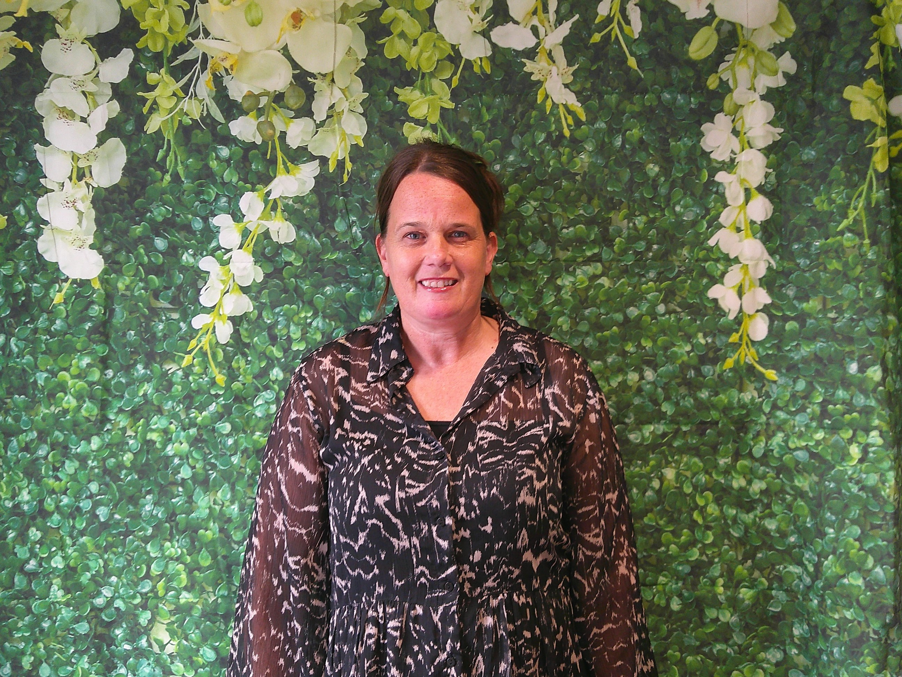
2 - I'm Heather and I am the literacy champion. I am also the Attachment Ambassador in the Explorers room. I am passionate about promoting literacy through play and creating a safe, nurturing space where children can form trusting bonds and feel secure. In my spare time I enjoy spending time with my friends, family and 2 dogs and love being outdoors!
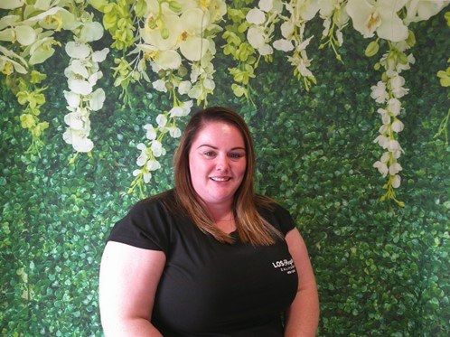
3 - I'm Yasmin and I am the wellbeing and regulation champion. I am passionate about ensuring children are supported to manage and regulate their emotions and have appropriate strategies to alleviate distressed behaviour. In my spare time I enjoy swimming and spending time with my son.
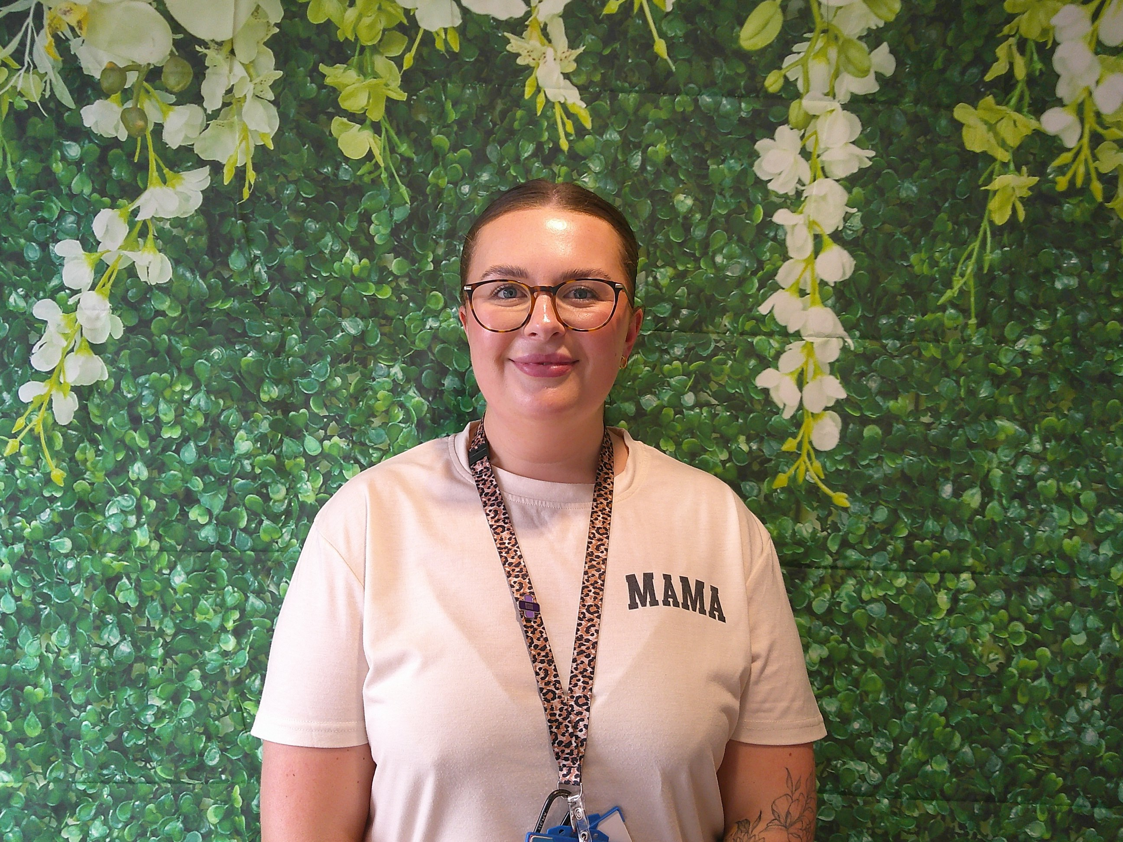
4 - I'm Erin and I job share with Yasmin. I too am the wellbeing and regulation champion and I am passionate about ensuring the values of nurture and attachment. In my spare time I enjoy spending time outdoors with my son Kai.
The ratio for children in the 2-3 ASN Room is 1 adult : 2.5 children, with a maximum capacity of 5 children.

Learning Environment
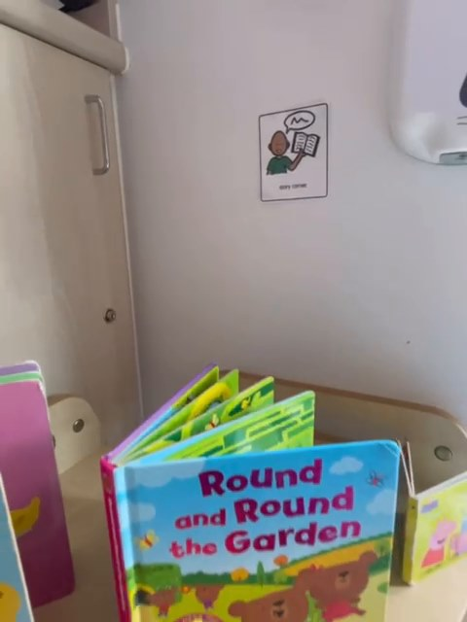
https://sway.cloud.microsoft/pxHE1dyRKuCG2H8m#content=BPz7AUGDuFsvy2

Getting It Right For Every Child (GIRFEC)

At Kirkstyle ELC we will ensure that your child’s wellbeing, learning and development is recorded in line with ‘Getting it Right for Every Child’, under the 8 wellbeing indicators and that this is shared with you regularly.
Getting it right for every child (GIRFEC) supports families by making sure children and young people can receive the right help, at the right time, from the right people. The aim is to help them to grow up feeling loved, safe and respected so that they can realise their full potential.
Wellbeing sits at the heart of the GIRFEC approach and reflects the need to tailor the support and help that children, young people and their parents are offered to support their wellbeing. A child or young person's wellbeing is influenced by everything around them and the different experiences and needs they have at different times in their lives.
Your child will be supported through the use of an Additional Support Plan (ASP) and Individual Education Plan (IEP) through a Staged Intervention approach. We work closely alongside partner agencies such as Health Visitors, Educational Psychology, Speech and Language Therapy, Occupational Therapy, Physiotherapy etc to ensure strategies are formulated to support your child to meet their full potential.
We have review meetings every 3 months which you will be invited to attend, along with any partner agencies supporting your child. Your child's Keyworker will consult with you at all stages and ensure that targets for your child are set collaboratively.

How are the Wellbeing Indicators used?
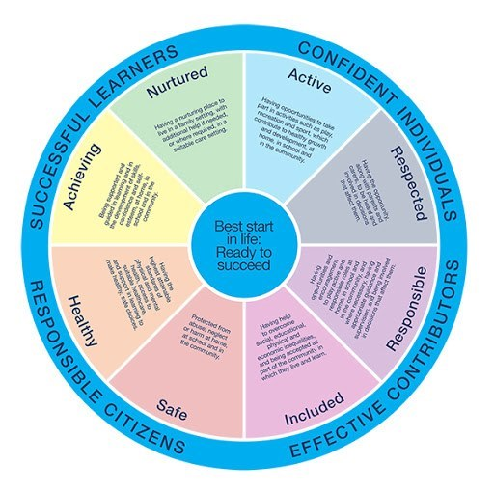
Safe - Protected from abuse, neglect or harm at home, at school and in the community.
Healthy - Having the highest attainable standards of physical and mental health, access to suitable healthcare, and support in learning to make healthy, safe choices.
Achieving - Being supported and guided in learning and in the development of skills, confidence and self- esteem, at home, in school and in the community.
Nurtured - Having a nurturing place to live in a family setting, with additional help if needed, or where not possible, in a suitable care setting.
Active - Having opportunities to take part in activities such as play, recreation and sport, which contribute to healthy growth and development, at home, in school and in the community.
Respected - Having the opportunity, along with parents and carers, to be heard and involved in decisions that affect them.
Responsible - Having opportunities and encouragement to play active and responsible roles at home, in school and in the community, and where necessary, having appropriate guidance and supervision, and being involved in decisions that affect them.
Included - Having help to overcome social, educational, physical and economic inequalities, and being accepted as part of the community in which they live and learn.
The eight wellbeing indicators are commonly referred to by their initial letters - SHANARRI.
Each child is unique and there is no set level of wellbeing that children should achieve. Each child should be helped to reach their full potential as an individual. The wellbeing indicators help make it easier for everyone to be consistent in how they consider the quality of a child or young person’s life at a particular point in time.
Families and people working with children and young people can use the wellbeing indicators to identify what help a child or young person needs in order to help them access the right support or advice.
All services working with children and young people, and those who care for them, must play their part to promote, support and safeguard children and young people’s wellbeing.


Key facts about wellbeing
1. Every child or young person should be safe, healthy, achieving, nurtured, active, respected, responsible and included.
These eight indicators help make sure everyone – children, parents, and the people who work with them, such as teachers and health visitors – has a common understanding of wellbeing.
2. The eight wellbeing indicators connect and overlap. For example, a health difficulty may have an effect on a child or young person achieving their goals or being active. When considered together the different elements of wellbeing give the whole picture of a child’s or young person’s life at a particular point in time.
3. A child’s or young person’s wellbeing is influenced by everything around them. This includes their individual circumstances, the support they get from their family and community, and the services that support them. Factors such as adequate sleep, play and a healthy, balanced diet have a positive impact on all aspects of a child’s or young person’s wellbeing. While the effects of poverty and isolation can have a negative effect on their wellbeing.
4. It is up to all of us – parents, early learning providers, health visitors, teachers, GPs, police – to work together to promote, support and safeguard the wellbeing of all of our children and young people. Children and young people have different experiences and needs at different times in their lives. Understanding how this affects their wellbeing, and providing the right support when they need it, helps them grow and develop and reach their full potential.


All behaviour is communication
At Kirkstyle ELC we recognise that children with additional support needs and communication barriers communicate through their behaviour.
All staff have undergone training on 'Promoting Positive Relationships and Understanding Distressed Behaviour'. We use these principles alongside the South Lanarkshire Council's 'Attachment Strategy' in our day to day practice and approaches.
Staff recognise that all behaviour is communication and have robust strategies in place to support children's positive behaviour whilst encouraging appropriate communication with peers. We work closely alongside partner agencies such as Educational Psychology and Speech and Language Therapy to ensure children are fully supported and are equipped with strategies for alternative communication.
It can be very frustrating for children with little or no language to express their wants and needs and this can result in them lashing out or becoming distressed. Children may also hurt themselves.
Children may display these behaviours for a range of different reasons e.g. having trouble processing their environment and what is happening around them e.g. difficulty processing and understanding what others around them are saying.
Children may find transitions in their day challenging e.g. moving from one activity to the next e.g. moving from play to have their nappy changed.
Children may find it difficult to follow an agenda out with their own.
Children may have sensory sensitivities to noise or other environmental factors which affects their ability to tolerate certain situations.
Our staff are committed to alleviating these stressors for our young children and are helping them to express themselves by more productive means.
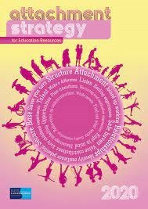

We understand that these incidents can provoke anxiety, not only for children, but for parents and carers. We are committed to ensuring the safety and wellbeing of all of our children. Please be assured that children are not purposely harming themselves and/or others and that this is a developmental stage that we are working continuously to support. Some of our strategies are listed below.
Short, positive commands recommended by Speech and Language Therapy e.g., ‘hands down’ ‘feet on floor’ etc.
Risk assessments in place for children’s communication attempts and strategies in place to alleviate and minimise risk.
Staff recognise children’s behaviour as communication attempts and support them to communicate in more appropriate ways e.g., Makaton signing.
Staff support children to play alongside/with their peer group and model alternative strategies for initiating play/communication.
Break off opportunities, ongoing throughout the day e.g., quiet periods in the Sensory Room or accessing outdoor area.
Shadowing and observing. Monitoring potential triggers or frustrations.
Redirecting children and using their motivators to engage them in learning experiences.
Facilitating children’s individual targets in small group experiences e.g., turn taking opportunities in the Sensory Room with one other child and an adult.
BASP’s in place for children who require them (Behavioural Assessment and Support Plan).
Regularly liaising with partner agencies to discuss strategies and progress.
Weekly ASN Staff Meetings to discuss strategies and progress.
De-escalation strategies in place.
Praising positive behaviour.
Limiting language.
Using visual cues to support understanding e.g., to support transitions in children’s day or to request items of choice.
Prior warnings and countdowns to prepare children for what is happening next.

Curriculum
Staged Intervention begins with ensuring an inclusive and appropriate curriculum, facilitated by supportive and nurturing adults. An inclusive curriculum involves having realistic expectations and supporting children to reach their full potential. Staff plan learning experiences in response to children's needs and interest and use curriculum documents to inform their planning, providing appropriate levels of challenge and support as required. Some of the documents we use are: a differentiated Curriculum For Excellence, Together We Can and We Will, South Lanarkshire Council's Framework for Supporting Pupils with Severe and Profound Needs (2015) and Education Scotland's Milestones for Supporting Children with Complex Additional Support Needs. These documents inform our planning process and ensures children are offered learning experiences appropriate to their age and stage.
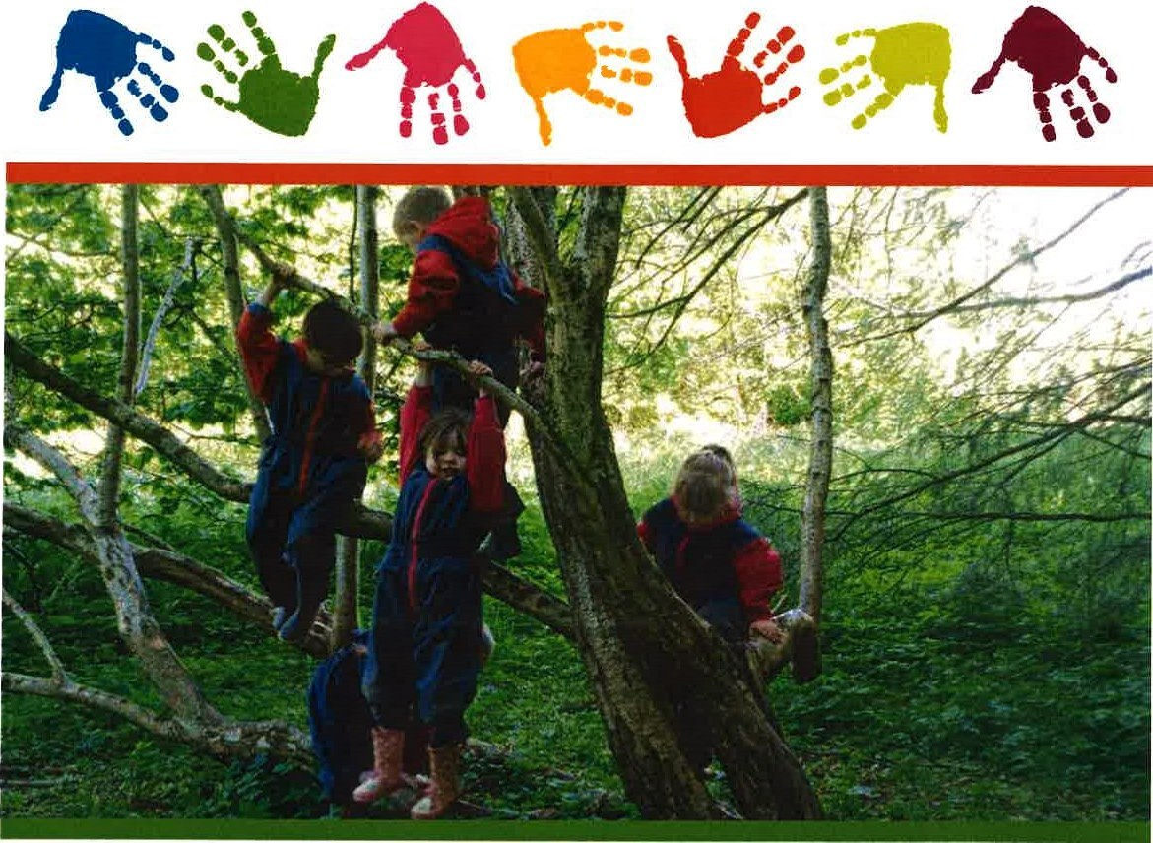
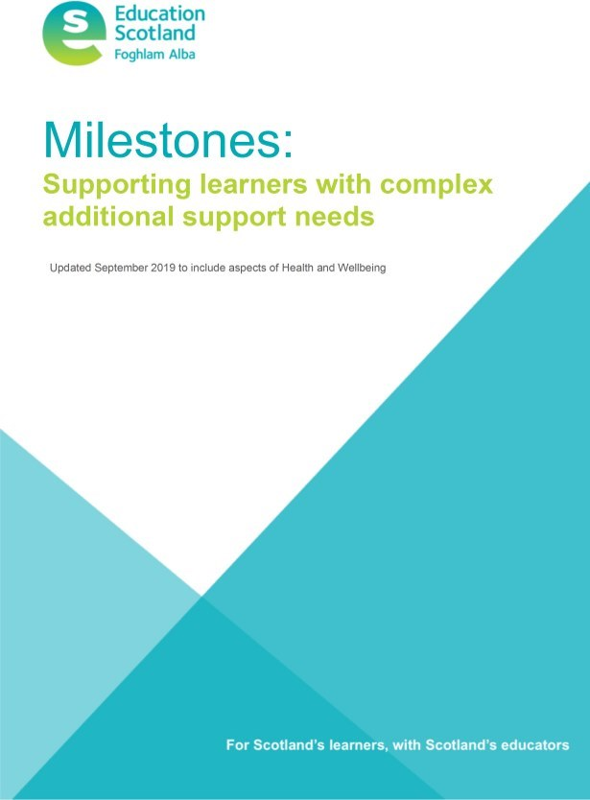
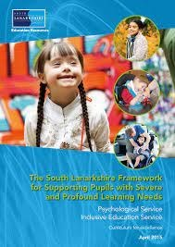


Nursery Information
For further information about Kirkstyle ELC please see our nursery handbook. Please do not hesitate to get in touch. Our details are below:
Kirkstyle ELC
15 Eastfield Road
Carluke
ML8 4NZ
01555 772856

gw20kirkstyleoffice@glow.sch.uk

