

Welcome to Kirkstyle ELC 2026
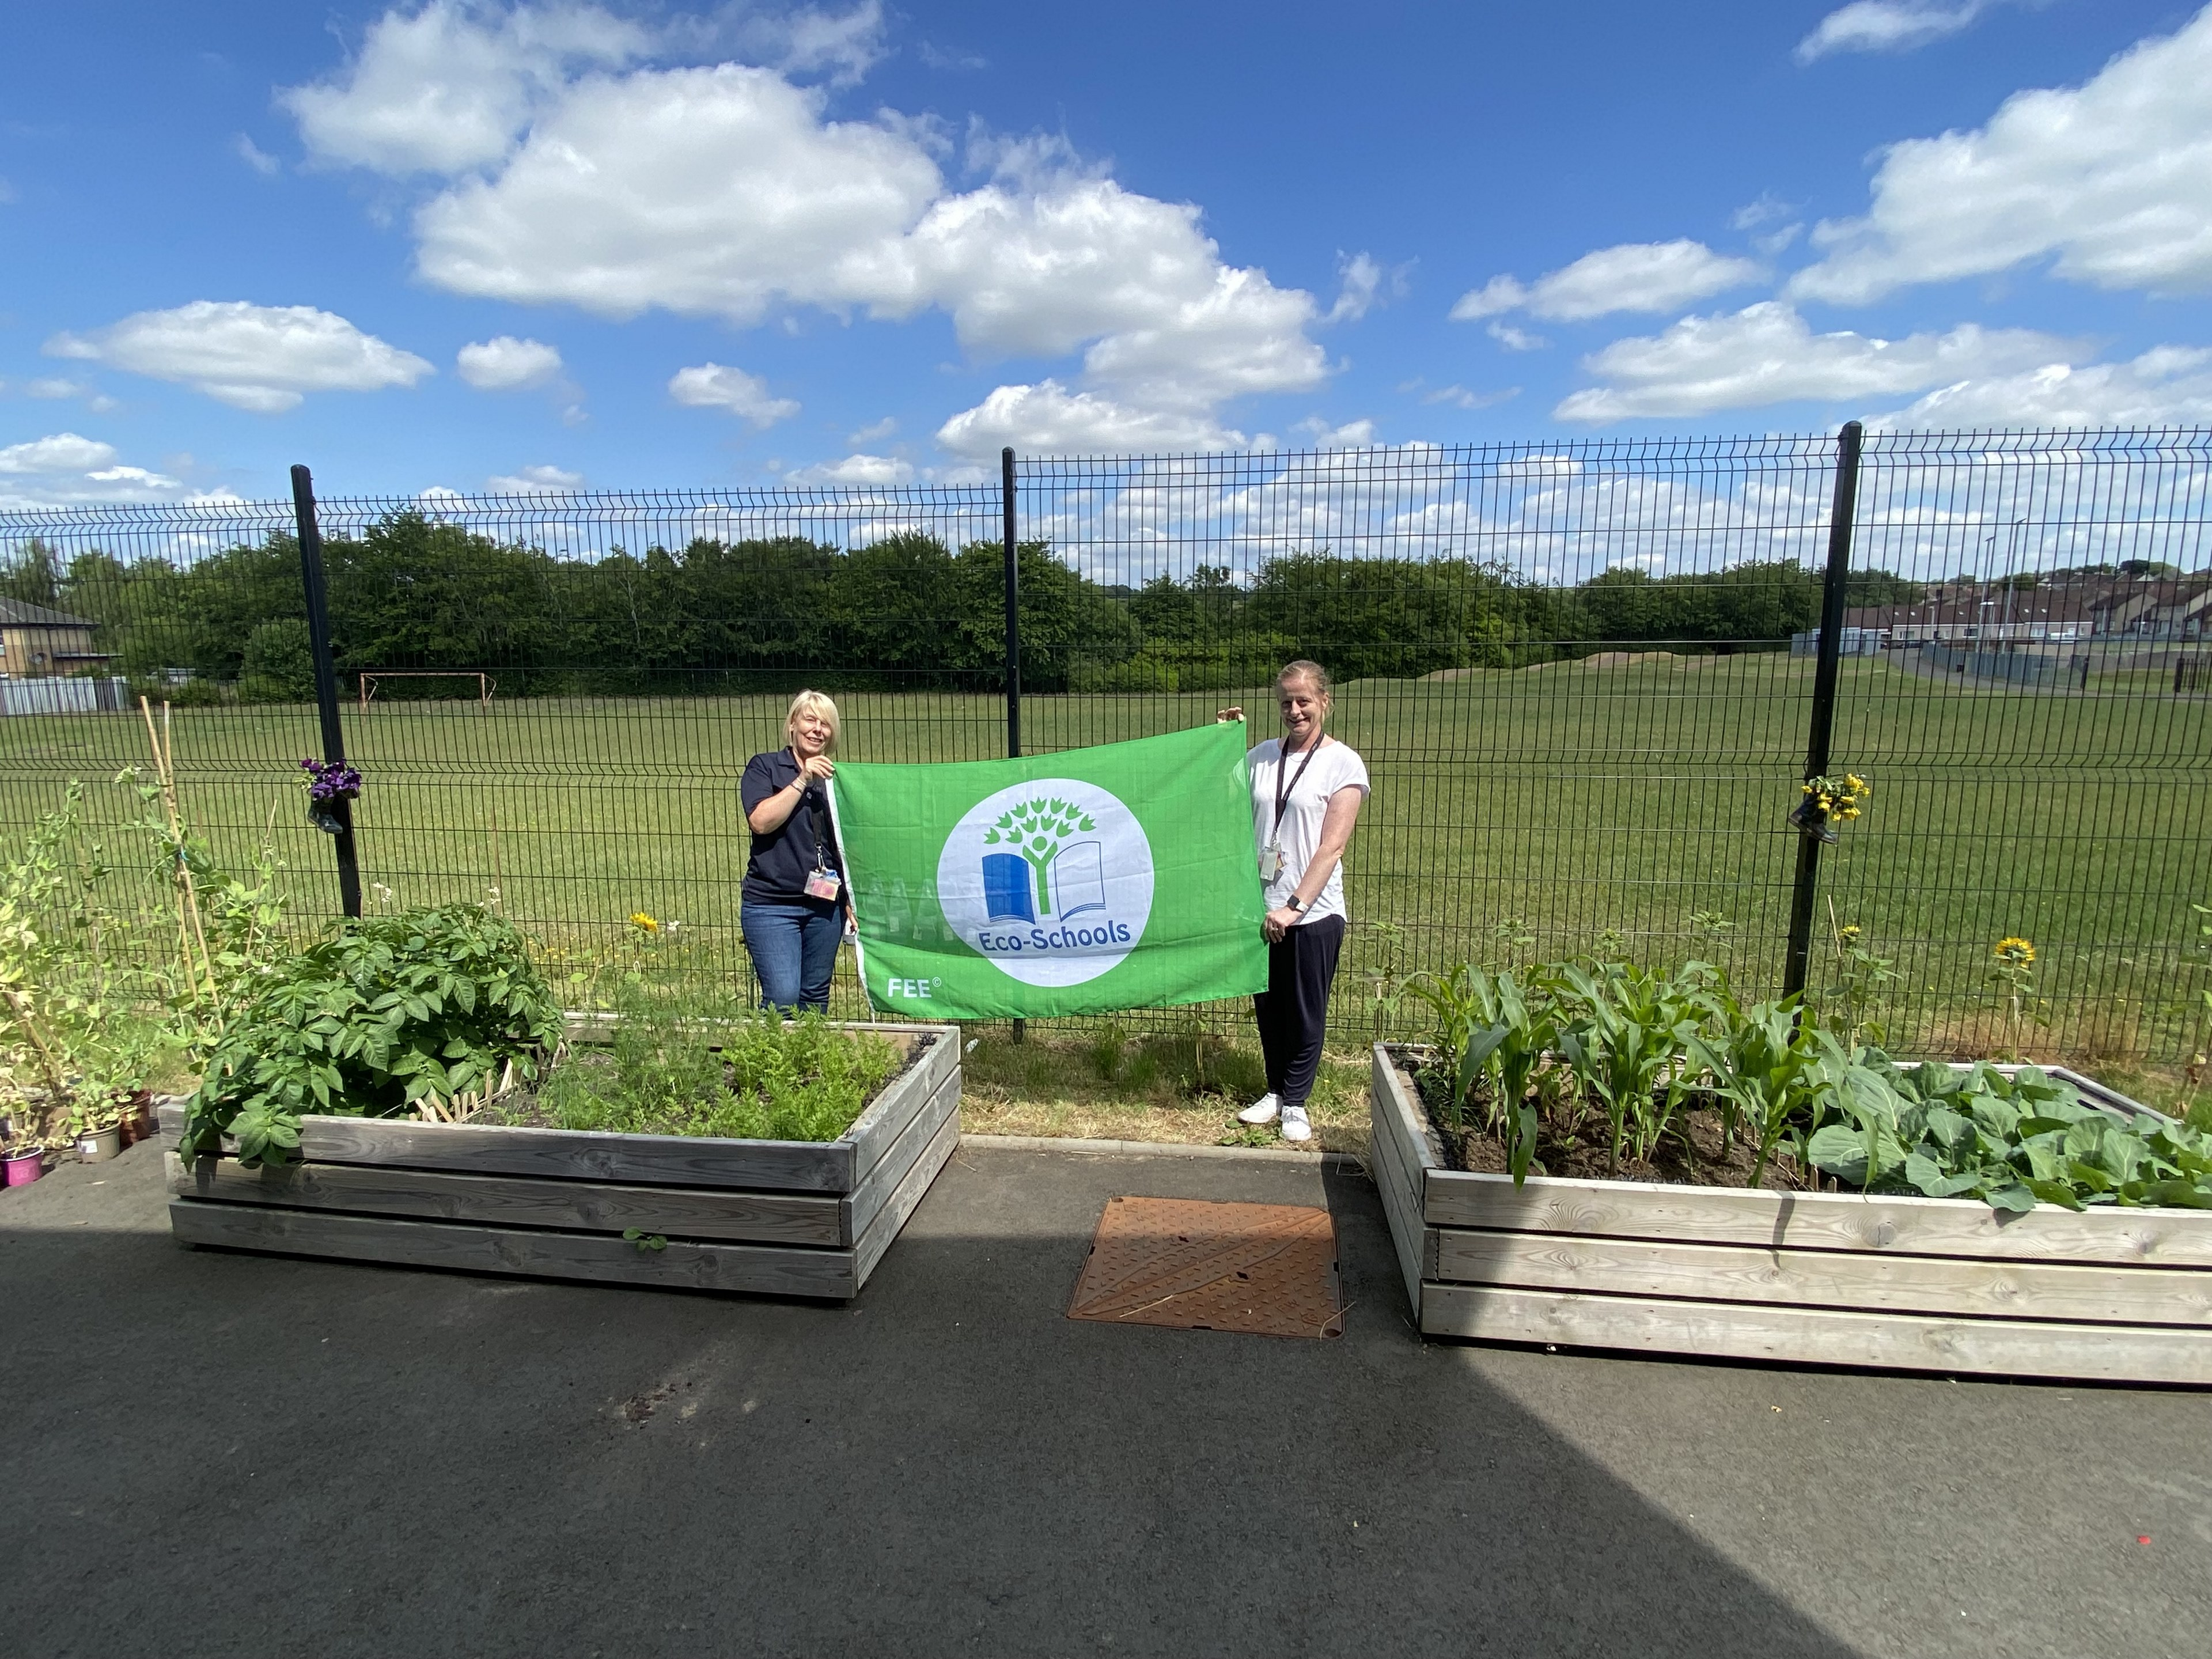
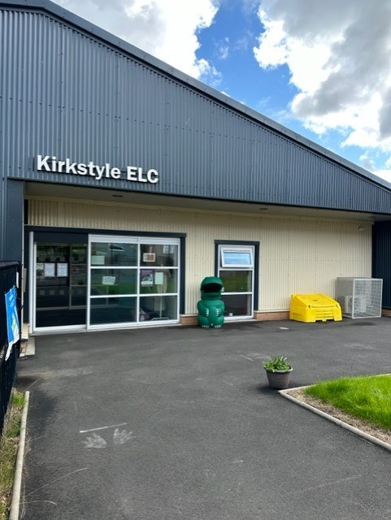
Welcome to Kirkstyle ELC. We would like to extend a warm welcome to you and your family. We are confident that you will benefit from the services and quality experiences this Integrated Unit has to offer.
We are so excited to meet you and your child and embark on this learning journey together. We look forward to sharing with you the most precious and important early years of your child’s life.
If at any time there is a matter you wish to discuss, please contact the Head of Integrated Unit (Sylvia), Depute (Rebecca Lennox) or Team Leaders (Aileen Currie / Nicola Rowan) who will be pleased to speak with you and support you in any way we can.
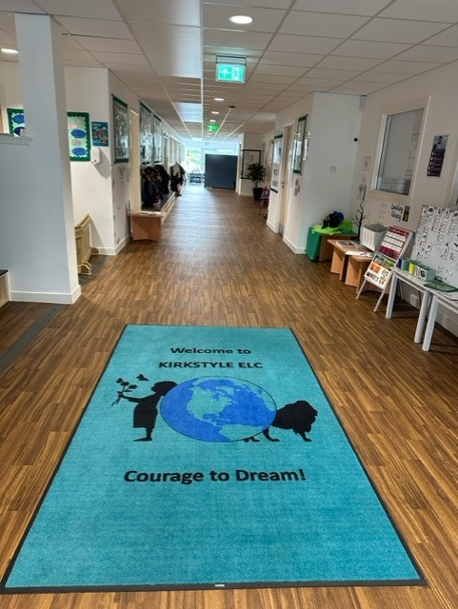
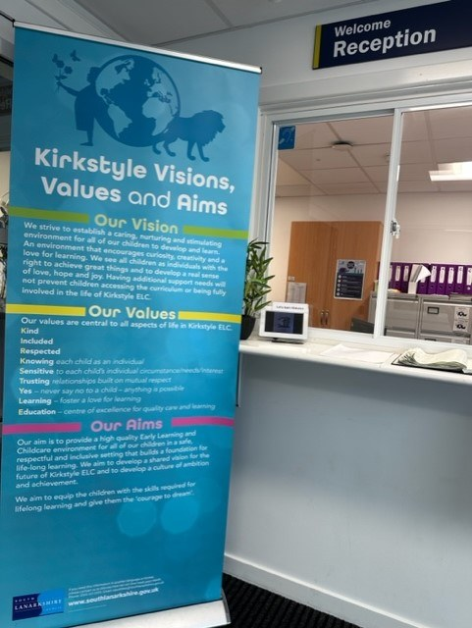
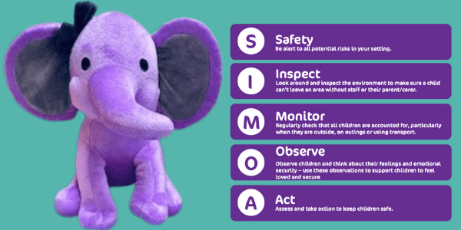

1 - Please give us a follow on Twitter to stay up to date. Here is the link. Home / X (twitter.com)

Nursery Uniform

Nursery uniform is not mandatory but can be purchased via https://schoolwearmadeeasy.com/search?q=kirkstyle&type=product
Uniform can also be purchased from Jean Sinclair's shop in Carluke.
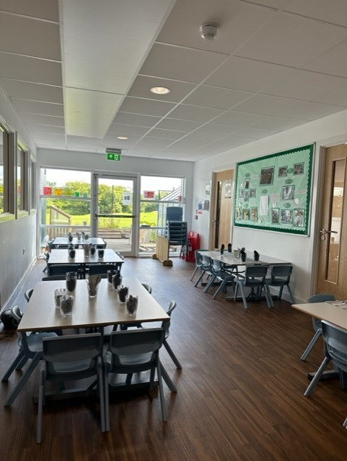
2 - This is our Bistro area. Everyday we all sit together and have our lunch.
Whilst in the ELC setting your child will be offered a variety of healthy snacks and lunches, depending on their allocated session.
If your child is staying in Kirkstyle for the whole day, they will be entitled to a meal at lunchtime (hot and cold options available daily). Lunch Menus can be found on the South Lanarkshire Council or Kirkstyle ELC Website. They will also be provided with a small snack, both morning and afternoon.
Children attending for a half day session will be provided with a more substantial snack consisting of a selection of fruit, breadsticks, cheese, toast, vegetables, other sundries and milk / water. Menus are planned in line with Scottish Milk and Healthy Snack Scheme.
At present, we are piloting a new system for ordering lunches. You will be required to order lunches weekly for your child. For the current 25-26 menu, please see image to the right. This can also be accessed via our website. A new menu will commence week beginning 24th August and will be distributed as soon as we receive it.
The meals are not made on the premises and are brought to the ELC on a daily basis. Dietary requirements are taken into consideration following the completion of relevant paperwork. Please see a member of management if your child requires an adapted menu.
During your child’s session at nursery they will have the opportunity to freely access water.
We are a nut free nursery and request that no nut products are brought on the premises.
A packed lunch can be provided if you feel your child will not eat the nursery lunch options on offer.
At Kirkstyle ELC we adhere to and follow good practice guidelines from Care Inspectorate for the prevention and management of choking episodes in babies and children, and Early Years choking hazards food safety advice from the Food Standards Agency. In relation to this, we advise that small fruit and vegetables you provide within your child’s packed lunch are prepared in the following ways. *Remove any stones or pips from fruit and vegetables. *Quarter (length ways) small fruit and vegetables such as cherry tomatoes, grapes, strawberries, blackberries.
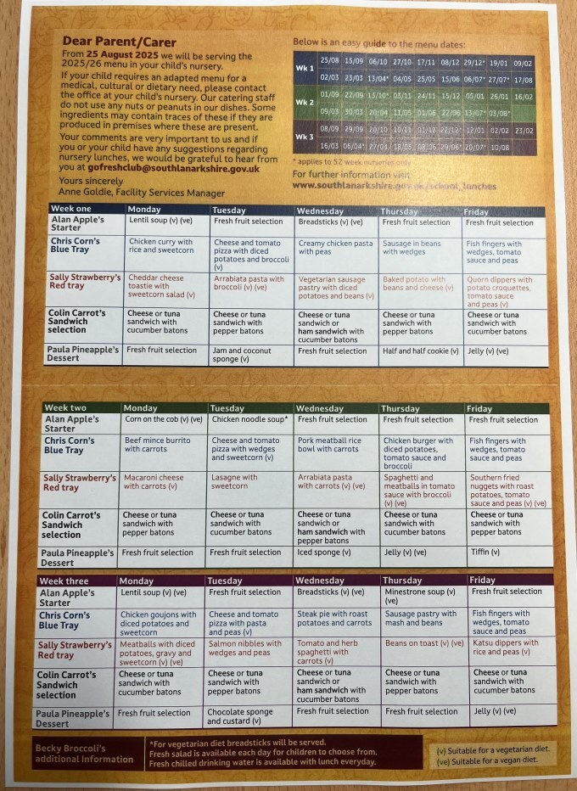

Meet the Adventurers 3-5 Mainstream Team
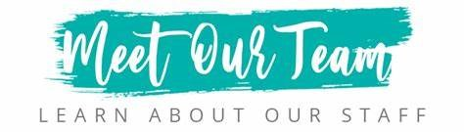

Our Management Team
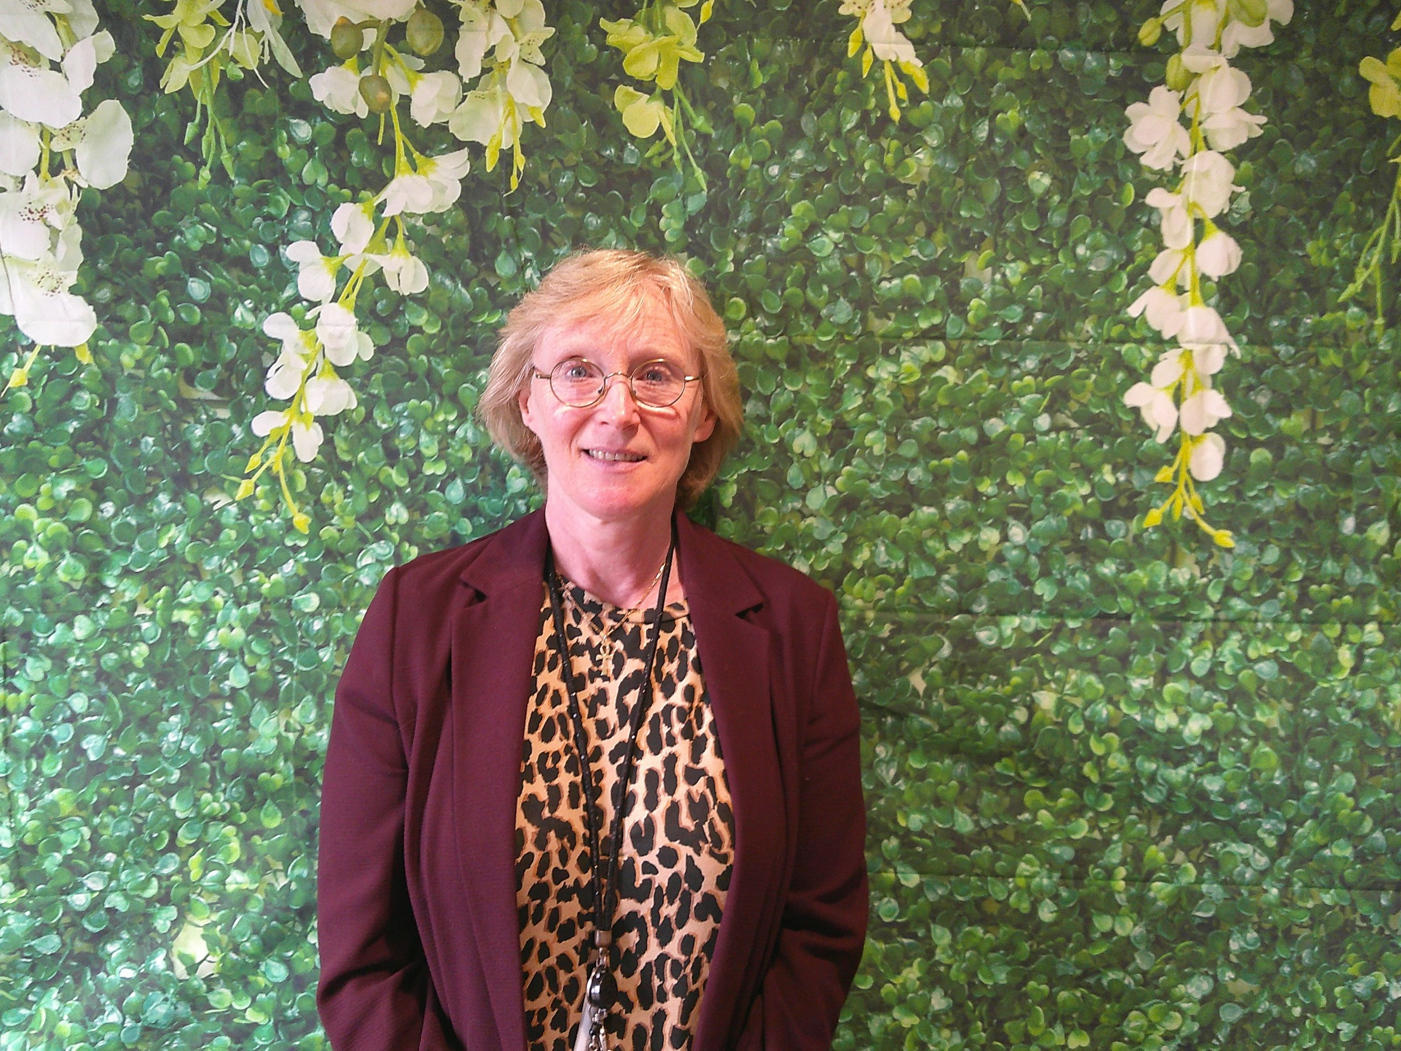
3 - Hello, allow me to introduce myself. My name is Sylvia Ross and I am the proud Head of Kirkstyle ELC. I am fortunate to have such a professional and dedicated whole staff team. In my spare time (what spare time?), I enjoy playing the accordion, walking, eating out, going to shows and being bossed around by my four year old kitten - Hector Barnaby Ross. I also teach line dancing!! Yeehaw! I look forward to meeting you all in the new term.
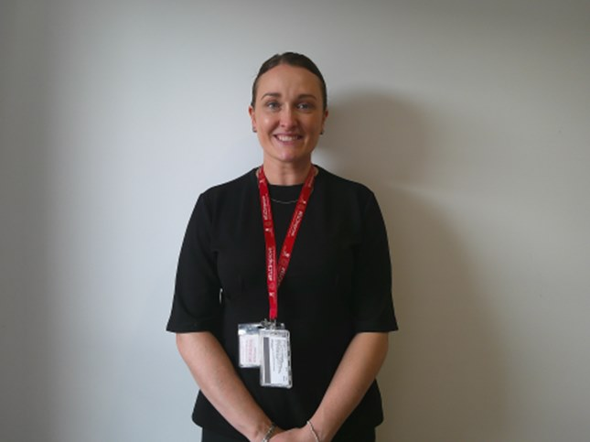
4 - Hello, my name is Rebecca and I am the mainstream Depute Head on a Monday, Tuesday, Thursday and Friday. My passion lies in Early Years and early education, particularly because those first five years of a child's life are most critical. In my spare time I enjoy adventures and exploring outdoors. I also love spending time with my children, friends and family.
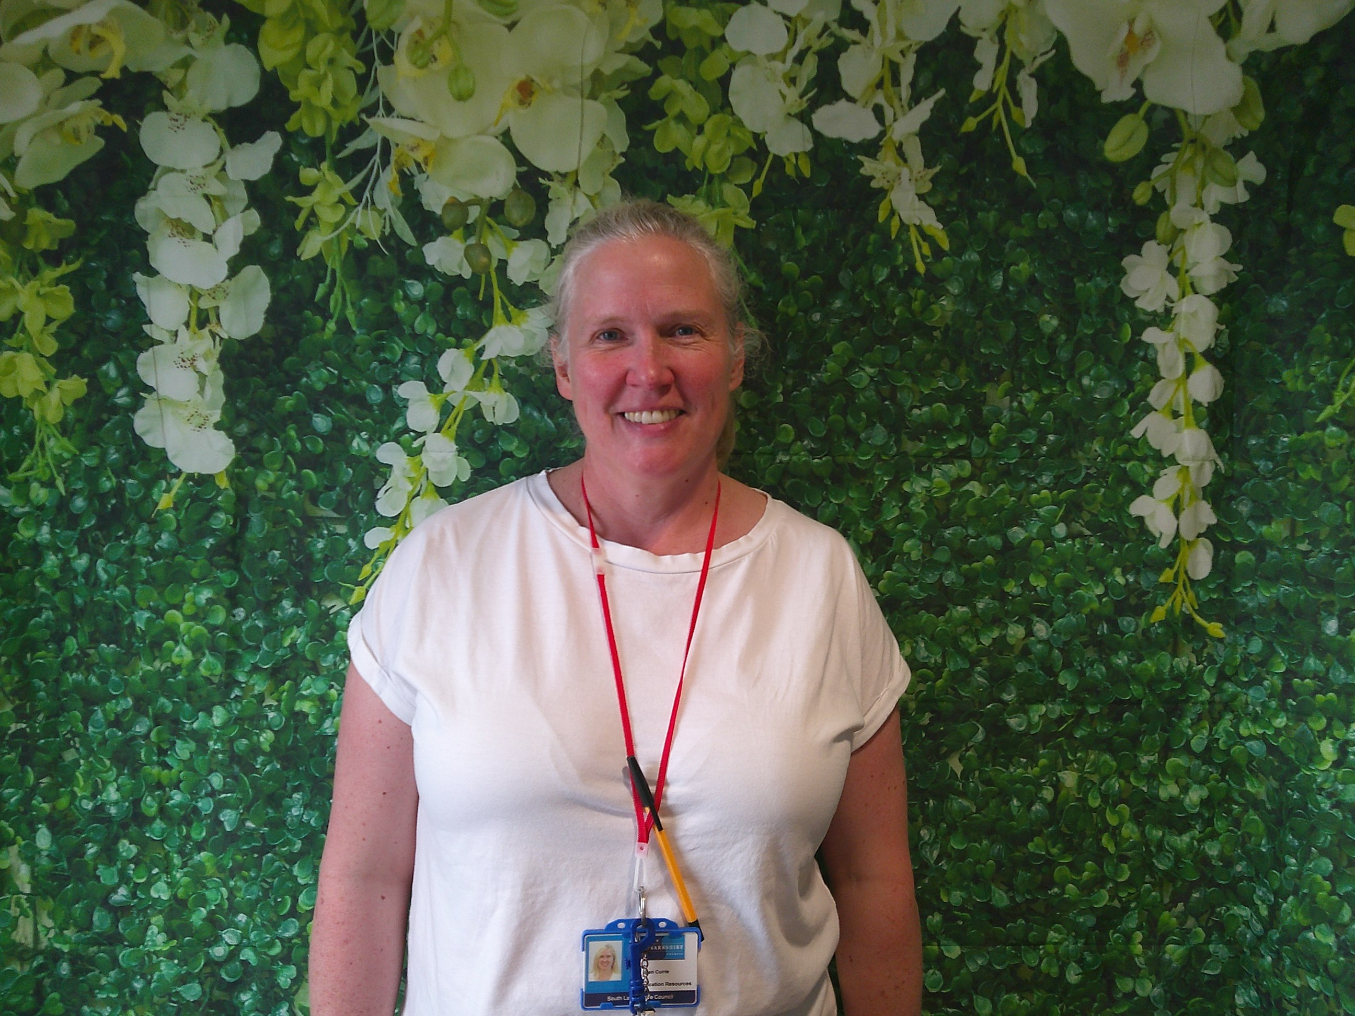
5 - Hello, my name is Aileen Currie. I am one of the Team Leaders for the Adventurers and Pioneers. I work every Monday, Tuesday and Wednesday. At nursery I enjoy taking the children for nurturing experiences. In my spare time I enjoy helping out on the farm and spending more time with my family.
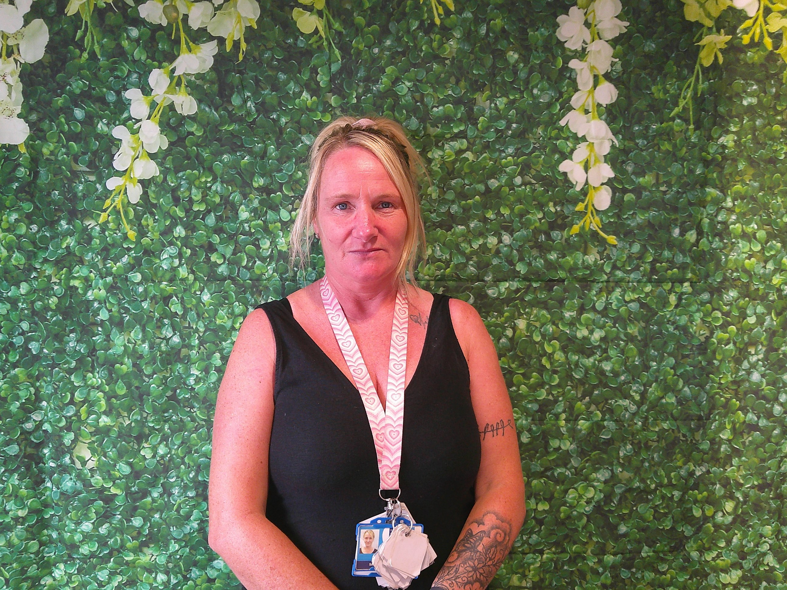
6 - Hello, my name is Nicola Rowan. I am one of the Team Leaders for the Adventurers and Pioneers. I am passionate in supporting the team create an environment which is inclusive, nurturing and engaging. When I am at home I like going long walks with my family. I cannot wait to meet all our new friends and look forward to our adventures together.
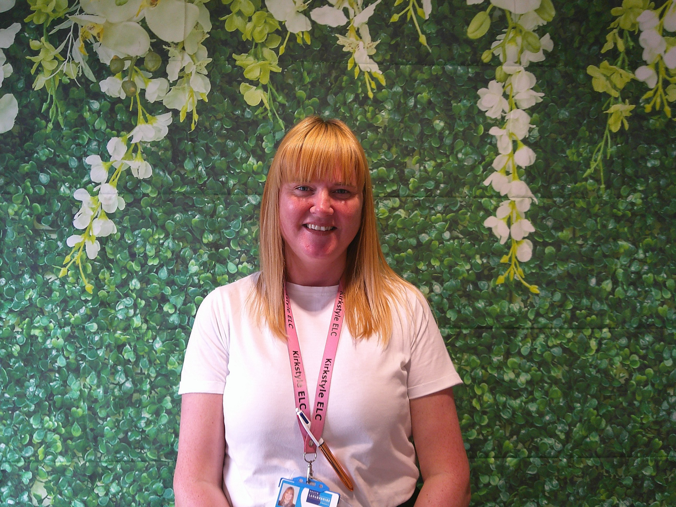
7 - Hello, my name is Karen and I am the parent and child support worker within Kirkstyle ELC. I help deliver PEEP sessions for families and support children with their targets and learning needs. I offer BookBug at home sessions and I am available to offer advice on various topics. I am also one of the Attachment Leads where I take forward Attachment informed practice. In my spare time, I love to go long walks with my dogs and travelling beautiful places in my caravan. I also like going to the gym and line dancing!
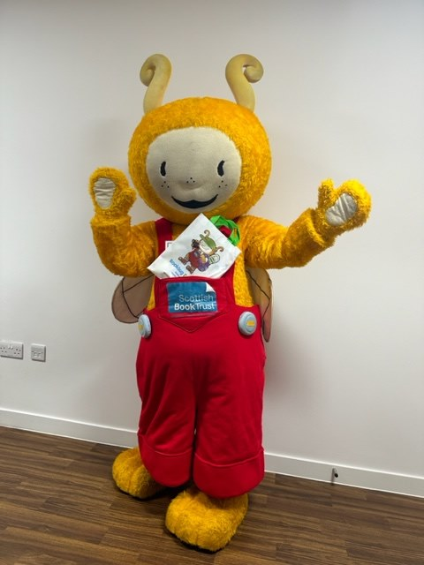
8 - Hello, my name is Book Bug and I love seeing all the children enjoying their sessions at Kirkstyle ELC. It is great to see everyone singing and dancing together! I can't wait to meet you all for lots of stories and rhymes!

Meet our Room One Team
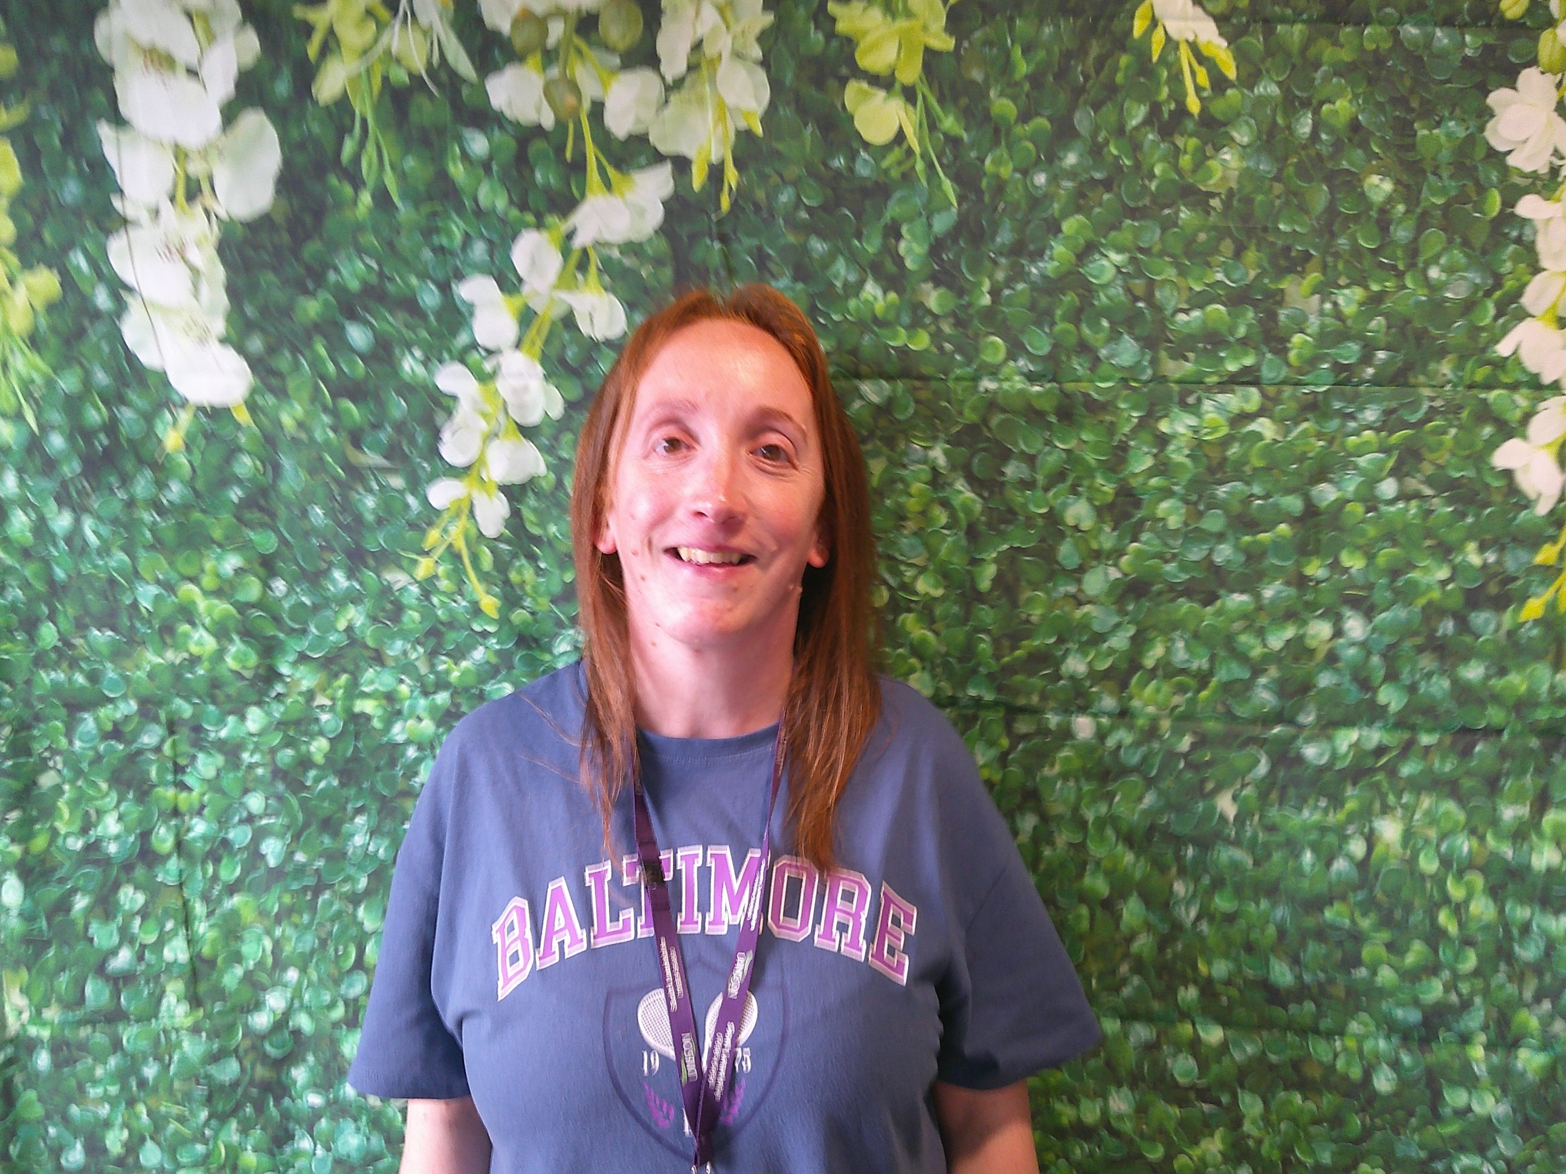
9 - Hi, my name is Lizann. I am an Early Years Support Assistant. I am also a qualified Early Learning and Childcare practitioner. I like going long walks and reading. I like to spend time with my family and friends. I love the outdoors. I am based within Room 1.
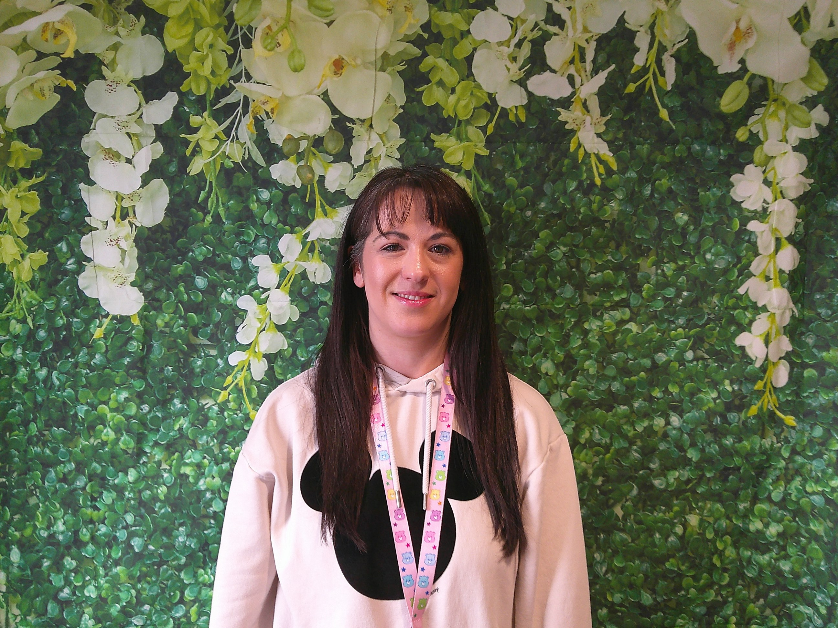
10 - Hi, I am Christine. I am an Early Years Practitioner in Room 1. I am the keyworker for the bat group alongside Erin and am the numeracy champion for Kirkstyle ELC. I work Monday, Tuesday and Wednesday Morning within Room 1. I live at home with my husband and my little boy. We love family days out to Millport and I love all things arts and crafts.
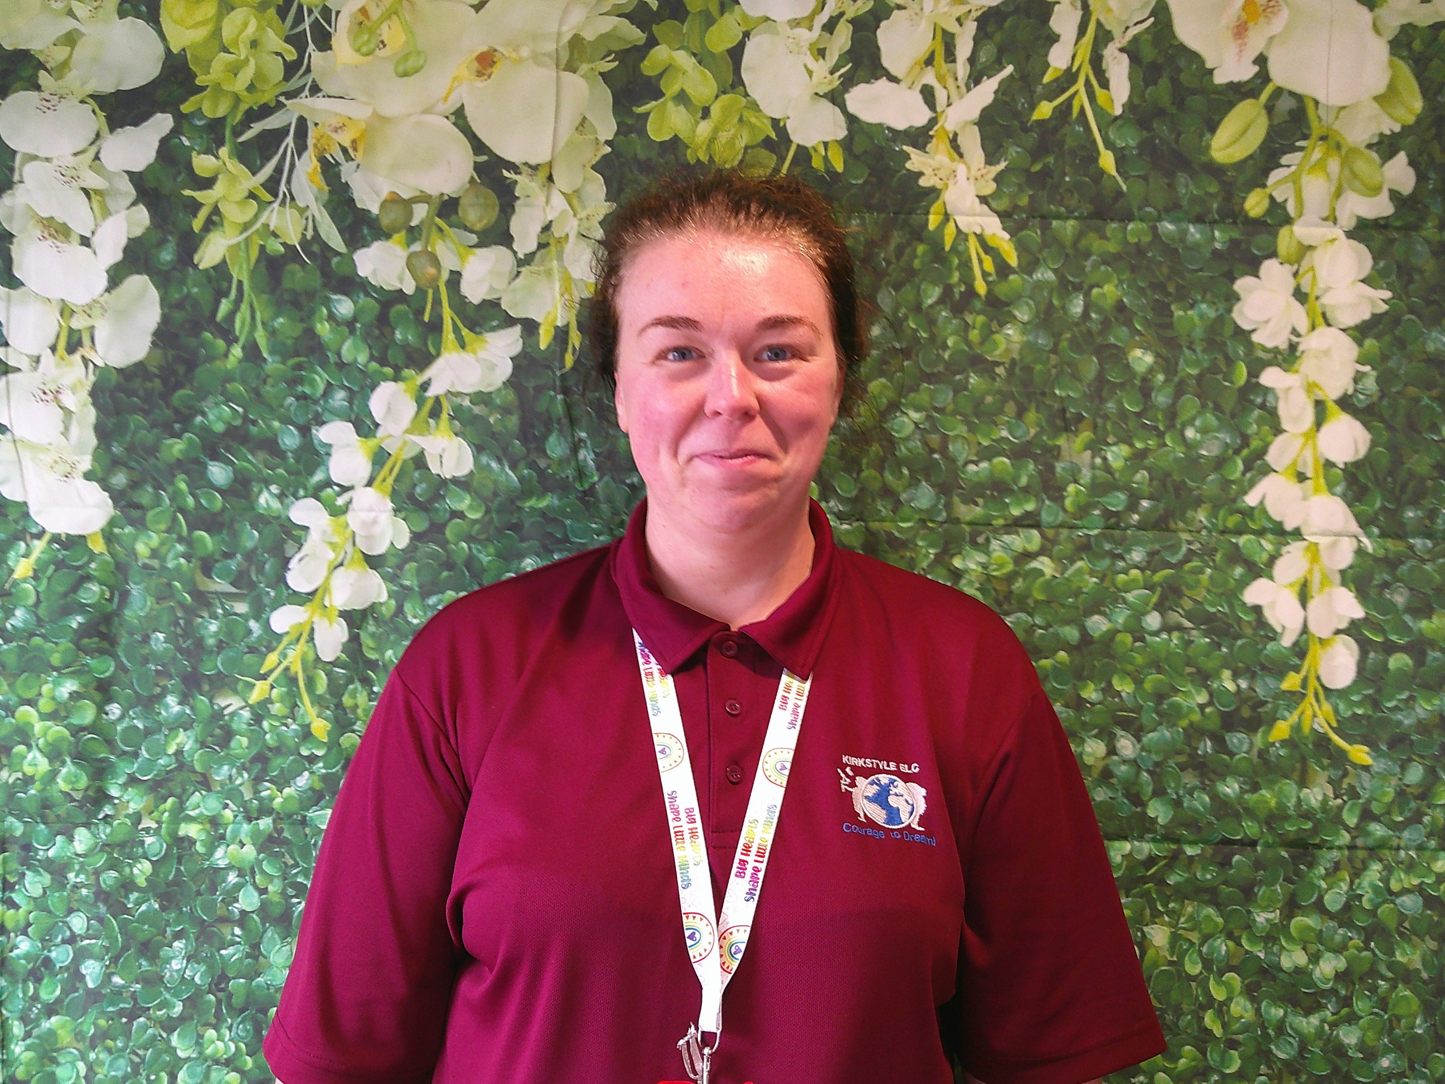
11 - Hello, my name is Kirsty and I am an Early Years Practitioner. I am the keyworker for the Owl group and am the literacy and attachment champion for Kirkstyle ELC. I love getting creative with the children. In my spare time I love spending time with my family. I am based in room one everyday.
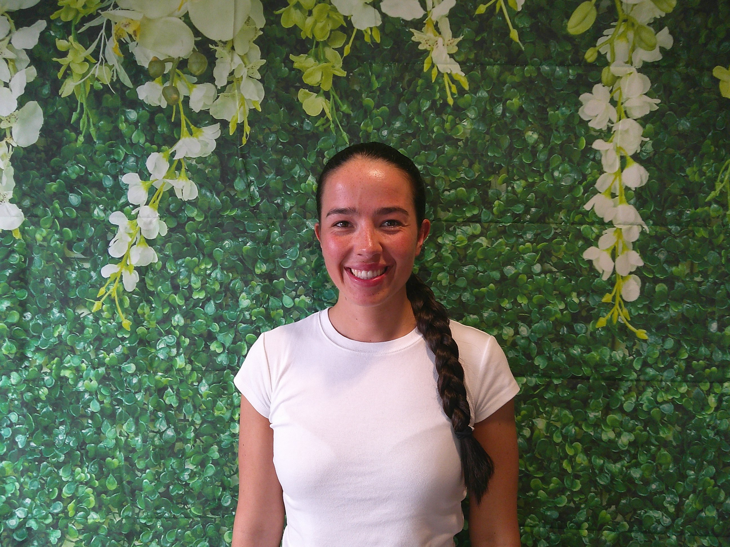
12 - Hello, my name is Nicole. I am the keyworker for the Rabbit group. I am the equality, diversity and inclusion champion for Kirkstyle ELC. I love long walks, yoga and running. I have a twin sister who looks exactly like me. I love spending time with my family.
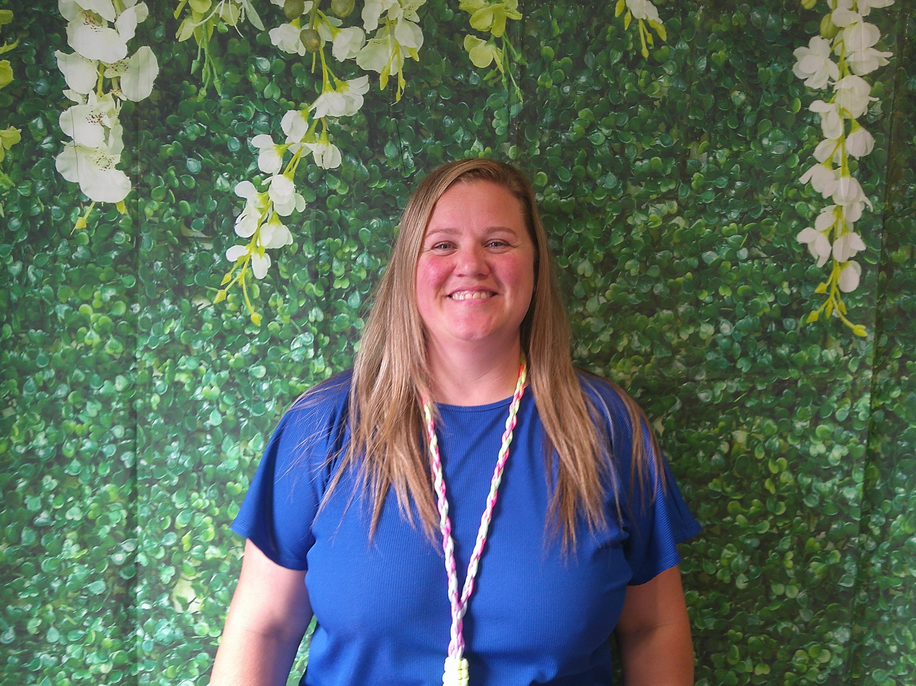
13 - Hello, my name is Mhari. I am the keyworker for the Squirrel group. I am the UNCRC (United Nations Convention on the Rights of the Child) champion for Kirkstyle ELC and am passionate about children's rights. I love outdoors and visits to the forest. I love spending time with my nephews, family and friends. I really enjoy DIY, swimming, listening to music and going to gigs.
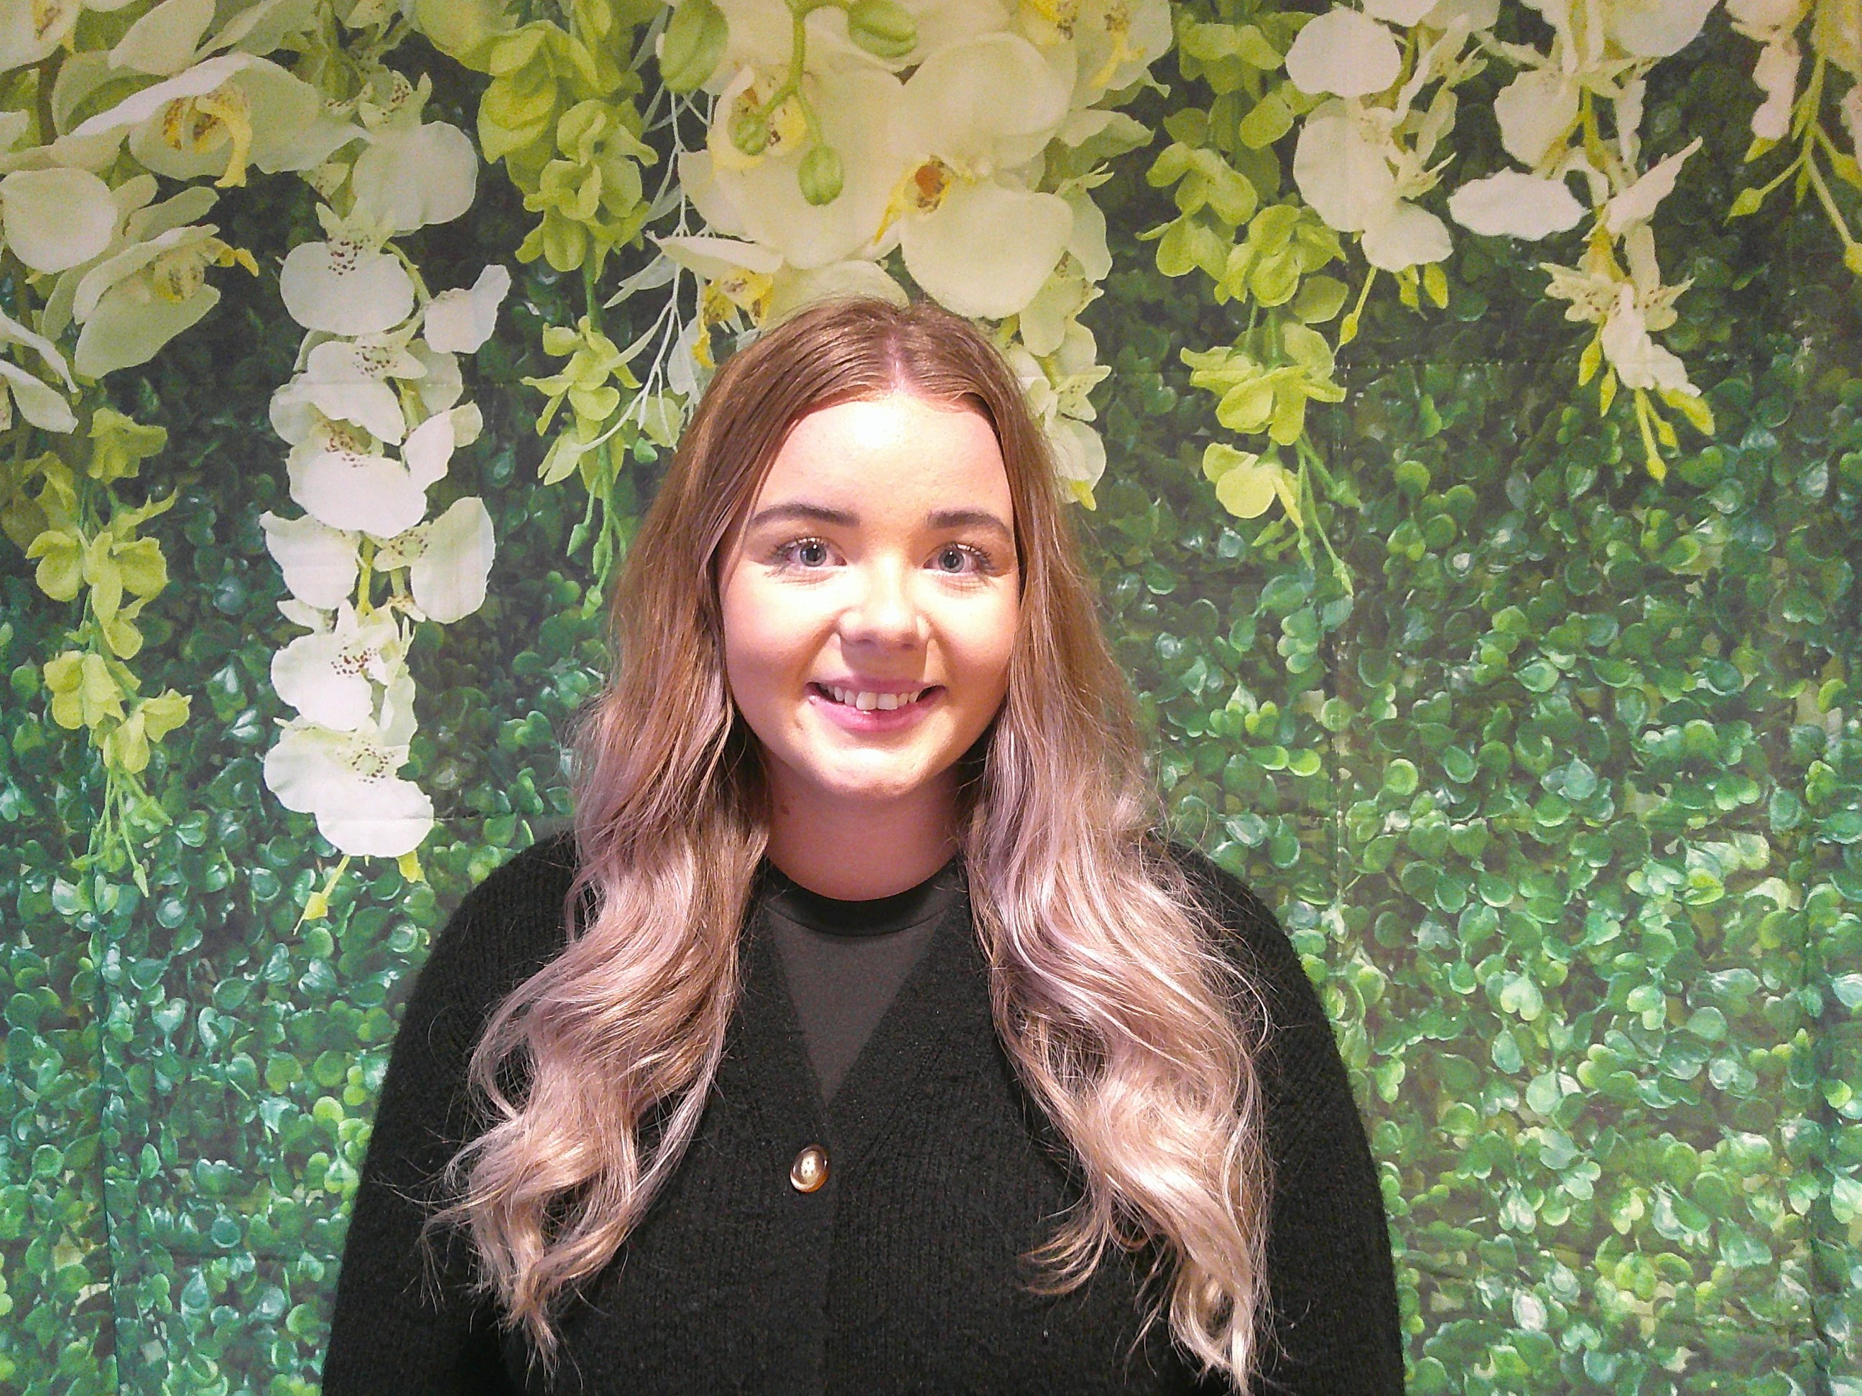
14 - Hello, my name is Jade and I am an Early Years Practitioner in Room One. I work Wednesdays, Thursdays and Fridays.
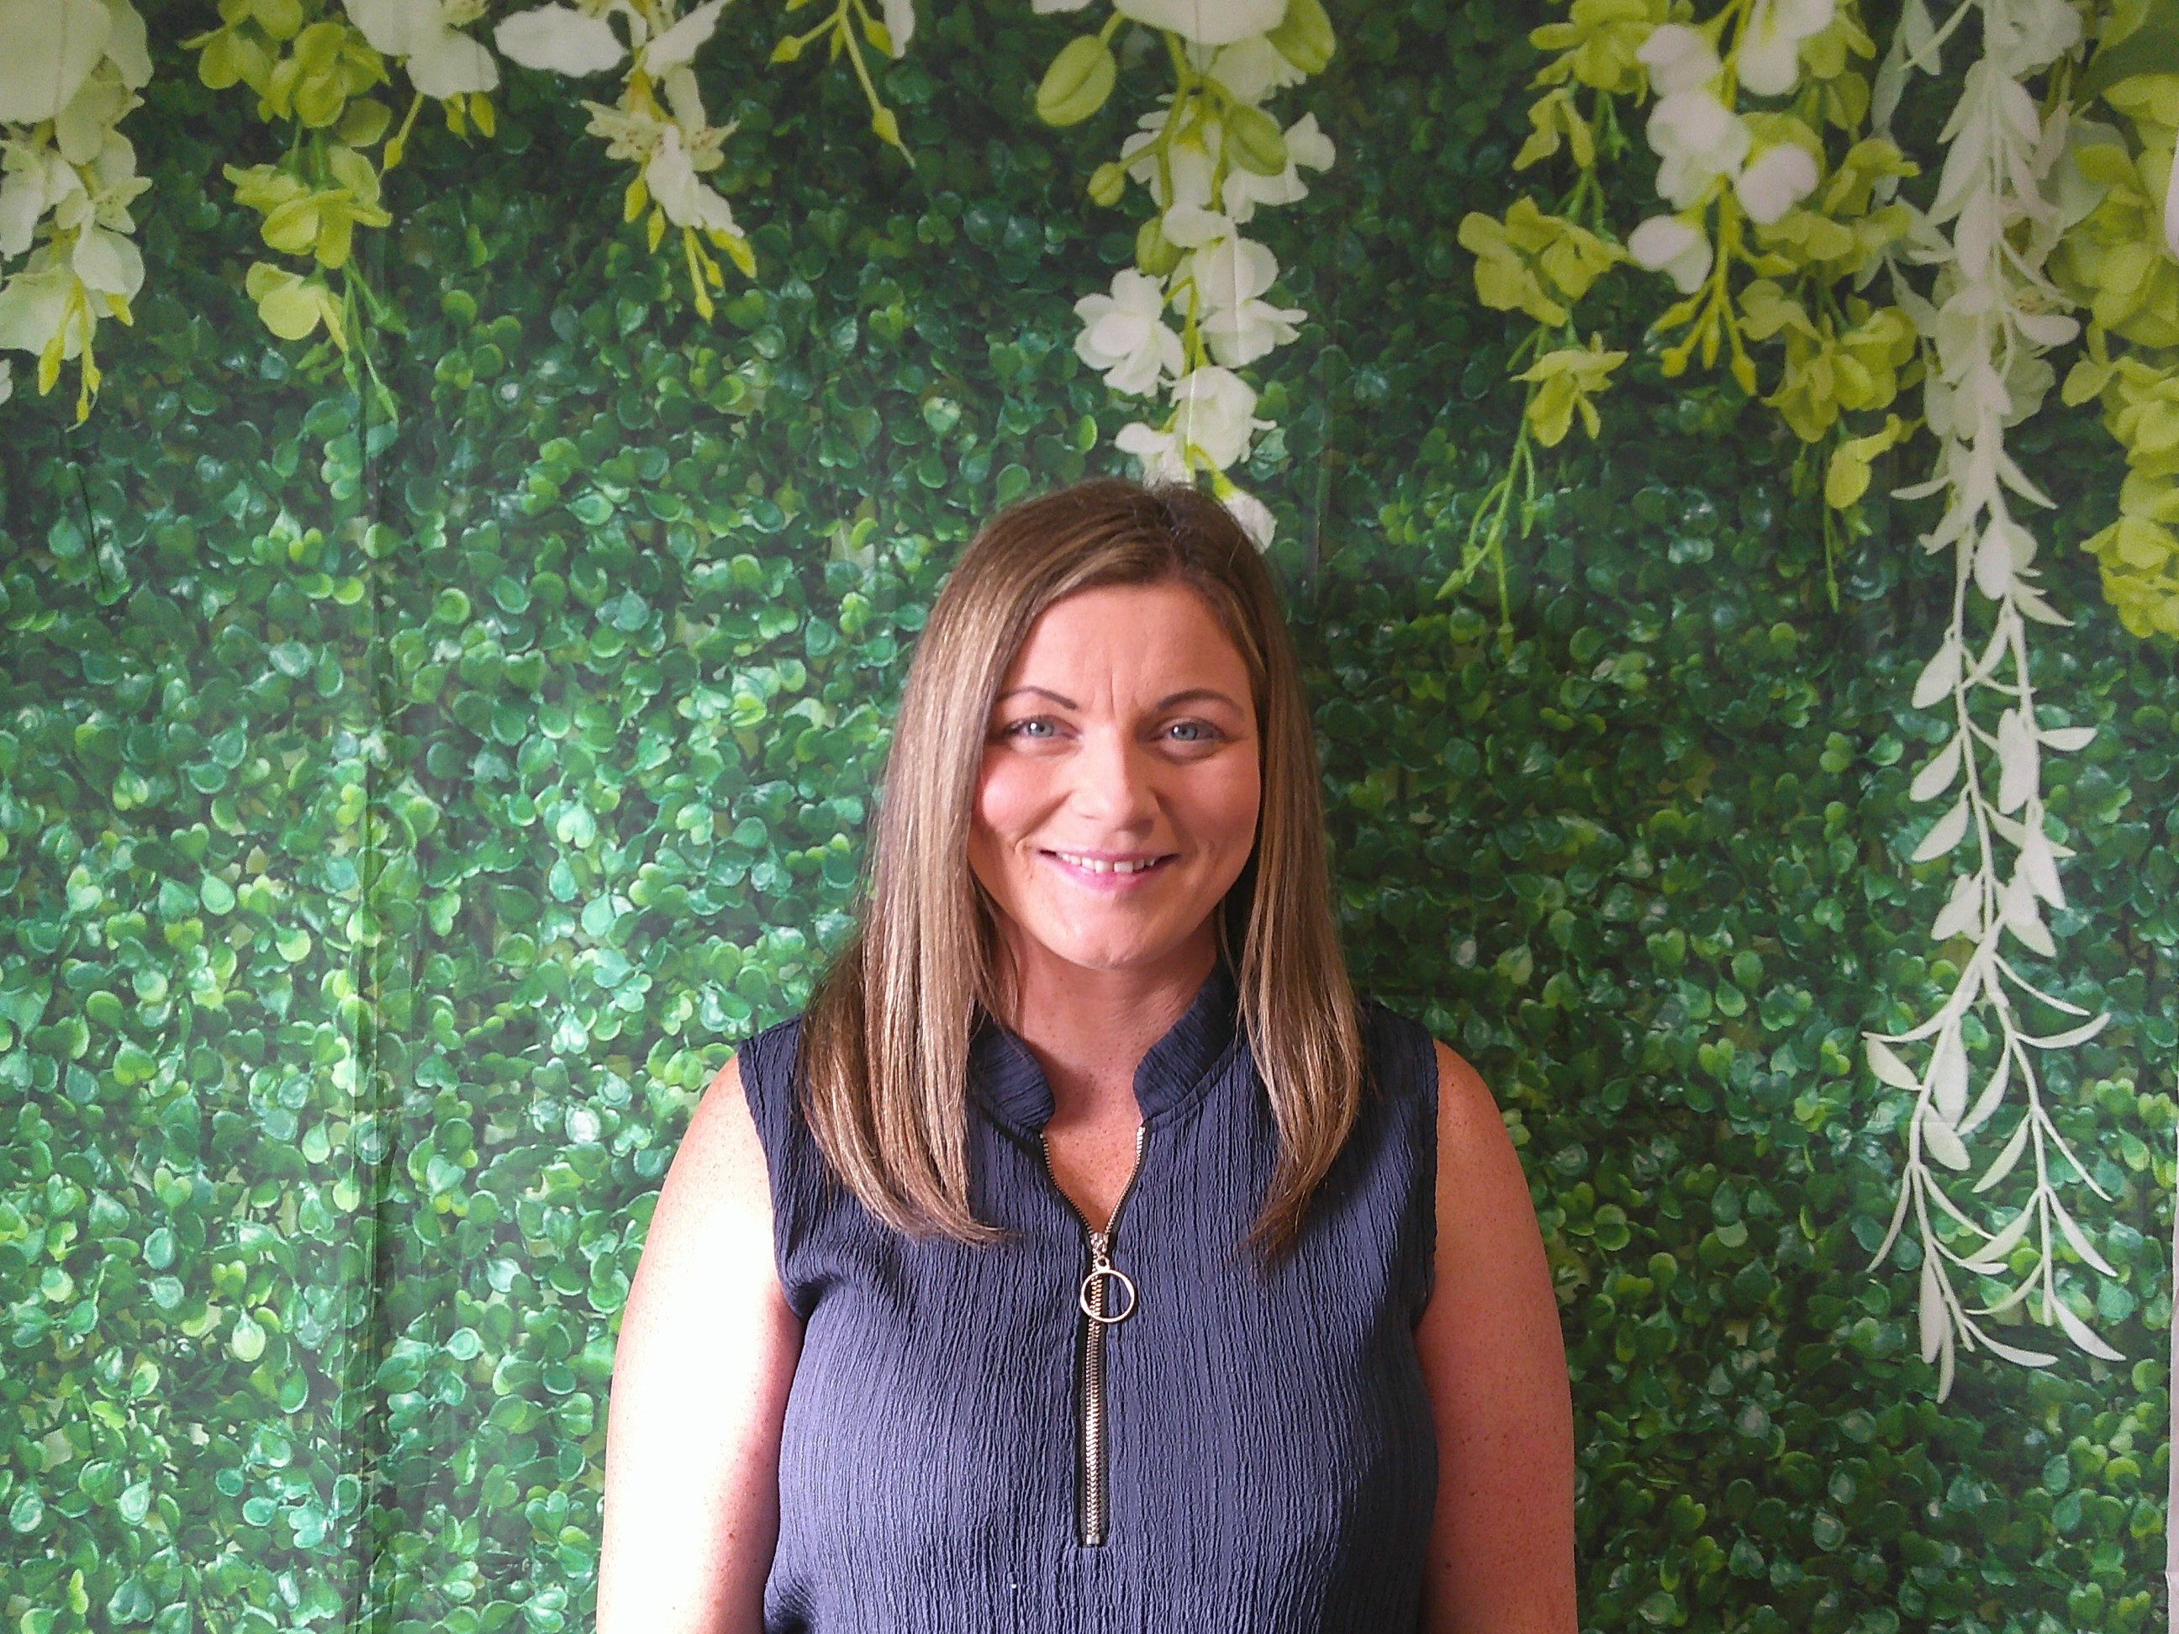
15 - Hello, my name is Nicola and the keyworker for the Robin group. I work Wednesdays, Thursdays and Fridays in Room One. I am particularly passionate about family and community engagement. In my spare time I love spending time with my children and five pets, (dog, cat, tortoise, budgie and hamster). I enjoy spending time in the great outdoors, cold water dipping and paddle boarding.
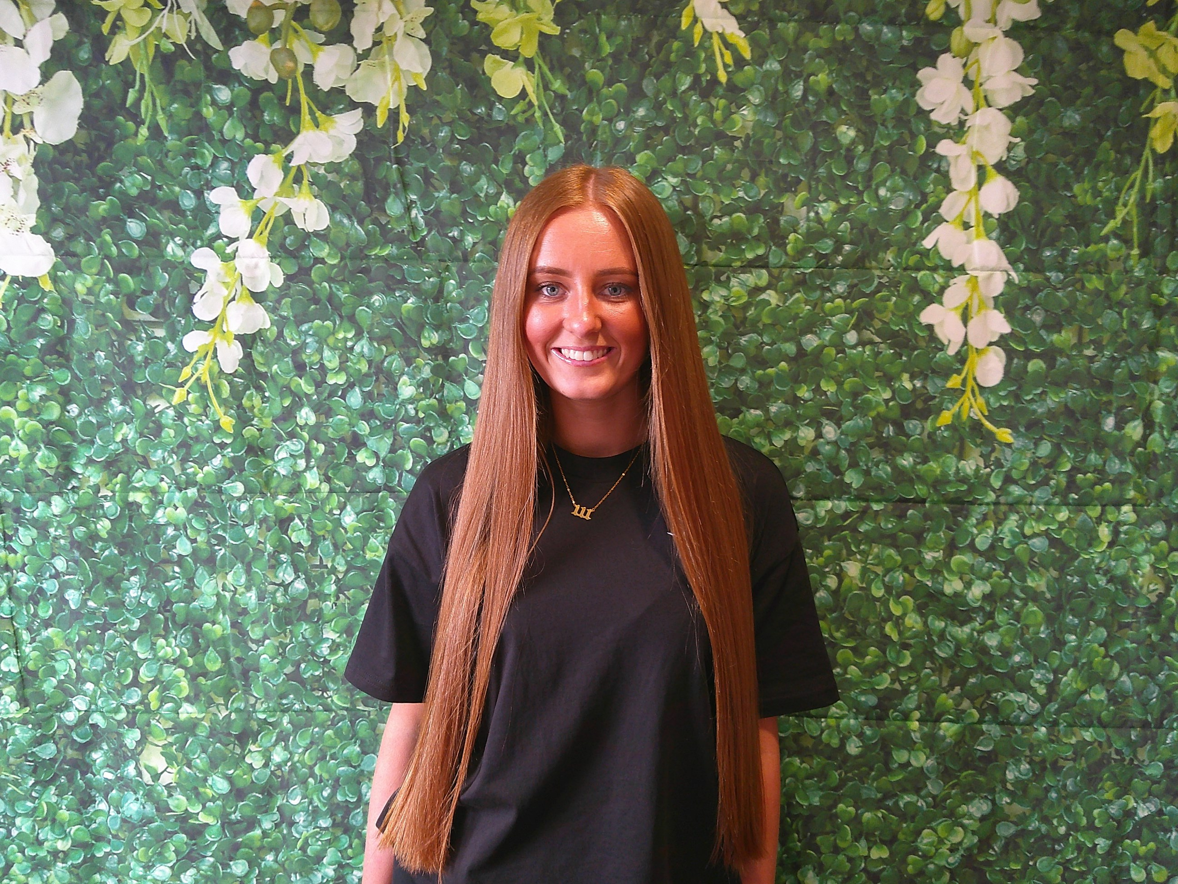
16 - Hello, my name is Holly and I am an Early Years Practitioner and the Keyworker for the Bat group. I work part time and I am based in Room one on a Wednesday, Thursday and Friday. In my spare time i take part in pageants and was recently crowned Miss Pageant Girl UK. I want to encourage children to follow their dreams and believe in themselves. I'm looking forward to meeting you all!
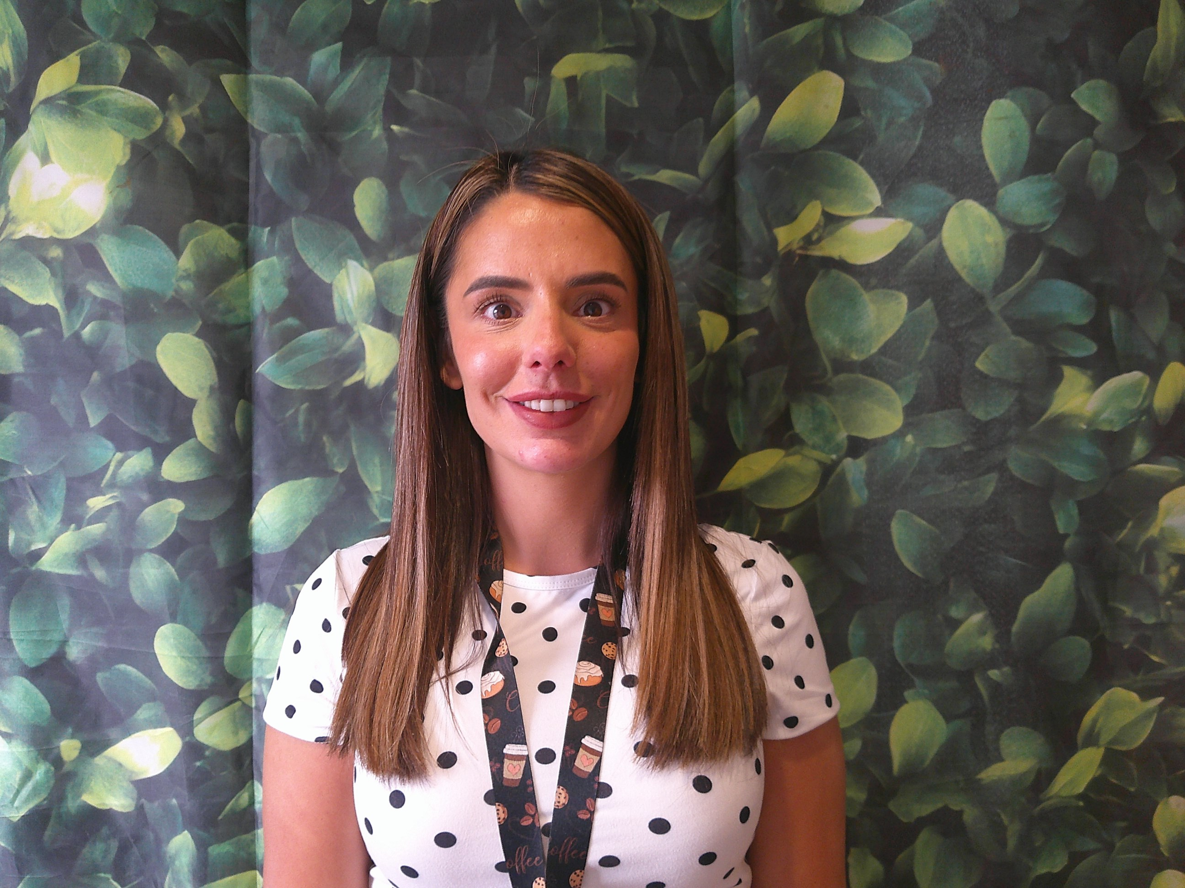
17 - Hello, my name is Narine and I am an Early Years Practitioner for the Deer group. I am based in the Adventurers Room 1. I love all things messy so you will usually find me where the mess is. I am passionate about nurture and attachment. In my spare time i enjoy spending time with my family which includes two young children. i am a bit of a book worm and I will never say no to a holiday. I can't wait to meet you all.

Meet our Room Two Team
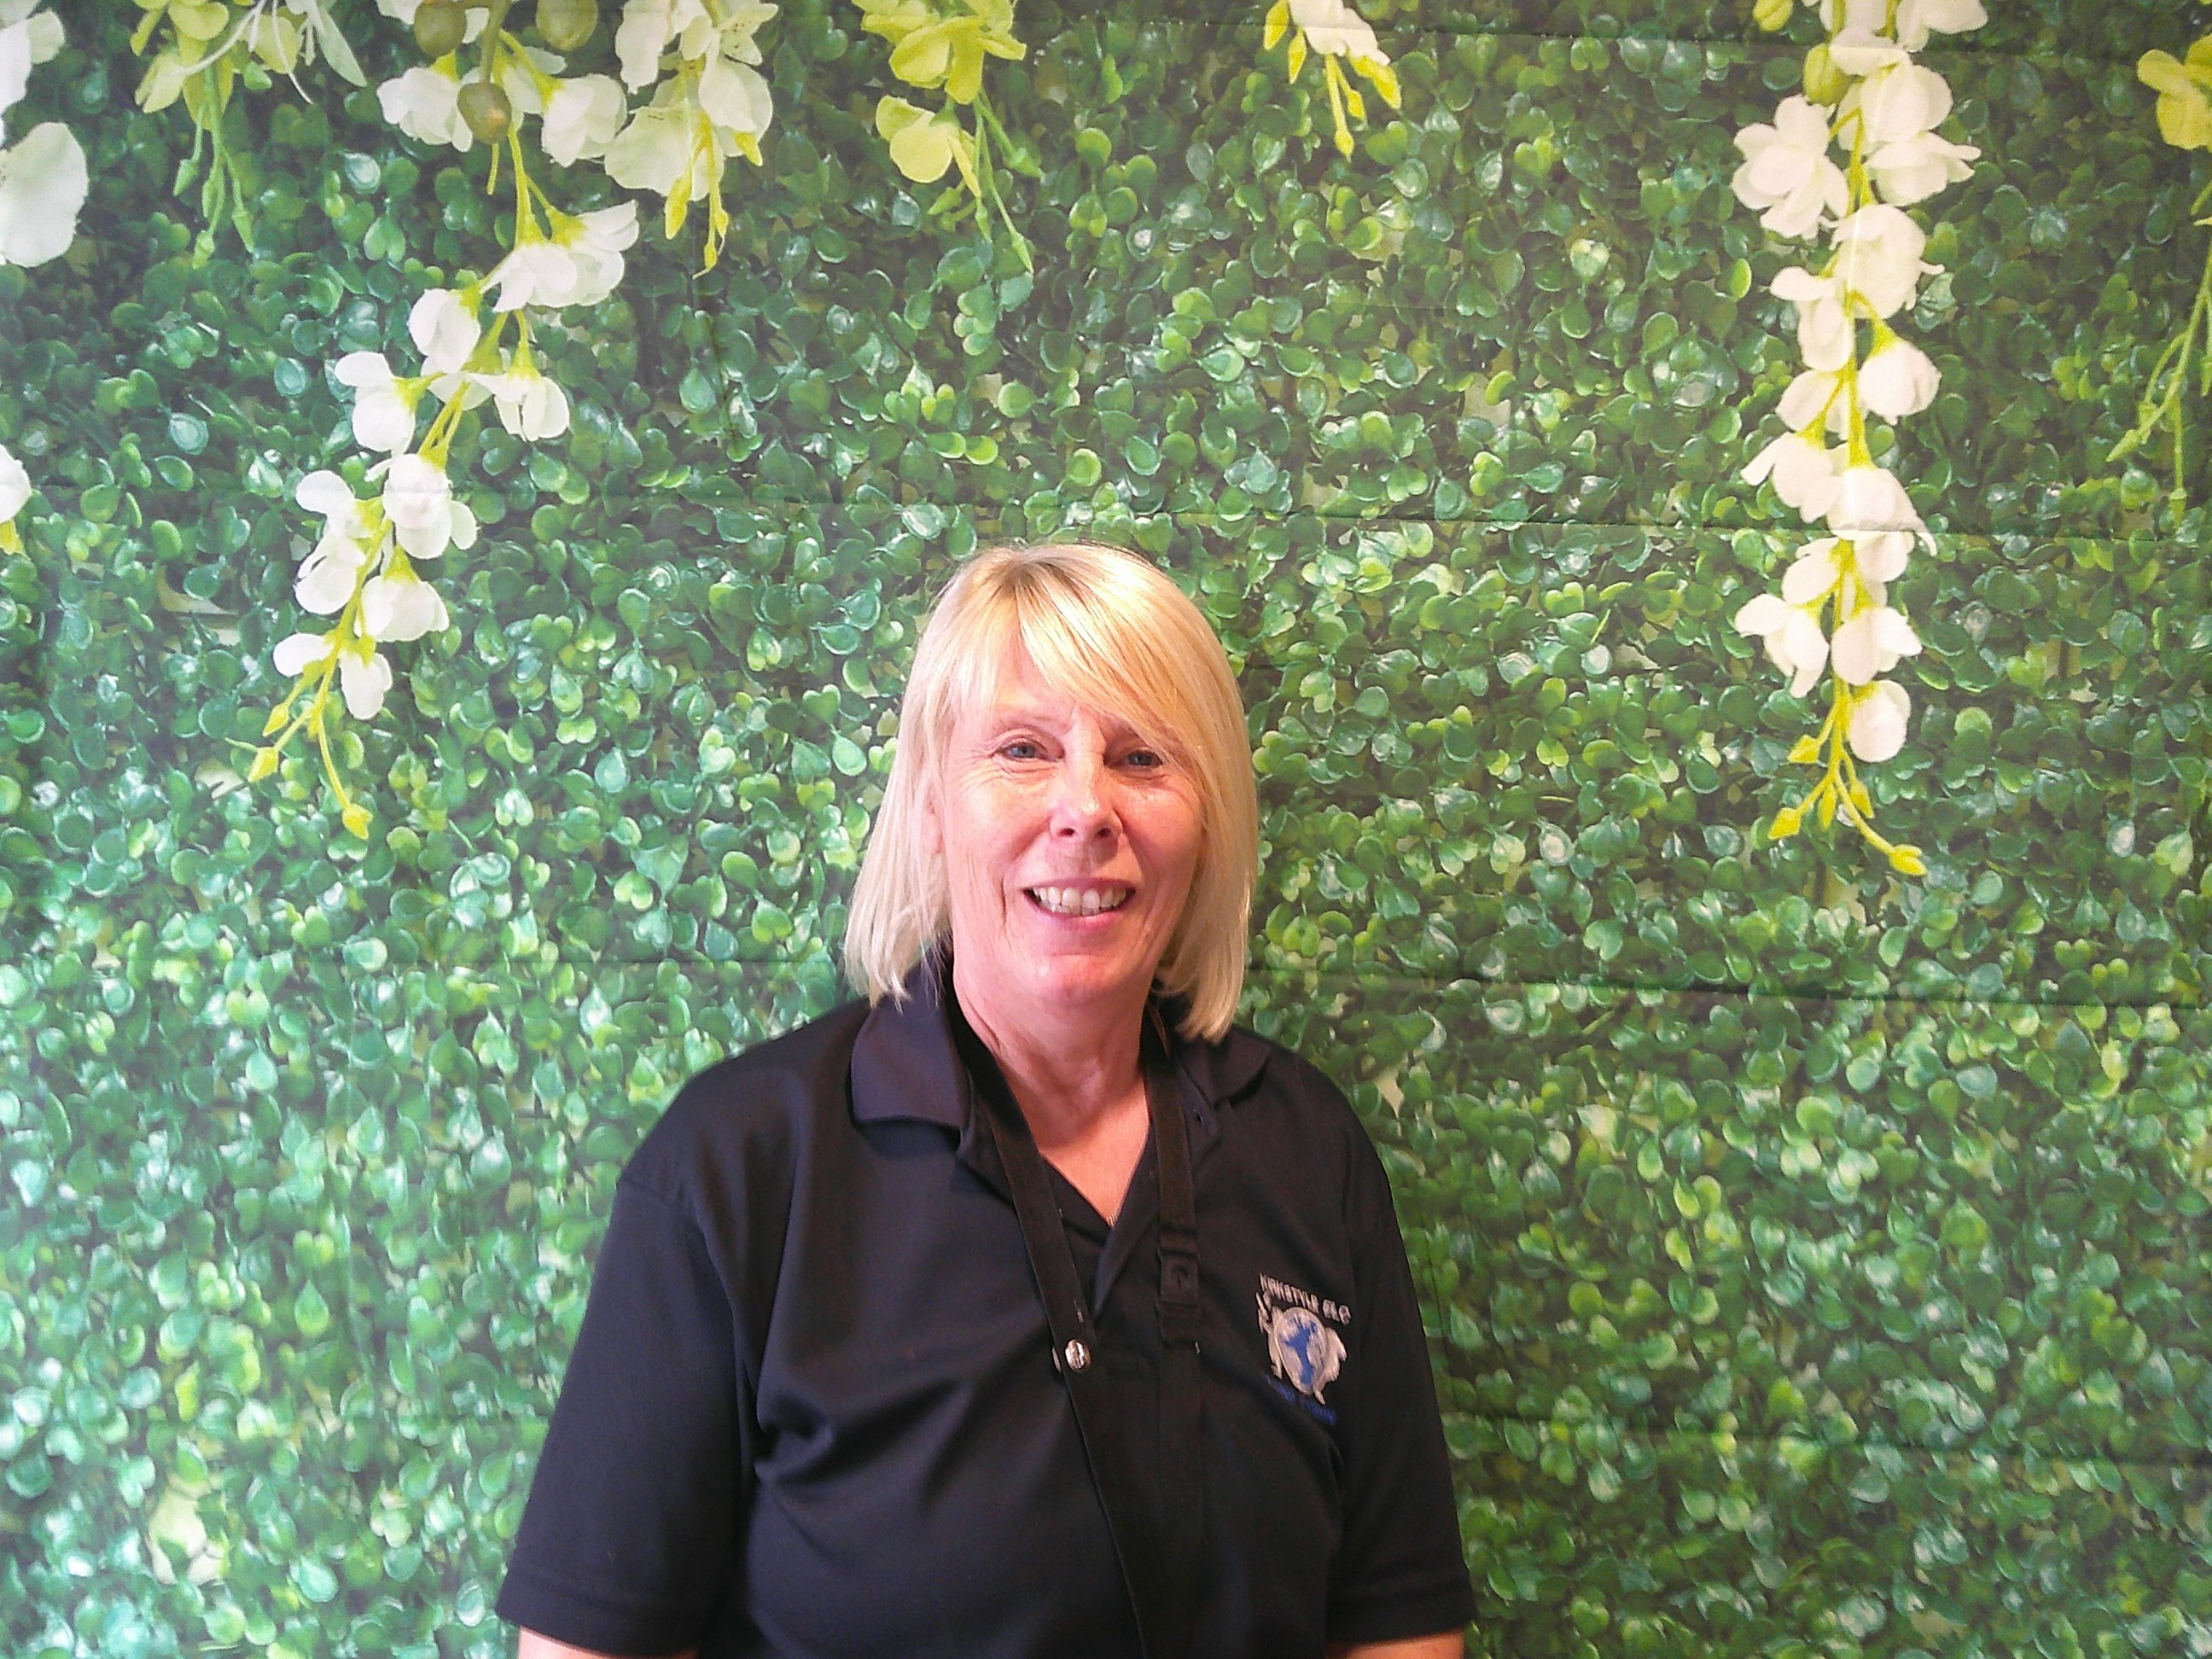
18 - Hi, my name is Eleanor. I am an Early Years Practitioner and I am the keyworker for the Otter Group within the Adventurers Room 2. I am the sustainability / outdoor learning champion for Kirkstyle ELC. I am a qualified Forest School Leader and I take the children weekly to the local woodland to participate in Forest School activities. In my spare time, I love going on walking holidays and spending time going on my paddleboard with friends and family. I can't wait to meet you all!
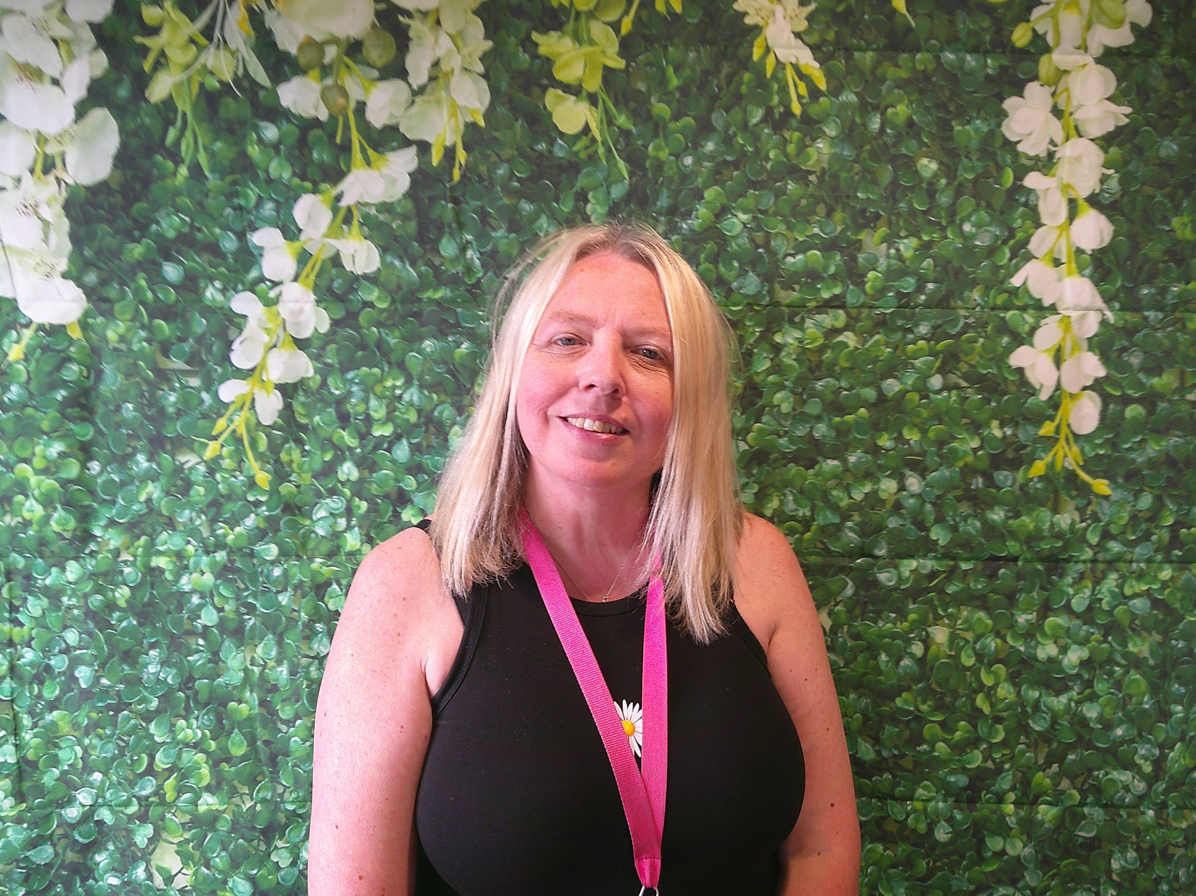
19 - Hi, my name is Margaret. I am an Early Years Practitioner. I am the Keyworker for the Badger group and am the numeracy and attachment champion for Kirkstyle ELC. I have created a nurture group which supports children's emotional and social needs. I like spending time with my friends and family. I have a dog called Columbo and I like to take him on long walks. I am very creative and love providing great experiences for all the children to enjoy!
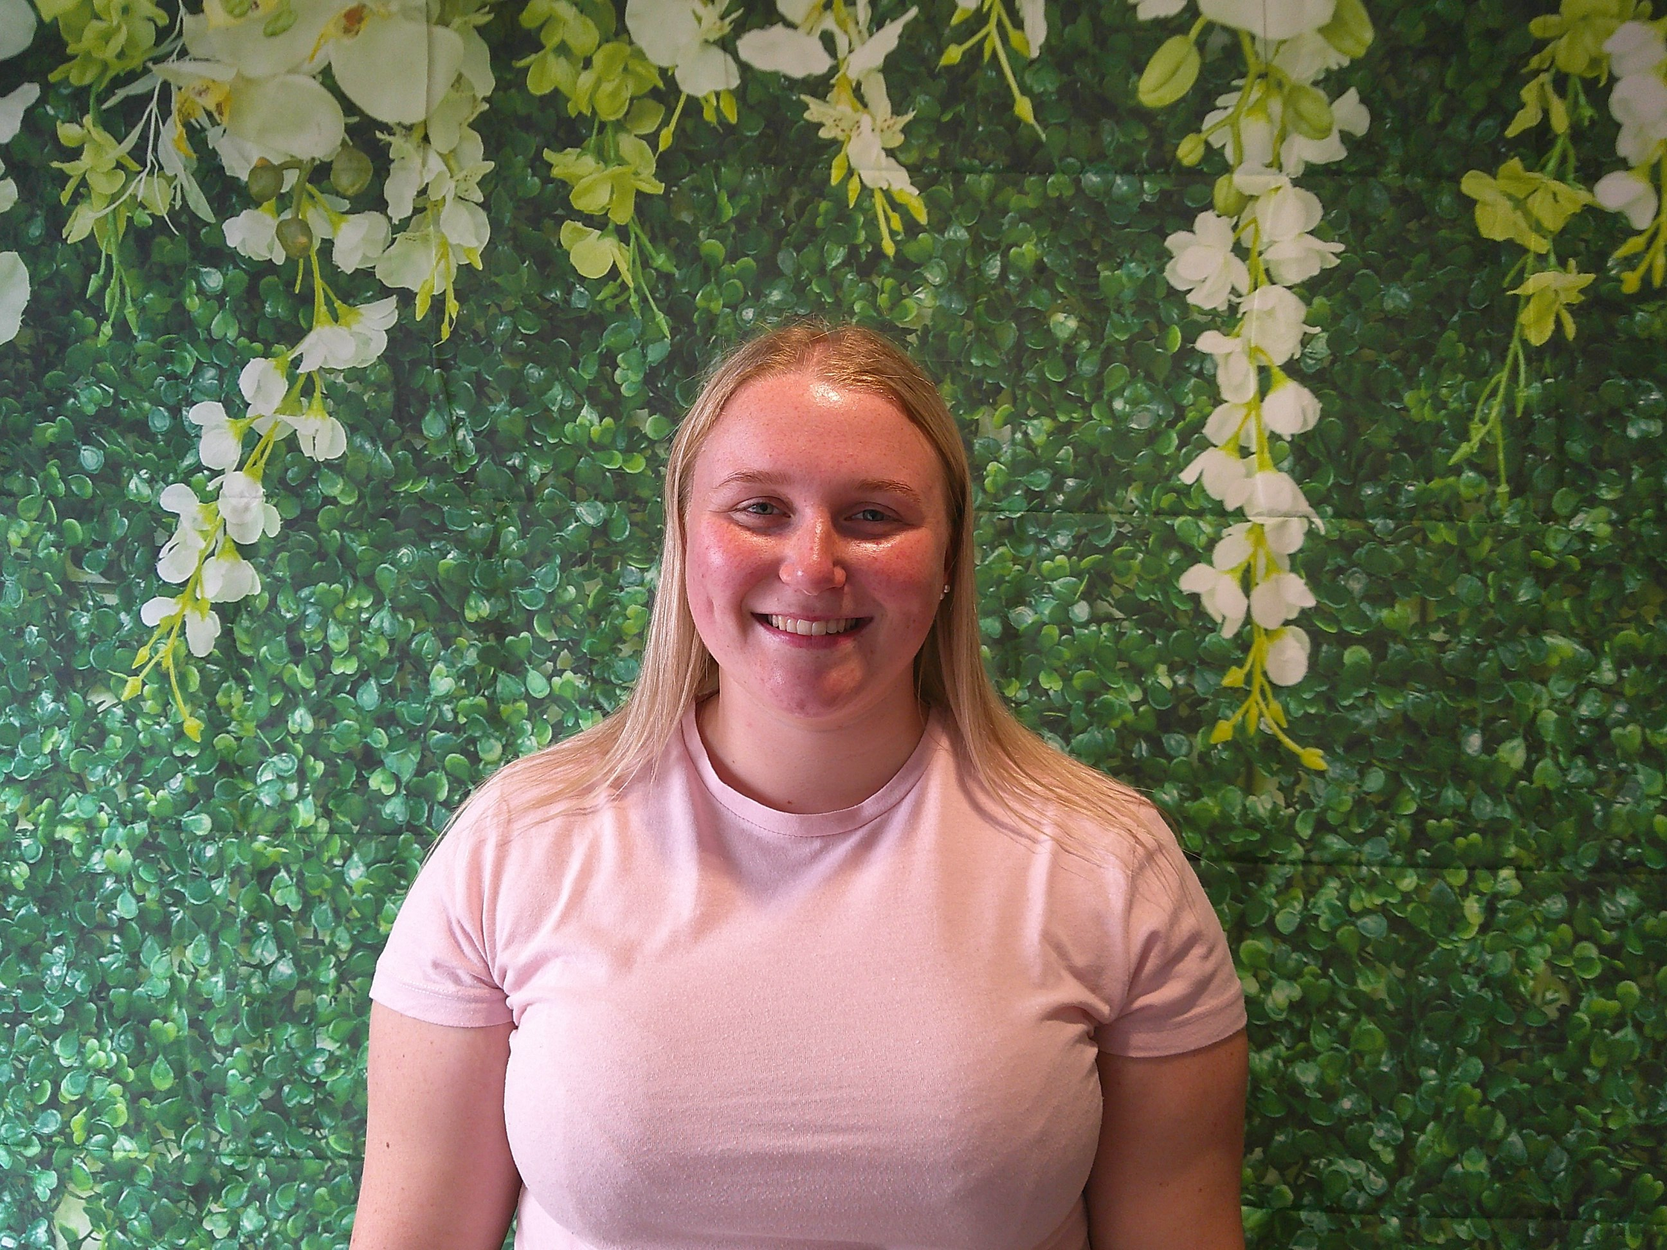
20 - Hi, my name is Katie. I am a qualified Early Years Practitioner. I am the keyworker for the Woodpecker group and the UNCRC (United Nations Convention on the Rights of the Child) champion for Kirkstyle ELC . I love to spend time with family and friends. I also love being outside in the nursery with the children.
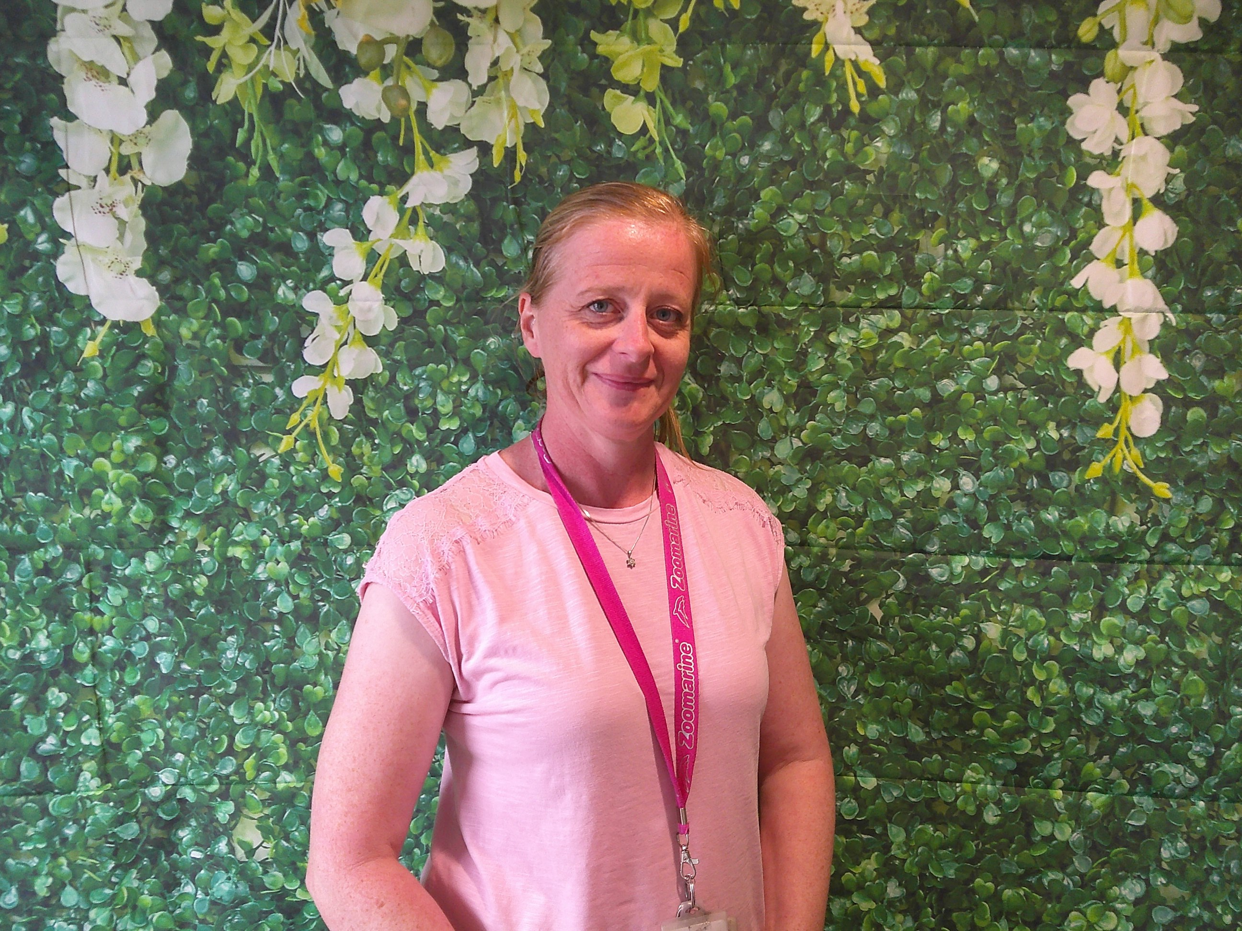
21 - Hi, my name is Fiona and I am an Early Years Practitioner. I am the Keyworker for the Fox Group and am the sustainability / outdoor learning champion for Kirkstyle ELC. I love spending time in the nursery garden with the children planting and growing in our amazing discovery garden. I am Kirkstyles gardening coordinator! In my spare time I love going on holidays and days out with my family and wee dog Mylo.
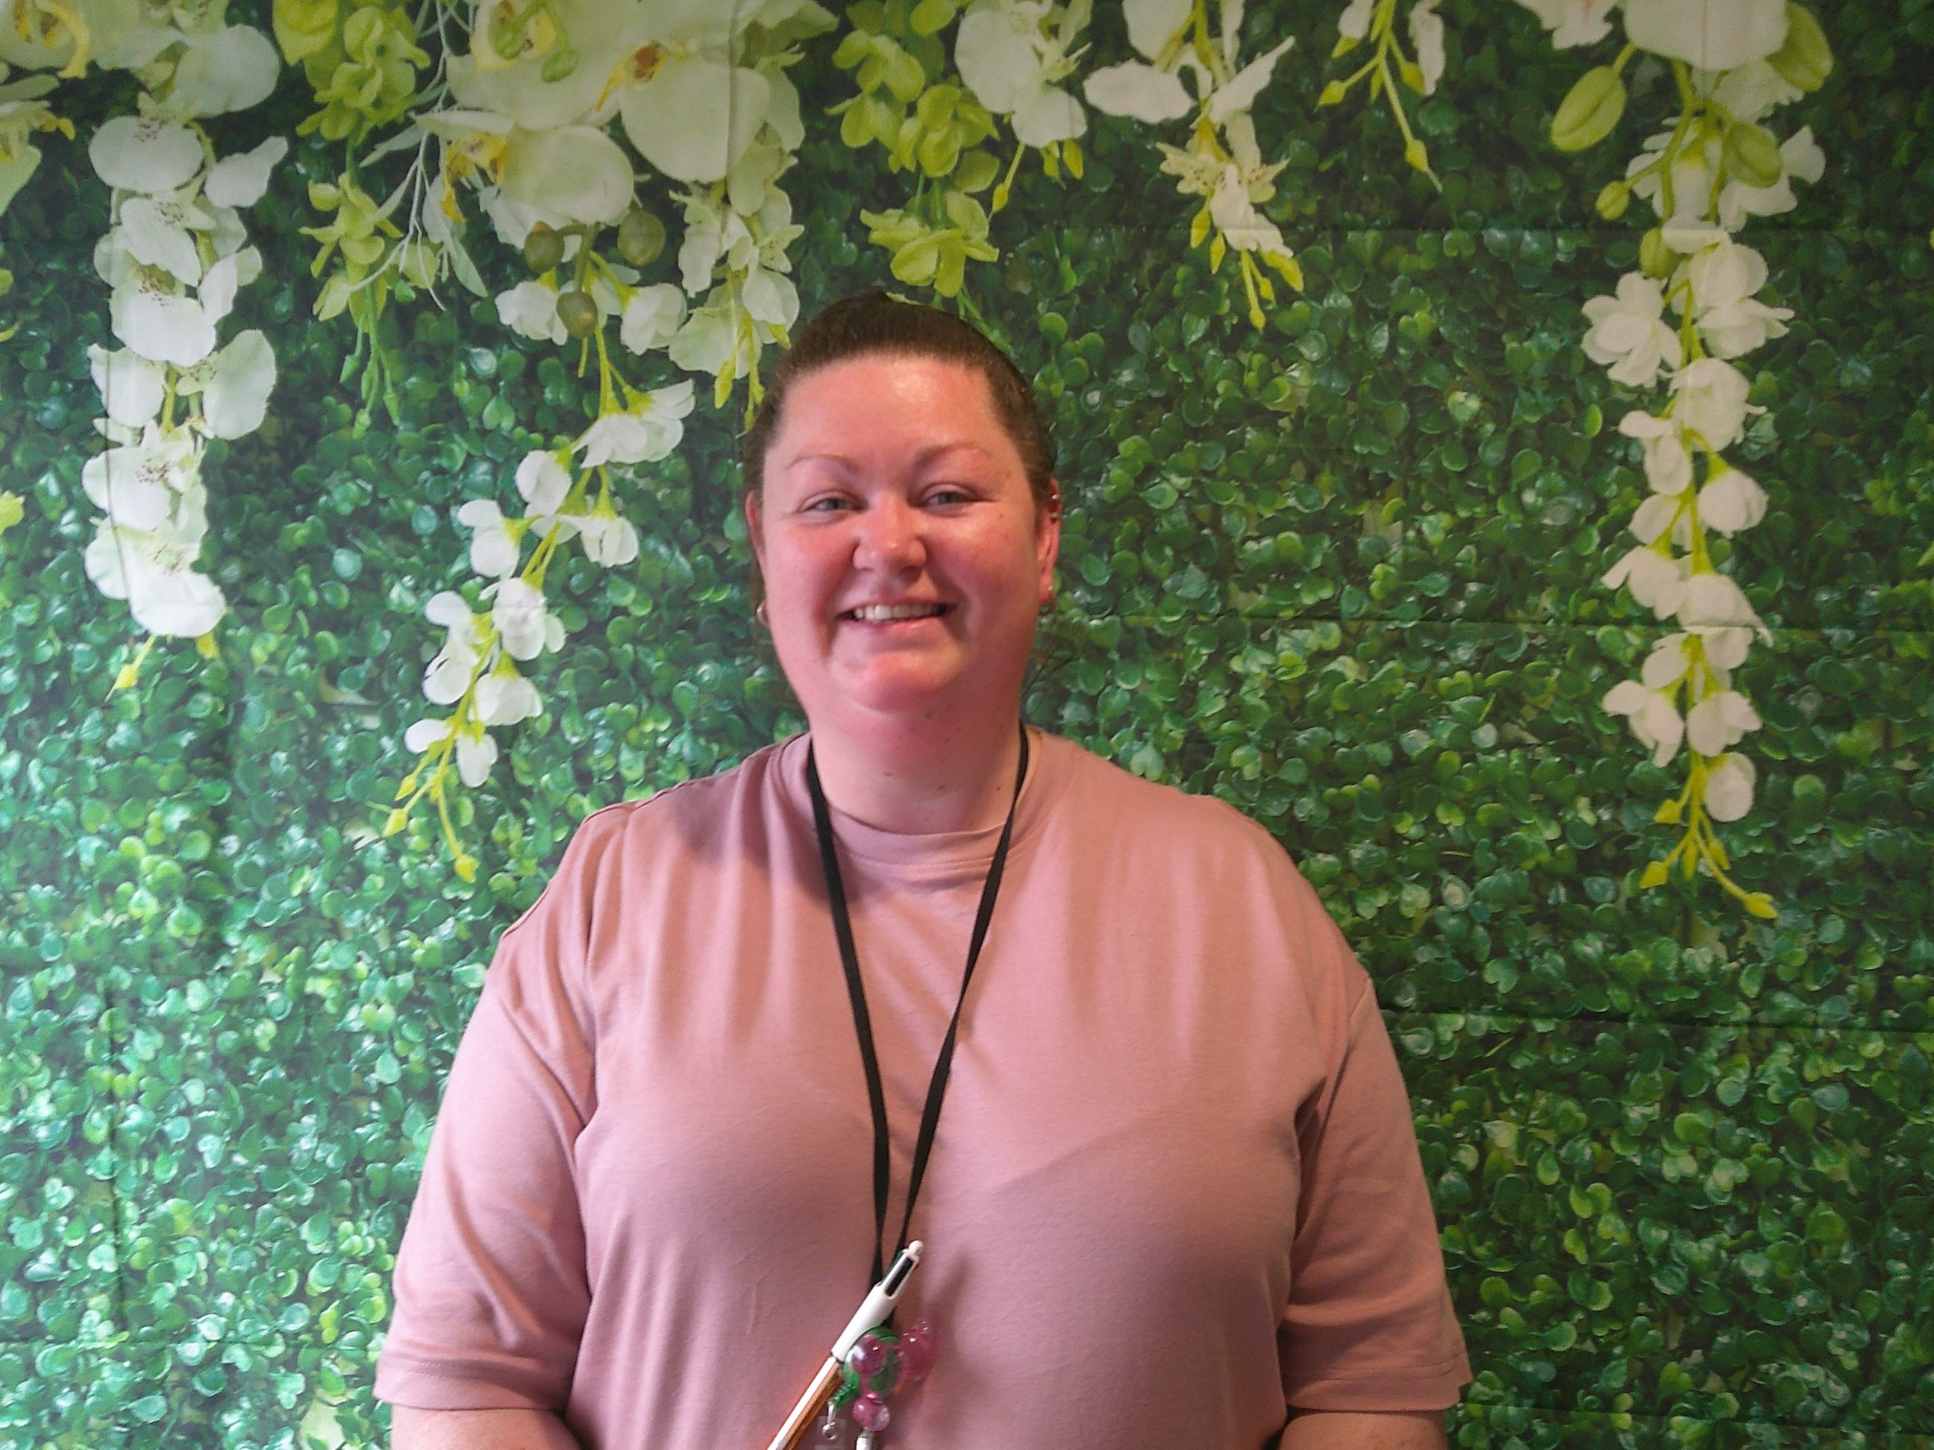
22 - Hi, my name is Rebecca. I am an Early Years Practitioner in Room Two. I am the Keyworker for the Hedgehog Group and am the literacy champion for Kirkstyle ELC. I like spending time with family and friends. I also like going on holiday and visiting new places. At nursery I like to play outside, read stories and be creative.
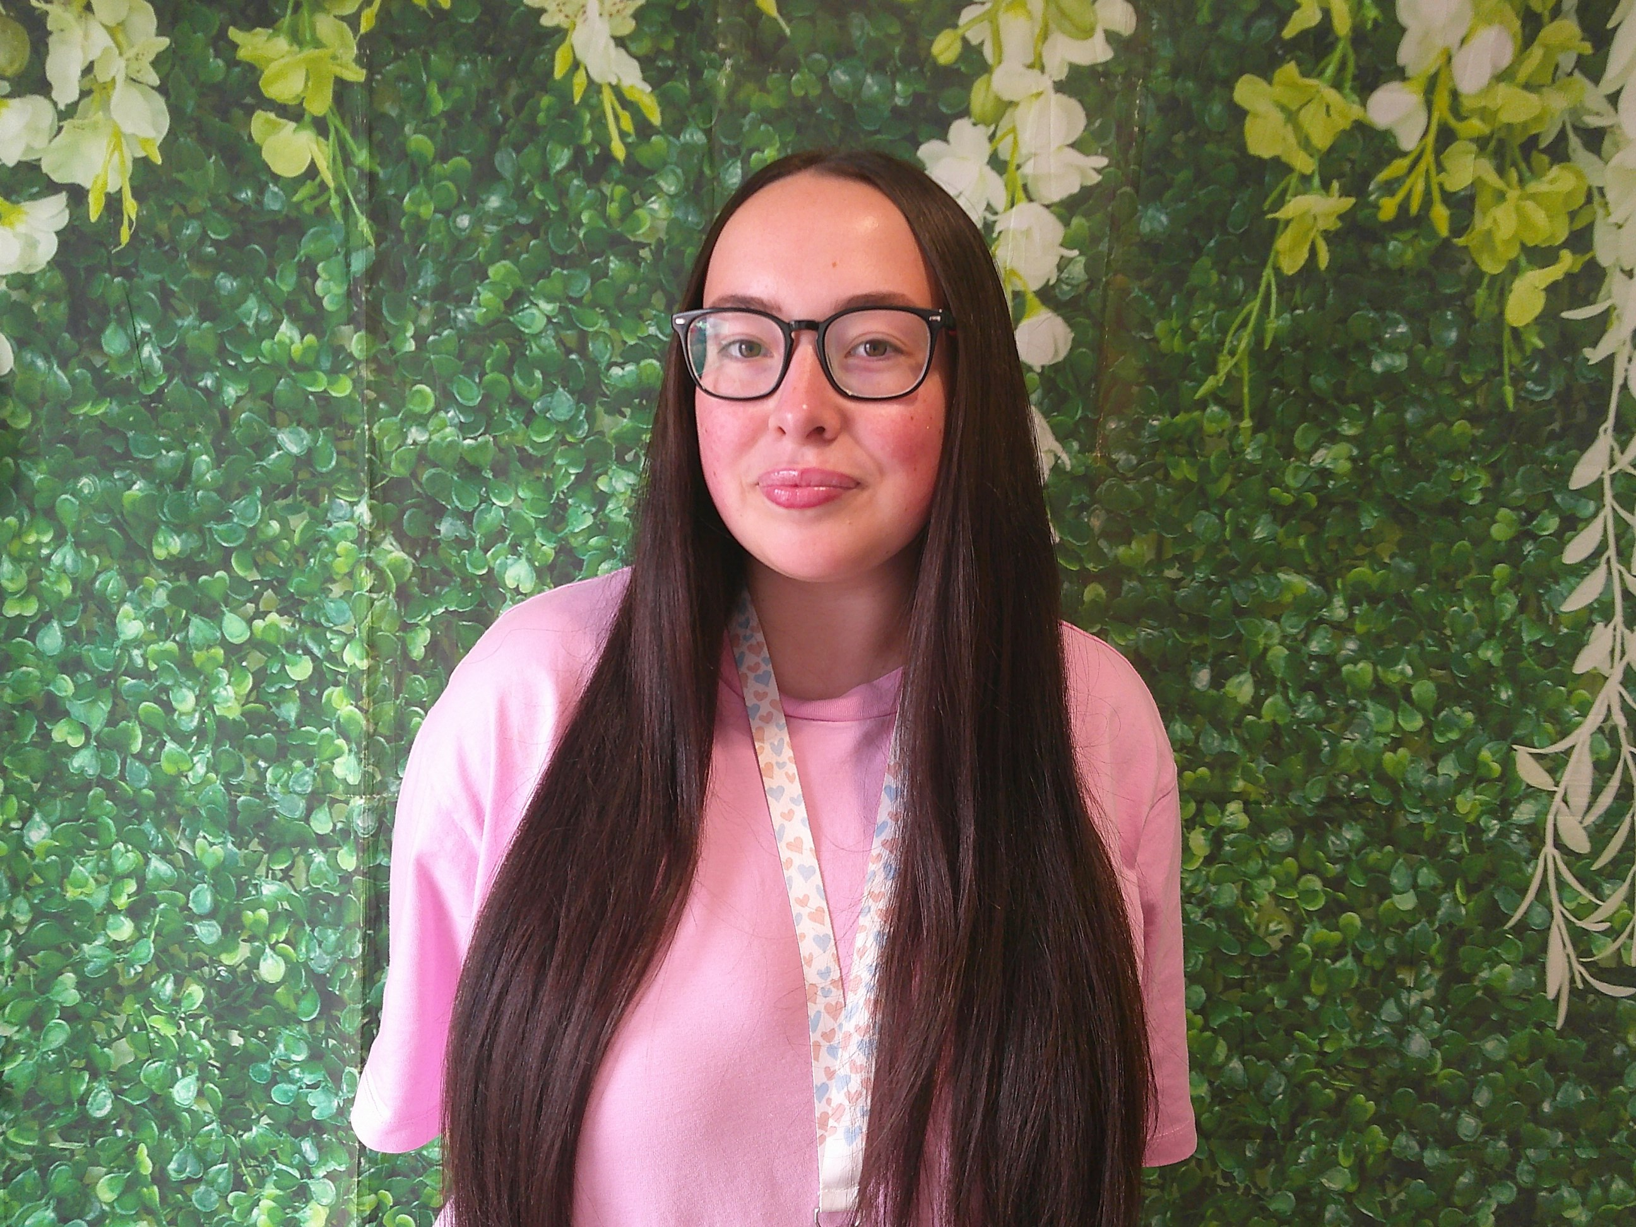
23 - Hello, my name is Caitlyn and I am Early Years Support Worker in Room Two. I love creativity and facilitating lots of messy, sensory activities like gloop. I also love being outdoors with the children. I enjoy spending time with my family and friends and I love to travel and visit different countries.
Every child will have a member of staff who is assigned as their Keyworker and will be the main point of contact. If you have any information to pass on, or if you have any specific questions about your child, then the Keyworker is the best person to speak to. All staff members working within the playroom will get to know your child individually and will build positive relationships with them. Your child’s Keyworker will discuss their care plans and targets, at least, every three months with you.

Our Learning Environment
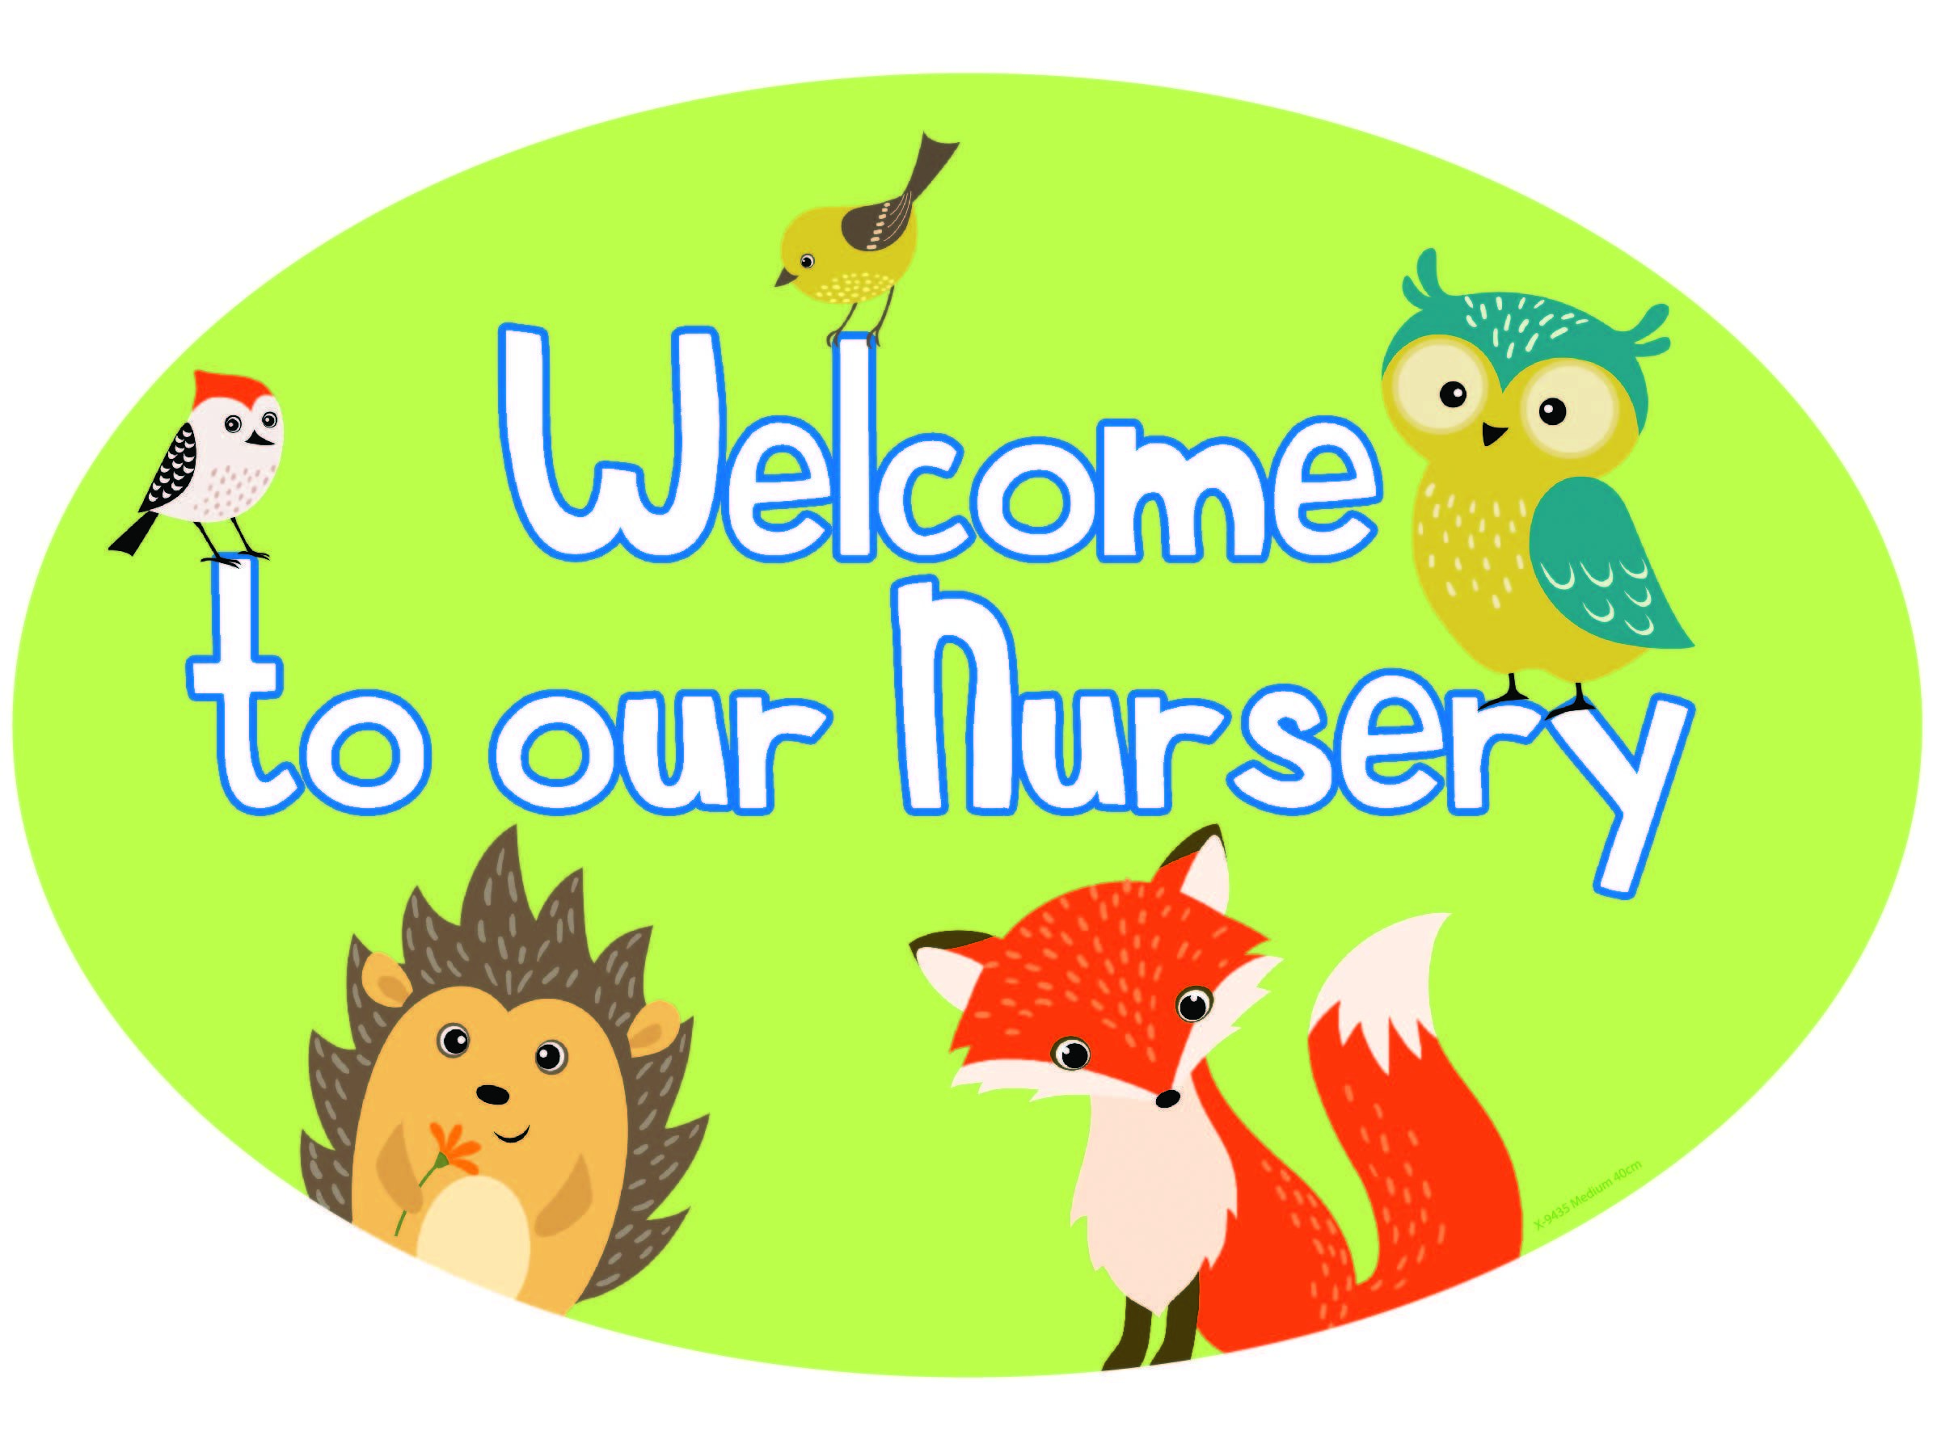

Welcome to Adventurers Room 1 Video

Welcome to Adventurers Room 2 Video

Welcome to our Sensory Room Video

Our Curriculum

We follow national guidance - Curriculum for Excellence and Realising the Ambition, alongside local guidance - Together We Can and We Will to get it right for our youngest learners.
Curriculum for Excellence places learners at the heart of education. At its centre are four fundamental capacities. These capacities reflect and recognise the lifelong nature of education and learning. The four capacities are aimed at helping children and young people to become:
- Successful learners
- Confident individuals
- Responsible citizens
- Effective contributors
Staff carefully plan relevant, stimulating and meaningful learning experiences to support children to achieve key learning outcomes - particularly focusing on health and wellbeing, numeracy and literacy. Staff also ensure that quality core provision is facilitated for daily 'free play', exploration and active learning. We ensure children are leaders of their own learning and are listened to and respected in the planning process.
Children will have individual learning targets which will be jointly set by parent / carer and keyworker during regular parent consultations. Progress and achievements will be recorded through photographs and observations compiled within child's own learning journal.
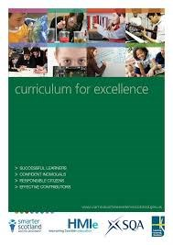
24 - Curriculum for Excellence
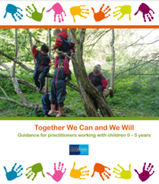
25 - Together We Can and We Will

26 - Realising the Ambition

Our Discovery Garden
Welcome to our discovery garden. We work hard all year to ensure the garden is full of amazing fruit and vegetables. We can't wait for you to help us all! We even give some of the vegetables to our market stall in the entrance hall. You can purchase these throughout the year!
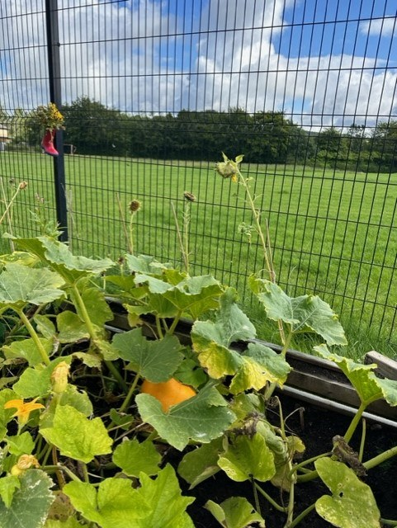
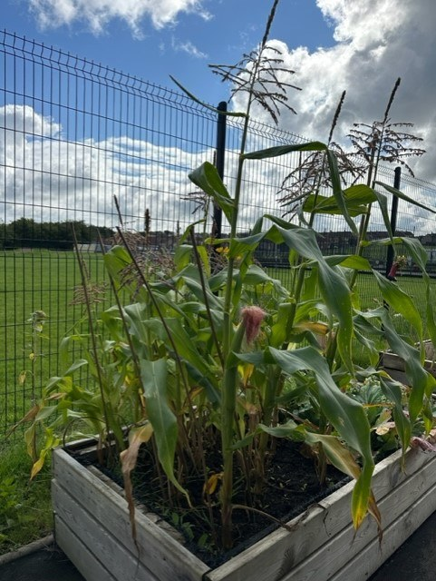
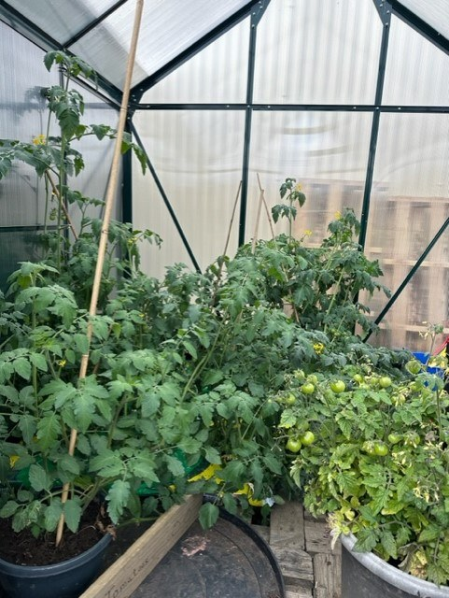
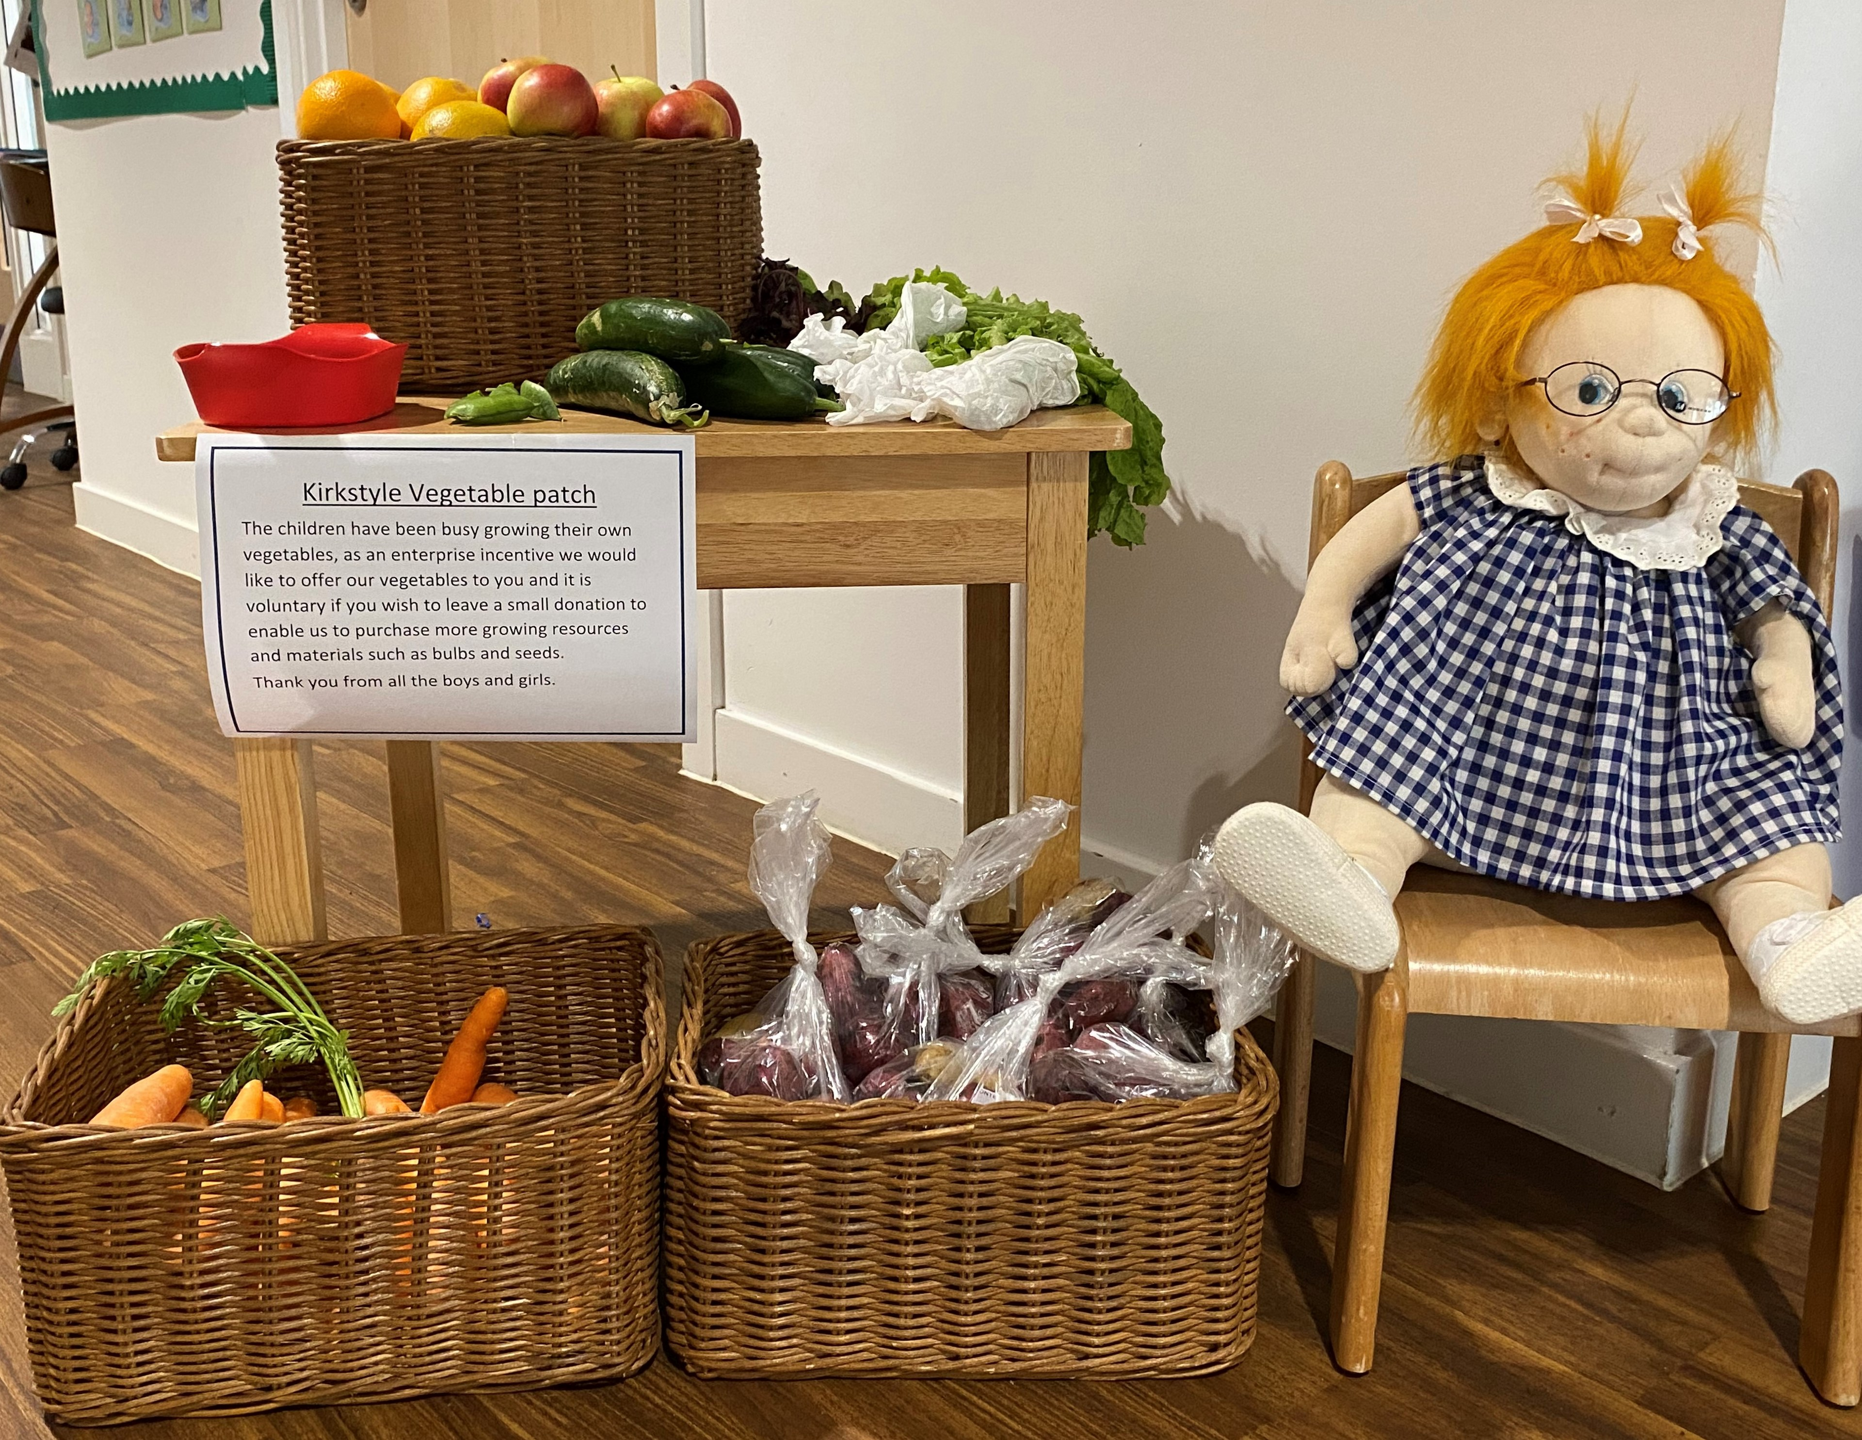
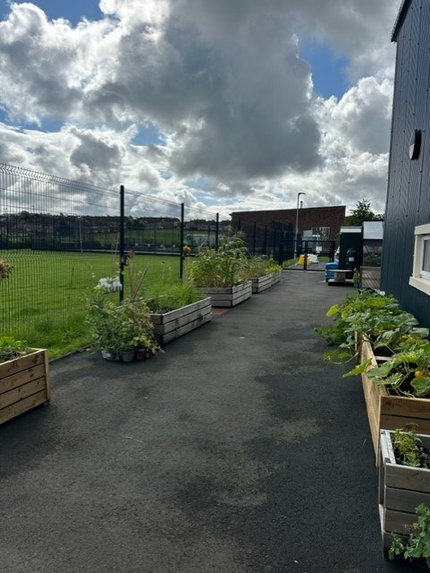
For further information about Kirkstyle ELC please see our nursery handbook. Please do not hesitate to get in touch. Our details are below:
Kirkstyle ELC
15 Eastfield Road
Carluke
ML8 4NZ
01555 772856

Email address: gw20kirkstyleoffice@glow.sch.uk
Kirkstyle ELC website: blogs.glowscotland.org.uk/sl/kirkstyle/

