Adding an additional account through the Google Classroom App
1. Download/Open the Google Classroom App
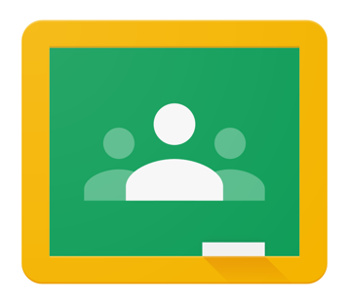

2. Once the app is open, click on the small circle in the top right-hand corner.
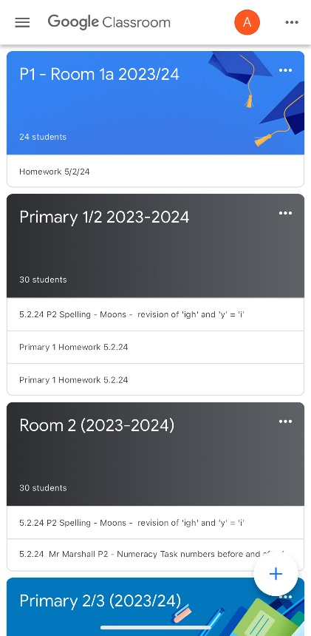
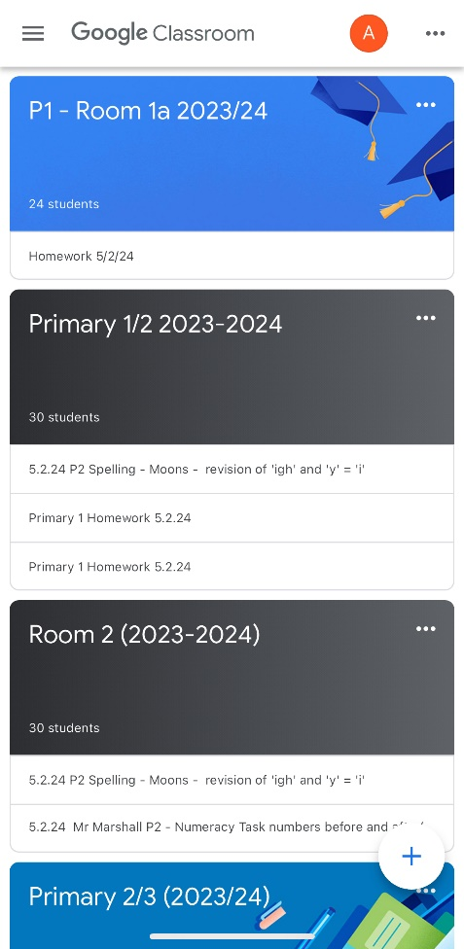

3. Once the circle has been clicked, the following screen will appear.
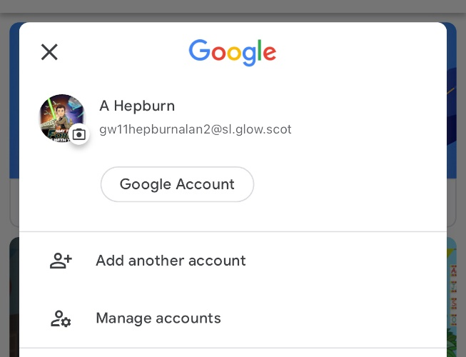

4. Select the ‘Add another account’ and you will be directed to the next window.

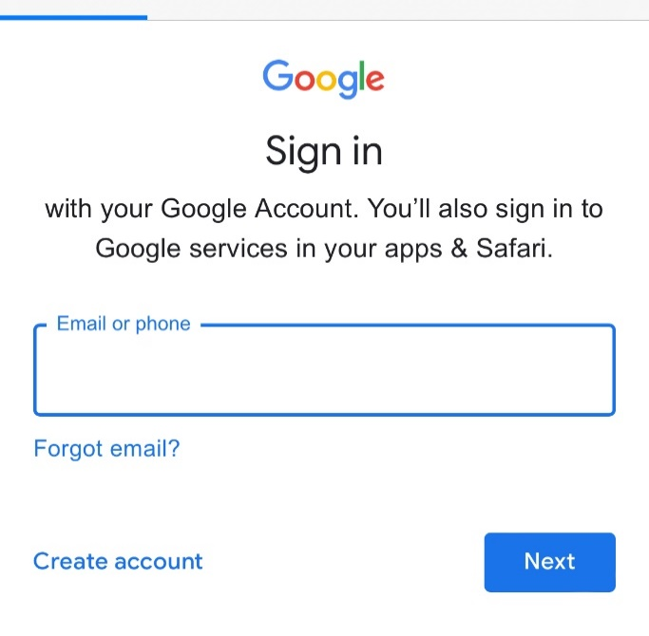

5. Type in the school Glow account for the child e.g. gw12smithjoe@sl.glow.scot and you will be redirected to the following screen.
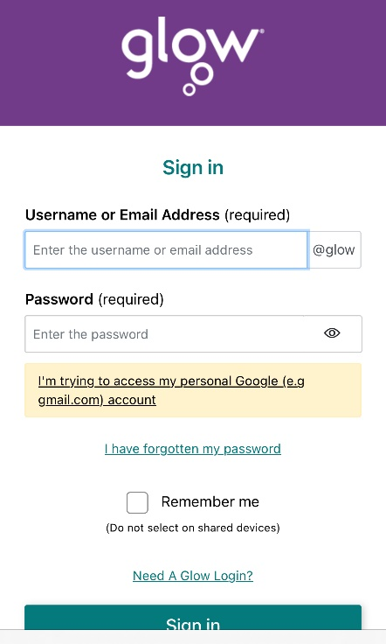

6. Type in the school Glow username and password but with a different end section e.g. gw12smithjoe@glow.sch.uk, which (if typed in correctly), should give you access to the classrooms in which your child has been assigned.
7. Clicking on the small circle in the top right-hand corner will allow you to toggle between eh different accounts saved on the device. Only education accounts can gain access to classrooms, personal accounts will ask for a class code to gain access.

