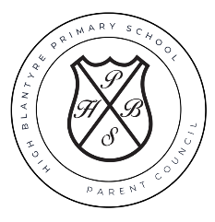
High Blantyre Primary School Parent Council
Agenda
Thursday 27 March 2025 6:00pm

1. Welcome & apologies
2. Approval of draft minutes 26 February 2025
3. Head Teacher update
3.1 PEF
3.2 Twitter
4. Funding update
5. Events
6. A.O.B

Next meeting date: 08 May 2025

