Dear Parent/Carer,
June is here and it is hard to believe that there is less than 3 weeks left of school. We have a very exciting few weeks ahead, starting on Monday the 10th of June, with a very busy and active Health Week, organised by Miss Gallagher. On Monday our Primary 6 Euro Quiz Team are off to The McEwan Hall in Edinburgh University and we wish them lots of luck as they represent our school and South Lanarkshire Council in The Euro Quiz National Finals. The Primary 7 pupils have been busy planning their end of term Leaver’s Assembly and I would like to invite everyone to join the whole school at Blantyre Old Parish Church on Tuesday the 25th of June at 10am, to say goodbye to our senior pupils. As this is the last newsletter of the session, I would like to take this opportunity to once again thank everyone for all of your continued support. It really has been a fantastic year at High Blantyre Primary with lots to celebrate! The school is going from strength to strength and I am so proud of everything the children, parents/carers, staff and community have achieved together. A massive thank you to our amazing, dedicated Parent Council, for their ongoing hard work, fundraising, endless support and all that they do for High Blantyre Primary.! I can not say enough how lucky we are ! Have a fantastic summer break making lots of memories and we will see everyone who is returning or starting school in August. Good Luck to our amazing Primary 7 children- we will miss you all! As always if you have any questions with regards to your child’s learning or wish to discuss any matter, we are always here and happy to help!
Thank you for your continued support. Kind regards, Kirsteen Helsby

As always, please do not hesitate to contact myself or a member of the Senior Management Team if you have any questions with regards to your child’s learning. Thank you for your continued support and partnership, Kind regards, Kirsteen Helsby

We are a Reading School  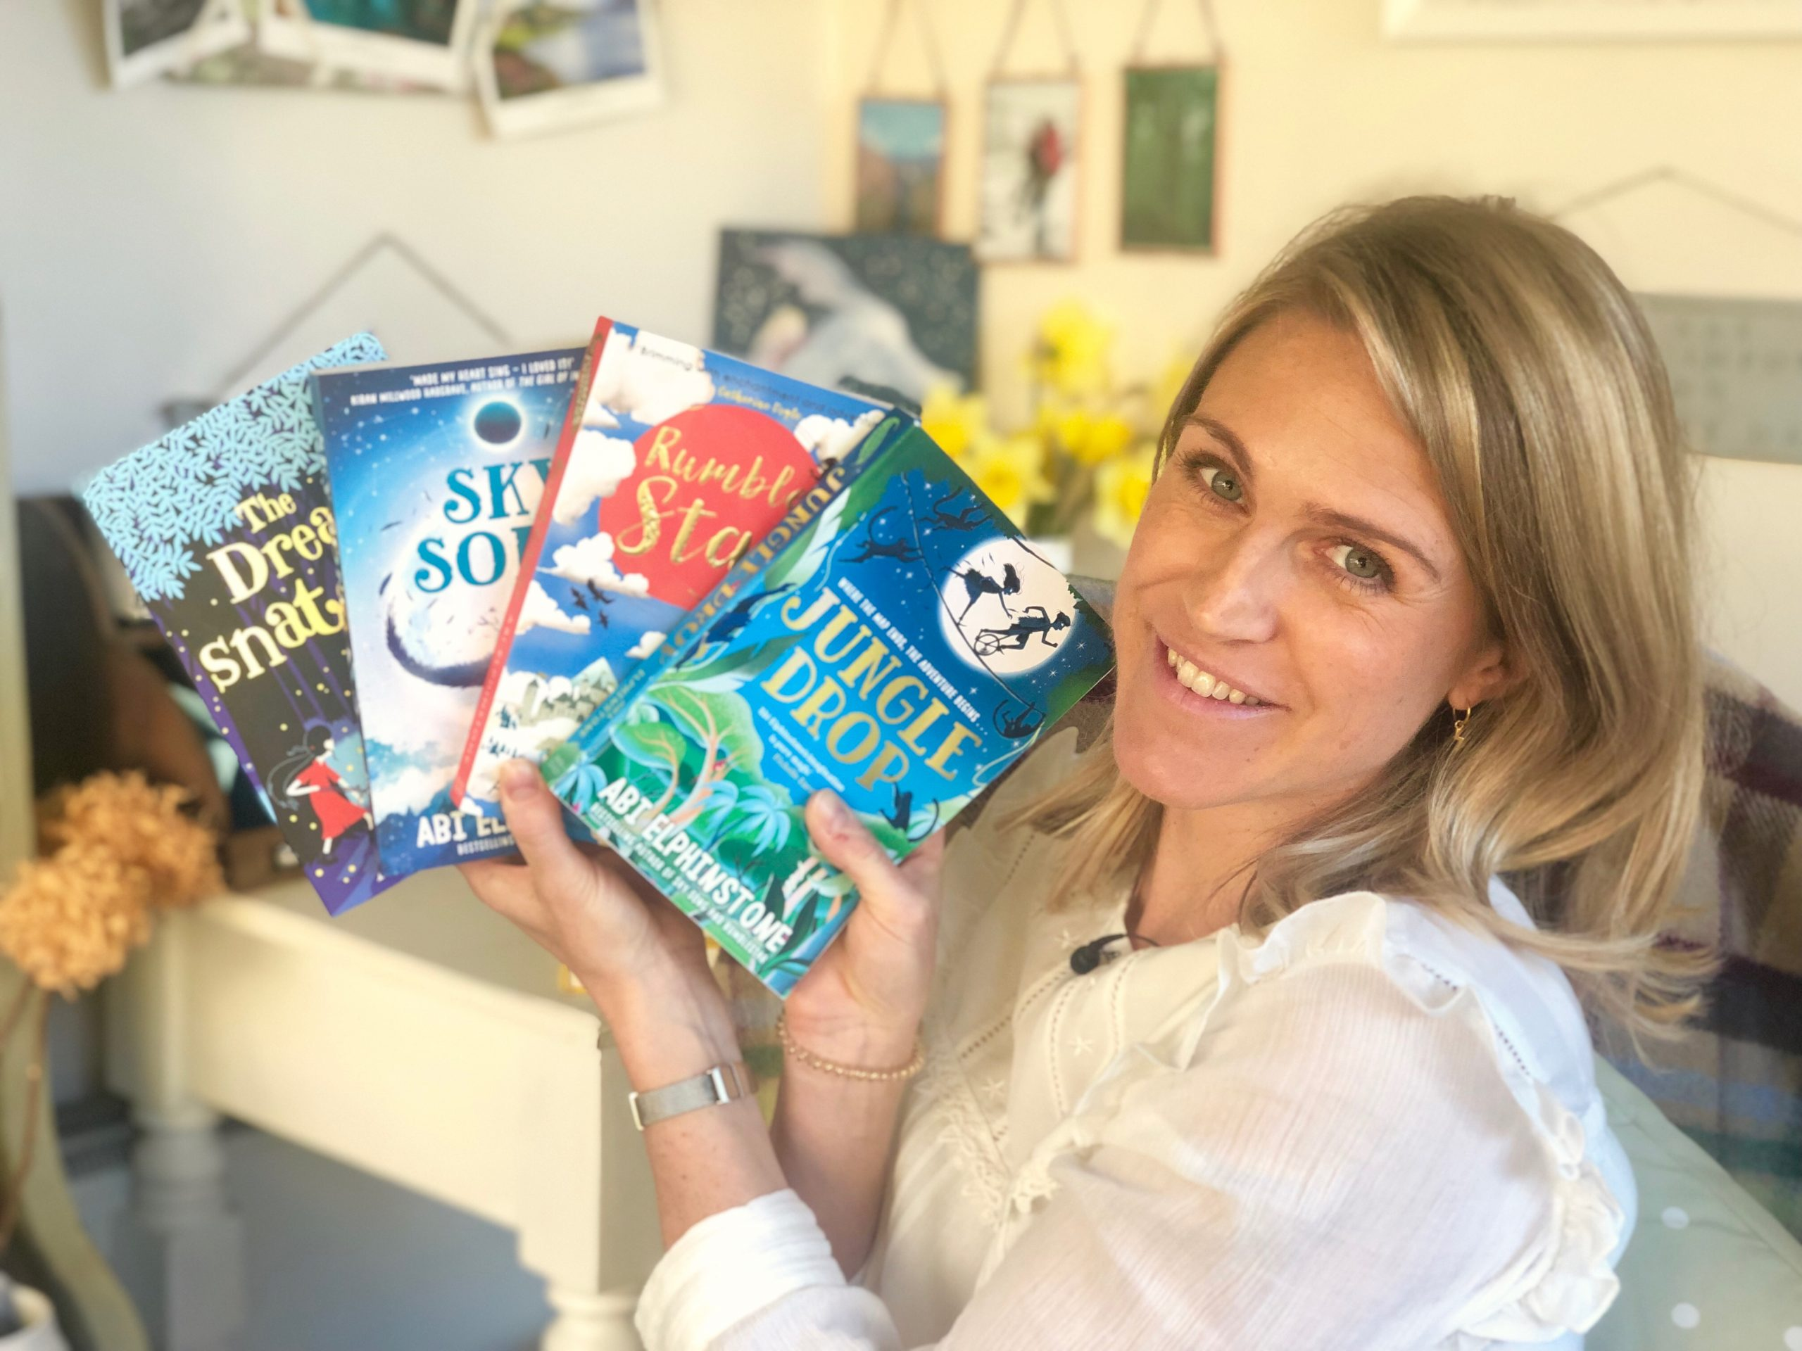
Simon Mugford Abi Elphinstone
Our children continue to enjoy the books written by our focus author’s for May and June by Simon Mugford and Abi Elphintone. Simon Mugford’s books are extremely poplular. Please see the links below to the Scottish Book Trust’s Recommneded montly books and Newly released books coming this June!
https://schoolreadinglist.co.uk/new-book-releases/books-of-the-month/
https://www.booktrust.org.uk/books-and-reading/our-recommendations/best-new-books/
We are also looking forward to launching our new E Book platform gifted to us by Browns through The Community Wish List- information will follow
soon!

 Staffing News
We are all delighted to welcome back Ms McDowall this month from her maternity leave. Ms McDowall will return to her teaching post full time in August.
Sadly, we will be saying goodbye to some of our teaching and support staff at the end of term. Miss Sim and Miss Elliot have both successfully completed their first year as newly qualifies primary teachers and are now applying for permanent teaching posts. We wish them lots of luck for their future career in education. Mrs Lannigan will be retiring after over 40 years of teaching service with South Lanarkshire Council and Mrs McDonagh has been a support assistant at High Blantyre Primary for over 18 years. They both have touched the lives of so many children and their families throughout their careers in education. We will all miss Mrs Lannigan and Mrs McDonagh very much and wish them both a very long, healthy and happy retirement.

Dates for your diary



Wednesday 5/6 Supported Classes
new P1 visit 10am
Thursday 6/6 Supported lasses
new P1 visit 10am
Thursday 6/6 Muiredge and Neilsland
Primary P5 Young Leaders of
Learning visit
Monday 10/6-14/6 Health Week
Monday 10/6 P6 Euro Quiz finals in Edinburgh
Monday 10/6 Supported Classes
new P1 visit 10am
Tuesday 11/6 Supported Classes
new P1 visit 10am
Tuesday 11/6 P6 Hockey Festival am
Tuesday 11/6 Sports Day
P1-3 11am P4-7 1.45pm
Thursday 13/6 Nursery Sports Day
Friday 14/6 Pupil Council Fun Run
Monday 17/6 Meet Your New Teacher
1.45-2.45pm
Wednesday 19/6 Parent Council Fun Day
Tuesday 18/6 P7 Blair Drummond Trip
Wednesday 19/6 P6/7 Happy Place workshop
Friday 21/6 Nursey Celebration 10am
Tuesday 25/6 P7 Leaver’s Assembly 10am
Tuesday 25/6 P7 Leaver’s Beach Party
6.30-8.30pm
Wednesday 26/6 School Closes at 1pm

School starts back for pupils on Wednesday the 14th of August 2024.

Please remember these dates are subject to change. We will always do our best to give as much notice as possible of any changes.

Celebrating Success

There has been lots more Sports achievements to celebrate over the past month.
Our boys and girls teams were fantastic at the Davie Cooper Tournament and were a credit to the school with regards to their behaviour and sportsmanship. Thank you to Susan Linder-Kelly, Stuart McIntosh and John McGovern for managing the teams on the day and also our large group of ‘Team High Blantyre’ parents, friends and family who came along to support our teams. Our boys were placed second in a strong group section and the girls were placed joint third following the semi finals.
Our school also participated in the Hamilton schools Track and Field event a few weeks ago. Our P7 boy’s relay team: Charlie, Marcus, Jeremiah and Cameron were placed second, Jerimiah was also placed 2nd in the 100m sprint and Marcus was third in the 600m. P6 pupil, Ava was 2nd in the 100m sprint. They will all attend the SLC finals at Carluke on Thursday the 13th of June. Well done everyone! George in P5 will also attend the finals for the 600m.
Finally, our netball team came a very well deserve third place in the Hamilton Schools Netball Festival.
We are very lucky to have so many opportunities for our children to represent our school through our extra curricular activity teams. If any parents/carers would like to help out with any of our teams/ clubs please get in touch.

+++++++++++++++++++++++++++++

 Baby News
Congratulations to Mrs McIsaac from Room 13 on the safe arrival of her beautiful new baby boy Gabrielle, born on , Mrs McIsaac and baby are both keeping well and big sister is very happy indeed!

