


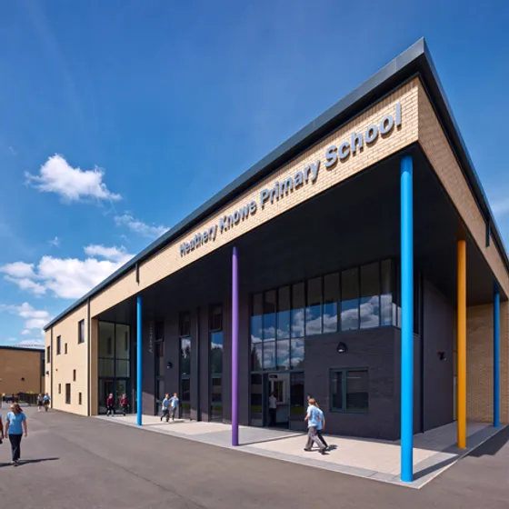



Heathery Knowe Primary School and Nursery
Handbook
January 2026

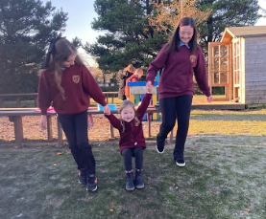
Heathery Knowe Primary School and Nursery
Whitehills Terrace
East Kilbride
G75 0NG
Phone: 01355 221042
Email:
office@heatheryknowe-pri.s-lanark.sch.uk
headteacher@heatheryknowe-pri.s-lanark.sch.uk
Website: https://blogs.glowscotland.org.uk/sl/heatheryknowehe/

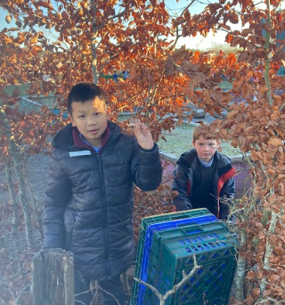

Contents

Welcome by the Head Teacher
Introduction
About our school and nursery
School Ethos
Staff List
Attendance
Parental Involvement/Parent Council
The curriculum
Assessment and Tracking
Reporting
Enrolment and Transitions
Support for Pupils
School Improvement
School policies and practical information
General Data Protection Regulation as supplemented by the Data Protection Act 2018 (GDPR)

If you need this information in another language or format, please contact us to discuss how we can best meet your needs.

Phone: 0303 123 1023
Email: education@southlanarkshire.gov.uk.

WELCOME BY THE HEAD TEACHER

Dear Parents, Carers, Families and Visitors,
I extend a warm welcome to Heathery Knowe Primary School and Nursery.
Throughout our school and nursery, we aim to provide children with a welcoming, caring, nurturing and inclusive environment. We recognise that relationships matter. Our staff team strives to provide a challenging and motivating learning environment, promoting positive attitudes, self-esteem and self-confidence in all of our children. Our ethos is built upon our vision:
Heathery Knowe is a place where love, learning and fun grow together to shape happy hearts, curious minds and responsible actions; when we are respectful, kind, resilient, included, trustworthy and safe.

We work hard to ensure that our children continue to progress, achieve and attain, equipped to become successful learners, responsible citizens, confident individuals and effective contributors.
Partnership with parents/carers and the wider community is an important feature of the learning and teaching process in Heathery Knowe. We aim to work with each family with impartiality, integrity, fairness, tolerance and mutual respect to meet the needs of learners and provide a rich and stimulating education for our young people.
We are proud of our school and nursery. If you have any questions or queries, or would like to visit us, please do not hesitate to contact me at school.

With kindest regards,

Clare Quinn
Head Teacher

Heathery Knowe is a place where love, learning and fun grow together to shape happy hearts, curious minds and responsible actions; when we are respectful, kind, resilient, included, trustworthy and safe.

INTRODUCTION
South Lanarkshire Council is the fifth largest authority in Scotland. It covers the following main areas; Clydesdale in the south which features extensive rural areas, Cambuslang, Rutherglen, Blantyre and Uddingston to the north as well as the towns of East Kilbride and Hamilton.
The Council’s Plan Connect sets out the Council’s vision which is, “to improve the lives and prospects for everyone in South Lanarkshire”.
For Education Resources this means delivering services of the highest quality as well as striving to narrow the gap. It is about continually improving the services for everyone at the same time as giving priority to children, young people, families, and communities in most need. The priorities for schools and services are set out in the Education Resources Plan which confirms the commitment to provide better learning opportunities and outcomes for children and young people.
This is available at Education Resources Plan 2025/26 Education and learning - South Lanarkshire Council

ABOUT OUR SCHOOL AND NURSERY


Heathery Knowe Primary School and Nursery
Whitehills Terrace
East Kilbride
G75 0NG
Phone: 01355 221042
Email: office@heatheryknowe-pri.s-lanark.sch.uk
Website: https://blogs.glowscotland.org.uk/sl/heatheryknowehe/
Instagram ?

Heathery Knowe is the neighbourhood school for the part of the Murray area south of the Murray Road extending from Kelvin Road to Owen Avenue / Lorimer Crescent and for Whitehills 1, 2, 3 and 8 areas. The school is non-denominational and caters for boys and girls from across the ages of 4.5 – 12 years old (Primary 1 – 7). We offer 1140 hours within our Nursery, accommodating approximately 40 children from 3 – 5 years old.

Current school roll: 255
Current nursery roll: 40
Heathery Knowe Primary is part of the Calderglen Learning Community.
We are one of nine mainstream primary schools associated with the local non-denominational secondary Calderglen High School (Murray, Mount Cameron, Blacklaw, Jackton, Long Calderwood, Halfmerke, Maxwellton and Hunter Primary). All the schools within the Calderglen Learning Community including Sanderson High, Greenburn School and Westmains have developed positive working relationships and are committed to ensuring a smooth transition from nursery to primary and primary to secondary education for all our pupils.
Communication
Parents are always welcome in Heathery Knowe and we believe good communication with parents and carers is of vital importance. We communicate in a variety of ways, including Parentsortal, ParentPay, Newsletters, email communication, letters, Instagram, phone calls, meetings, assemblies and our website. Parents Portal is our main source of communication, this is being used as a communication platform across South Lanarkshire Council.
Parents may wish to contact the school to discuss an aspect of their child’s learning or experience at school. Concerns will be addressed by the Senior Leadership Team, either by Ms Quinn, or Mrs French and should be directed to them in the first instance. Wherever possible, we will make contact with you on the same day to discuss any concerns, and keep you informed about any action we plan to take.
Should you have a concern or issue, would like more information about Heathery Knowe, or just want to share a good idea or give of your time, please do not hesitate to contact us in person, by phone, letter or e-mail office@heatheryknowe-pri.s-lanark.sch.uk
It is important that parents and carers inform the school of any change to the following:
- home telephone number
- mobile number
- work number
- emergency contact details

Visiting our School
We are happy to arrange a visit to our school for existing or prospective parents. During the visit, we will offer a tour of the school and nursery and answer any questions you may have. Please contact the school office to arrange a visit to Heathery Knowe.
Attendance at School
Every effort should be made to ensure that your child attends school during term time. Please contact the school as soon as possible if your child is unable to attend school.
SCHOOL ETHOS
Be safe
Be kind
Be ready to learn

These three rules encompass Heathery Knowe’s ethos and values. We promote positive relationships within the school and foster an ethos that encourages all pupils to respect themselves and others. Encouraging every child to meet their full potential is at the heart of everything we do at Heathery Knowe Primary School and Nursery and we aim to ensure that all our children are nurtured, safe, active, healthy, achieving, included, respected and responsible.
We foster a culture of kindness and respect at Heathery Knowe and recognise the value of teamwork and friendship. Our children are encouraged to be active partners in their learning and their views are listened to and respected. Our school and nursery vision is

Heathery Knowe is a place where love, learning and fun grow together to shape happy hearts, curious minds and responsible actions; when we are respectful, kind, resilient, included, trustworthy and safe.

We work hard to ensure that our children continue to progress, achieve and attain, equipped to become successful learners, responsible citizens, confident individuals and effective contributors.
Promoting Positive Relationships
At Heathery Knowe Primary and Nursery, we believe that a positive school ethos promotes learning. Promoting positive relationships is a key element in ensuring a happy and purposeful learning environment in our school.
Promoting positive relationships and understanding distressed behaviour:
- Has a positive influence on pupil and teacher morale, making school an interesting and enjoyable place.
- Influences pupils’ levels of attainment.
- Is part of the personal and social development of pupils.
- Is necessary for pupils’ safety and wellbeing.
- Is central to the organisation of school life.
The relationship between pupils and staff is based on mutual trust and respect. Good order and educational progress depend on pupils observing school rules not only in the classroom but also when moving within the school building and grounds, as well as when travelling to and from school.
At Heathery Knowe, we encourage all pupils to:
- Be Safe – always behaving in a way that keeps themselves and others safe.
- Be Kind – showing kindness across the school community.
- Be Ready – be ready to learn at all times.
Our Promoting Positive Relationships and Behaviour guidance is implemented by all school staff.

Class Charters
Individual teachers ensure children know the rules and routines in each classroom situation but essentially, children are asked to be considerate of all others within class, to treat them as they would wish to be treated and to take appropriate care of all classroom property and the property of others. Children are encouraged to work to the best of their ability and to be able to work both collaboratively and independently, as appropriate to their stage. Each class has created a Class Charter, identifying selected rights from the UNCRC and respectful actions that the class all strive to maintain to ensure that everyone’s rights are respected.
Nurture Principles
We are a “National Nurturing School”, and we ensure that kindness and respect is the golden thread that runs through everything we do. Our learners are fully aware of the United Nations Charter on the Rights of the Child (UNCRC) and that the rights of our learners are upheld. Our children are encouraged to understand that with those rights comes the responsibility to ensure that others’ rights are valued and respected too.
We have embedded the six Nurture Principles into life at Heathery Knowe:
- Children’s learning is understood developmentally.
- The classroom offers a safe base.
- The importance of nurture for the development of wellbeing.
- Language is a vital means of communication.
- All behaviour is communication.
- The importance of transition in children’s lives.

It is the responsibility of staff within the school to ensure that PTC members, parents and pupils are involved in the creation of a positive school ethos.
Equally, the school, whilst trying to promote positive behaviour, must support young people should incidents or bullying occur. Parents have a significant role to play in working with the school so that teachers, parents and pupils know what is expected of them in trying to change the behaviour and attitudes that contribute to bullying behaviour.
Our approach is to create an environment where better behaviour will encourage better learning. The school, along with the support of parents, can work together to create a learning environment which young people can enjoy and feel safe.
Incidents of bullying should be reported to the school immediately so that each alleged incident can be looked at. Together we can work towards creating a safer school for children and staff.
In addition, a guideline (Promoting Positive Relationships and Understanding Distressed Behaviour) has been produced to support all teaching and support staff and inform them of their roles and responsibilities in respect of dealing with the small number of children and young people who display distressed behaviour. Early identification is crucial so that intervention can be provided to support children and young people to help them address their issues and concerns. Staff training is provided to help develop the skills needed to respond to and manage challenging behaviour. A wide range of appropriate staff development opportunities has been developed for this purpose.
We are grateful that our parents help support us. We ask that you:
- Know, understand and support the guidelines your child is expected to follow.
- Draw a parallel between home and school.
- Ensure regular and punctual attendance.
- Support the school dress code.
- Celebrate your child’s achievements.
- Encourage your child’s increasing independence and responsibility.
- Communicate any concerns / problems to the school.

Everyone has a role to play in helping make Heathery Knowe a happy, productive place to be.
Role in the Community


The school is held in high regard in the neighbourhood, and as opportunities arise, the school joins in local events organised by South Lanarkshire Council and the Community Council. We make good use of the local sports grounds, local swimming pool and the East Kilbride Central Library. We have an excellent relationship with the staff and children of St. Louise Primary, and share experiences with them, such as our Christmas Carol Service, sustainable wreath swap, and some joint playtime experiences.
Fund raising events in aid of local and national charities are held each year. Close links have been formed with the wider community, e.g. Strathcona House, Calderglen Park, East Kilbride Library, and EK Foodbank. The school has also taken opportunities to make links with local businesses and other local educational establishments and South Lanarkshire College.
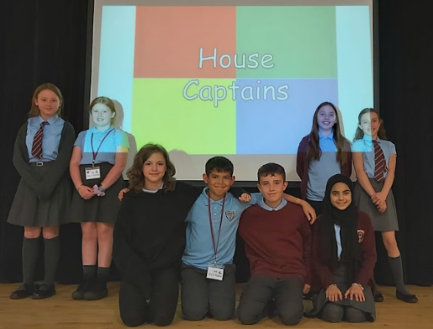
Heathery Knowe runs a “house system”, which allows each child to be part of a smaller team than the school as a whole. It motivates them and increases teamwork, leadership and responsibility within the school. Our House Captains play an important role in school life. House tokens are awarded for a variety of reasons where children are showing that they are modelling our school values.
Celebrating Success
We love celebrating success at Heathery Knowe! Our infamous HK Hugo Post runs on a Friday afternoon and certificates are distributed to children for lots of different reasons. At our weekly assemblies, we also celebrate the following:
- HK Hugo – awarded to the class who has demonstrated our school values.
- Golden Dustpan and Brush – awarded to the tidiest class.
- Golden Welly – awarded to someone who has demonstrated kind and safe outdoor play (perhaps showing creativity and skill development).
- HK Cup – awarded to somebody for going above and beyond, demonstrating values and standing out for all the right reasons.
We recently had a competition to design our new HK celebrating success postcards and children are enjoying receiving these in HK Hugo Post!

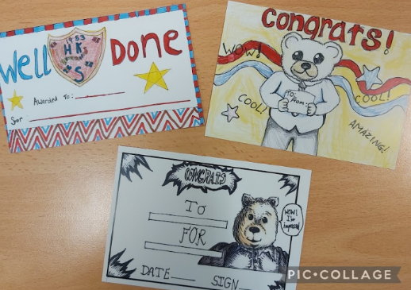

In Heathery Knowe, we believe that every child can achieve success in a wide variety of ways, and challenge every learner to explore the opportunities that will encourage them to fulfil the four capacities of the Curriculum for Excellence, to become Successful Learners, Effective Contributors, Responsible Citizens and Confident Individuals.
We celebrate success at our weekly assemblies, which showcase a wide range of skills and talents and demonstrate the achievement of skills across those four capacities.
Children experience equality of opportunity both at home and at school. Learning and teaching takes place in all kinds of ways, within school and outside of it and of course children develop views and attitudes from their own experiences and the examples they encounter on a daily basis.
We ask for parents’ co-operation to encourage children to develop attitudes to help them achieve their full potential unaffected by discrimination of any form.
We aim to encourage and motivate all pupils to be involved in all aspects of the curriculum and out of school activities. Teaching and learning through Health and Wellbeing encourages the development of positive attitudes and personal social skills.
Courses are built on the principles of equality, justice, mutual respect and focus on issues such as:
- keeping safe
- challenging stereotyped assumptions.
- raising self-esteem.
- fostering positive relationships.
- promoting cultural identity.
- acting independently and decision-making.
- taking responsibility for one’s actions.
- working with others.
- rights and responsibilities.
- leadership.

Diversity is celebrated through teaching and learning in Religious and Moral Education, and through assemblies and storytelling. We aim to foster tolerance in our children so that they will be caring individuals who will be able to take their place in a democratic society as responsible and caring citizens.


A variety of extra-curricular activities are offered to our children, including Library, Netball, Badminton, Hockey, Football, Chess, STEM, Web Club, Dance, Arts & Crafts and Into Film. We are always looking to extend the choice of activities for our children when the opportunity arises.
We are always on the lookout for parents, grandparents and members of the community to come along and share their skills and expertise. Please contact us at the school if you think you could help us out with lunchtime or after school activities.

Music Tuition
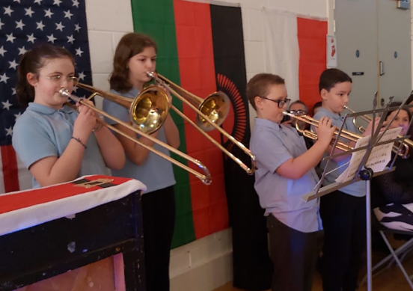
Instrumental music lessons are offered to children in a number of primary schools across South Lanarkshire Council through our Instrumental Music Service (IMS). In Heathery Knowe, we offer brass and woodwind tuition, from Primary 5 onwards.
Participation in a programme of instrumental music study can help children develop as successful learners, confident individuals, responsible citizens and effective contributors. Children who participate in instrumental music through tuition are often offered opportunities to further develop their playing by participating in extra-curricular activities through bands, orchestras and other ensembles.
Wider Contexts for Learning
Throughout the school year we take up every opportunity to involve our children in learning experiences out with the school boundaries and out with school hours and we are fortunate to be well supported by staff and parents when organising such events. These can be to museums and parks, or more routinely to East Kilbride library, or even walks around the local community. Our new school building provides a wide range of learning opportunities in its grounds too. We particularly love celebrating at special events with our school community.


Outdoor Residential Visits
Each year our Primary 7 children attend a residential break at Lockerbie Manor. The purpose of the residential week is to develop in our children cooperation, team spirit, self-esteem, self-confidence and self-awareness.

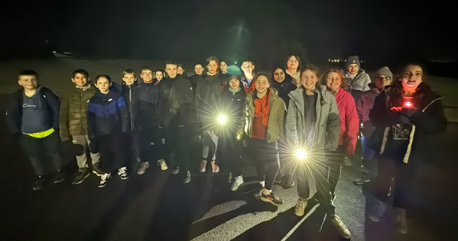

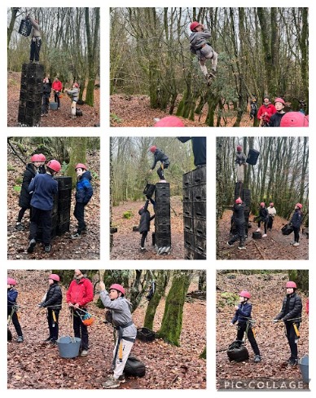
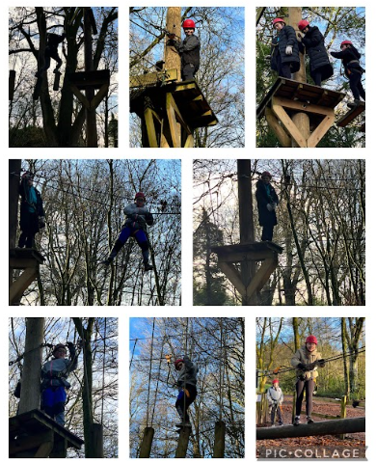

STAFF LIST
Senior Leadership Team
Head Teacher Ms Quinn
Depute Head Teacher Mrs Laura French
Principal Teacher Mrs Karen McGee
Class Teachers
P1 Mrs Rosemary MacOwan / Mrs Jennifer Hughes
P1 Mrs Amy Munn
P2 Miss Nicola Dickson
P3 Miss Deans
P3/4 Mrs Jacqueline Gray / Miss Grantham
P4/5 Miss Gillian Inglis
P5 Mrs Audrey Spence
P6 Mrs Louise Murphy
P6/7 Miss Kimberley Wharton
P7 Mrs Karen McGee
Additional Teachers Mr Marc Loveday

Early Years Team Leader Mrs Carine McPherson
Early Years Practitioners Miss Laura McGregor
Mrs Tracy Beaton
Mrs Lucy Perrett
Mrs Fiona Hutton

Early Years Support Worker Mrs Gina Liddell-Love

School Support Staff Mrs Carole-Anne Robertson (Team Leader: Tues – Fri)
Gemma Hughes (Office)
Mrs Gillian Baird
Mrs Miriam Gardiner
Mr Allen Gow
Mrs Teresa Neil
Mrs Dorothy Rankin
Mrs Debbie Summers
Janitorial Staff Mrs Lindsay ?

Visiting Staff
Specialist Support Teacher Miss Elaine Buchanan (School)
Mrs Julie Glavin (Early Years)
Educational Psychologist Mr Rick Walsh
Music Tutor Mr Stuart Pollock (Brass)
Mr Dean Garrity (Woodwind)
Active Schools Coordinator Mr Craig Allardice

ATTENDANCE

Encouraging School Attendance
We believe that regular school attendance is key to raising attainment and achievement. It’s a shared responsibility among parents/carers and the school to emphasise the importance of attending school.
For your convenience, school holiday dates and in-service dates can be found on the council’s website: www.southlanarkshire.gov.uk.

Every effort should be made to ensure that your child attends school during term time. Please contact the school as soon as possible if your child is unable to attend school.
It is important for the school to work with parents/carers in encouraging children to attend school. All absences are required by law to be recorded. Absences will normally fall under two categories – authorised or unauthorised absence. In cases where your child is unable to attend school, parents are asked to:
- Contact the school office if you know in advance of any reason why your child is likely to be absent from school (e.g. an appointment).
- Notify the school first thing in the morning if your child is going to be absent, let the school know the likely date of return and keep them informed if the date changes.
If you do not contact the school to notify us with a reason for your child's absence, staff will make contact with you if they haven’t heard about your child’s absence. This could be via text message or phone call. If you receive a text message, please contact the school office by phone or email.
If you know your child has a hospital/dental appointment, please let us know in advance.
Requests for your child to be absent from school to make an extended visit to relatives either in the UK or overseas must be made in writing to the head teacher, detailing the reason, destination and duration of absence and arrangements for their continuing education. On these occasions the pupil will be marked as an unauthorised absence.
Parents may request that their children be permitted to be absent in order to celebrate recognised religious events. Advance notice should be provided to the school when children will be absent. Appropriate requests will be granted, and the pupil noted as an authorised absentee in the register.
Family Holidays During Term Time
Family holidays taken during school term time will be recorded as unauthorised absences in line with Scottish Government and South Lanarkshire Council policy. The school is not required to provide work during this period, and parents are asked to avoid arranging holidays that disrupt their child’s learning.

Information on emergencies:
We make every effort to ensure the school remains open during term-time for pupils. However, on occasions circumstances may arise which can affect the school. Schools may be affected by, for example, severe weather, power failures or through any other circumstances that may impact on the school day. In such cases we shall do all we can to let you know as soon as possible. We shall keep in touch by the most appropriate method at the time normally through text message, and via our social media channels.
In cases of severe weather in the morning such as snow and a heavy frost and if there is a reason the school cannot open in the morning at the normal time, we will adopt the protocol for a delayed start until 10am.
If this is the case a message via social media and on the council’s website will be posted.
The Council’s website www.southlanarkshire.gov.uk will be used to let you know if the school is closed or has a delayed start. Further information will be provided later in the day as to whether the school will be open as normal the next day.
Things we need you to do:
- It is important for parents/carers to let the school know of any change to your mobile/home telephone number and change of address.
- If for any reason, you are unsure if the school is open visit the website www.southlanarkshire.gov.uk or email education@southlanarkshire.gov.uk
The school holiday dates, and in-service dates are available from the website www.southlanarkshire.gov.uk.

PARENTAL INVOLVEMENT / PARENT COUNCIL

Parental Involvement and Parent Councils

Parents and carers play a vital role in their child’s learning. Research shows that when families are involved, children do better at school and beyond. South Lanarkshire Council values parents as partners and works closely with schools to make this happen.

Why Parental Involvement Matters
- Strong partnerships help schools understand children’s needs and help parents feel informed and supported.
- Parents can reinforce learning at home, making schoolwork more meaningful and connected to everyday life
- Parental involvement can help children develop a love of learning and resilience when facing challenges
- When parents work with school and take an interest in learning, children often achieve more academically and feel more confident.

Our Commitment
We want parents and carers to:
- Feel welcome and involved in school life.
- Be well informed about their child’s learning.
- Have opportunities to support learning at home.
- Share views and take part in discussions about education.

Parent Forum and Parent Council
- Every parent with a child at school is part of the Parent Forum.
- Each school has a Parent Council, a formal group that represents parents’ views and works with the school to improve learning and experiences.

Connect – Supporting Parent Councils
All Parent Councils in South Lanarkshire are members of Connect, Scotland’s national organisation for parent groups. Connect offers:
- Free training and advice for Parent Councils.
- Resources and guides to help parents support learning.
- Insurance cover for Parent Council activities. Find out more at https://www.connect.scot.

Other Helpful Resources
- Parentzone Scotland – Practical advice and information about learning, additional support needs, and how to get involved: Parentzone Scotland | Education Scotland
- National Parent Forum of Scotland – Guidance and updates for parents: https://www.npfs.org.uk.

Getting Involved
Interested in joining the Parent Council or helping in school? Contact your school office or visit the Council website for details.

Heathery Knowe Parent Teacher Committee (PTC)
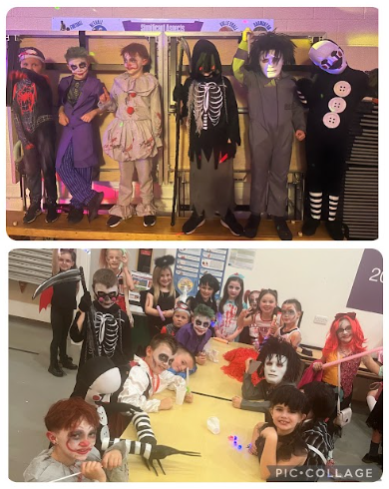
Every parent with a child at Heathery Knowe Primary School and Nursery is automatically a member of our parent forum. The Parent Council is a formal group, with a constitution, and acts as the Parent Voice of the school. Heathery Knowe has an active Parent Council, known as the PTC (Parent Teacher Committee), formed from the amalgamation of the PTA and the Parent Council, in 2009.
In Heathery Knowe, the PTC provides support to the school in a wide and varied range of areas such as supporting the Curriculum for Excellence, homework, improving communication with parents and other school improvement plan priorities. They also work very hard at raising much needed funds for the school and organising events and evenings for parents, children and families.
Meetings are held every other month, on the last Tuesday of the month, starting at 7pm. The Annual General Meeting is held in May. New committee members are elected each year in May. The Committee produces Newsletters each session to keep all parents/carers updated on the work being undertaken.

Please come along and lend us your whole-hearted support either by volunteering for the Committee or by attending meetings and helping at events.
Office Bearers
Chair Person Mrs Lisa Fraser
Vice Chair Person Mrs Denise Smith
Secretary Mrs Catherine Kennedy
Treasurer Mrs Lorna McCulloch

Get in touch
You can get in touch with the PTC at any time, either through their Facebook page (Heathery Knowe Primary PTC) or by emailing hkptc.secretary@gmail.com.
How can you help?
In any way you can! We openly welcome new members, although you might not be able to join us for the PTC meetings. If you can help at any of the PTC events or activities, your help (however much or little you are able to give) will be greatly appreciated. Here are some of the ways you could support the PTC:
- Volunteering to help at PTC events (e.g. Discos, Fayres, etc.).
- Helping with planning (either at PTC meetings or at other times).
- Sharing fundraising ideas.
- Help to source donations for raffle prizes throughout the year.
- Share a particular skill or talent.
- Perhaps you have some helpful contacts for when the PTC are organising events.
There are so many ways that you can get involved to help!
Parentzone Scotland?
Parentzone Scotland is a unique website for parents and carers in Scotland, from early years to beyond school. The website provides up-to-date information about learning in Scotland, and practical advice and ideas to support children’s learning at home in literacy, numeracy, health and wellbeing and science. Information is also available on Parentzone Scotland regarding additional support needs, how parents can get involved in their child’s school and education.
Parentzone Scotland also has details about schools, including performance data for school leavers from S4-S6 and links to the national, local authority and school level data on the achievement of Curriculum for Excellence levels.
Parent Helpers
Parents/Carers are encouraged to lend their support to school and can help in a variety of ways. In the past parents have worked alongside staff, supervising children in art/craft activities, ICT, paired reading, language and maths game, class trips, etc.
Parents or Carers who feel they would like to contribute in any way to the school should contact the Head Teacher, or a member of the school staff. Your help will be greatly appreciated by children and staff.
All parent helpers must be Disclosure Checked, known as PVG, as per South Lanarkshire Council Policy.
THE CURRICULUM

Curriculum for Excellence is the name given to the curriculum in Scotland for all children and young people aged 3-18. It is forward looking, coherent, flexible and an enriched curriculum that provides young people with opportunities to engage with the knowledge, skills and attributes they will need to flourish in life, learning and work.
The curriculum places learners at the heart of education and at its centre are four fundamental capacities - successful learners, confident individuals, responsible citizens, and effective contributors. It includes all of the experiences that are planned for children and young people to support the development of their skills, wherever they are being educated, for example in the family and community, pre-school centre, nursery, and school.
In taking this forward our school will work closely with South Lanarkshire Education Resources and other services to enrich the curriculum, to provide the best possible education for all children and young people. We wish you to feel confident that your child is encouraged and supported to develop their literacy, numeracy and other skills whilst they attend our school. The curricular areas are as follows:

- Expressive arts
- Languages and literacy
- Health and wellbeing
- Mathematics and numeracy
- Religious and moral education
- Science
- Social studies
- Technologies

If you want to know more about Curriculum for Excellence, please visit Scotland's Curriculum for Excellence (scotlandscurriculum.scot).
Our learning and teaching activities are based on the outcomes and experiences in the guidelines that all schools have for Curriculum for Excellence.
Level Stage
Early The pre-school years and Primary 1 or later for some.
First To the end of Primary 4, but earlier or later for some.
Second To the end of Primary 7, but earlier or later for some.
In Heathery Knowe Primary, we have been developing our curriculum based on the design principles of Curriculum for Excellence, to ensure that we plan activities that have breadth, depth, progression, coherence, challenge and enjoyment, personalisation and choice and relevance.
Every child is encouraged to explore their potential through a wide range of learning experiences - in the subject areas listed above, through interdisciplinary learning across subject areas through the wider ethos and life in the whole school, and through the recognition of personal achievements.
We aim to identify any barriers to learning and support children to overcome them.

Expressive Arts
By linking their learning experiences to their imagination, children learn to express themselves and appreciate the expression of others through art, music, dance and drama. These subjects are taught so that children can learn the necessary skills, develop an awareness of beauty and promote their individual talents. Often the work is based around a theme or as part of Interdisciplinary Learning, which utilizes a number of areas of the curriculum.

Languages and Literacy
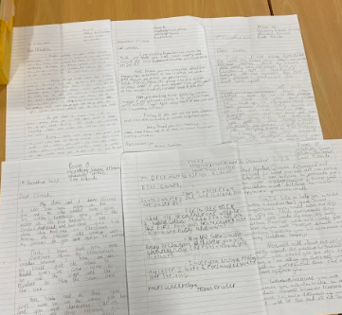
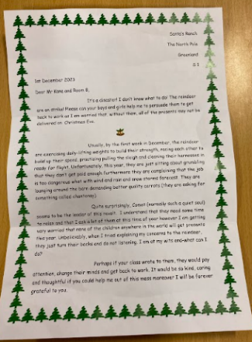
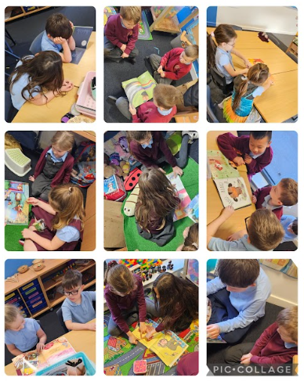
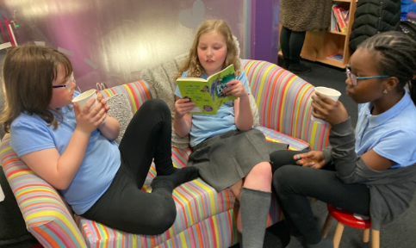
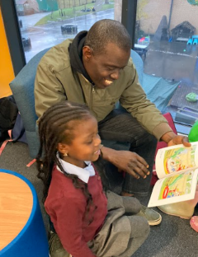
At Heathery Knowe Primary School and Nursery we place the acquisition and development of literacy skills at the heart of our practice. We recognise that the development of literacy is central to expressing emotions and developing a sense of personal identity as well as being of paramount importance in thinking and learning. Literacy is fundamental to accessing all areas of learning. Being literate increases opportunities for individuals in all aspects of life by laying the foundations for lifelong learning and work.
At Heathery Knowe Primary School and Nursery we strive to ensure that every child should become a competent and confident user of the English language: able to live, work and succeed in a literate world where they have the ability and skills to be all they can be. In the 21st Century, this means being able to communicate effectively, expressing ideas and opinions both orally and through various media. Children will develop the skills which will enable them to understand and make informed decisions by interpreting and analysing information using various critical literacy skills. They will have the skills, knowledge and understanding to be creative, self-reflective, solve problems, collaborate and build positive relationships.
All teachers read to the children each day to promote reading for enjoyment. Classes have an opportunity to visit the school library. Each class has its own library area which is maintained to a high standard. Within each class library there are a range of genres, levels of challenge and across a wide range of areas of interest. Across the school, children participate in ‘Reading with Hugo’ each day to provide a protected time to read for enjoyment. All stages follow North Lanarkshire Council Active Reading framework.
We enjoy hosting our Reading Café throughout the school year in our new fully refurbished school library, where families can come and enjoy a refreshment and some time to read together.
Health and Wellbeing
The purpose of the Health and Wellbeing curriculum is to develop the knowledge, understanding and skills, capabilities and attributes necessary for mental, emotional, social and physical wellbeing. It is the responsibility of every teacher to contribute to learning and development in this area.
Physical Education is included in this area of the curriculum. We teach all children the value of participation in a range of sporting and physical activities. We strive for excellence in sport and believe that competition is an important part of children’s learning and development. Each pupil is entitled to two hours of Physical Education per week.
Other areas of Health and Wellbeing include:
- planning for choices and change (career education)
- food and health
- substance misuse
- relationships, sexual health and parenthood

Promoting Alternative Thinking Strategies (PATHS)
At Heathery Knowe Primary School, we follow PATHS, a programme designed to facilitate the development of self-control, emotional awareness and interpersonal problem-solving skills. This forms a weekly Health and Wellbeing lesson from Primary 1-7.

Mathematics and Numeracy
At Heathery Knowe Primary School and Nursery we aim to teach mathematical concepts within familiar contexts and with deep understanding of the processes involved. Mathematics and Numeracy is the study of the properties, relationships and patterns in number and shape, and the application of this knowledge to analyse, interpret, simplify and solve problems. Mathematics is important in everyday life allowing us to make sense of the world around us. Children are encouraged to learn actively throughout the school to allow the children to explore, discover and learn in a ‘hands on’ manner. Pupils are also given the opportunity to solve problems using a range of strategies. A variety of resources are used to support learning and ensure progression and development of mathematical knowledge and numeracy.
The following approach to teaching Numeracy and Mathematics aims to:
- develop fluency of recall of number facts.
- develop a problem-solving approach to mathematics, recognising discussion as a key skill in developing reasoning, flexibility and justification of approach.
- develop conceptual understanding using a concrete – pictorial – abstract approach.
- promote positive mathematical mindsets in children and their families.

Developing fluency using ‘Big Maths’
Big Maths is a daily sequential programme of mental maths provision with a strong emphasis on learned facts and developing the mental agility to do something with these facts. It develops core skills in one clear method. All are taught in the same way, repeatedly, to embed these fundamental skills.
Big Maths highlights how small steps of progress with core numeracy follow on logically from one to the next. It is based upon the principle that there are 4 core skills that lie at the heart of numeracy. These core skills form the platform for virtually all other maths skills and are known as CLIC:
- Counting
- Learn Its
- It’s Nothing New
- Calculations
At Heathery Knowe Primary School:
- Big Maths is taught consistently across the school and children are familiar with the framework.
- Big Maths should be taught every day for 20 minutes from Primary 1-7.
- Every class should have a Big Maths display as part of the numeracy board.
- Every child should record their CLIC and Learn It score each week.

Religious and Moral Education
As a non-denominational school, we ensure that our RME programme does not promote one religion to the exclusion of other beliefs. We aim to give children knowledge of the basic tenets of religion, its place in our society and in the wider world.
Learning through religious and moral education enables children to:
- recognise religion as an important expression of human experience.
- learn about the beliefs, values, practices and traditions of Christianity and other world religions and viewpoints independent of religious belief.
- explore and develop knowledge and understanding of religions, recognising the place of Christianity in the Scottish context.
- investigate and understand the responses which religious and nonreligious views can offer to questions about the nature and meaning of life.
- recognise and understand religious diversity and the importance of religion in society.
- develop respect for others and an understanding of beliefs and practices which are different from their own.
- explore and establish values such as wisdom, justice, compassion and integrity and engage in the development of and reflection upon own moral values.
- develop their beliefs, attitudes, values and practices through reflection, discovery and critical evaluation.
- make a positive difference to the world by putting beliefs and values into action.

Spiritual, social, moral, and cultural values (religious observance)
In Heathery Knowe Primary School and Nursery, we emphasise the need for good manners and morals, mutual respect and tolerance at all times. Good social habits and attitudes are built into the curriculum to ensure every pupil is aware of the importance of being considerate and caring towards others.
A copy of our Religious Observance and Chaplaincy guidance for parents is available at the school office.

Rights of Parents / Carers
Scottish Government Ministers consider that religious observance complements religious education and is an important contribution to pupils’ development. It should also have a role in promoting the ethos of a school by bringing pupils together and creating a sense of community.
There is a statutory provision for parents to withdraw children from participation in religious observance. Any requests should be made in writing to the Head Teacher. This right of parents’ wishes will be respected.
Where a child is withdrawn from religious observance, we will make suitable arrangements for your child to participate in a worthwhile alternative activity.
Parents may request that their children be permitted to be absent in order to celebrate recognised religious events. Advance notice should be provided to the school when children will be absent. Appropriate requests will be granted, and the pupil noted as an authorised absentee in the register.

Science
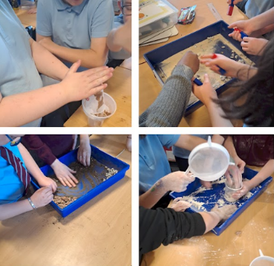
Science is taught through both specific lessons and appropriate links with other areas of the curriculum. Our Science programme provides children with many opportunities to develop their practical investigative skills.
Areas of Science covered in Heathery Knowe include…
- Planet Earth
- Forces, electricity and waves
- Biological systems
- Materials
- Topical Science
- STEM (Science, Technology, Engineering and Maths)

Social Studies
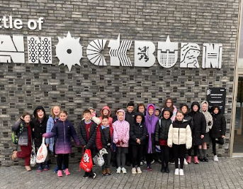
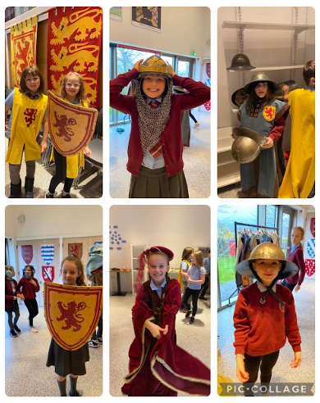
In Social Subjects the learning is based around themes, topics and projects which help develop skills and knowledge of people, past events and societies, people, place and environment and people in society, economy and business.
The children as they participate in the programme will:
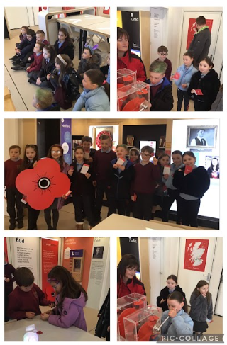
- develop their understanding of the history, heritage and culture of Scotland.
- broaden their understanding of the world by learning about human activities and achievements in the past and present.
- develop an understanding of the principles of democracy and citizenship.
- learn how to locate, explore and link periods, people and events in time and place.
- learn how to locate, explore and link features and places locally and further afield.
- engage in activities which encourage enterprising attitudes.
The local environment provides many areas for study. Our Social Studies topics and projects involve many links with other areas of the curriculum and visits in the local community and further afield. Much of our Social Studies learning is taught through interdisciplinary topics, where learning from different areas of the curriculum is integrated.
Technologies
We work hard to keep pace with new developments in technology so that our pupils will have the skills needed to succeed in modern society. We are lucky to have access to desktop computers, chrome books and iPads across the school. Information and Communication Technology (ICT) is used across the curriculum. Our network allows all pupils access to the internet and the security filter means that pupils can access only suitable material. All pupils / families are asked to sign an Internet Access Agreement. Other technology work is done in the context of themed projects or standalone units focusing on a particular aspect of design or uses of technology in society. All classrooms in the school have interactive LCD screens and we have wireless access throughout the building and parts of the outdoor learning area.
ASSESSMENT AND TRACKING

Teachers continually assess pupils’ work on a daily basis, using a variety of formative assessment strategies, integral to the learning and teaching. Group and individual teaching allows each child to work at his/her pace and level. Teachers use the range of assessment activities to record each child’s progress in relation to the outcomes for each curricular area and track their progress across each level of Curriculum for Excellence. Teachers then plan for learners’ continued progress in relation to the Curriculum for Excellence outcomes and matched to individual needs. A record of each child’s progress is kept and reported to parents. In addition to this, termly learning targets are shared with learners. These are broad statements which allow a dialogue about progress between learners, their parents and school. All class teachers engage in regular professional dialogue with regarding tracking and monitoring of pupils’ progress across the curriculum.
From time to time, each year group undertakes diagnostic tests in aspects of literacy and numeracy, to ensure progress and identify any additional support needs.
We aim to ensure each child is given the opportunity to achieve his/her full potential and our children are encouraged and guided to assess their own work and to become independent learners.
Parents are welcome to call at the school to discuss their child’s progress with the class teacher, or a member of the School Leadership Team, by arranging an appointment at the school office.
We want to share with you how your child’s learning is progressing. We do this through parent contact evenings, reports, telephone calls, emails and sometimes via Google Classroom updates.
Here are some more ways we share learning at Heathery Knowe…
Meet the Teacher booklets Newsletters
Open Days / Exit Point Events HK Post (certificates / postcards)
HK Cup Award Golden Welly Award
Celebration Week
Ongoing feedback in class work Parents’ Meetings / Phone Calls
Review Meetings (where appropriate) PTC Meetings
Reports Reading Café
OPAL Stay and Play
REPORTING

Heathery Knowe Primary School and Nursery recognise that good teamwork among parents/carers, children and school is the key to a successful education for your child. We will provide parents with reports so that you can see what your child is doing and how they are progressing. In addition, there will be parents’ meetings which offer you the opportunity to discuss how your child’s progressing and how you can contact the school if you wish further information. The school will offer you an appointment time so that you can visit in person to discuss your child’s education.
Our ‘learner reports’ will help you to get to know more about the curriculum which each child follows and will describe their strengths, achievements and areas for development so you know what encouragement and support you can give.
We welcome any comments or additional information from parents to help us provide the best possible education for your child.
We have Open Doors days throughout the school session, where parents are invited to come and see the “school at work”, and a sample of children’s work is sent home on a termly basis, to reflect the shared targets.

ENROLMENT AND TRANSITIONS
Enrolment – how to register your child for school
To register your child for school you should complete our online registration form. This can be done using the South Lanarkshire website:
www.southlanarkshire.gov.uk/info/200186/primary_school_information/392/enrolling_your_child_for_school
If you have any difficulty in identifying your catchment school, please email Edsuppserv.helpline@southlanarkshire.gov.uk.
The online registration form will ask you to provide each child’s full birth certificate and two pieces of recent official documentation both containing your permanent home address for example a utility bill, council tax statement, housing rent card, child benefit documentation.
Proof of where the child lives may also be needed.
If your child is due to start school in August 2026, you can enrol online from Monday 5 January 2026. Your catchment school will contact you between Monday 12 to Friday 16 January 2026 to confirm your enrolment.
If your child attends the nursery of your catchment school, please do not assume that they will automatically be transferred. You must register them as normal at the school that is in the catchment area for your home address.
If parents want their child to go to another school, they must enrol in the first instance with their catchment school and intimate that they wish to make a placing request. An online placing request form should then be completed. This is available from the SLC website – www.southlanarkshire.gov.uk or by contacting edsuppserv.helpline@southlanarkshire.gov.uk or phone 0303 123 1023.
Change of School/Placing Request
Normally children attend the school in their catchment area. However, there are times when parents may wish their children to go to other schools. If you wish your child to go to another school, then you may make what is known as a ‘placing request’. If you live in South Lanarkshire and decide to submit a ‘placing request’, we are unable to reserve a place in your catchment school until the Council have made a decision on the ‘placing request’. Please note if your ‘placing request’ application is unsuccessful and all places at your catchment school are filled you will be offered a place at the next nearest appropriate South Lanarkshire School.
Please note that if an application for a ‘placing request’ is successful then school transport is not provided.
If you move out with your catchment primary school a ‘request to remain form’ must be completed. If you move out with your catchment primary, this may affect your right to transfer to the associated Secondary School. Please note the secondary school is determined by the pupil’s permanent home address and chosen denomination. If you require further information, please contact Education Support Services on edsuppserv.helpline@southlanarkshire.gov.uk or 0303 123 1023.
Transition from primary to secondary school
A Learning Community is made up of local education establishments including a secondary school, the local primary schools, early years establishments, early years partners and bases which provide specialist additional learning services. Establishments work together to plan better outcomes for children and young people. The Learning Community develops ways of working between establishments and with other agencies and organisations to ensure services are responsive, accessible and are delivered as effectively as possible. All the establishments and services in a Learning Community share priorities for improvement and are involved in the deployment of additional support to meet the needs of the child and family.
Heathery Knowe Primary School and Nursery is part of the Calderglen Learning Community. Every effort is made to make this transition as smooth as possible for the pupils with increasing liaison between Primary 7 and S1, both formal and informal.
Pupils normally transfer from primary to secondary school between the ages of 11½ and 12½, so that they will have the opportunity to complete at least 4 years of secondary education. Arrangements are made by the school to transfer children to the associated secondary school as determined by their home address. Parents of P7 children will be informed of the transfer arrangements made for their child to attend secondary school.
We will also provide you with information at this time on events designed to support P7 children before they move on to secondary school.
SUPPORT FOR PUPILS

Getting it right for every child
Getting it right for every child (GIRFEC) supports families by making sure children and young people can receive the right help, at the right time, from the right people. The aim is to help them to grow up feeling loved, safe, and respected so that they can realise their full potential.
Most children and young people get all the help and support they need from their parent(s), wider family, and community but sometimes, perhaps unexpectedly, they may need a bit of extra help. GIRFEC is a way for families to work in partnership with people who can support them, such as teachers.
If you have any concerns about your child’s wellbeing, you can speak to the named person who will work with you to provide support and decide how to move forward. Your school will let you know who this is. It is likely to be the Head Teacher in a primary school and a principal teacher (pupil support) in Secondary.
More information can be found on: www.scotland.gov.uk/gettingitright
Support for All (Additional Support Needs)
A very wide range of factors may lead to children and young people having a need for additional support. These factors fall broadly into four overlapping themes:
- learning environment.
- family circumstances.
- disability or health need.
- social and emotional factors.
Continuous assessment allows teachers to monitor each child’s progress.
Heathery Knowe Primary School supports children with additional support learning needs, through a team approach. The most effective support is provided directly in class by the class teacher and with the support of our school support assistants.
Should any difficulties be diagnosed by ongoing assessments and observations, class teachers consult with Senior Leadership Team, the Additional Support Needs Specialist Teacher, Miss Buchanan (P1-7) or Miss Glavin (Early Years), and, sometimes, the Educational Psychologist, Mr Walsh, to develop appropriate intervention and support strategies. These strategies are discussed with parents. Additional Support Plans or Coordinated Support Plans will be developed as and when appropriate.
Each pupil’s progress is constantly monitored and recorded by class teachers and regularly reviewed. Parents are invited to attend review meetings. Records are kept of all meetings and interventions planned.
Partner agencies are welcomed to support the range of additional support needs in school, for example, Physiotherapists, Occupational Therapists, Speech Therapists and other professionals, as appropriate.
South Lanarkshire Education Resources have published a series of leaflets available which cover information for parents and carers about the Additional Support for Learning Acts. These are available through the school or on the South Lanarkshire Council website www.southlanarkshire.gov.uk.
Enquire
Enquire is funded by the Scottish Government to provide information on the framework for supporting children who require additional support for learning and to encourage positive partnerships between families, schools, and local authorities to ensure children get the right support.
Enquire – the Scottish advice service for additional support for learning
Enquire offers independent, confidential advice and information on additional support for learning through:
Phone Helpline: 0345 123 2303
Address: Enquire
Children in Scotland
Rosebery House
9 Haymarket Terrace
Edinburgh
EH12 5EZ
Email Enquiry service: info@enquire.org.uk
Advice and information is also available at www.enquire.org.uk
Enquire provides a range of clear and easy-to-read guides and fact sheets including the parents’ guide to additional support for learning.
If you would like to order our leaflets, postcards or guides to share with parents and carers of pupils in your school, please contact us on info@enquire.org.uk
Attachment Strategy for Education Resources
Attachment – what we do to support children and young people
South Lanarkshire Council Education Resources is committed to improving outcomes for children and young people by creating emotionally supportive learning experiences in our nurseries and schools.
The Education Resources Attachment Strategy supports the action in the ‘Getting it Right for Every Child in South Lanarkshire’s Children Services Plan 2021-23’, following the launch of the Attachment Strategy in 2020, to provide staff training in Attachment and Trauma based practice.
What does it set out to do?
The aim of the strategy is to promote better experiences of attachment for South Lanarkshire’s children and young people and to ensure that all education practitioners understand the importance of attachment theory and its application and how positive relationships can make a difference to outcomes.
How can I find out more?
South Lanarkshire Council Education Resources have published a series of leaflets and posters for establishments and for parents/carers which aim to share information on attachment theory and on how this informs the ways in which we support children and young people.
These are available in schools and on the SLC Staff Learning Centre Sway accessible by teachers and staff.

Promoting Positive Relationships and Understanding Distressed Behaviour (PPRUDB)

PPRUDB is South Lanarkshire’s framework for understanding and managing behaviour in schools. It emphasises that all behaviour is a form of communication, often indicating unmet needs, and stresses the importance of building positive relationships as a fundamental skill for teachers and a preventive approach to distressed behaviour. The guidance aligns with key Scottish Government policies and legislation and supports the development of safe, inclusive, and nurturing school environments.

Children and young people who feel safe, healthy, respected, and included are more likely to develop self-confidence and resilience. South Lanarkshire Council’s attachment-informed, trauma-sensitive approach, aims to create a secure base and safe haven to reduce the impact of adverse childhood experiences. School staff recognise that distressed behaviour can stem from disrupted attachment, anxiety, and other complex needs, including neurodevelopmental conditions and limited communication skills.

When incidents of distressed behaviour arise in schools, staff will use a range of strategies to de-escalate situations and prevent re-occurrence. Strategies include structuring the environment with consistent routines and quiet areas, adapting communication to accommodate speech and sensory needs, and building positive relationships based on shared values. Setting clear limits with dignity, active listening, and inclusive teaching practices support behaviour management. Planning for transitions and using support plans like Additional Support Plans (ASPs) and Behaviour Assessment and Support Plans (BASPs) assist in addressing individual needs.

Each educational establishment should use the PPRUDB framework to develop and implement a relationships and behaviour policy through consultation with staff, pupils, and parents, reviewing it every three years.
Further information is available from the Headteacher of the establishment your child attends.

SCHOOL IMPROVEMENT
Every school session, the School Improvement Plan is published which outlines our main development priorities for the year ahead. This is as a result of a range of evaluation activities designed to find out how well we are doing. Ongoing activities, such as evaluations of events, comments at parents’ meetings and on samples of work sent home are examples of how we can measure our success and identify improvements that could be made. Each school session we seek to engage parents, children, staff and partners in a range of self-evaluation activities (such as questionnaires to parents, or input at PTC meetings). These help us to evaluate our performance and plan how we can best improve what we do. From last year’s self-evaluation we have a number of key priorities that are set out in the School Improvement Plan for session 2025 to 2026. A copy of this is below.
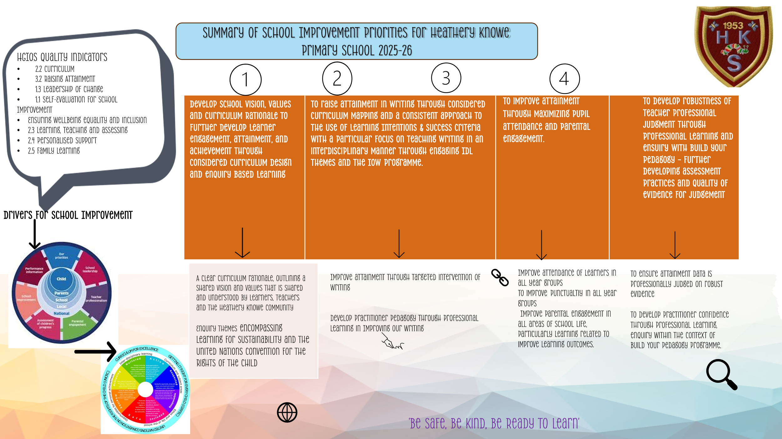

The Standards and Quality report is published annually on the website and highlights the school’s achievements over the last 12 months and identified areas for improvement.

Please copy and paste this link to view our 2024-2025 Standards and Quality report.
https://sway.cloud.microsoft/2KMx4iKHqeS5m43q?ref=Link

SCHOOL POLICIES AND PRACTICAL INFORMATION

Nursery Meals
All children (over two years old) attending a local authority nursery will be provided with a free lunch.
Nursery lunches and snacks are based on nutritional requirements from the NHS “Setting the Table” guidance.
Nursery age children will also receive milk and a healthy snack free of charge under the Milk and Healthy Snack scheme 2021. This will be provided by the establishment.
Primary pupils
Primary pupils
Healthy eating is something that the school supports, and a range of meals are available at lunchtime that meet the Nutritional Requirements for Food and Drink in Schools (Scotland) Regulations 2020
All primary schools run a Breakfast service from 8.15am to 8.45am with pupils being offered a selection of toast, cereal or fruit along with a cup of milk.
For their lunch each day pupils have the option to choose from two hot meal options (one being vegetarian option) plus a sandwich selection everyday.
All meals also come with fresh chilled drinking water, vegetable choice, salad selection, seasonal fruit and depending on the day - soup or a dessert.
Milk will be available for those pupils entitled to free school meals through the free school meal eligibility scheme at morning break or lunchtime.
Pupils in:
Primary 1 - 5 receive a free school lunch.
Primary 6 - 7 meal cost is £2.62

School lunches and milk can be paid for through your Parentpay account or Paypoint facilities in local shops.

NB School Meal prices are reviewed annually and may be subject to change

School lunches and milk can be paid for through your Parentpay account or Paypoint facilities in local shops.
Please note that School Meal prices are reviewed annually and may be subject to change.
Adapted diets
If your child within Heathery Knowe Primary School or Nursery requires an adapted diet for medical reasons please speak to the school/nursery office who will provide the request form for you to complete. In addition, if you have a halal or vegan diet request for your child, please speak to the school office who will provide you with a request form.
Free School Meals
Children of parents who receive the following benefits are entitled to a free lunchtime meal for their child:
- Income Support
- Income-based Job Seeker's Allowance
- Income-based Employment and Support Allowance
- Scottish Child Payment (P6 and P7 pupils)
- Support under Part VI of the Immigration and Asylum Act 1999
- Universal Credit (and your earned income is less than £850 as assessed by the Department for Work and Pensions in the assessment period immediately preceding the application for free school meals)

If you are in receipt of Housing Benefit and/or Council Tax Reduction from us there is no need for you to apply online, we will use the information we hold to automatically award free school meals (P6 to S6) and/or school clothing grants (P1 to S6) to eligible families.
We would encourage parents of children who are in receipt of any of the above benefits to take up this opportunity of having a meal provided for their child when they are at school. Arrangements are in place so that children who receive free meals are not singled out and we encourage all children to remain in school at lunch time.

Further information can be found at Free school meals - South Lanarkshire Council or by
accessing the QR below -


At Heathery Knowe Primary School, children in Primary 1-7 can attend Breakfast Club from 8:15am-8:45am each school day. There is no cost.
School uniform
We ask all parents/carers to support the school by encouraging your child(ren) to adhere to the agreed dress code and the wearing of our school uniform. The wearing of a school uniform helps promote the identity of the school in the local community and helps create an ethos of sharing and pride in the school.
In addition, the wearing of a uniform helps towards increasing the protection of all pupils. The wearing of a uniform helps staff and the pupils to distinguish between who belongs to the school and those who may be visitors. This enables staff to approach and identify visitors more readily and helps in trying to offer a safer environment for pupils and teachers alike.
Equality of opportunity is an important aspect of the life of the school. Any proposals on the dress code and on what constitutes the school uniform will be the subject of discussion with the Parent Council and, where appropriate, consultation with parents, pupils and staff.
Our uniform consists of:
Blazer | Maroon | Sweatshirts | Maroon / Grey
Shirt | Blue | Skirt | Grey
Trousers | Grey | Tie | Maroon with stripes
Polo shirts | Pale blue | Fleeces | Maroon
Jogging trousers | Grey
The badge, which features on our uniform, was designed by a Primary 7 pupil and voted for by the children.
Some uniform items can be purchased at the school office. Uniform items can also be ordered directly from Schoolwear Made Easy at:
http://www.border-embroideries.co.uk
and click on the schools online ordering tab at the bottom of the page.
A range of our uniform can also be ordered from Supermarkets.
There are forms of dress which are unacceptable in all schools such as:
- the wearing of football colours
- clothing with slogans that may cause offence (anti-religious, symbolism or political slogans)
- clothing which advertises alcohol, tobacco, or drugs
- clothing which can be deemed unsuitable in terms of health and safety grounds such as shell suits, combat style clothing, dangling earrings, loose fitting clothes particularly in practical classes.
- articles of clothing that could be deemed to inflict damage on other pupils or be used by others to do so.
- footwear that may damage flooring.

Allergies
A significant number of children and young people in our schools will have allergies and it is important that parents keep the school fully informed on these matters.
Allergies can present in a variety of ways and can occur at any point in a person’s life. Symptoms range from mild to severe. Children and young people known to have an allergy with moderate to severe symptoms will likely have a Health Care Plan drawn up by the NHS. This will detail symptoms and appropriate interventions.
It is vital that parents share this information with the school and continue to provide any updated information.
Where symptoms are mild and a Health Care Plan is not in place, parents should still continue to liaise regularly with the school on any new triggers, medications and actions required.
In all cases, our employees need to know your child’s symptoms, treatments and any actions required to help prevent exposure to the allergen and minimise the risk of allergic reactions.
Employees in schools will receive training on allergies and will liaise with parents and NHS on any additional specialist training required.
In supporting children and young people with allergies, school employees will operate in accordance with South Lanarkshire Council’s Safe Systems of Work / risk assessment and national guidance on the administration of medicines.
Mobile Device Policy
Our school follows South Lanarkshire Council guidance on mobile device use, which is rooted in Scottish Government policy. Mobile technology can support learning and communication, but it can also disrupt lessons and affect wellbeing if misused. To maintain a safe, respectful, and inclusive learning environment, pupils are expected to use mobile devices responsibly and in line with school rules.
Devices should not be used during class unless specifically permitted for learning purposes.
The policy has been developed in consultation with pupils, parents, and staff to balance the benefits of technology with the need to minimise distractions and protect privacy. We ask parents to support this approach by reinforcing responsible use at home and ensuring that devices are used appropriately.

Support for parent/carers
Clothing grant
In certain circumstances the Council provides support to parents/carers for the purchase of school wear. This also now includes nursery children aged 3 and 4 years old.
Eligibility criteria and online applications can be found at
www.southlanarkshire.gov.uk.
Or via this link
Clothing grants - South Lanarkshire Council

Applications can be made online at www.southlanarkshire.gov.uk. Should you require further information, or you are unable to submit an application online then please contact the helpline number 0303 123 1011 (option 5).
School hours/holiday dates:
School Day
9:00am-3:05pm
School starts 9:00am
Break 10:30-10:45am
Lunch 12:30-1:20pm
Home time 3:05pm
Nursery Day
8:45am-2:45pm
Nursery lunch 11:30am
School Holidays (2025 / 2026)

School holidays

School holidays 2025/26 (approved)
These school holiday and in-service dates were approved by the Education Resources Committee on Tuesday 29 October 2024.

August 2025
- Tuesday 12 August - teachers return
- Tuesday 12 and Wednesday 13 August - in-service days (all schools)
- Thursday 14 August - pupils return to school

September 2025
- Friday 26 September and Monday 29 September (September weekend holiday)

October 2025
- Monday 13 to Friday 17 October (October break)

November 2025
- Monday 10 November (in-service day)

December 2025 and January 2026
- Friday 19 December (schools close at 2.30pm)
- Monday 22 December to Friday 2 January 2026 (Christmas/New Year break)
- Monday 5 January 2026 - pupils return to school

February 2026
- Monday 16 and Tuesday 17 February (February break)
- Wednesday 18 February (in-service day)

April 2026
- Thursday 2 April* (schools close at 2.30pm)
- Friday 3 April to Friday 17 April (Easter/Spring break)
- Monday 20 April - pupils return to school

May 2026
- Monday 4 May (May day)
- Thursday 7 May** (in-service day - all schools)
- Friday 22 May and Monday 25 May*** (Local holiday)

June 2026
- Thursday 25 June (schools close at 1pm for summer break)
*Good Friday falls on Friday 3 April 2026
**In-service day proposed to coincide with Scottish Parliamentary Election. Subject to change.
***Lanark schools will close on Thursday 11 and Friday 12 June 2026
Pupils attend school for 190 days and teachers attend for 195 days.

School holiday dates and in-service dates are available from the website www.southlanarkshire.gov.uk.
School transport
South Lanarkshire Council has a policy of providing school transport to primary pupils who live more than one mile by the recognised shortest walking route from their catchment school. This policy is more generous than the law requires. This means that the provision of transport could be reviewed at any time. Parents who consider they are eligible should complete a form online www.southlanarkshire.gov.uk or contact 0303 123 1023. These forms should be completed and returned before the end of March for those pupils starting the school in August to enable the appropriate arrangements to be made. Applications may be submitted at any time throughout the year and will be considered by Education Resources.
A privilege transport scheme is operated for mainstream school contracts where a pupil is not entitled to school transport. Privilege transport will only be granted providing there is spare capacity on an existing school contract and will be from and to designated pick up and drop off points. Privilege transport will not be provided where a service bus is used on the school run. Any spare capacity will be allocated using agreed priorities. More information on school transport is available www.southlanarkshire.gov.uk/info/200188/secondary_school_information/545/school_transport or phone 0303 123 1023.
Pick-up points
Where school transport is provided it may be necessary for pupils to walk a certain distance to the vehicle pick-up point. Walking distance in total, including the distance from home to the pick-up point and from the drop-off point to the school in any one direction, will not exceed the authority’s distance limit for school transport.
It should be noted that it is the parent’s responsibility to ensure their child behaves in a safe and acceptable manner while travelling in, and alighting from, the vehicle. Misbehaviour can result in your child losing the right to school transport.
Parents are asked to note that South Lanarkshire Council does not provide transport for those pupils who attend school via a placing request.
Any other information on transport appropriate to the school should be mentioned.
Insurance for schools – pupils’ personal effects
South Lanarkshire Council is concerned at the level of claims being received for loss or damage to pupils’ clothing or personal effects. Parents are asked to note the Council’s position in terms of insurance for pupils’ personal effects:
Insurance for Pupils’ Personal Belongings

Personal Items
- The Council cannot accept responsibility for the loss or theft of personal belongings, including mobile phones, tablets, or other valuables. These are brought to school at the pupil’s and parents’ own risk.
- To reduce the chance of loss, please avoid sending expensive or unnecessary items to school.
- School staff are not permitted to look after pupils’ personal belongings.
- This policy also applies to musical instruments and equipment used for school activities. If these items are left at school, it is at the pupil’s and parents’ own risk.
- For valuable items such as musical instruments, parents should make sure they are covered by their own household insurance.

Clothing
- The Council will only consider claims for damage to pupils’ clothing if the damage was caused by negligence on the part of the Council or its employees.
Claims for any other reason cannot be accepted by the Council’s

Promoting positive behaviour
It is the responsibility of staff within the school to ensure that parent council members, parents and pupils are involved in the creation of a positive school ethos that encourages good behaviour. Equally, the school whilst trying to promote positive behaviour must support young people should incidents or bullying occur. Parents have a significant role to play in working with the school so that teachers, parents, and pupils know what is expected of them in trying to change the behaviour and attitudes that contribute to bullying behaviour.
Our approach is to create an environment where better behaviour will encourage better learning. The school, along with the support of parents, can work together to create a learning environment which young people can enjoy and feel safe.
Incidents of bullying should be reported to the school immediately so that each alleged incident can be looked at. Together we can work towards creating a safer school for children and staff.
In addition, a guideline (Promoting Positive Relationships and Behaviour) has been produced to support all teaching and support staff and inform them of their roles and responsibilities in respect of dealing with the small number of children and young people who display challenging behaviour. Early identification is crucial so that intervention can be provided to support children and young people to help them address their issues and concerns. Staff training is provided to help develop the skills needed to respond to and manage challenging behaviour. A wide range of appropriate staff development opportunities has been developed for this purpose.
Child Protection
All staff in educational establishments in South Lanarkshire Council receive an annual Child Protection update and are required to follow the advice and guidance contained within relevant Education Operating Procedures. They must also complete a mandatory Learn on Line Course “Child Protection in Education”.
South Lanarkshire’s children’s services partnership works together to support children, young people, and their families so that children grow up in communities where they are safe, healthy, active, achieving, respected, responsible and included, and have the opportunity to achieve their full potential. They are committed to continuously improve our services to ensure children, young people and their families get the right support at the right time.
Sometimes children and young people need additional help to make sure that they are “cared for and protected from abuse and harm in a safe environment in which their rights are respected” (CPC South Lanarkshire Child Protection shared vision). The Child Protection Committee has the overarching responsibility to ensure that agencies individually and collectively work to protect children and young people as effectively as possible.
All staff have a responsibility to report any suspicions that a child has been abused or is at risk of harm, abuse, or neglect. Robust procedures and guidance are in place to support education staff to:
- be alert to signs that a child may be experiencing risks to their wellbeing,
- report concerns to the head of establishment or the child protection coordinator without delay.
- be actively engaged in support and protection and development of wellbeing.
If you would like more information, or have a concern of a child protection nature, please contact the head of the educational establishment which your child attends.
The Child Protection Committee’s website has a range of useful information for parents/carers to help them keep their children safe. www.childprotectionsouthlanarkshire.org.uk.

Our Commitment to Children’s Rights
In line with the United Nations Convention on the Rights of the Child (UNCRC), our school is committed to respecting and promoting every child’s rights. We believe that children have the right to express their views on matters that affect them, and we will actively listen and take these views into account when making decisions.
To achieve this, we will:
- Create opportunities for pupils to share their opinions through class discussions, pupil councils, and consultation activities.
- Ensure that decisions about school policies and practices consider the voice of the child.
- Promote an inclusive, rights-respecting environment where every child feels valued and heard.
This approach supports our aim to empower learners, strengthen partnerships with families, and uphold equality and participation for all.

GENERAL DATA PROTECTION REGULATION AS SUPPLEMENTED BY THE DATA PROTECTION
ACT 2018 (GDPR)

Information on pupils, parents and guardians is held by the school to enable the teaching, registration, and assessment of pupils as well as associated administrative duties. The information is stored and used as per the requirements of the GDPR, with South Lanarkshire Council defined as the data controller. The Council have established a data protection policy that applies to all of its school.
Education Resources has also prepared a privacy notice (below) which sets out how we will deal with personal information as part of our statutory function as an education authority. For more information, please contact the school.
Privacy Notice
Introduction
In line with the General Data Protection Regulation (GDPR) we have produced this privacy notice to inform you how we deal with personal information as part of our statutory function as an education authority.
The Council has a legal obligation to deliver effective education services to children, young people, and adult learners in South Lanarkshire. In order to do this, we need to collect personal information about children, young people, and their families so that we can help them to learn and keep them safe.
Using your personal information
The Council is a “controller” of the personal information you provide when enrolling for a nursery or school, applying for an education service, or participating in groups or activities provided by Education Resources.
Information we collect from you about you and your child at enrolment.
When you enrol for a nursery or school, we ask for the following information:
- parent/carer contact details (name, address, phone, email).
- the child’s name, date of birth, gender, and address.
- information about medical conditions, additional support needs, religion, and ethnicity.
- any information you may wish to provide about family circumstances.

Information we collect at other times.
We will also collect information at other times such as when you apply for a benefit, request a services or other support. We will provide an additional privacy notice at these times.
If you apply for an education service or benefit, such as school transport, free school meals, clothing grant, placing request or EMA, we will also ask for personal information as set out above. We will also ask for information about your income for education benefits applications.
If you make a request for additional support such as an educational psychologist or other support for learning, we will ask for more detailed information to allow us to provide the most appropriate support for your family. This may include information about family circumstances or medical conditions.
If there are concerns about your child’s wellbeing and/or your child has needs that may require additional support, we will wish to work with you to collect and consider information to enable us to help you get the right support at the right time in line with the Getting it right for every child approach.
We require this information to ensure that children and young people are educated appropriately, supported, and that we take account of their health and wellbeing. We will also ask you to update this information annually and to tell us when there are changes to your details.
Information that we collect from other sources.
As an education authority and as part of our statutory function in accordance with our legal obligations, we receive information from other sources such as the SQA, the NHS or Social Work about you or your child, this includes:
- exam results and assessment information.
- information about health, wellbeing, or child protection.

Why do we need this information?
We need this information so the Council can ensure it is delivering education services appropriately to all learners:
- for the education of children, young people and adult learners.
- for teaching, enrolment, and assessment purposes and to monitor the educational progress of children, young people and adult learners;
- to keep children and young people safe and provide guidance services in school;
- to identify where additional support is needed to help children, young people and adult learners with their learning;
- to maintain records of attendance, absence and behaviour of children and young people (including exclusions);
- to support children and young people moving on each year from nursery to primary, primary to secondary and when they move or leave school;
- to help us develop and improve education services provided for young people, adult learners, or families.
In accordance with our legitimate interests as an education authority we will also use your information to create statistical reports.

We will share your information with:
As an education authority and as part of our statutory function in accordance with our legal obligations we will share information with other bodies or parts of the Council, including:
- The Scottish Government and bodies such as Education Scotland, Scottish Qualifications Authority, Skills Development Scotland, and other organisations that support children and young people’s learning.
- Other parts of the Council when required for services such as school meals, school transport, education benefits and with Social work in connection with any child protection concerns we become aware of.
- The NHS, to support health initiatives in accordance with the legal obligation on the Council in terms of section 39(3) of the National Health Service (Scotland) Act 1978.
- South Lanarkshire Leisure and Culture Limited, where children and young people are participating in sports and leisure activities.
- Other schools/local authorities – if a child moves or transfers to another school the Council has an obligation to pass on information with regards to pupil records to the new school/local authority.
You have the right to access your personal information as well as the rights of rectification, erasure, restriction, and the right to object. For information on these rights and how to exercise them or for information about how we manage your personal information, you can get a copy of our full privacy notice from our website:
(https://www.southlanarkshire.gov.uk/info/200235/meta/1730/general_privacy).
Our full privacy notice will also provide information on how to make a complaint or to request a paper copy of the privacy notice from the Data Protection Officer.
Appendix A
This annex gives a list of useful information and the links to the content is now available from the Council’s website by accessing the following link http://www.southlanarkshire.gov.uk/info/200186/primary_school_information/1264/curriculum_for_excellence/3
The list is not intended to be exhaustive, and authors may wish to consider additional sources of school, local and national information, material, and resources.
Contact Details
Education Scotland’s Communication Toolkit for engaging with parents.
The Scottish Government Guide Principles of Inclusive Communications provides information on communications and a self-assessment tool for public authorities.
Choosing a School: A Guide for Parents - information on choosing a school and the placing request system
A guide for parents about school attendance explains parental responsibilities with regard to children’s attendance at school.
Parental Involvement
Guidance on the Scottish Schools (Parental Involvement) Act 2006 provides guidance on the act for education authorities, Parent Councils, and others.
Parentzone provide information and resource for parents and Parent Councils
National Parent Forum for Scotland; www.npfs.org.uk
School Ethos
Supporting Learners - guidance on the identification, planning and provision of support
Journey to Excellence - provides guidance and advice about culture and ethos.
Health and wellbeing guidance on healthy living for local authorities and schools
Building Curriculum for Excellence Through Positive Behaviour and Relationships outlines the Scottish Government’s priority actions around positive behaviour in schools and is also a source of support.
Scottish Catholic Education Service’s resource ‘This is Our Faith’ which supports the teaching and learning of Catholic religious education.
Curriculum
Information about how the curriculum is structured and curriculum planning.
Information about the outcomes a learner can expect to experience and achieve across literacy, numeracy and health and wellbeing, as well as the 8 curricular areas.
Advice, practice, and resources to support the experiences and outcomes on literary, numeracy and health and wellbeing.
Broad General Education in the Secondary School – A Guide for Parents and Carers
Information on the Senior Phase
Information on Skills for learning, life, and work
Information around the Scottish Government’s ‘Opportunities for All’ programme
Information for organisations responsible for the planning, management and delivery of career information, advice, and guidance services
The Skills Development Scotland website ‘My World of Work’ offers a number of tools to support career planning.
Assessment and Reporting
Building the Curriculum 5: a framework for assessment provides guidance around the assessment framework.
Information about Curriculum for Excellence levels and how progress is assessed.
Curriculum for Excellence factfile - Assessment and qualifications
Information on recognising achievement, reporting, and profiling.
The Scottish National Standardised Assessment- in Scotland, pupils in P1, P4, P7 and S3 complete online standardised assessments in literacy and numeracy as part of their everyday learning and teaching.
Transitions
Curriculum for Excellence factfile - 3-18 Transitions - provides information on the transitions children and young people will face throughout their education and beyond.
Career Information, Advice and Guidance in Scotland - A Framework for Service Redesign and Improvement provides guidance on career information, advice, and guidance strategy.
Choices and changes provides information about choices made at various stages of learning.
The Additional support for learning page provides links to relevant legislation and guidance, including the arrangements that should be in place to support pupils with additional support needs.
Supporting Children's Learning Code of Practice includes specific requirements on education authorities and others under the new legislation in relation to transition.
Enquire is the Scottish advice service for additional support for learning.
Parenting Across Scotland offers support to children and families in Scotland.
Support for Pupils
The Additional support for learning page provides links to relevant legislation and guidance, including the arrangements that should be in place to support pupils with additional support needs.
Information about the universal entitlement to support that underpins Curriculum for Excellence
Supporting Children's Learning Code of Practice (Revised edition) - provides Statutory guidance relating to the Education (Additional Support for Learning) (Scotland) Act 2004 as amended.
Getting It Right For Every Child and Young Person, is essential reading for anyone involved or working with children and young people, including practitioners working in adult services with parents and carers.
School Improvement

Scottish Schools Online - provides a range of school information, including contact details, school roll, facilities, website, inspection reports.
Education Scotland’s Inspection and review page provides information on the inspection process.
Scottish Credit and Qualifications Framework (SCQF)
Scottish Qualifications Authority provides information for teachers, parents, employers, and young people on qualifications.
Amazing Things - information about youth awards in Scotland
Information on how to access statistics relating to School Education
School Policies and Practical Information
National policies, information and guidance can be accessed: from the Scottish Government website on www.gov.scot with an update on school inspection outcomes being available via the Education Scotland website.

