Heathery Knowe Primary School and Nursery

Homework Policy

**RRS Articles 18 & 28**

# Rationale

“Homework is considered to be tasks given to pupils by their teachers to be completed outside of usual lessons” (**Education Endowment Foundation, 2017)**

Providing homework for pupils is common practice in primary and secondary schools in Scotland and research has suggested it has a positive impact on learners when activities are short, focused interventions that relate directly to what is being taught and that are built on in settings/schools which is what we aim to provide in Heathery Knowe Primary. Additionally Education Scotland’s ‘Review of the impact of the Scottish Schools (Parental Involvement) Act 2006’ highlights the findings from the Education Endowment Foundation (2017) and highlights that ‘Schools whose pupils do homework tend to be more successful’. This document also highlights the importance of schools supporting parents in gaining skills and information in order to help them support pupils effectively at home.

# Aims

In Heathery Knowe Primary School we aim to provide homework that:-

* is relevant, varied and challenging
* is differentiated appropriately to meet the needs of all learners
* is purposeful and **reinforces** classroom learning
* allows individual pupils to develop skills in a specific aspect of the curriculum
* encourages independence and ownership and responsibility for learning
* occasionally homework may not be reinforcement, but instead new learning e.g interviewing parents/ carers or grandparents, or finding things out at home etc
* encourages home learning by providing opportunities for parental involvement
* creates opportunities for home/school dialogue as well as providing regular information for parents
* encourages pupils and families to be involved in their local community

# Homework in Heathery Knowe Primary

**Supporting Parents**

A Homework Guide for each stage in the school is provided to parents at the beginning of the school year during the ‘Meet the Teacher’ event. This outlines the different aspects of homework, when homework will be given to pupils and when homework should be returned. It provides useful websites to support parents in working with pupils at home. Any additional resources are sent home to further support parents such as spelling word lists and reading strategies as well as numeracy resources such as number bonds cards. Big Maths booklets are also distributed to each stage in order to support parents.

We recognize the importance of children developing knowledge and skills across the curriculum, as well as leading active and healthy lifestyles . We know that many children attend outside clubs and can be busy in the evenings, and as such we have provided a rough guide to help parents /carers in knowing how much time should be spent on home learning tasks.

Primary 1-2: 15-20 minutes including reading

Primary 3-4: 20-25 minutes including reading

Primary 5-6 : 25-30 minutes including reading

Parent workshops, including homework workshops, provide further insight into strategies and approaches in order to enhance parent understanding and confidence in a variety of curricular areas. Teachers share expectations with parents and parent feedback is always encouraged.

# Distributing and Assessing Homework

* + Homework is distributed on a Friday and collected on a Thursday – this allows maximum time, including weekends for children to complete tasks
  + Teachers occasionally give pupils homework projects with a completion date and which may take several weeks
  + P1-3 pupils receive a Homework Grid outlining all homework for the week
  + P4-7 pupils stick/write homework in their homework jotters
  + Teachers will feedback to pupils on homework through written comments and discussion either individually or as a class

**Areas of the Curriculum Covered in Homework**

All areas of the curriculum are important, but as you would expect a child’s abil;ity to read and write impacts across the curriculum and in their day to day life therefore literacy homework is a must. We understand there are occasions where homework is incomplete, howe er, if this is a regular pattern parents will be contacted by the school to discuss the ways in which this can be improved.

**Literacy**

**Spelling**

* + P2-7 pupils receive spelling homework weekly
  + P1 pupils focus on phonics – letters and sounds which is incorporated into homework
  + Each pupil receives a spelling list which consolidates spelling rules being taught in class and which come from our Spelling Programme or are identified as an area of development from writing activities in class
  + Words are differentiated for groups or individuals in a class
  + Spelling lists consist of between 5 and 15 words depending on the stage and needs of pupils
  + Pupils will have a spelling task which may writing sentences/paragraphs or using active strategies
  + P1 pupils focus on phonics rather than spelling

# Reading

* + Pupils receive reading homework weekly
  + Pupils may be expected to read with their parents using reading strategies shared
  + Pupils may complete a comprehension task linked to this text or a text that is linked to IDL topics/other curricular areas
  + Pupils will read a text/novel and complete tasks that are differentiated and appropriate for their reading ability
  + Pupils may also receive research tasks where they use digital technologies to enhance learning

# Writing

* + Pupils should write sentences/paragraphs as part of weekly spelling homework in most stages
  + “Talk Homework” should be given where pupils are given the focus of each week’s class Writing lesson to discuss with parents in order to prepare them for this

# Listening and Talking

* + Occasionally pupils may be given Listening and Talking tasks such as learning poetry and preparing class talks and presentations

# Numeracy

* + Pupils receive numeracy homework weekly
  + Numeracy homework is differentiated according to their areas of development
  + Tasks are varied involving active, practical and written activities often set in a real-life context
  + Tasks may involve using digital technologies to enhance learning
  + Appropriate resources are sent home to support pupils and parents
  + ​

# Other Curricular Areas

* + Pupils receive homework weekly that can be linked to a variety of other curricular areas
    - Health and Wellbeing
    - Technologies
    - RME
    - Science
    - Social Studies and Interdisciplinary Topics
    - Expressive Arts
  + Task are varied including active, practical and written activities
  + Tasks may involve using digital technologies to enhance learning
  + Such activities may also encourage pupils to work with their parents as well as be part of their local community

# Challenge Homework Grid – See Appendix 2

A monthly challenge grid is distributed to children to allow them to challenge themselves at home. This includes a variety of activities giving pupils the opportunity to develop their skills across the curriculum. Teachers may choose to collect this homework each week or at the end of the month.

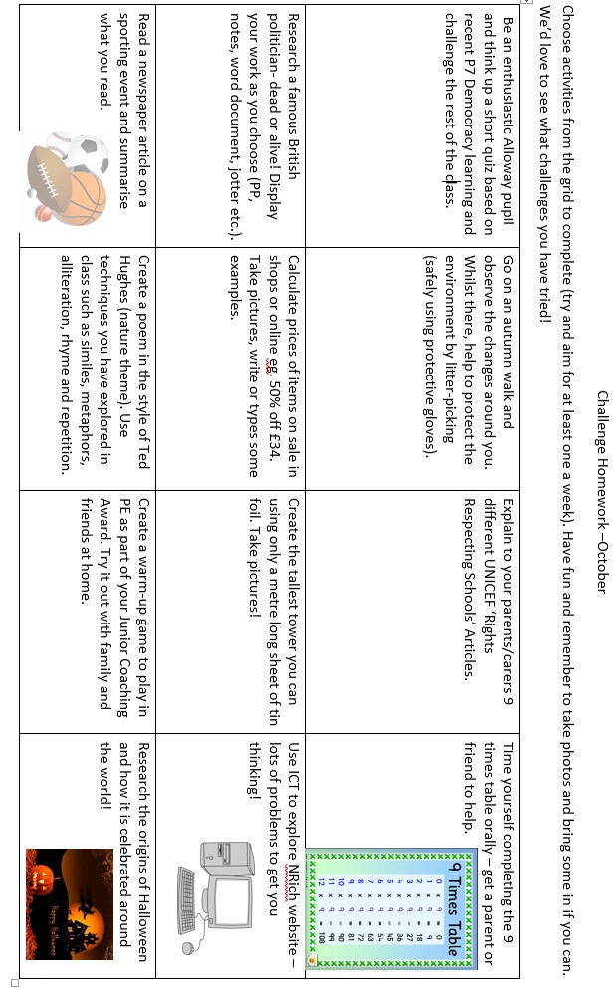Appendix 2

Updated Jan 2019