**Heathery Knowe Primary School and Nursery, South Lanarkshire Council**

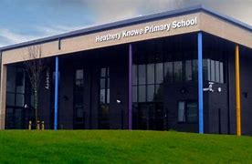



**Cost of the School Day Policy 2024 - 2025**

At Heathery Knowe Primary School and Nursery we recognise the need to reduce the Cost of the School Day for all our pupils and particularly for our pupils who are already experiencing poverty.  We examine the school Day through the following headings: Uniform, Travel, Learning, Friendship, School trips, Eating, Fun, Clubs and Home learning.

**Uniform**

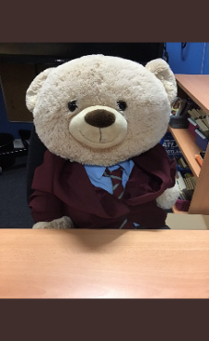

Our current uniform in school is a blue shirt or polo shirt and grey trousers / skirt with a maroon or grey jumper. The PE kit comprises of a blue / white tee shirt or polo shirt with navy shorts / leggings. There is no uniform in nursery. Children in the school and nursery play and learn outdoors each day and require waterproof trousers, jackets, and wellies. The school provides these for children as required and maintains a supply of pre-used uniform, outdoor and casual clothing to provide to families. In addition, we also have Halloween costumes and Christmas jumpers too in a variety of sizes. Parents and Carers can purchase the uniform with the badge embroidered onto the clothing from Border Embroideries; this is optional.  Families are provided with details for a staff member in the school to request support in providing uniform or casual clothing. Miss Wharton currently co-ordinates this support and can be contacted at the school (01355 22104

**Travel**

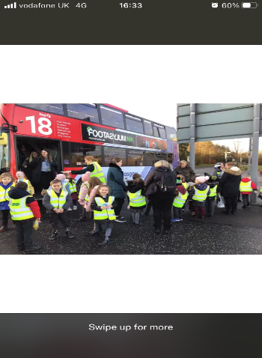

Most of our children walk or cycle to school and some arrive by car.  Transport is not required across our catchment area with all children deemed to live within a safe walking distance to school and nursery. There are no associated costs with travelling to school for those children living within the catchment area.

**Learning**

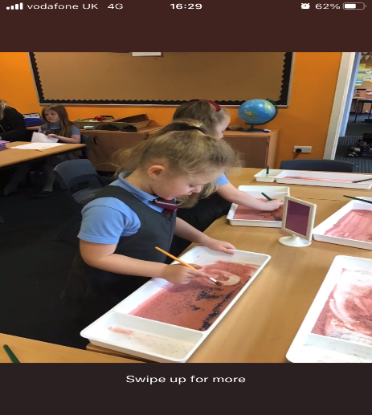

Children at Heathery Knowe Primary School and Nursery do not need to pay for any core learning activity, except for a contribution to learning to swim in Primary 5. Pens and pencils are provided, and young people do not need to bring their own equipment.  Children are welcome to borrow equipment if they need it for homework (e.g., a notebook or craft equipment). Young people in receipt of means tested Free School Meals do not need to pay for core curriculum including swimming lessons and fees are reduced for other children as much as possible.



**Friendships**



We ensure that any pupil experiencing poverty-related bullying has a way of reporting this in confidence.  We teach young people about poverty related issues as part of our health and wellbeing programme with a particular focus on equity taught through a ‘Big Question’ approach and Rhyme Time. The core values of being safe, kind, and ready to learn encompass all aspects of education about equity. We gather the views of our young people and families on the Cost of the School Day and involve them in decision making around this.

**School Trips**



Currently our trips are planned each year by the teaching staff with all associated costs carefully considered. The average cost of trips for pupils is £12 and we give sufficient notice so that it never needs to be paid at a cost of more than £1 per week.  We try to reduce the cost by fundraising and negotiating reduced prices with service providers.  We share information about how to contact the school to seek support with paying for excursions and pro-actively contact families who are experiencing poverty to offer further subsidy.



**Eating at school**

Last school year 26 % of pupils were in receipt of Free School Meals.  We never discuss who is in receipt of free school meals with pupils. We estimate that approximately 70 % of pupils who are eligible for Free School Meals take up their entitlement.  In order to increase that percentage we intend to share information with new families enrolling at the school and annually with existing families.

We have a daily Breakfast Club for pupils and offer ‘Toast to Go’ if children arrive late. Any leftover milk and fruit from the school canteen at the end of each week is given to our nursery or school pupils.

**Period Poverty**

Within the school, there are sanitary products for pupils to access if required to tackle period poverty. Primary 5-7 teachers lead learning conversations with pupils. Following discussion, sanitary boxes are located in the senior and disabled toilets so that they could access this if/when required.  Free products are given out annually to all senior girls if / when required. All senior girls are provided with products before the summer holidays. Through our school newsletter, we have communicated with families that there are free products in school for any adults to access.

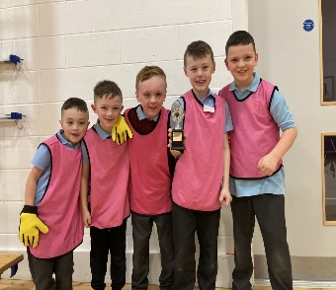 **Social Events**

Heathery Knowe Primary School and Nursery recognise that events planned for enjoyment can add pressure to families.  We look carefully at attendance and participation in these events in order to see if there are any poverty-related patterns that require action.  Heathery Knowe Primary School never holds dress down or dress up days to reduce pressure on families. As with school trips, events are planned at the start of each session in partnership with the Parent Teacher Council. Fundraising events are planned to ensure costs are spread across the school year. When young people cannot afford to take part in any activity, we ensure they can still experience it by paying for it using the school fund. We currently fund raise by holding discos, a Christmas and Summer Fayre and up to three other fundraising events. Each year children make, wrap, and take home a Christmas gift for a family member with no associated costs.



**School Clubs**

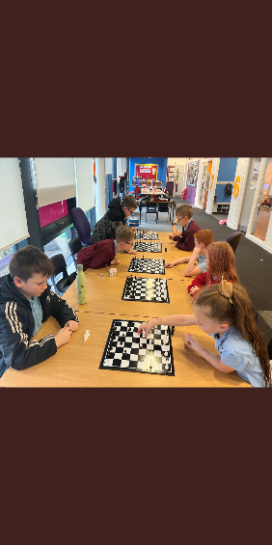

At Heathery Knowe Primary School and Nursery we have netball, football, athletics, film, library, debating, STEM, and chess clubs . We do not charge any young person to take part.  Some clubs require specific equipment e.g., football boots, and we do what we can to help families who may not be able to afford these by using grants, school funds and donated items.

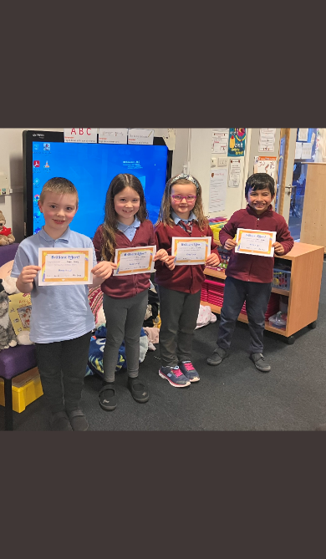**Home Learning**

We try to reduce the cost of learning at home as much as possible by providing all materials when required and offering our ICT lending library. This ensures that all pupils no matter their family circumstances can complete any homework activity.  Homework is not linked to our Promoting Positive Relationships and Understanding Distressed Behaviour Policy.

The Cost of the School Day is an area that requires constant vigilance and will not be ‘fixed’ by any one action.  In our Improvement Plan for 2022/2023 we will be focusing on:

* Seeking external funding grants to support the development of learning experiences at Heathery Knowe PS and Nursery at no cost to families.
* Creating an annual map of associated costs to ensure they are spread across the school year.
* Setting up a loose change box in the foyer for the collection of coins.

