 Gilmourton Primary

November 2018

SCHOOL and CLASS NEWS

|  |  |  |  |
| --- | --- | --- | --- |
|  | Science | Health and Wellbeing | Assemblies |
| P1-3 | Energy and Electricity | **Healthy Lifestyles**   * I make full use of and value the opportunities I am given to improve and manage my learning and, in turn, I can help to encourage learning and confidence in others. * Representing my class, school and/or wider community encourages my self-worth and confidence and allows me to contribute to and participate in society. * Through taking part in a variety of events and activities, I am learning to recognise my own skills and abilities as well as those of others.   **PE**   * I am developing my movement skills through practice and energetic play. * By exploring and observing movement, I can describe what I have learned about it. * I am developing skills and techniques and improving my level of performance. * I can recognise progress and achievement by discussing my thoughts and feelings and giving and accepting feedback. | **Key Messages:**  I can give it a go.  I will try.  We have people in school and home who can help and support us.  When things are hard we need to work hard  I can get better if I work hard |
| P4-7 | Friction, Streamlining and Gravity | **Healthy Lifestyles**   * I make full use of and value the opportunities I am given to improve and manage my learning and, in turn, I can help to encourage learning and confidence in others. * Representing my class, school and/or wider community encourages my self-worth and confidence and allows me to contribute to and participate in society. * Through contributing my views, time and talents, I play a part in bringing about positive change in my school and wider community.   **PE**   * I am developing skills and techniques and improving my level of performance. * I can recognise progress and achievement by discussing my thoughts and feelings and giving and accepting feedback. * I practise, consolidate and refine my skills to improve my performance. * By reflecting on my own and others’ work and evaluating it against shared criteria, I can recognise improvement and achievement and use this to progress further. |

Tickets for our Christmas Show, The Christmas Factory, will be available in December. Please look out for the letter coming home with additional information re times and ticket allocation.

Work in expressive arts will be supplemented over the coming weeks by preparing for our Christmas Show. Pupils will be learning scripts and songs in order to put together a performance for family and friends. This encompasses many skills and learning experiences:

* **Performing**: *I have experienced the energy and excitement of presenting/performing for audiences.*
* **Art**: creating scenery and props*: I have the opportunity to choose and explore a range of media and technologies to create images and objects, discovering their effects and suitability for specific tasks.*
* **Dance**: *I am becoming aware of different features of dance and can practise and perform steps, formations and short dance.*
* **Drama**: *I have developed confidence and skills in presenting drama which explores real and imaginary situations, using a script.*
* **Music**: *I can sing and play music, showing growing confidence and skill while learning about musical notation and performance directions.*

Participating in a performance involves the development of skills for learning, life and work such as remembering lines and lyrics, thinking creatively and working with others.

**DIARY DATES**

**November**

|  |  |
| --- | --- |
| Mon 19 Nov | School Closed: In-service day |
| Week beginning 19 Nov | Book Week Scotland |
| Fri 30 Nov | CHARITY DAY: Children First-Kilts for Kids |

December

|  |  |
| --- | --- |
| Tue 11 Dec | Christmas Show: 1.30pm and 6.30pm |
| Wed 12 Dec | Christmas Lunch |
| Tue 18 Dec | Coffee and Carols-10.00am |
| Fri 21 Dec | Christmas Party |
| School closes at 2.30pm on Fri 21 Dec Schools re-open on Mon 7 Jan 2019 | School Closed: Christmas/New Year |

CELEBRATING SUCCESS

Congratulations to Ellen-P5 –who received a Highly Commended certificate for her Road Safety poster.

We continue to celebrate achievements made outwith school on our Gilmourton Superstars wall display. Thanks to those who have been providing details of the many and varied achievements our pupils make on a daily basis. Please continue to share these with us. (Feedback sheets accompany this newsletter.)

P4-7 completed some stunning pictures to commemorate Armistice Day. Mr Telfer made use of the art work at the service in Avendale Church Hall on Sunday 11 November 2018.

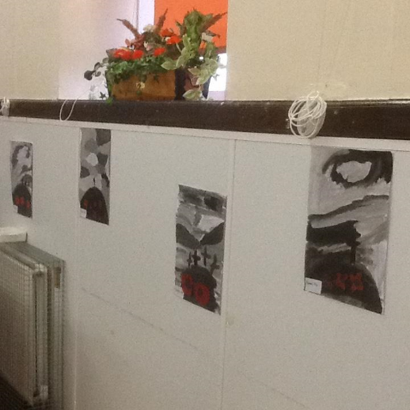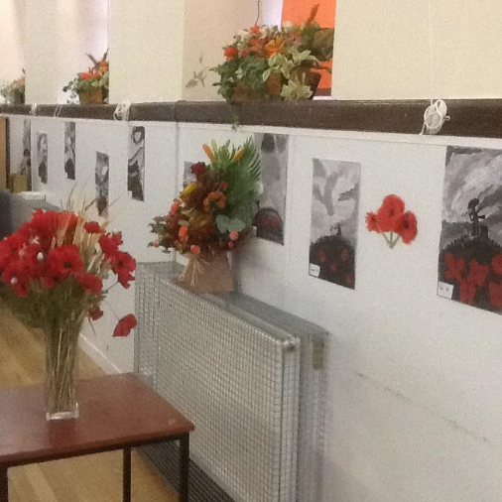

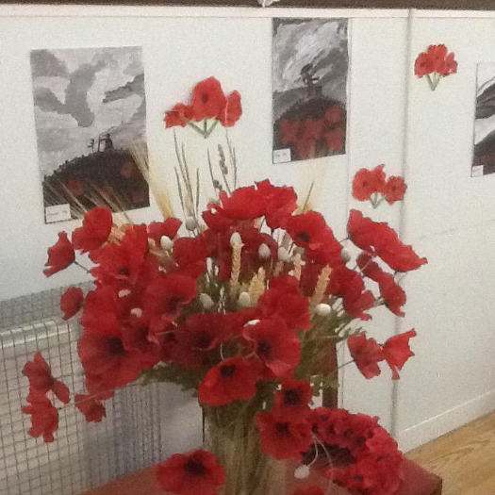

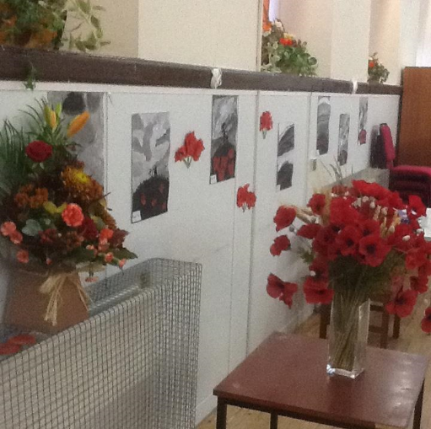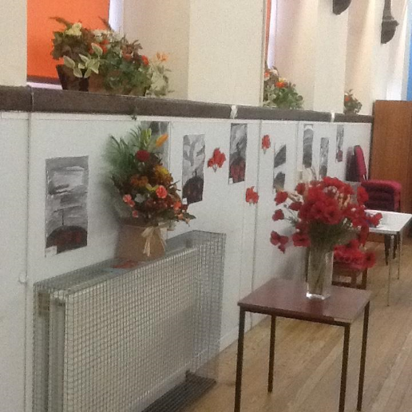

**ADVERSE WEATHER**

We continue to be optimistic with regards to adverse/severe weather. However, in order to be prepared, I would like to issue guidance regarding adverse weather.

We are able to contact parents by text message in the event of the school having to close early.

In order to assist with this it is vital that the mobile phone numbers we have are up to date. Please contact the school office if you require to update contact details.

The South Lanarkshire Council website is extremely helpful in keeping parents/carers notified about school closures: [**www.southlanarkshire.gov.uk**](http://www.southlanarkshire.gov.uk)

In the event of school closure, we will add suggestions for possible activities that can, if parents wish, be carried out by pupils at home. These will be available on the school website:

[www.gilmourton-pri.s-lanark.sch.uk](http://www.gilmourton-pri.s-lanark.sch.uk)