South Lanarkshire Council

Recovery Standards and Quality Report June 2021

East Milton Primary School
Standards and Quality Report Session 20/21

Our School (Roll/context etc)

East Milton Primary is situated in Westwood, East Kilbride and has been part of the local community for over 60 years.

In 2014 the school moved into its new building. At present, we have eight classes in the school, Primary 1 to Primary 7. Our early years provision can accommodate children for 1140 hours.

Our current roll is 263. We have 13 teachers, both full-time and part-time in school. The school’s management team comprises of a Head Teacher, Depute Head Teacher and two job sharing Principal Teachers. Within the nursery we have 7 members of staff; team leader, nursery teacher and five early years workers. We also benefit from 9 school support assistants.

We promote positive relationships within the school , fostering an ethos which encourages all pupils to respect themselves and others. The school community selected our values of: wellbeing, respect, teamwork, achievement, excellence, friendship, kindness and courage which underpin everything we do as a school.

We aim to ensure that the education we provide addresses the individual needs of all our children, taking forward the principles of best practice gained from national and local guidance. The learning climate we create endeavours to be motivating and relevant to our children’s needs.

All teaching staff are skilled in planning and delivering Curriculum for Excellence. We use a variety of assessment techniques and data to identify pupil strengths and development needs.

In East Milton we will continue to develop our ethos of achievement and celebrate success for all, whilst ensuring the promotion of equality and fairness. We value the learning and achievements of all our children and promote high aspirations and ambition to enable them to achieve their potential and contribute positively to the world in which they live.

Our aim is to work collaboratively with pupils, parents, carers, partner agencies and local business to provide consistently high quality learning experiences. We aim to continue to develop partnership working and evaluate this effectively to ensure it makes a positive difference to the quality of support for children and families.
We have a range of experience and expertise within the school. Each member of staff shares their skills with colleagues and benefits from collegiate working within our own establishment and with colleagues in other schools across the learning community.

There are opportunities for staff to take on a variety of leadership roles within the school, learning community and the council ensuring that our staff have opportunities to share expertise and continue to develop professionally. We have a systematic and planned approach for staff development and professional review. This identifies individual and whole school needs and draws on local and national priorities.

We aim to implement South Lanarkshire Council’s seven core policies, school guidelines, national improvement framework and all current legislation to ensure improved practice.
Our Recovery Plan, for our establishment and our Learning Community, forms the basis for continuous improvement, reflection and review of practice; self evaluating against HGIOS4 and HGIOELC. We aim to keep all stakeholders well informed about our work on identified development priorities and to consult with them on both action for improvement and progress. We aim to take forward the improvement plan priorities, as agreed with South Lanarkshire Council, and evaluate its impact on improving outcomes for all our children.
Key Successes/Challenges and Achievements Session 2021/22
Challenges
- Implementing ever changing covid guidance
- Operating in Nursery Pods of 8
- Parental anxiety
- Improving pupils’ social interaction skills, positive growth mindset and resilience
- Staying connected as a school community
- Managing and staffing a hub whilst delivering a full live programme of remote learning
Successes
- Teamwork
- 100% of pupils had access to IT during remote learning
- Staff ability to rapidly upskill for potential remote learning
- Delivery of 3 live teaching sessions per day during remote learning
- Level of pupil engagement during period of remote learning
- Improved IT skills of pupils and staff (including Google Classroom )
- Education Scotland consulted nursery on our successful use of Learning Journals during in playroom and remote learning

Remote Learning Jan-March 2021
Provide a brief, evaluative commentary on this period. This should cover:
- Google Classroom and Learning Journals (nursery) were used to support learning and teaching during remote learning. P1-7 staff delivered 3 live sessions per day to replicate as close as possible the school day and to encourage connectivity between teacher and pupils and pupils with their peers.
- Early Years Workers posted activities every morning for the children and their families.
- Pupil Engagement Rates during remote learning were high:

School Survey on Quality of Remote Learning Experience
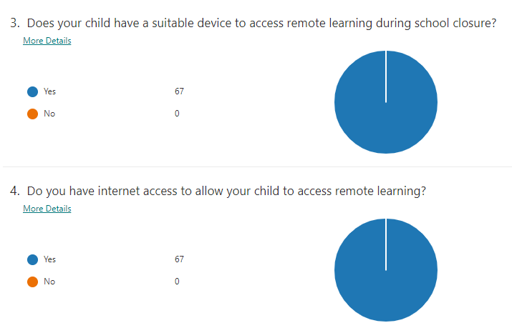

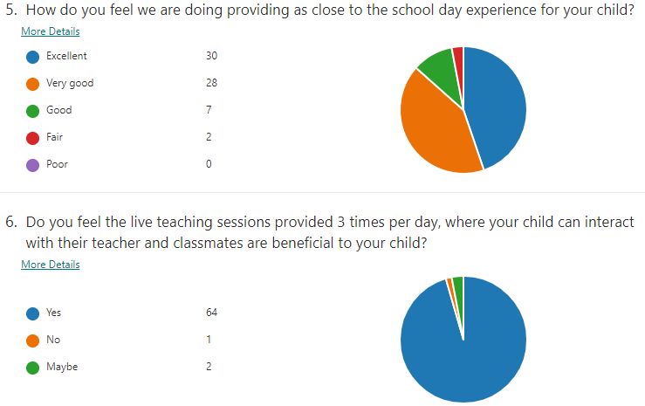

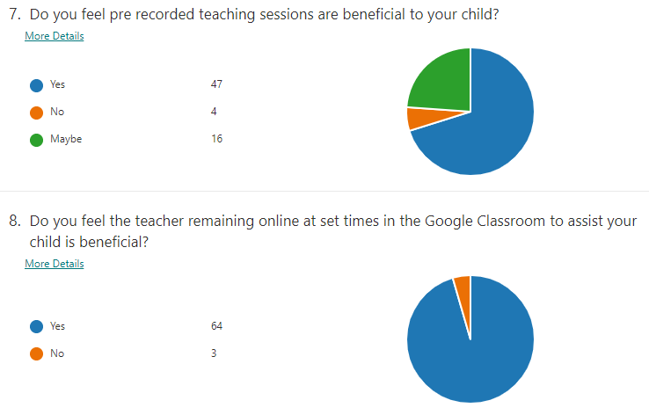

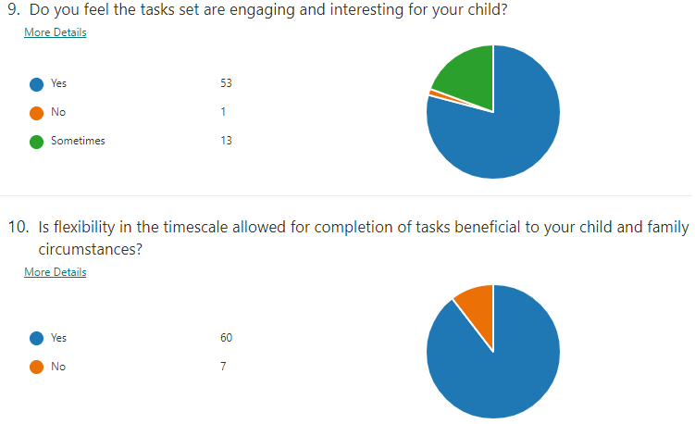

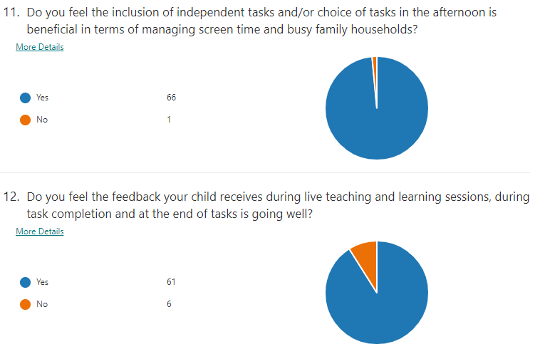

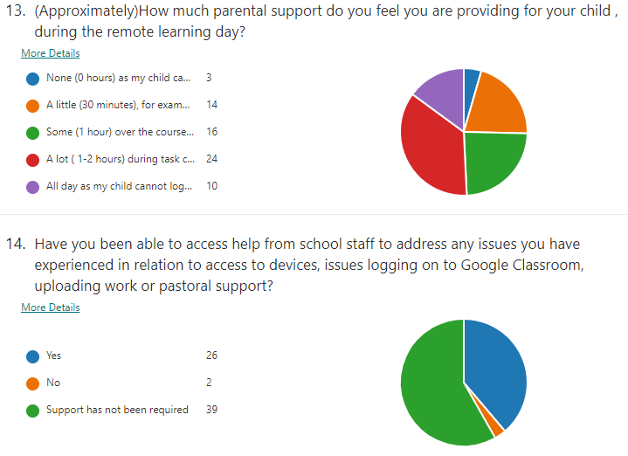
Nursery Survey on Quality of Remote Learning Experience
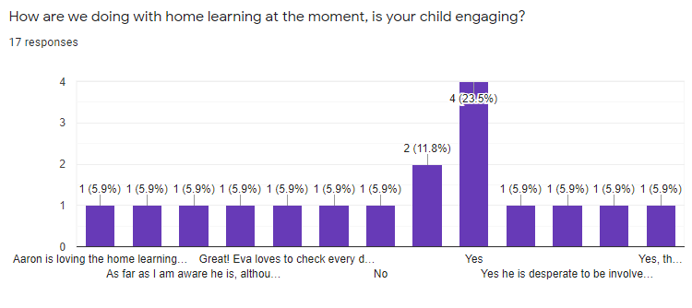

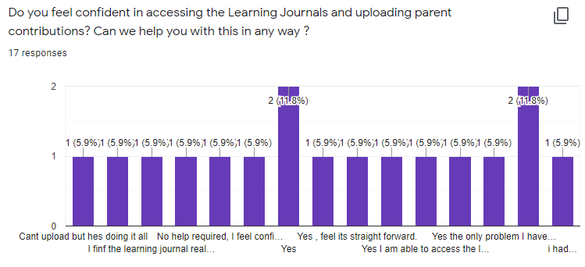

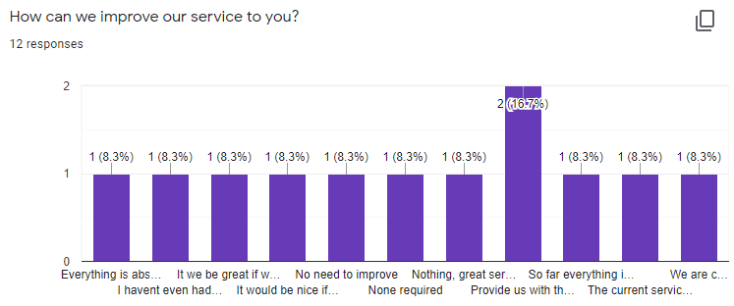

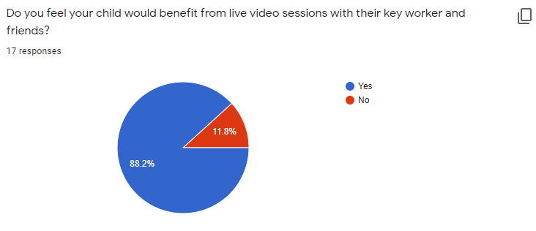

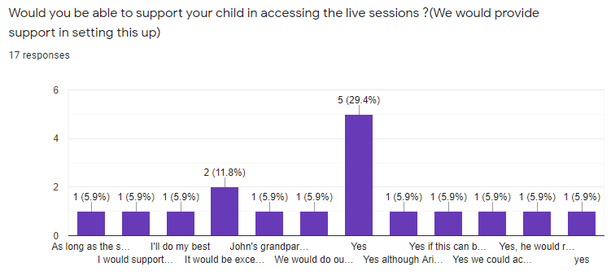

Challenges and opportunities
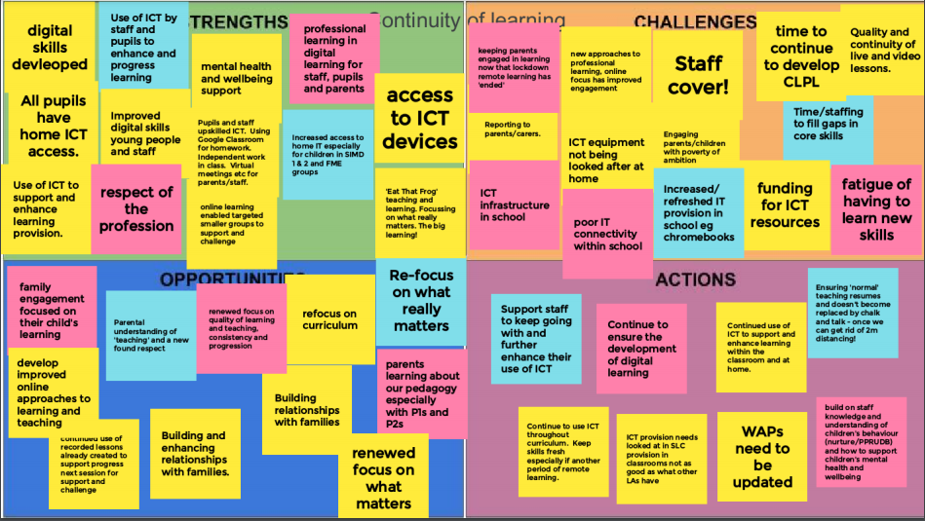

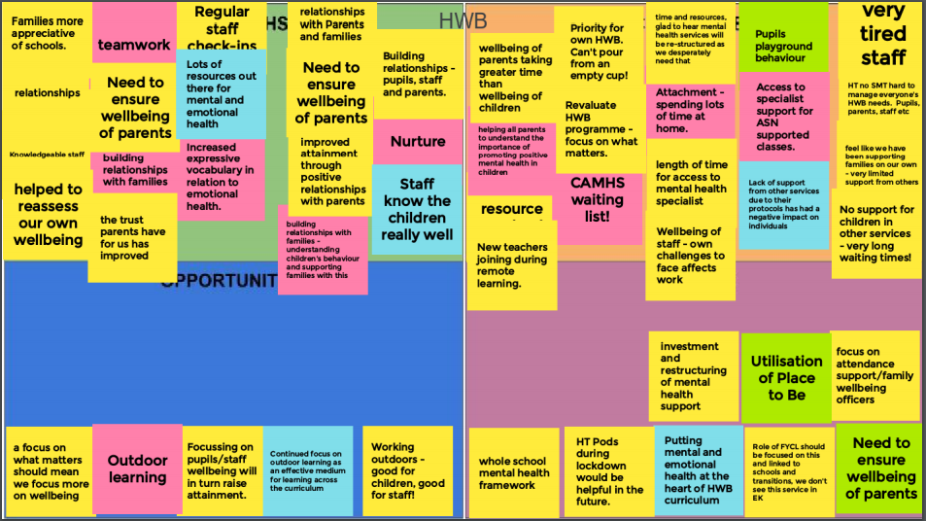

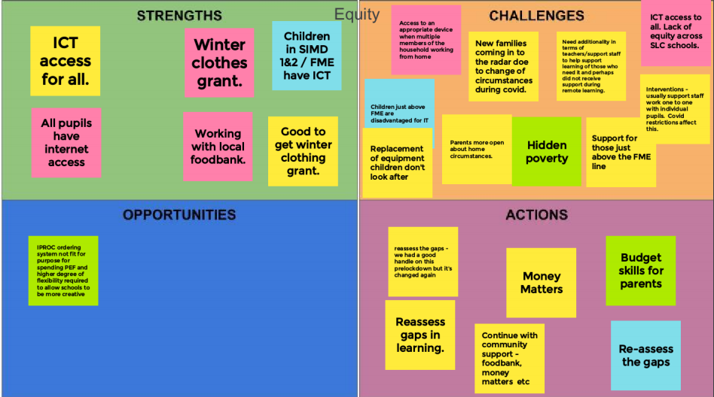

- Learning Arising From This Period
- Teamwork, flexibility and adaptability of staff is exceptional
- How well we know our pupils and families
- Importance of access to IT for all pupils and families
- Importance of outdoor experiences and play
- Increased awareness of the importance of wellbeing for all of our school community (parents/carers/staff,pupils0
- Staff ability to rapidly upskill for potential remote learning
- Learning Community Google Classroom with resources now available
- The continued importance and supportive factor of relationships: staff with staff/ staff with pupils/ school with families
- Increasingly parents/carers have looked to the school for support with their own mental health and that of their children
- Increased/ new found respect for the school from parents/carers
- Live teaching contributed significantly to level of pupil engagement during period of remote learning
- Improved IT skills of most pupils and staff
- Assessment, data analysis and moderation has been more difficult during this period

Next steps
- Focus on Health and Wellbeing of the whole school community
- Focus on Equity
- Focus on Literacy
- Focus on Numeracy
- Rekindling Learning Community Collegiate work in areas of Moderation and Science
- Building on increased and improved ICT skills
- Importance of ring fencing time for robust quality management on key areas of
- moderating pedagogical practice through classroom/playroom observations and professional discussions
- support, challenge and pace
- data analysis (assessment, attendance, equity) to identify progress, barriers, gaps in learning and inequalities
Planning for and Evaluating improvement
As children and young people returned to our buildings in August 2020 following the first National lockdown, we prioritised three key areas for development: Health and Wellbeing, Equity and ensuring Continuity of Learning for children/young people. These priorities formed the basis for our School Improvement Plan.
What follows is a copy of this plan and a review of our successes in delivering on what we set out to achieve. As part of this review, we have identified new priorities, and these will form the basis of our new School Improvement Plan for Session 2021/22.

Improvement Priority 1 - Promote the positive health and wellbeing of children & young people, parents/carers and staff |  |  | How will we know we’ve been successful?
Quality Indicator  3.1 Ensuring wellbeing, equality and inclusion  - Wellbeing  - Fulfilment of Statutory Duties  - Inclusion and Equality | Recovery Priority  These have been generated as a series of prompts/suggestions to assist schools with the recovery planning process. They are based around current research and information around recovery and National Guidelines. | Key Recovery Tasks  (School specific)  This section is for school-specific planning. What needs to be done in your specific context? Who will be involved and when? Set SMART targets. | Desired Outcomes and Impact  This section should give a brief indication of what success would look like and how it will be measured.
Theme: Whole School Wellbeing  Rationale: School ethos is a determinant in promoting social and emotional wellbeing and mental health for everyone within the school community.  A sense of Belongingness and Connectedness is always a powerful support for children, young people, and adults, especially as a buffer to adversity. This is mediated through Quality Relationships, and a range of Attachment Informed Practices.  Staff will have had a range of experiences during this period and will need a flexible and personalised approach that emphasises the ongoing importance of self-care.  It will be important to work out where children and young people are in terms of their wellbeing through observation, conversation, and further assessment with planned interventions for some.  Establishments, at all stages of this pandemic, have a critical role in remaining connected with families and supporting learning and wellbeing. Schools should engage directly with parents and in a compassionate, personalised way to foster confidence. | Schools need to:  - Assess current position in terms of whole school wellbeing. Use authority guidance/toolkit or other audit tools.  - Plan a whole -school co-ordinated approach to identifying need and for planning appropriate, measured, responsive interventions to identified issues on an ongoing basis. This should explicitly refer to the post COVID needs and context and also acknowledge that some children will have gained skills as well as have needs.  - Plan how best to promote an attachment -informed ethos and environment that nurtures reconnection, transitions and belonging within their unique context, based on the SLC attachment strategy.  - Focus upon a practical roll-out of SLC Attachment strategy including ensuring staff are appropriately trained.  - Provide opportunities for Staff Development which allow staff to focus on individual and collective wellbeing needs of their children and young people, especially their most vulnerable.  - Identify partners from beyond the school that may be needed to help with the recovery process e.g. psychological services, third sector agencies.  - Work with parents and carers to raise awareness and understanding of the importance of attachment and of a recovery curriculum. Engage with stakeholders in the wider school community.  - Have overt plans in place to support the wellbeing needs of staff which acknowledge that there will be many different circumstances and concerns. Ensure communication channels are clear and consider how staff may both support and help each other. Ensure there are clear processes in place which support all personnel functions, and which allow staff to be included and consulted. | Key Recovery Tasks (school specific)  - Staff questionnaire on lockdown experience (SMT)  - Parent Questionnaire on lockdown experience (SMT)  - Buddy system for staff (Pair up staff in pairs/trios) (SMT)  - Drop in sessions during non class contact time for staff with SMT/ Team (HT/DHT) Leader/Nursery Team Leader  - INSET on work/life balance (DHT)  - PRD with personalised wellbeing targets built in (HT/DHT/ Nursery Team Leader)  - SLC services eg Pam Assist  - Attachment INSET- webinar and school audit, (SMT, staff)  - Attachment Presentation for Parent Council/ leaflets, links, sign posting to services for parents (DHT)  - Devise safe ways for children to express privately their positive/negative experiences of lockdown (All staff)  Eg Feelings boxes, poetry, art, skills listing, emotions work  - SHANNARI- wheel to track from baseline, devise SHANNARI characters, socially distanced assembly (Microsoft Team Meeting in each class?)  - Boxall Profile completion (Teacher)  - Staged Intervention (Teacher/DHT)  - Consultations with Specialist Support Teacher/Psychologist (DHT)  - Lego Emotions (PEF teacher and Specialist Support Services)  - Counselling Service accessed according to need (DHT)  - Brief Solution Focussed Therapy (Ed Psych)  - CUSTTAD (SpS Team)  - Nurture Based Approach (cooking, craft group etc)  - Child yoga (Active Schools)  - Staff yoga (3rd sector)  - Skill and talent sharing (Pupils)  - Camp Craft/ Den Building (3rd sector/ Teachers) | Desired Outcomes and Impact  Staff and pupils reconnect with school life  Old relationships are rekindled and new positive ones formed between peers, between pupils and staff and between school staff and parents  All stakeholders have access to appropriate support and interventions  Pupils develop emotional literacy  All staff develop understanding of Attachment, an attachment informed approach is in place with adults able to respond appropriately and with understanding in order to meet pupil, staff and parent need.
Theme: HWB CURRICULUM  Rationale: The approach to the curriculum, learning and teaching is a key part of ensuring recovery. Effective delivery of a “recovery curriculum” is underpinned by recognition that all Behaviour is Communication.  Reconnection with learning focusses upon key themes of; supporting engagement and motivation, readiness to learn, connection to prior learning and metacognitive approaches.  Involving children and young people in decisions is part of a rights-based approach and acknowledged as best practice. It is strongly associated with good outcomes, including recovery from adversity. | Schools need to:  - Contextualise the ’Reconnection & Recovery’ guidance to develop a recovery curriculum within a unique context.  - Ensure Effective planning and monitoring is in place to support the learning and teaching process in the promotion of resilience and the support of mental, emotional, social, and physical wellbeing  - Enable opportunities for children and young people’s voices to influence decisions and ensure the curriculum is responsive to needs. | INSET- Promoting Positive Relationships and Understanding Distressed Behaviour (DHT)  Health and Wellbeing Curriculum Focus  - Bounceback  - Mindfulness  - SULP  - Sleep, diet, physical, relationships, emotional literacy wellbeing lessons (Healthy Schools website, SHRP)  - Protective Behaviours (HT)  - Cooking (health and safety dependant)  - Rights Based Learning,Class charters, revisiting Playground Charter (Rights Basedc Learning Committee)  Pupil Committees- Health and Wellbeing, Leadership, Pupil Council, Sports Leadership | Pupil voice is heard  Pupils develop emotional literacy  All stakeholders place health and wellbeing at the centre  Outdoor learning utilised fully  Tracking and monitoring used to inform practice

Improvement Priority 1 - Health and Wellbeing
Progress Report June 2021

What did we actually achieve? | How do we know? | What do we need to do next?
With reference to the above priorities, please provide a commentary of what was achieved and what was not. This section may include a description of other priorities under this banner that may have been added in to respond to events or circumstances.  - Drop in sessions during non class contact time for staff with SMT/ Team (HT/DHT) Leader/Nursery Team Leader  - Online meetings 3 times per week  - 4 Whatsapp Groups set up  - Work/life balance, physical and mental health  - Attachment INSET- webinar and school audit, (SMT, staff)  - Counselling Service accessed according to need (DHT)  - Nurture Group and Give Us a Break Group  - Health and Wellbeing Curriculum Focus | Please detail evidence of impact here. This may be quantatitive e.g. data or qualititive e.g. feedback from stakeholders.  - During in school working staff were supported via informal drop ins/chats to HT/DHT and Team Leader  - During remote learning 3 online meetings per week set up to discuss problems, concerns, problem solve and share updates  - SMT Group undertook group calls and video calls to support one another  - Teaching Staff group problem solved and supported one another timeously throughout the teaching day and beyond  - Nursery staff shared links to resources  - Team Leader and SMT liaised with SSAs.  - Safe Systems of Work (working from home) implemented  - Regular discussions and check-ins on de-stressing strategies  - WTA was adapted to ensure staff workload was focussed on teaching, learning and assessment and staff wellbeing was protected  - PRDs had personalised wellbeing targets  - All school staff undertook level 1 attachment training. Staff report better understanding of the needs of individual children  - Place2Be providing service. Counsellor post advertised, interviews took place and post filled. Greenhills PS will provide base. Counsellor will work remotely throughout the summer.  - Unable to run  - Pupils were initially pleased to see their friends when school reopened but within a few weeks it was evident that some pupils had lost their resilience, had poorer social skills and aggression was raised. The following was undertaken:  - Rights Based Learning ensured we revisited our playground charter and classroom charters.  - Bounceback programme has been used as a key resource to help build resilience back up  - Positive mindset activities undertaken and embedded in ethos and day to day classroom life.  - It was agreed that Term 4 would have a heavy health and wellbeing focus.  - Outdoor Learning undertaken whenever possible  - School continue with Walk A Mile and have entered the Road to Wembley Challenge (led by House Captains)  - HT and Chair of Parent Council discussed concerns, agreed an action plan and HT communicated to parent body how the school was going to address concerns and help pupils  Shanarri wheels/charts used throughout year to track pupil health, guide teachers planning and identify need for interventions. | Please list your new priorities under this heading. These will form the basis of your SIP for Session 21/22.  - Continue increased connectivity via CAT, staff meetings and one-to-one support  - Continued use of Whatsapp groups for emotional support and social connectivity  - Attendance at HT Support Pods (if running)  - HT undertaking Mental Health Champion training and disseminating information and utilisation of strategies  - PRD process to include wellbeing target  - Completion of Level 2 attachment Training  - Identification, prioritisation and referral of target pupils to Place2Be  - Heather and Lynne to lead (restrictions permitting)  - Development of whole school Health and wellbeing Policy and Practice to include:  - Mental, Social and Physical wellbeing  - Planning for Choices and Change  - Physical Education, Physical activity and Sport  - Food and Health  - Substance Misuse  - Road Safety  - Cycling Proficiency  - Walk a Mile  - WOW  - RSHP  - Outdoor Learning  - Bounceback  - Growth Mindset  - Rights Based Learning (Class, playground and SchoolCharter)  - Protective Behaviours  - Whole School Behaviour Policy  - Bullying Policy  - Emotional Literacy  - Relaxation  - First Aid including CPR  - Links to Food technology  - Links to Science (Biological Systems)  - Wellbeing Wednesdays for pupils and staff  - Health week  - Attachment  - PPRUDB  - Assessment  - More robust Tracking and Monitoring of Health and wellbeing via Shanarri tools  - Target setting in Learning Journals

Improvement Priority 2 - Planning for Equity |  |  | How will we know we’ve been successful?
Quality Indicator  2.4 Personalised Support  - Universal Support  - Targeted Support  - Removal of barriers to learning  3.1 Ensuring wellbeing, equality and inclusion  - Wellbeing  - Fulfilment of Statutory Duties  - Inclusion and Equality  3.2 Raising Attainment and Achievement  - Attainment in Literacy and Numeracy  - Attainment over time  - Overall quality of learners’ achievements  - Equity for all learners | Recovery Priority  These have been generated as a series of prompts/suggestions to assist schools with the recovery planning process. They are based around current research and information around recovery and National Guidelines. | Key Recovery Tasks (School specific)  This section is for school-specific planning. What needs to be done in your specific context? Who will be involved and when? Set SMART targets. | Desired Outcomes and Impact  This section should give a brief indication of what success would look like and how it will be measured.
Theme: Re-identifying the poverty-related attainment gap.  Rationale: To plan effectively to address the “gap” there needs to be a clear understanding of what the current “gap” is. Learners will have had a varied experience during their home learning period, and won’t necessarily be at the same point in their learning when they left school in March. Some learners will be further ahead; some at the same point; with others showing limited progress if any. Schools therefore, need to reconsider their “gap” and re-assess to establish where the current gaps and barriers to learning are for their learners. This provides a clear foundation for improvement and planning. | Schools need to:  - Consider the experiences learners have had during the school closure period, drawing on for example:  - Engagement data  - Home-school communication  - Home-learning submissions  - Engagement at hubs  - Use a range of quantitative and qualitative measures to undertake a new “gap” analysis for all pupils, which takes account of:  - Learners’ wellbeing (e.g. Boxall profile, observations, wellbeing indicators)  - Attainment (e.g. standardised assessments, class work, use of benchmarks, in-school assessments)  - Engagement (e.g. Leuven scale, observational data)  - Participation (home-learning participation data)  Purple text gives examples of how schools may tackle this; this isn’t exhaustive but provides a starter for ten. Take a balanced and staged approach to assessment; remember learners are recovering and beginning to re-engage with their learning, and that their wellbeing comes first. Remember that some children may well have gained skills/experiences as well as lost them.  - Undertake a rigorous analysis of the pre and post lockdown data with all relevant staff to establish the school’s new “gap” position. This will enable identification of groups/learners/stages requiring targeted additional support. | Key Recovery Tasks (school specific)  Learning Experiences during school closure  - Pass on notes from previous teacher  - HT updates  Wellbeing Indicators  - SHANNARI laminated cards used for tracking and monitoring (TEACHER/PUPIL)  - SMT act upon and discuss with SpST, parents, Psych Services re appropriate input (Interagency)  - Boxall for identified pupils (SpST)  Attainment  (Measuring attainment will be undertaken in an unobtrusive, staged manner using our normal range of approaches and resources)  - Teacher/EYW Observations  - Discussions with pupils on new skills development  - Formative Assessment  - Summative Assessment  - Standardised Assessment  - Diagnostic Assessment  - Engagement Data  (East Milton TLC Group and SMT)  Gap Identification and Analysis  - Collate new FME data (HT)  - Class on a Page update (HT)  - Analyse class/ group of learners/ stages Attainment of a Level/ Progression Pathways through a level/ Standardised results (HT/DHT/PT)  - Plan targeted support with focus on H&Wb, Lit, Num (DHT/PT)  - Timetable support for specific interventions (DHT) | Desired Outcomes and Impact  Pupils needed assessed in staged manner so as not to cause stress eg unobtrusive observation before any formal assessment  Appropriate interventions selected to address need  New base line along with tracking and monitoring of progress shows positive impact and benefit to individuals/target groups
Theme: Planning to close the poverty-related attainment gap and reduce learners’ barriers to learning.  Rationale: As learners return to school, SAC/PEF plans need to be flexible and adaptable to meet the current needs of learners as blended learning is implemented. Whilst there will be parts of the equity plans that are still relevant and can delivered, there will also be parts that are no longer relevant and therefore need to be altered and adapted following the re-identifying of the gap, and the need to take account of the new blended learning taking place. Note, any changes, to SAC/PEF plans must still adhere to the guiding principles in which this funding was intended. | Schools need to:  - Consult with all stakeholders (learners, parents, staff, partners) when making decisions around the PEF/SAC funding during the recovery phase.  - Explore evidence based approaches through EEF, National Improvement Hub, SLC HWB recovery support document, etc. to inform thinking.  - Engage in professional dialogue with staff to establish the best approaches to close the poverty-related attainment gap. Ensure agreed approaches provide additionality.  - Review staff training needs.  - Review current partnership working.  - Consider how you will measure and evidence impact; plan this into home and school approaches.  - Consider how blended learning will affect our most disadvantaged learners: what support can be delivered while learning at home and in-school? You may find the EEF covid-19 resources helpful when considering this. | Assessment of Need completed then:  - Consult with Staff, Parent Council and Pupil Council on spending (HT)  - Utilise Existing Skills/resources available eg Catch Up Numeracy, Catch Up Literacy, 5 Minute Box for Literacy, 5 Minute Box for Numeracy, Nurture ABC, Give Us a Break, Nurture based approach (SSAs/SMT)  - Attachment Champion (DHT)  - Attachment Training and Google Meet training to be undertaken (All staff)  - Utilise Health and Wellbeing Recovery Kit (HT/DHT)  - Consult Ed. Psych and Specialist Support Team re most suitable interventions (DHT)  - Build in Google Meet for vulnerable pupils on days not in school (non class committed staff)  - Utilise online tools to support pupil online learning and parents’ ability to support (PT) | Tracking and monitoring indicates positive progress in closing the gap  PEF allocation used to ensure families financially affected by COVID-19 are not disadvantaged.  Staff are skilled in delivering interventions/supports  Joined up working with Specialist Support Team and Educational Psychologist to ensure appropriate strategies/intervention/training is provided  Utilisation of 3rd part sector services if required.  Equitable access to resources including IT
Theme: Tracking and monitoring impact of equity approaches.  Rationale: To ensure maximum impact for learners, there needs to be rigorous, regular tracking and monitoring of equity approaches. This enables schools to understand what works well, and to build on this, but also ensures approaches can be changed, stopped or adapted quickly when there is little/no impact. | Schools need to:  - Identify key measures, which will evidence impact for your approaches. Consider: when; how; by whom; bureaucracy.  - Engage in dialogue with staff, pupils and parents to discuss progress and analyse the evidence obtained from your key measures. Use these to inform planning; alter plans promptly and accordingly if little/no impact evidenced.  - Consider points in planning section to find alternative approaches. | - Salford Reading Test (SSAs)  - PM Benchmarking (SSAs)  - Single Word Spelling Test (SMT)  - QUEST (P4 first)  - Progress in Maths Test (PT)  - ELSA (P1 teacher)  - Boxall (Teacher)  - SHANNARI tracking and monitoring (Teachers)  Qualitative data (All staff) | Efficient tracking and monitoring will identify what is working and therefore should continue, what is not and therefore should stop.
Theme: Cost of the School Day  Rationale: The coronavirus will have affected families in different ways. Those who experienced poverty prior to the epidemic were already pushed into unacceptable hardship, and may have been pushed deeper into poverty due to the effects of the coronavirus. There will also be a number of families who are now experiencing poverty who weren’t before. As a result, cost of the school day has never been more important. We need to poverty-proof our approaches, particularly as we move towards a blended learning approach to ensure no learner misses out due to financial constraints. | Schools need to:  - Revisit Child Poverty Action Group Website  - Read CPAG article on impacts of school closures.  - Revisit your CoSD Position Statement. Consider how you can best eliminate charges for families.  - Consider how you will equip learners with the tools required to undertake home-learning.  - Consider how our actions can inadvertently alienate families in poverty.  - Use knowledge/intelligence and sensitively engage with families as appropriate to understand any financial impacts.  - Consider how you can sensitively support families by signposting them to financial supports or by supporting them as a school community.  - Consider staff training needs – ensure all staff are consistent in their approach to poverty.  - Consider what changes will need to be made to the school calendar in light of changes to family income. | Cost of the School Day Policy-In session 2020-2021 school will not be requesting money for either essentials or treats  Undertake survey on what we could recycle re-use within our community (Eco Committee)  Financial workshops/ leaflets/possible drop in (TBC)  School calendar reviewed (SMT and Parent Council)  Alternatives to previously large outgoings explored (SMT and Parent Council)  Staff INSET (All staff)  Interrogate Child Poverty Action Group website and CPAG (SMT) | No child is disadvantaged educationally due to poverty  No family is under undue stress trying to meet school related expenses  Appropriate access to resources, including IT

Improvement Priority 2 - Equity
Progress Report June 2021

What did we actually achieve? | How do we know? | What do we need to do next?
With reference to the above priorities, please provide a commentary of what was achieved and what was not. This section may include a description of other priorities under this banner that may have been added in to respond to events or circumstances.  - Reduced timetable of 5 minute box for target group  - Reduced timetable of Catch-Up Literacy for target group  A reduced programme was delivered due to covid restrictions. Pupils B, D and F made minimal progress and this was due to lack of engagement during period of remote learning.  Digital Inclusion  The school applied for 55 devices through the Scottish Government Digital Inclusion Scheme to provide chromebooks on a permanent loan basis.  The school also applied for a further 67 devices to go out on loan to pupils still without access to devices for remote learning.  Cost of the School Day  School Essentials  The school supplied all stationery equipment to pupils. There was no cost attached to any of the activities in school.  Winter Clothing  The school utilised the allocation of £246 to assist families struggling to afford winter clothing. The school app was used to promote the Winter Jacket Recycling Scheme.  Financial Support for Families  The school ensured parents/carers were aware of the financial support available to them by posting information on the school app on the following:  - NHS Rehoming of Bicycles Scheme  - Best Start Foods Bonus  - Period Poverty  - Winter Fuel Payment  - £100 Winter Payment  - Free School Meals Payments for pupils self isolating  - Free School Meals Payments during school holiday periods  - £500 Self Isolation Support Grant  - Aberlour Urgent Assistance Fund  - New Scottish Child Payment Benefit  - Best Start Grant | Please detail evidence of impact here. This may be quantatitive e.g. data or qualititive e.g. feedback from stakeholders.  One child who made minimal progress did not engage well.  Every pupil in East Milton had access to a device for remote learning.  Pupils had all necessary equipment provided during both in school learning and during remote learning.  3 jackets and pairs of wellies were purchased from the funds.  A survey undertaken in May indicated the numbers of families who benefitted from the various financial supports.  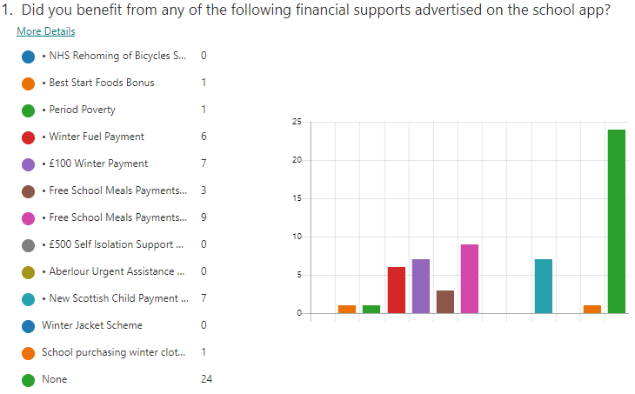 | Please list your new priorities under this heading. These will form the basis of your SIP for Session 21/22.  - Continue to use 5 minute box for target groups  Continue to use Catch-Up Literacy for target groups  - Continue to invest in ICT for all both in school and at home  - Consultation with target group on 5% spend of Pupil Equity Funding  - School uniform recycling scheme  - Money Matters Event  - Working with local foodbanks and community groups  - Cooking group with ingredients to use at home to repeat the dish  - Equity Lead attendance at events/meetings

Improvement Priority 3 - Continuity of Learning |  |  | How will we know we’ve been successful?
Quality Indicator  2.2 Curriculum  - Rationale and design  - Development of the curriculum  - Learning pathways  - Skills for learning, life and work  2.3 Learning, teaching and assessment  assessment  - Learning and engagement  - Quality of teaching  - Effective use of assessment  - Planning, tracking and monitoring  3.2 Raising Attainment and Achievement  - Attainment in Literacy and Numeracy  - Attainment over time  - Overall quality of learners’ achievements  - Equity for all learners | Recovery Priority  These have been generated as a series of prompts/suggestions to assist schools with the recovery planning process. They are based around current research and information around recovery and National Guidelines, including the SLC Recovery Guidance documentation.  Links are included where appropriate.  Please note - there are 2 Head Teacher consultative groups currently working with senior officers to produce Local Authority suggested recovery phase ‘curriculum models’ for both the Primary and Secondary sectors. As soon as the recommended models have been assessed for operational practicalities (including services such as cleaning, transport, catering etc) they will be emailed to all Head Teachers. | Key Recovery Tasks (School specific)  This section is for school-specific planning. What needs to be done in your specific context? Who will be involved and when? Set SMART targets. | Desired Outcomes and Impact  This section should give a brief indication of what success would like and how it will be measured.
Theme: Learning In School  Rationale:  The implementation of physical distancing will impact upon the capacity for in-school learning within a specific setting. For the first phase of re-opening, schools should assess the maximum number of pupils they can safely accommodate at any one time while maintaining a quality learning environment,  Remaining in-school provision should be distributed across all year groups to ensure that every pupil benefits from in-school learning wherever possible  It would be naive of any Headteacher to think that the child will pick up the Curriculum at exactly the same point at which they left it on the day their school closed. Too much has happened. Listen to what the children are saying. Look at what the children are experiencing. None of this follows the usual pattern of a school year with all of the annual cycle of events. It feels like a period of true social disorder. Compassionate Leadership is crucial at this time.” The Recovery Curriculum, Think Piece  Schools should consider the needs of children and young people after a prolonged period of remote learning and absence from school. It will be important to promote reconnection and recovery within the curriculum.  Decisions need to be made about what assessments will be used to re-assess the regulation, wellbeing and learning needs for each child. Very careful consideration should be given to the use of summative tests as a route to baseline pupils.  This will be a time to make even more use of outdoor learning opportunities. In accessing a range of outdoor experiences, learners can build upon and develop skills that attribute to their holistic health and wellbeing.  It is clear from all of the recent research that core teaching delivered in person by teachers in schools is most impactful. However where this teaching time is reduced the technology should be viewed as a way to enhance and consolidate the core teaching vs replacing it.  Whilst the adults begin preparation and decision making, consider how we empower learners during this preparatory period. Ensure as leaders you gather views learners in their recovery, along with parents/carers . | Schools need to:  - Consider your current position in terms of staffing and pupil numbers. Use Local Authority and National Risk Assessment advice and recovery planning guidance to plan an in school curricular provision.  - Plan a whole school approach to how you will best utilise your learning spaces, taking account of social distancing and the types of learning episodes this will allow you to deliver.  - Consider if communal and social areas could be repurposed to provide additional learning space.  https://www.gov.scot/publications/coronavirus-covid-19-re-opening-schools-guide/  - Assess which curricular areas you are able deliver and resource in school, both in terms of physical spaces and staff capacity.  - Consider how you will build opportunities for staff to work collegiately to moderate and assess within this structure.  - Consider planning for longer blocks of learning over a longer-term timetable where possible (ie for secondary – 3hrs of a face to face learning of a subject once every 2 weeks)  - Review your school’s learning, teaching and assessment processes. Your assessment guidelines will need to take account of the different learning experiences pupils will have had during school closures, there should be a clear focus on health and wellbeing and the use of high-quality formative assessment.  - Consider how you will continually assess learner progress and engagement to ensure appropriate support is being provide.  - Consider what CLPL you will need to offer staff to allow them to deliver the recovery curriculum in school and how this will be facilitated.  - Subject leaders/specialists should consider which areas of the curriculum are best suited to home/online learning and which areas require face to face learner/teacher interaction. In school curriculum should focus on the communication of complicated or new concepts, problem solving activities which might require specialist support and practical or investigative work.  - Identify how you will convey all information to learners and to parents/carers and strategies to engage with them further on supporting learning in school.  - Consider how to take account of parental views and pupil voice when developing the learning in your school. | Key Recovery Tasks (school specific)  Focus on health and wellbeing, literacy and numeracy. (TLC Group)  Utilisation of outdoor learning spaces within school grounds and local area  Eg Orienteering, nature projects, playground games, active learning, Countryside Rangers Service, Bikeability, Gardening (TLC Group)  Break out spaces and active learning room to be used for interventions and ICT (SSAs)  Class set of ipads and some chrome books to be timetabled or allocated to children (PT)  Play based learning approach in P1. Staff training and resources to ensure social distancing (P1 teacher/DHT)  Purchase additional resources for when children need own equipment eg science materials, cooking materials (HT)  East Milton Has Talent Showcase  Socially distanced online meetings  Staff utilising photographic/video evidence to moderate (All staff)  PRD’s will include staff wellbeing (HT/DHT/Nursery Team Leader)  CPD calendar based on school needs (All staff)  WTA based on school needs and implemented adhering to socially distancing (HT/ Union Rep)  School App with additional function of email used to communicate with parents  Microsoft Form Surveys for parents and carers analysed (Parent Council/Pupil Leadership Team))  Guardian email to be utilised on Google Classroom | Desired Outcomes and Impact  Gradual build up to delivery of as full a curriculum as possible in a safe manner  Space used well and creatively.  Timetabling of space, indoor and out  Pupils can share new skills with teachers and peers  All pupils have space and equipment required to safely access education  Continue to stay connected and report via online platforms until restrictions are lifted.  TPJ is backed up with robust range of assessment evidence  Wellbeing of all remains at forefront of all we do. Regular check ins will ensure the best possible mental health and wellbeing.  2021 Recovery Plan and collegiate work is tailored to meet the needs of the school community but will be flexible/subject to change as need arises.  Continued use of app.  Continued use of electronic consultation.  During lockdown periods this will utilised to keep parents updated about their child’s progress.
Theme: Learning At Home  Rationale:  A blended model of in-school and in-home learning is reliant on consistent, easy to use in-home learning materials which are intended to support and complement, but not replicate, in-school learning. This includes consideration of the specific needs of learners with additional support needs and other families most in need of support.  While recognising that in-home learning takes many forms (including support from families) and is by no means all IT based, an approach to digital learning should be implemented to mitigate negative impacts on equity. This will specifically focus on providing digital access for pupils who do not have this at present.  Schools should consider how they track ongoing engagement in remote blended learning and support families where it is clear this is an area of significant difficulty. | Schools need to:  - Consider how you will facilitate home learning given the staffing you have available both within your establishment and across the locality. What will this look like at various stages across the school.  - Can staff who are shielding work on developing and leading on online learning opportunities?  - Take account of the existing resources you have access to and how these can be used to support learning at home.  - Consider what CLPL you will need to offer staff to allow them to deliver the recovery curriculum at home and how this will be facilitated.  - Review and plan how you will deliver and set work at home and how feedback will be given to learners.  - Establish a baseline on the number of pupils and staff who have home access to ICT.  - Consider how to take account of pupil voice in their learning at home.  - Identify how you will convey all information to learners and to parents/carers and strategies to engage with them further on supporting learning at home.  - Consider how you will measure and track engagement with home learning | Google Classroom-  - new Google Classroom “Learning Bubbles” to be set up (TEACHERS)  - Set up Guardian email (OFFICE/PT)  - Re issue instructions to parents on accessing Google Classroom (HT)  - Virtual Meet the teacher on blended learning, the setting of and purpose of work for completion at home (TEACHERS)  - Staff to undertake Google Meet Training (TEACHERS, MRS LINTON & MRS SUTHERLAND)  - Google Meet School Policy to be devised (PT)  - Google Meet responsible user agreement to be signed (PARENTS)  - Google Meet to be used for eg teachers communicating with learners at home, teachers at home communicating with learners in school, streaming of lessons to another room or from another school or teacher, recording of lessons to provide reinforcement and consolidation, live streaming to facilitate with learners and staff in different locations whole school assembly (TEACHERS & SMT)  - Pupils to receive more instruction on how to save, upload and submit work on Google Classroom (TEACHERS)  - Increased use of Staff Microsoft Team to facilitate collaboration and sharing of resources (TEACHERS & SMT)  - ICT Coordinator to share info/train/signpost training for staff on use of creative teaching tools eg. Thinglink  - Staff to utilise SLC Staff Learning Site to download and upload resources (TEACHERS)  - Work with parents and pupils with dyslexic type difficulties to identify support required and online tools to assist eg Read and Write for Google Chrome (DHT)  - Explore tracking and monitoring features within Google Classroom and agree and share school policy with staff, pupils and parents (TEACHERS & SMT)  - Provide home learning toolkit for pupils (SMT)  - Continue with Learning Journals as a home school link and communication tool (P1 teacher)  - Agree support which will be provided by staff working from home (SMT, Mrs McKenna and Mrs Mathieson and SSAs on Wednesdays)  - Devise and agree comprehensive blended learning policy which will include digital, physical resource based, differentiation, personalisation and choice, sharing of LI and SC and application of skills (SMT and staff) | Pupils able to access online learning (access to device, confident in using Google Classroom, uploading work etc)  Parents confident in how they can support their child, what to do if they have an issue or require additional support)  Staff confident in delivering high quality online teaching within safe parameters.  Policy and procedures in place to ensure safety of all.  Pupils able to navigate Google Classroom and utilise online support tools  Staff remain connected and are able to be supported and give support to colleagues.  Thinglink used to support virtual transition.  Good practice and resources are shared.  Online support for identified target groups to help reduce barriers to learning.  Pupil progress is up to date  Pupils have access to more traditional learning and during periods of isolation due to COVID have work set if they are well enough.  This was not undertaken  The 2 teaching staff were signed off work. SSAs supported in the hub, undertook further online traing and manned the hubs.  Blended learning did not transpire.  Work was available for pupils self isolating.  3 live teaching sessions per day, during school closure ensured pupils were able to stay connected with their teacher and peers.

Improvement Priority 3 - Continuity of Learning
Progress Report June 2021

What did we actually achieve? | How do we know? | What do we need to do next?
With reference to the above priorities, please provide a commentary of what was achieved and what was not. This section may include a description of other priorities under this banner that may have been added in to respond to events or circumstances.  - School App and Vscene used to communicate with parents  - Survey of East Milton Remote Learning Experience Undertaken  - ICT Coordinator to share info/train/signpost training for staff on use of creative teaching tools  - Staff upskilled on utilisation of a variety of online platforms to assist in the continuity of learning during school closure.  - Instructions on using Google Classroom, Read Write and “go to sites” for helpsheets/video tutorials etc used to assist parents and children  - Provide home learning toolkit for pupils  - Use of Learning Journals and Google Classroom as a home school link and communication tool  Assessment Data  - SWST  - NGRT  SNSA data (Literacy)  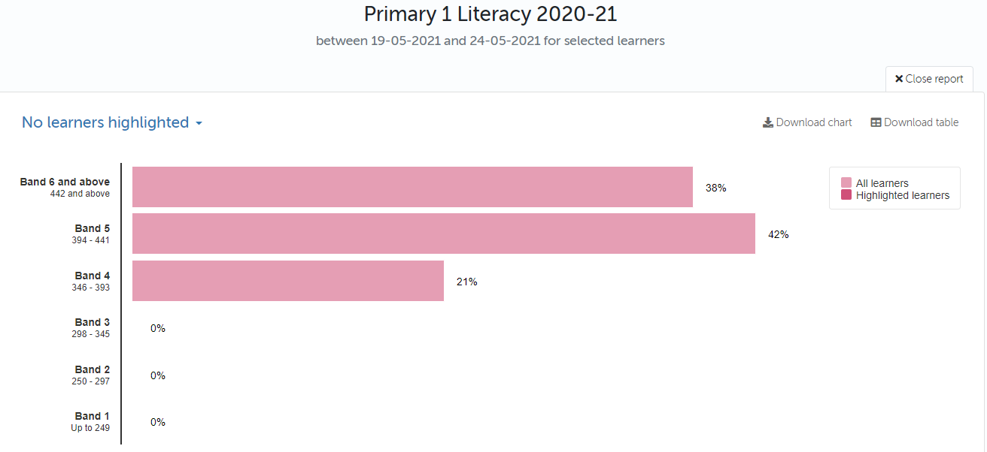  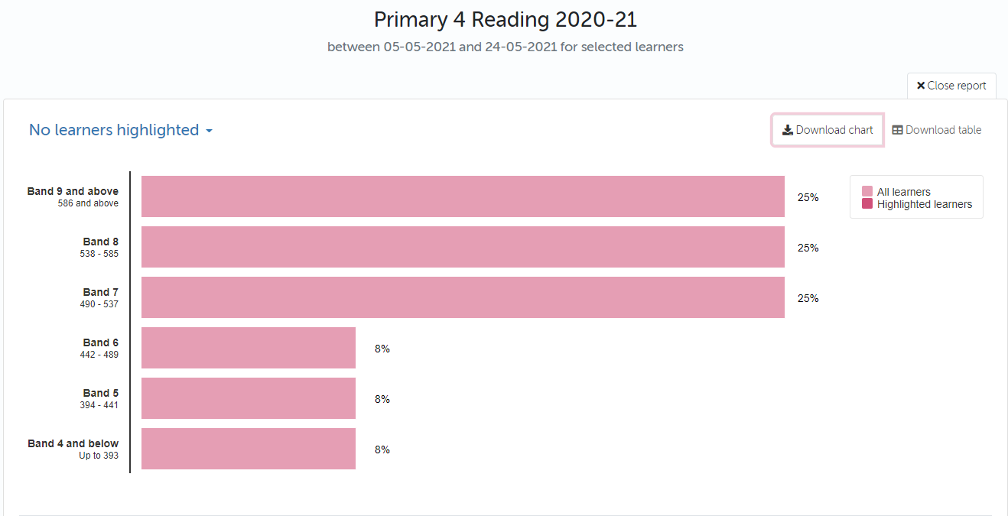  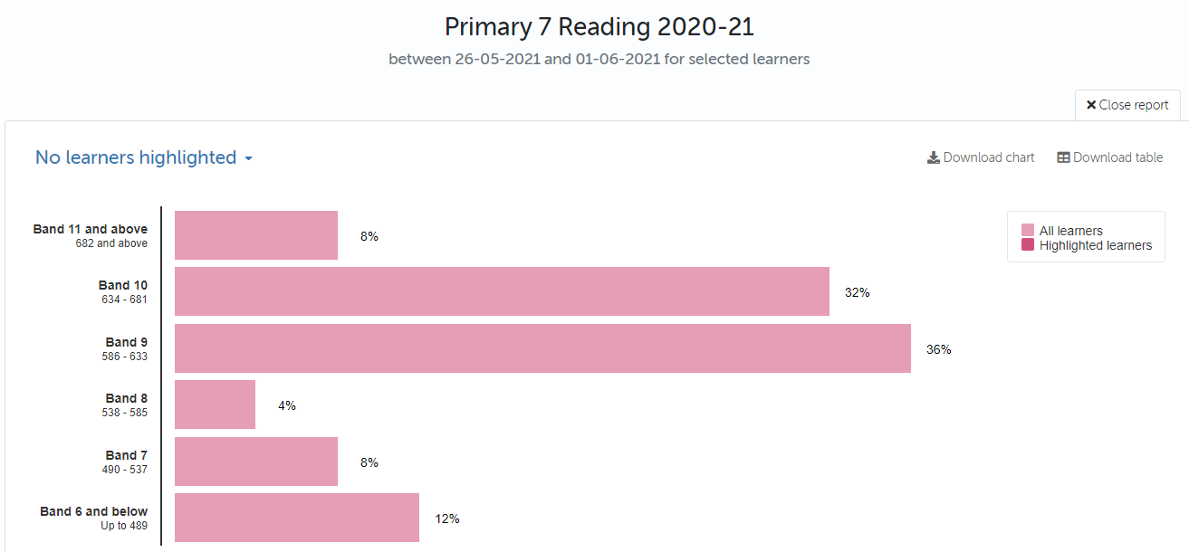  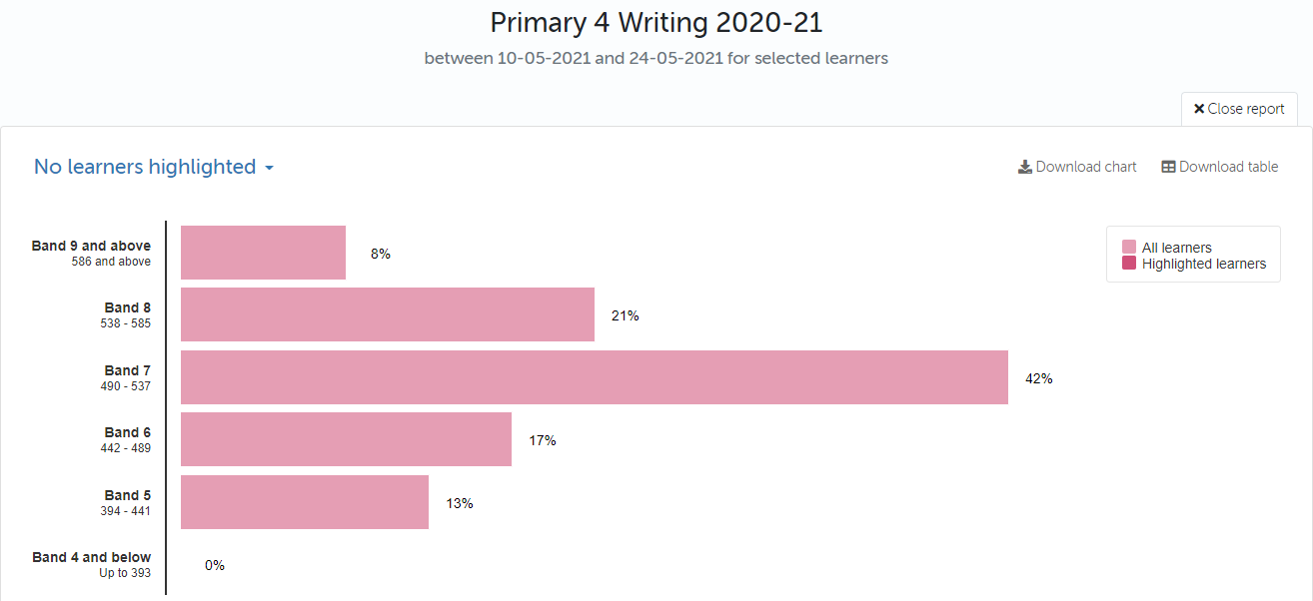  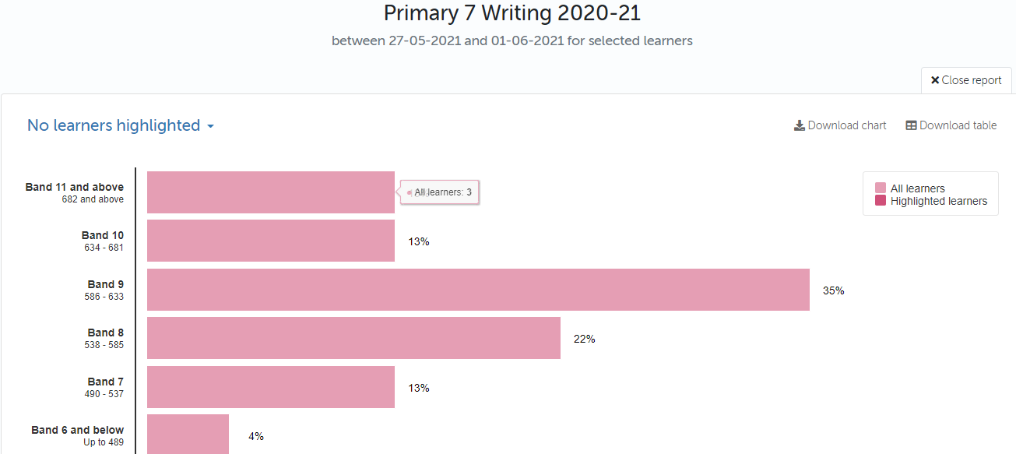  SNSA data (Numeracy)  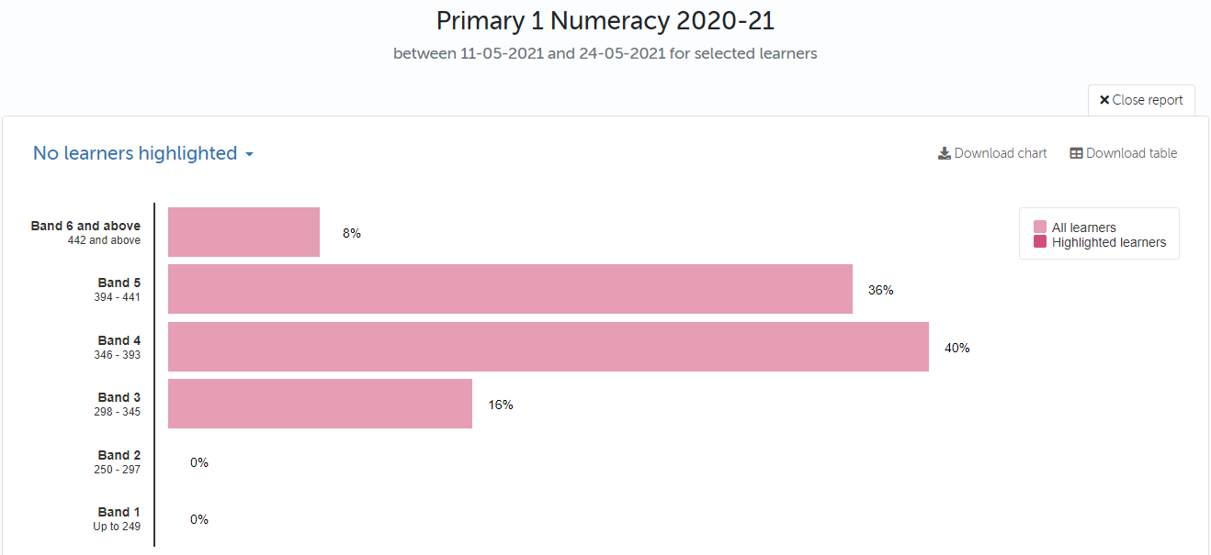  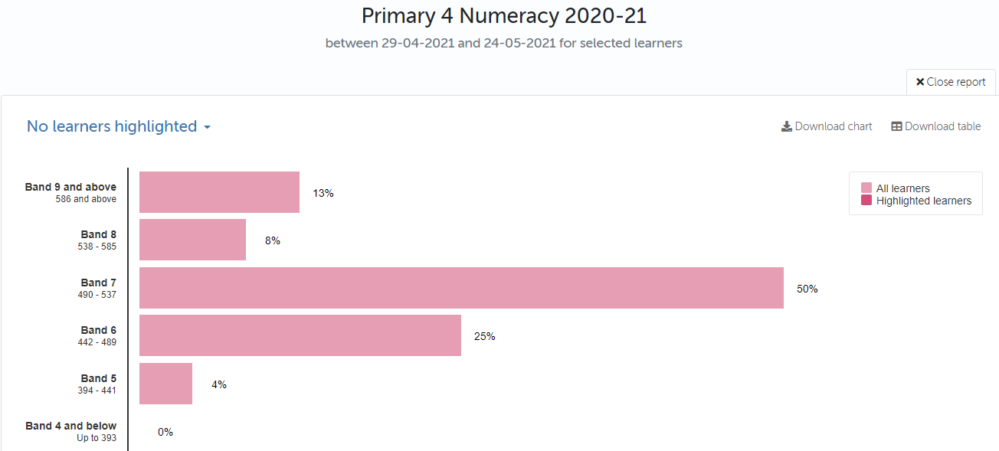  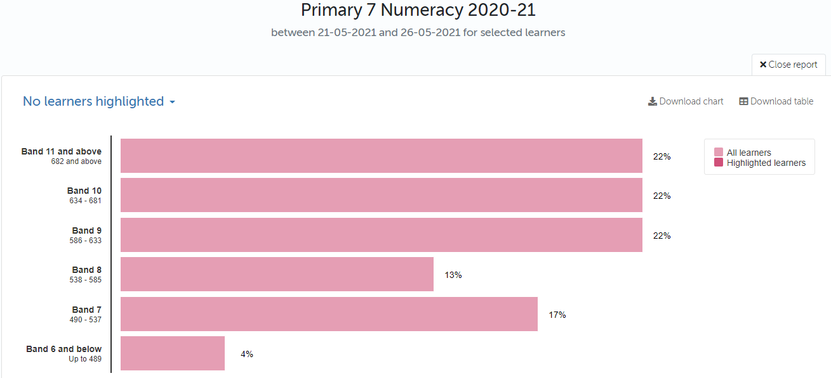 | Please detail evidence of impact here. This may be quantatitive e.g. data or qualititive e.g. feedback from stakeholders.  (See survey response on pages 5-10)  Staff were highly proficient delivering high quality live lessons 3 times per day during remote learning making the remote school day as close as possible to in school teaching and learning.  Staff provided high quality feedback to pupils.  Teachers submitted their identified CLPL development needs to HT in place of CAT nights.  100% of pupils had access to a device.Pupils were able to upload, save and submit work and use Read Write to overcome literacy barriers  Home learning toolkits were made available for pupils self isolating or for whom paper packs were preferred.  The nursery utilised Learning Journals to post high quality activities and keep in touch with families.  Standardised Spelling scores have dipped.  P2- 0% beyond level  23% on track  55% not yet on track  22% not on track  P3- 12% beyond level  36% on track  36% not yet on track  16% not on track  P4- 13% beyond level  42% on track  29% not yet on track  16% not on track  P5- 20% beyond level  35% on track  30% not yet on track  15% not on track  P6- 12% beyond level  32% on track  44% not yet on track  12% not on track  P7- 15% beyond level  30% on track  40% not yet on track  15% not on track  Standardised Reading scores have remained steady  P2/3A- 22% beyond level  48% on track  17% not yet on track  13% not on track  P2/3B- 5% beyond level  53% on track  31% not yet on track  11% not on track  P3/4- 4% beyond level  59% on track  25% not yet on track  12% not on track  P4/5- 5% beyond level  43% on track  33% not yet on track  19% not on track  P5- 17% beyond level  46% on track  37% not yet on track  0% not on track  P6- 20% beyond level  40% on track  40% not yet on track  0% not on track  P7- 15% beyond level  53% on track  19% not yet on track  11% not on track | Please list your new priorities under this heading. These will form the basis of your SIP for Session 21/22.  - Helpsheets/video/workshop on basic IT/pedagogy for parents  - Digital Schools Award  - Continued use of ICT across the curriculum  - Continued ICT training for staff, built into EIP and PRDs  - Increased use of ICT to support ASN  - PT to continue Google Educator and Google trainer course  - Google Classroom to be used for elements of homework programme and in class learning and teaching  - School ICT policy  - Continued use of Learning Journals extending to more robust tracking and monitoring  - Targeted use of data to identify gaps in learning and inform planning in order to plug the gaps  - Active spelling strategies fully utilised  - Intervention programmes in place for target groups  - Renewed focus on reading strategies  - Continued use of PM Benchmarking  - Quality Management Focus on pedagogical practice, pace, challenge and support  - Literacy Policy to be reviewed to include:  - Reading  - Writing  - Spelling  - Talking and Listening  - Resources (North Lanarkshire Active Literacy, Talk for Writing etc)  - Pedagogy  - Reading Culture  - Assessment and Moderation  - Interventions  - ASN  - Use of Technology  - More robust Tracking and Monitoring  - Target setting in Learning Journals  - Maths Policy to be reviewed to include  - Number, Money, Measure  - Shape, Position and Movement  - Information Handling  - Resources  - Pedagogy  - Assessment and Moderation  - Interventions  - ASN  - Use of Technology  - More robust Tracking and Monitoring  - Target setting in Learning Journals  - Focus on staff CLPL  - PRD to include maths target  - Roll out of Maths Recovery, Numicon and Concrete, Pictorial and Abstract Approach

