

.... where every learner is unique

Nursery Handbook

Contents

Section One Our Establishment Aims

Section Two General Information

- Hours of opening
- Daily sessions
- School holidays, Public holidays, Inservice days
- Admissions Policy
- Age range of children in establishment
- Numbers of children at each daily session and patterns of attendance
- Indoor shoes
- Suitable clothing
- Register of applicants
- Enrolment procedures
- Attendance
- Arrival and collection of children
- Safe Sleep Policy and Procedures
- Breastfeeding Friendly Policy
- Insurance
- Excursions and consent forms
- Transport
- Emergency closure arrangements
- Emergency contacts
- Lunches
- Snack and the promotion of healthy eating habits
- Accommodation for parents
- Parents Management Committee
- PACS – Parent and Child Support Group
- Smoking
- Child Protection
- Mobile Phones
- Sleep Policy

Section Three Medical Information
- Medication
- If your child becomes ill
- Minor accidents and upsets
- Visits to the establishment by medical staff

Section Four The Establishment Curriculum
- How we promote learning
- What we do
- Assessment
- Supporting children with difficulties
- Working together to support learning

Section Five Parental Partnership
- Working with you
- Support for Parents
- Working together to promote positive behaviour
- Information on adult groups
- Fund-raising

Section Six The Wider Community
- The establishment and the community
- Services within the community
- Links with primary schools

Section Seven Participation
- Participation Strategy

Section Eight Other Information
- Suggestions and complaints
- Useful addresses
- Disclaimer on changes to information given

Statement of Purpose and Improvement Objectives

The vision of South Lanarkshire Council is to ‘Work together to improve the quality of life for everyone in South Lanarkshire’.

The purpose of Education Resources is to support this vision through ensuring that all learners:

- are effectively supported to raise their attainment and achieve their full potential
- benefit from an appropriate range of learning opportunities which match their individual needs
- are actively engaged, as appropriate, in evaluating the quality and impact of their learning experiences
- are safe and feel valued when using Education Resources premises.

This will be achieved by ensuring that all learners:

- access a curriculum which reflects national and council priorities and best practice in education
- experience a motivated and professional workforce who demonstrate best practice in providing opportunities for learning
- have access to modern resources which are used effectively to maximise the impact of learning experiences
- benefit from partnership working and the integration of services.

Section One
EARLY LEARNING UNIT
VISION, VALUES AND AIMS

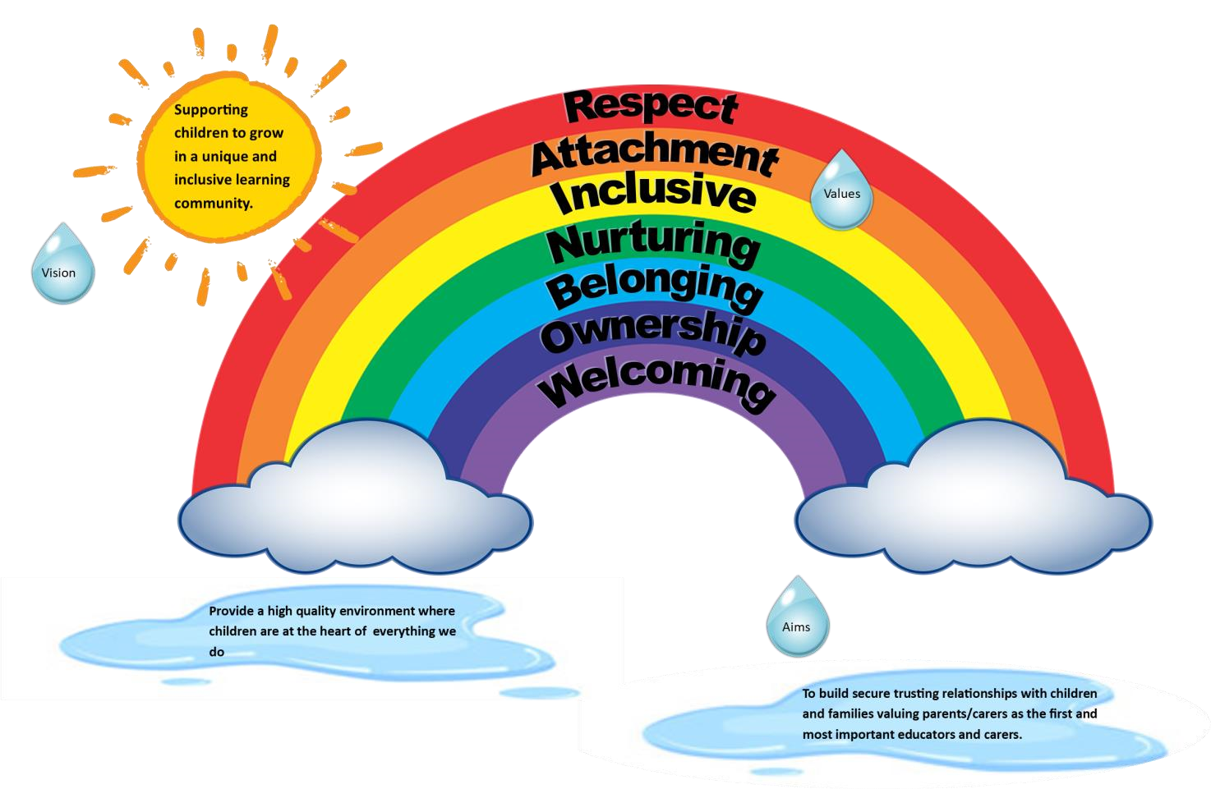

Non-denominational Policy of the Establishment
The establishment is non-denominational. We respect and welcome children and families of all religions, faiths and beliefs.

Our Equal Opportunities Statement.
All early years’ establishments should reflect the Council’s equal opportunities policies and be anti-racist, anti-sexist, multi-cultural and non-discriminatory. All early year's establishments also recognise the rights of both men and women to work or to care for children. Provision should take account of the needs of children with disabilities or chronic illness. These principles are reflected in the criteria used to admit children to nursery and in the curriculum of all establishments.

Address: Early Learning Unit
30 Hope Street
Hamilton
ML3 6AF
Telephone No: 01698 281 228
Email: gw14eluoffice@glow.sch.uk
Hours of Opening: 8.00am to 6.00pm

We are an extended day establishment open between 8.00am and 6.00pm, offering a flexible service to children aged 6 weeks until they start school 52 weeks per year. Sessions and any additional charges can be discussed with Debbie Shaw, Head of Integrated Unit or one of our Deputes if you require assistance

Holidays and Closure Dates

Information about school holidays, public holidays and in-service days is available on the South Lanarkshire Council website and should be checked regularly for the most up-to-date information.
To help families plan ahead, reminders of upcoming holidays, closure dates and in-service days will also be communicated through Learning Journals and other nursery communication channels where appropriate.
We encourage parents/carers to keep the nursery informed of any planned family holidays or periods of absence to ensure attendance records remain accurate. Any changes to published closure dates will be communicated to parents/carers as soon as possible.

Admissions Policy.

Applications are considered according to a series of priority groups.
Priority 1 is given to children who may be vulnerable or require additional support, including children who:
- Are affected by abuse, domestic violence, substance misuse, or disability within the home.
- Have additional support needs.
- Are looked after, accommodated, or subject to a Kinship Care Order.
- Have refugee status.
- Have parents who are care experienced.
- Meet the criteria for funded two-year-old provision (where applicable).
Applications within Priority 1 must be supported by an appropriate wellbeing or single-agency assessment.
For all other children, places are allocated according to age, stage, residency, and the nature of the application (new application or transfer request). Priority is generally given to:
- Eligible children living within South Lanarkshire.
- Children in their pre-school year.
- Children in their ante pre-school year.
- Transfer requests where there has been a significant change in circumstances.
- Children living outwith South Lanarkshire but within the catchment area of a South Lanarkshire primary school.
- Children living outwith South Lanarkshire Council area.

Additional Hours
Once all eligible children have been allocated their funded entitlement, additional hours may be offered. These are prioritised as follows:
- Children in Priority 1.
- Children whose parent(s)/carer(s) are in employment, training, or education.
- All other children.

Important Information
- Access to ELC is available regardless of age, gender, race, religion, or additional needs.
- Provision is offered on a non-denominational basis.
- Children deferring entry to Primary 1 are regarded as returning children.
- Transfer applications are considered within the relevant academic year only.
- Where possible, siblings and multiple birth children will be offered the same attendance pattern within the same nursery.
- Blended placements across two providers can be arranged by agreement.
- Bespoke attendance patterns may be considered where practical.
- Applications for Cross Border Funding are considered through the Council's Cross Border Funding Protocol arrangements.

For full details of the admissions process, families should refer to the South Lanarkshire Council Early Years Admissions Policy.

Enrolment Procedures.

Once your child has been allocated a place, a member of staff will contact you to confirm your email address you will then receive an email to arrange the enrolment process and agree a start date. Before your child begins nursery, you will be invited to attend a Stay and Play session. This provides an opportunity for you and your child to visit the nursery together, meet staff, explore the learning environment and become familiar with the daily routine.

We also offer a home visit, which is normally arranged for the day before your child's start date. The home visit allows nursery staff to get to know your child in a familiar environment, share information about the nursery, answer any questions you may have and help ensure a smooth transition into nursery life, this is also an opportunity to complete enrolment forms and discuss care plans

To support children in settling happily and confidently into nursery, we operate a staggered induction programme. A small group of children start every few days, enabling staff to give each child and family individual attention during the transition period.

Emergency Contact Information

The safety and wellbeing of children is our highest priority. We ask all parents/carers to provide the nursery with the details of at least two emergency contacts who can be contacted if a parent/carer is unavailable.
Emergency contacts should be adults who:
- Are known to the child.
- Can be contacted quickly in an emergency.
- Are able to collect the child from nursery if required.

It is essential that parents/carers keep all contact information up to date, including home addresses, telephone numbers, mobile numbers and emergency contact details. Any changes should be reported to the nursery as soon as possible. Having accurate and current emergency contact information ensures that we can respond promptly and effectively should an emergency arise during your child's time at nursery.

Settling in Procedure

We recognise that starting nursery is a significant milestone for both children and their families. We aim to make this transition as positive and supportive as possible by working closely with parents and carers to develop a settling-in approach that meets each child's individual needs. Prior to starting nursery, staff will discuss the settling-in process with parents/carers and agree arrangements that will help their child feel safe, secure and confident.

On their first day, children will attend for one hour, with their parent/carer remaining within the nursery building throughout the session, if your child was not settling, we would shorten this time appropriately. This allows children to explore the environment, become familiar with staff and begin building positive relationships while knowing their parent/carer is nearby. Following the initial session, staff and parents/carers will review how the child has settled and agree the next steps together. The length and frequency of future sessions will be carefully planned according to the child's individual needs, ensuring that the transition into nursery takes place at a pace that is comfortable and appropriate for them. If your child is transported to nursery, this will not start until at least two weeks after their start date. We recognise that every child is unique, and our flexible, child-centred approach helps ensure that children develop confidence and feel happy, secure and ready to engage in nursery life.

Numbers of Children and Patterns of Attendance

Our nursery is registered to accommodate up to 116 children at any one session across a range of specialised and mainstream learning environments. Children are grouped according to their age and individual needs to ensure they receive the highest quality care, support and learning experiences.
The nursery includes the following rooms:

Butterfly Room
- Up to 20 children
- For children aged 3–5 years
- Provision for children with additional support needs
Caterpillar Room
- Up to 10 children
- For children aged 2–5 years
- Provision for children with additional support needs
Grasshopper Room
- Up to 6 children
- For children aged 0–5 years
- Provision for children with additional support needs
Ladybird Room
- Up to 64 children
- For children aged 2–5 years
- Includes places for:
  - 10 two-year-olds
  - 54 three to five-year-olds
Bumble Bee Room
- Up to 10 children
- For children aged 2–3 years
Dragonfly Room
- Up to 6 children
- For children aged 0–2 years

Attendance Patterns

Session times and attendance patterns vary depending on your child's age, stage of development and allocated place. Individual attendance arrangements, including funded entitlement and any agreed patterns of attendance, will be discussed with you during the enrolment process. Where possible, we will work with families to accommodate individual circumstances and support children's wellbeing, learning and development. Requests for attendance beyond a child's funded entitlement may be available, subject to capacity, and may incur a charge. Where additional hours are agreed, parents/carers will receive a contract outlining the attendance pattern, terms and conditions, and any costs payable. Information about current charges will be provided before any contract is agreed.

Suitable Clothing.

Children learn best through active, hands-on experiences and often enjoy a wide range of messy, creative and outdoor activities. While we encourage children to wear aprons during messy play, accidents do happen, so we ask that children come to nursery dressed in comfortable, practical clothing that can be easily washed. Outdoor play is an important part of our daily routine and children access the outdoor environment in most weather conditions. Please ensure your child has appropriate outdoor clothing, including a waterproof jacket and suitable footwear. During warmer weather, we ask that every child has a sunhat clearly labelled with their name. Sunhats should be kept in your child's personal tray, so they are readily available when needed. We also ask that parents/carers provide a complete change of clothes, including:

- Tops
- Trousers/leggings
- Underwear
- Socks

These should be kept in your child's bag and stored on their peg. Having spare clothing available helps staff support children's comfort and independence throughout the day. Please ensure that all clothing, footwear and personal belongings are clearly labelled with your child's name to help us return items quickly if they become misplaced.

Attendance.

Regular attendance at nursery is important as it helps children build positive relationships, develop confidence and fully benefit from the learning experiences and opportunities provided. Many learning experiences are planned over a period of time, with learning from one day often being revisited and extended on subsequent days. Establishing good attendance habits also helps prepare children for the transition to primary school.

The nursery has a responsibility to ensure the wellbeing and safety of all children. If a child is absent and we have not been informed of the reason, nursery staff will attempt to contact parents/carers. If we are unable to make contact, we may contact the child's emergency contacts to confirm their whereabouts and wellbeing. Parents/carers are also asked to keep the nursery informed of any planned holidays or extended absences. Where a child's place is not being used regularly and no satisfactory explanation has been provided, the nursery may review the placement. In some circumstances, and following discussion with the family, a nursery place may be withdrawn to allow it to be offered to another child requiring a place.

Arrival and Collection of Children.

To ensure the safety and wellbeing of all children, it is expected that a responsible adult, aged 16 years or over, brings children to and collects them from nursery. On arrival, you and your child will be welcomed by a member of staff who will record your child's attendance on the daily register. If someone different is collecting your child, parents/carers must inform the nursery in advance. This helps us ensure children's safety and avoid situations where staff are unable to release a child because the adult is not known to them. As part of our collection procedures, parents/carers will be asked to provide a family password when their child starts nursery. If an unfamiliar adult arrives to collect a child, staff may ask for this password as an additional security measure. However, a child will not be released solely on the basis of a password. Staff will contact the parent/carer to verify the identity of the person collecting the child and confirm that arrangements have been made before allowing the child to leave the nursery.

For children who travel to and from nursery by taxi or bus, parents/carers are responsible for notifying the transport provider directly of any changes to collection or drop-off arrangements. We also ask that the nursery is informed of any significant changes that may affect your child's attendance. These procedures help us maintain a safe and secure environment for all children in our care.

Safe Sleep Policy

Our safe sleep procedure follows national guidance from the Care Inspectorate and Cot Death Trust to provide a calm, secure, and supportive environment for your child's rest. We strictly adhere to a child-led approach, meaning a child’s sleep will never be unnecessarily disturbed, and the nursery will not force a child to stay awake if they are tired, as rest is vital for their physical and mental development. To ensure the highest safety standards, children are placed to sleep on their backs in the "feet to foot" position within a clear sleep space free from bibs, toys, or cot bumpers. We maintain a well-ventilated room temperature between 16°C and 20°C and use waterproof, disinfected mattresses with light, breathable blankets. Every sleep session is formally recorded, with staff conducting physical checks every 15 minutes to monitor the child's breathing, position, and well-being. The full Safe Sleep Policy is available on request.

Breastfeeding Friendly Awareness Policy

We are committed to providing a nurturing and inclusive environment for all breastfeeding families. We welcome breastfeeding in all areas of the nursery and provide quiet, private spaces for those who prefer them. To support you, we offer comfortable seating, access to water, and temporary milk storage if required. Our staff are trained to offer respectful support, particularly during your child’s settling-in period. The full Breastfeeding policy is available to all families.

Personal Belongings and Toys

Children sometimes enjoy bringing a special item from home to share with their friends and talk about during nursery sessions. While we welcome opportunities for children to share their interests and experiences, we ask parents/carers to consider carefully whether items are suitable for nursery and to avoid sending valuable or irreplaceable belongings.

Please note that the nursery and South Lanarkshire Council cannot accept responsibility for the loss, damage or theft of personal items brought from home. To help prevent items from being misplaced, we recommend that personal belongings brought to nursery are clearly labelled with your child's name.

Community Visits, Partnerships and Educational Excursions

We place great value on helping children develop a sense of belonging within their local community. Through a range of community partnerships and real-life learning experiences, children have opportunities to explore the world around them, develop social skills, and make meaningful connections with local people and services. As part of our curriculum, children may take part in regular visits within the local community, including walks to nearby parks, shops, cafés, libraries and other community facilities. These experiences support children's learning and development by helping them understand their local environment, develop independence, and build confidence in a variety of social situations.

We work closely with a range of community partners to enhance children's learning experiences and foster positive links between the nursery and the wider community. Visits and visitors help children learn about different roles within society and contribute to their understanding of the world around them.
To allow children to participate in local community visits within walking distance of the nursery, parents/carers are asked to provide consent as part of the enrolment process. Details of these local outings are covered within the enrolment documentation.

Children also have opportunities to participate in our Forest Kindergarten programme, where they engage in regular outdoor learning experiences within natural environments. Forest Kindergarten sessions encourage children to develop confidence, resilience, creativity and problem-solving skills through hands-on exploration and play. These visits support children's physical wellbeing, promote a connection with nature, and provide rich opportunities for learning across all areas of the curriculum.

For visits that involve transport, longer journeys or day trips further afield, additional information and a separate consent form will be provided in advance. Parents/carers will be fully informed about the purpose of the visit, travel arrangements and any specific requirements before permission is requested.
All visits and outings are carefully planned, risk assessed and supervised to always ensure children’s safety and wellbeing.

Transport Arrangements

Transport is not normally provided for children attending Early Learning and Childcare establishments. However, in some circumstances, South Lanarkshire Council may provide transport for children with additional support needs where attendance at a specialist placement requires travel beyond their local area.
Where transport has been arranged, children will travel in appropriately equipped vehicles with suitable seating, harnesses or restraints, as required. An escort will normally accompany children during their journey to help ensure their safety and wellbeing.

Parents/carers are encouraged to discuss transport arrangements with nursery staff if they have any questions or concerns. If you have any worries regarding your child's safety, seating arrangements or transport provision, please do not hesitate to contact the Head of Integrated Unit, who will be happy to discuss these with you. We work closely with families and transport providers to ensure that children travel safely and comfortably to and from nursery.

Parking and Drop-Off Arrangements

To help ensure the safety of children, families and staff, we ask all visitors to follow the nursery's parking and drop-off procedures. Designated parking spaces are available for parents/carers when dropping off and collecting children from nursery. There are two designated accessible parking spaces within the car park. These spaces should only be used by Blue Badge holders.

Vehicles transporting children to and from nursery, including buses and taxis, have dedicated parking bays clearly signposted as the "Bus and Car Drop Off Area." To ensure safe access for children, parents/carers must not park in these spaces. All other parking spaces within the car park are reserved for staff use only.
We ask all drivers to park considerately, follow any signage, and take extra care when moving around the nursery grounds, particularly during busy arrival and collection times. Your cooperation helps us maintain a safe environment for everyone in our nursery community.

Unexpected Nursery Closures

We make every effort to ensure that the nursery remains open during the published opening hours. However, there may be occasions when circumstances beyond our control require the nursery to close temporarily or alter its normal operations.

Examples of situations that may lead to a closure include:
- Severe weather conditions
- Power or utility failures
- Transport disruptions
- Building emergencies or health and safety concerns
- Other unforeseen circumstances

Should a closure be necessary, we will communicate information about the closure and any arrangements for reopening as quickly as possible. Parents/carers will be kept informed through a range of communication channels, which may include:
- Telephone calls or text messages
- Learning Journals
- Blue Sky
- South Lanarkshire Council's website
- Local radio stations
- Local news outlets, where appropriate

We appreciate the support and understanding of families during any periods of disruption and will endeavour to provide timely updates whenever

Lunches

Most children attend nursery for half-day sessions and therefore do not require a lunch while attending.
Children aged 2 years and over who attend on a full-day basis are entitled to a nursery lunch. A variety of nutritious hot and cold meal options are available, and menus will be shared regularly with families.
Children under 2 years of age should bring a packed lunch from home. We ask that packed lunches are clearly labelled with your child's name and include an ice pack where required to keep food fresh.
If your child is going to arrive later than their normal start time and requires a nursery lunch, parents/carers should telephone the nursery as early as possible to notify staff and place a lunch order, the latest time to order lunch is 10.30am. This helps ensure that an appropriate meal is available for your child on arrival. We are committed to promoting healthy eating and ensuring that all children have a positive lunchtime experience in a safe, relaxed and supportive environment.

Smoke-Free Environment

To promote the health, safety and wellbeing of all children, families and staff, the nursery operates a strict smoke-free policy. Smoking is not permitted anywhere within the nursery building or grounds, including entrances, pathways, car parks and outdoor play areas. This policy also applies to electronic cigarettes (e-cigarettes), vaping devices and similar products. This is particularly important as we have oxygen within the building. We appreciate the cooperation of all visitors in helping us maintain a healthy, smoke-free environment for everyone.

Animals in the Nursery

Animals can provide valuable learning experiences for children; however, to ensure the health, safety and wellbeing of all members of our nursery community, animals are not permitted within the nursery building or grounds without prior agreement from the nursery management team. Any planned visits involving animals will be carefully considered and risk assessed, with appropriate information shared with families where necessary.

Mobile Phones and Electronic Devices

To protect the privacy, safety and confidentiality of children, families and staff, the use of mobile phones and personal electronic devices is restricted within the nursery. Parents, carers and visitors are asked not to use mobile phones, tablets or other devices capable of taking photographs or recordings within nursery playrooms, corridors or outdoor areas. Mobile phones may only be used within the Parents' Room or Staff Room. We appreciate your support in helping us safeguard all children and maintain a secure environment.

Nut-Free Environment

The nursery is a nut-free environment due to severe allergies experienced by some children and adults within our setting. Parents/carers are asked not to send any foods containing nuts into nursery, including packed lunches, snacks, or other food items. This includes products that contain nuts as ingredients, as well as foods labelled as containing traces of nuts where possible. We kindly ask all families to check food labels carefully before bringing any food items into the nursery. Your cooperation is essential in helping us minimise the risk of allergic reactions and ensure that the nursery remains a safe and inclusive environment for all children.

Child Protection and Safeguarding

The safety and wellbeing of all children is our highest priority. Nursery staff have a professional and legal responsibility to safeguard children and protect them from harm. All staff receive regular child protection and safeguarding training and are required to follow South Lanarkshire Council's Child Protection Procedures and national guidance. Staff are expected to remain vigilant and respond appropriately if they have concerns about a child's welfare. Debbie Shaw, Head of Integrated Unit, is the designated Child Protection and PREVENT Co-ordinator within the Early Learning Unit. In her absence, concerns should be reported to the Early Years Deputes, Rebecca Murray or Nicola Greig, who will take appropriate action in line with nursery procedures and local authority guidance.

If a member of staff has concerns that a child may be at risk of harm, they have a duty to share this information with the Child Protection Co-ordinator. The concern will be assessed and, where necessary, advice will be sought from, or a referral made to, Social Work Services and other relevant agencies to ensure the child receives appropriate support and protection.

Child protection concerns may relate to any form of abuse or harm, including:
- Physical Abuse – causing physical injury or harm to a child.
- Emotional Abuse – persistent emotional ill-treatment that affects a child's emotional development and wellbeing.
- Sexual Abuse – involving a child in inappropriate sexual activity or behaviour.
- Neglect – the persistent failure to meet a child's basic physical and/or emotional needs.

We recognise that safeguarding children is a shared responsibility and work closely with families and partner agencies to promote children's wellbeing and ensure they are safe, healthy, nurtured, achieving, active, respected, responsible and included. The nursery also has a responsibility under the PREVENT Duty to help safeguard children from radicalisation and extremism. Staff are trained to recognise potential concerns and to respond appropriately in accordance with national and local guidance.

Copies of the nursery's Child Protection and Safeguarding Procedures are available for parents/carers on request and can be accessed within the nursery. If you have any questions regarding child protection or safeguarding procedures, please speak to Debbie Shaw, Head of Integrated Unit, or in her absence, Rebecca Murray or Nicola Greig.

Section Three: Health, Medication and Medical Information

The health, safety and wellbeing of all children is a priority within the ELU. To help us provide appropriate care, parents/carers must ensure that staff are kept informed of any medical conditions, allergies or health concerns affecting their child.

Medication

If your child requires medication during their time at nursery, this should be discussed with the Head of Integrated Unit or a member of the nursery management team before the medication can be administered.

All medication brought into the nursery must:
- Be prescribed for the child (excluding nappy cream which does not contain a steroid).
- Be in its original container.
- Have a pharmacy prescription label clearly showing the child's name, dosage and instructions for use.
- Be handed directly to a member of staff.

Where a child may require emergency medication or ongoing medical intervention, an individual healthcare Protocol/Care Plan will be completed in partnership with parents/carers and relevant health professionals. To ensure information remains accurate and up to date, these plans must be reviewed and updated every 28 days.

Parents/carers must also inform the nursery if their child:
- Has asthma and there are specific activities, environmental factors or circumstances that may trigger an attack.
- Has epilepsy or any other medical condition requiring emergency intervention.
- Has allergies, including food allergies, medication allergies or allergies to environmental factors.
- Has any additional healthcare needs that may impact on their time at nursery.

If Your Child Becomes Unwell

If your child is unable to attend nursery due to illness, parents/carers should contact the nursery as soon as possible and no later than 9.30am for morning sessions or 1.30pm for afternoon sessions.
If your child becomes unwell while attending nursery, staff will contact a parent/carer and request that the child is collected. If parents/carers cannot be reached, we will contact the child's emergency contacts.
It is therefore essential that all contact information is kept up to date and that emergency contacts are available should the need arise.

Accidents, Incidents and Upsets

Despite our best efforts to provide a safe environment, minor accidents, bumps and upsets can occasionally occur as children learn, play and explore. Qualified first aiders are available within the nursery and will provide appropriate first aid, reassurance and comfort when required. Parents/carers will be informed of any accident or incident involving their child and an accident form will be completed for acknowledgement and signature.
Where an injury involves a bump, knock or injury above the neck, parents/carers will be contacted as soon as possible. For children who travel by taxi or other transport arrangements, a copy of the accident form will be sent home in their nursery bag. Parents/carers are asked to sign and return the form at the earliest opportunity.

Visits from Health Professionals

From time to time, healthcare professionals and Health Board staff may visit the nursery to support children's health and wellbeing. These visits may include observations, assessments, health promotion activities or individual support for children. Parents/carers will be informed whenever their child is directly involved in any health-related assessment, intervention or visit.

Sickness and Diarrhoea

To help prevent the spread of infection and protect the health of all children and staff, the nursery follows current NHS guidance relating to gastrointestinal infections.
Children who have experienced vomiting, and/or diarrhoea must remain away from nursery until they have been symptom-free for 48 hours after their last episode of vomiting and/or diarrhoea.
We appreciate the support of families in following this guidance to help maintain a healthy environment for everyone within the nursery. Please follow the link to find out more information: Is my child too ill for school? - NHS

Section Four: Curriculum Rationale
. 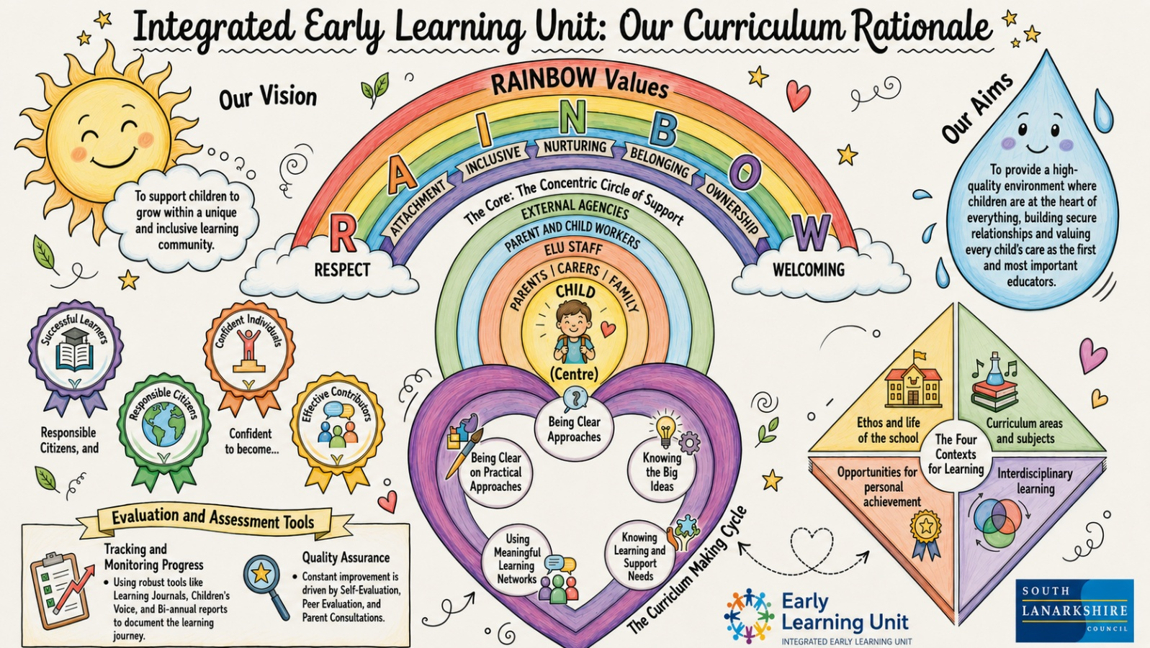

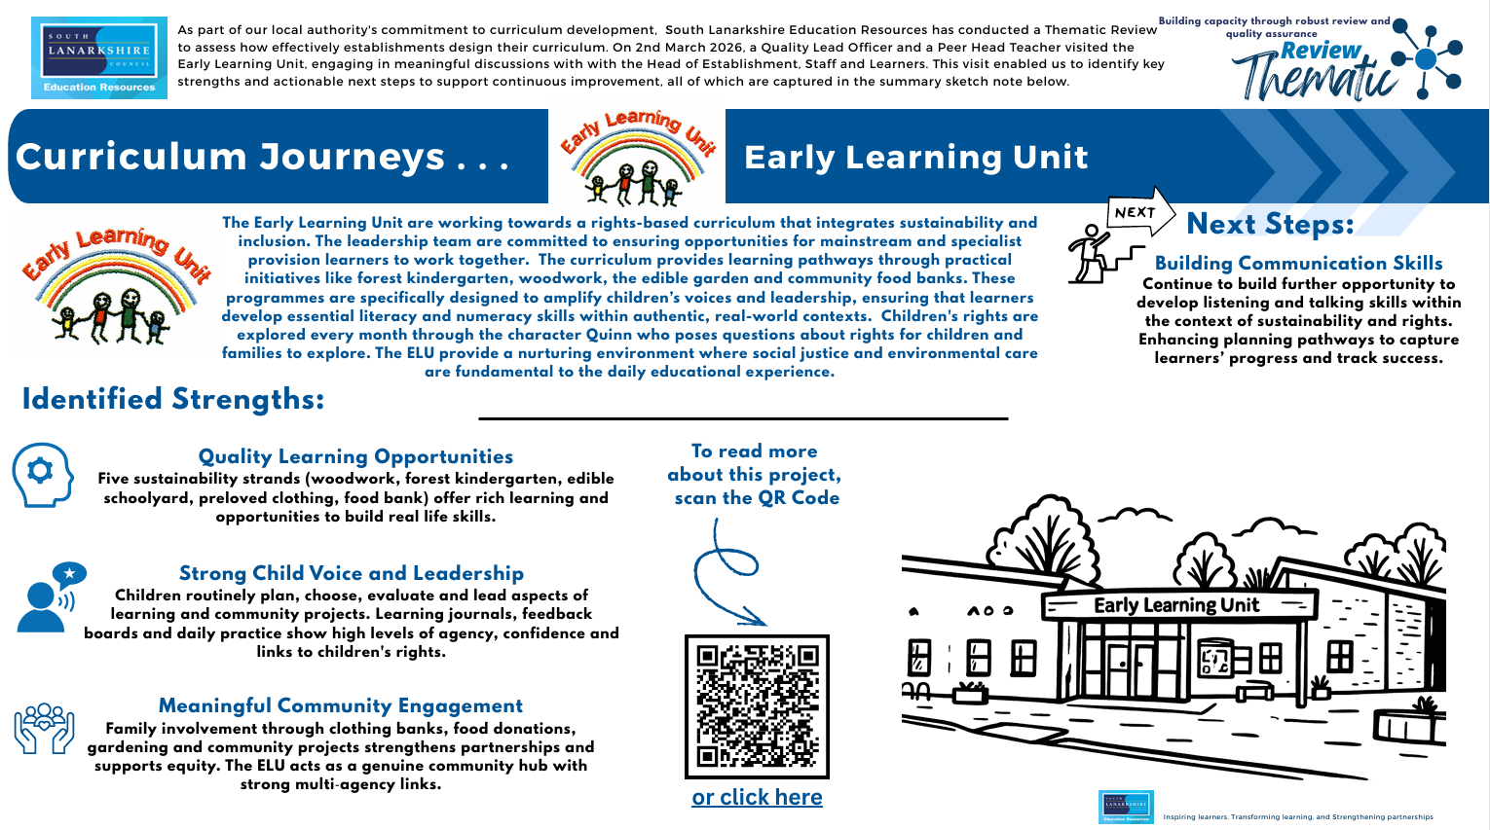

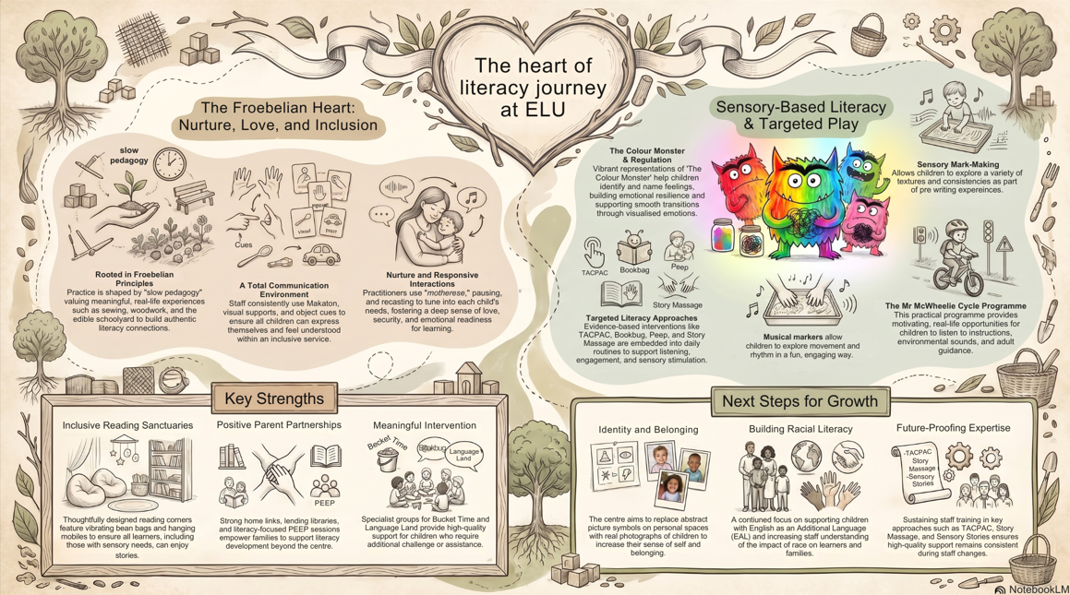

Section Five: Parental Engagement and Involvement

Parental Engagement and Involvement

We believe that children achieve the best outcomes when families and nursery staff work together in partnership. Positive relationships between home and nursery help children feel secure, supported and confident in their learning and development.

Parental engagement refers to the meaningful involvement of parents and carers in their child's learning and development. This includes the interest, encouragement and support provided at home and through ongoing communication with nursery staff.

Parental involvement refers to the active participation of parents and carers in the life of the nursery. This may include attending events, sharing skills and experiences, taking part in learning activities, supporting outings or contributing to nursery improvement and decision-making.

We value the important role that parents and carers play as their child's first and most influential educators. We therefore encourage families to be actively involved in nursery life and to work in partnership with staff to support each child's learning journey.
There are many opportunities for parents and carers to become involved, including:

- Sharing information about their child's interests, achievements and wellbeing.
- Contributing to learning journals and observations.
- Participating in Stay and Play sessions and family learning events.
- Attending meetings, consultations and information sessions.
- Joining celebrations, nursery events and community activities.
- Sharing skills, hobbies, cultures or experiences with children.
- Providing feedback to help us evaluate and improve our service.

We encourage parents and carers to speak with staff about ways they can become involved in their child's learning and in the wider life of the nursery. If you have any questions regarding parental engagement or involvement, please feel free to speak to a member of staff when dropping off or collecting your child.

Support for Parents and Families

The nursery has a Parent and Child Support (PACS) Worker who works closely with children, families and staff to promote positive outcomes for children and provide additional support where required.
The Parent and Child Support Worker primarily supports families of children with Additional Support Needs, offering practical guidance, advice and emotional support. This may include support with:

- Promoting learning and development at home.
- Play experiences and activities.
- Behaviour support strategies.
- Building routines and independence skills.
- Signposting to other services and support agencies.
- Supporting transitions and family wellbeing.

Support is tailored to the individual needs of children and families and is provided through partnership working with parents, carers and other professionals where appropriate. Our aim is to build strong, trusting relationships with families and ensure that every parent and carer feels valued, supported and included as an important part of our nursery community.

Working Together to Promote Positive Relationships and Understanding Distressed Behaviours

Nurture, Wellbeing and Positive Relationships

At our Early Learning Unit, we are committed to providing a nurturing, inclusive and emotionally supportive environment where every child feels safe, valued and understood. Our approach is underpinned by the Six Principles of Nurture, which recognise that children's wellbeing, relationships and emotional development are fundamental to their ability to learn and thrive.
We understand that all behaviour is a form of communication. Children may at times experience strong emotions and display dysregulated behaviours when they are finding it difficult to express their needs, feelings or experiences. Our role is to respond with empathy, patience and understanding, helping children to identify, manage and regulate their emotions while developing positive relationships and resilience.
Staff work closely with children and families to develop trusting relationships and to gain an understanding of each child's individual needs, interests and circumstances. Through consistent routines, responsive interactions and supportive guidance, we help children feel secure and develop a strong sense of belonging within our nursery community.
Children are provided with a range of opportunities and spaces to support emotional regulation and wellbeing. These include our Nurture Nook, as well as our Dark Sensory Room and Light Sensory Room, which offer calm, supportive environments where children can regulate, relax and re-engage with learning at a pace that is appropriate for them. These spaces are used proactively to support wellbeing and self-regulation and are available throughout the nursery day as required.
Where additional support is needed, staff work in partnership with parents/carers and, when appropriate, other professionals to ensure a consistent and nurturing approach between home and nursery. By working together, we aim to help every child develop confidence, emotional literacy, self-esteem and the skills needed to build positive relationships and succeed in their learning.
Our nurturing approach reflects our belief that children's learning is understood developmentally, that nurture is important for wellbeing, that all behaviour is communication, and that transitions are significant in the lives of children. Through these principles, we strive to create an environment where every child can feel safe, respected, included and ready to learn.

Section Eight: Other Information.

Suggestions, Feedback and Complaints

We are committed to providing a high-quality service and continually improving the experiences we offer to children and families. We welcome feedback from parents and carers and value suggestions that help us reflect on and develop our practice.
If you have any suggestions, comments or ideas about any aspect of the nursery, we encourage you to speak to the Head of Integrated Unit in the first instance. Alternatively, suggestions can be submitted confidentially using the suggestion box located within the nursery.
We believe that concerns are best addressed through open and respectful communication, and we aim to resolve any issues promptly and fairly. If you have a concern or complaint about any aspect of the service, we encourage you to discuss this with the Head of Integrated Unit as soon as possible. In most cases, concerns can be resolved informally through discussion and partnership working.
Should you feel that your concern has not been resolved satisfactorily, or if you would prefer to speak to someone else, you may contact the Early Learning and Childcare Locality Lead Officer for further advice and support.

Janice Tod
Education Resources
Almada Street
Hamilton
ML3 0AE
Tel No: 01698 454973

Care Inspectorate
We hope that any concerns or complaints can be resolved quickly and positively through discussion with nursery staff, the Head of Integrated Unit, or the Early Learning and Childcare Locality Lead Officer. However, parents and carers also have the right to raise concerns directly with the Care Inspectorate, which regulates and inspects care services in Scotland.
The Care Inspectorate welcomes feedback about the quality of care and support provided by registered services and can offer advice on the complaints process.

Care Inspectorate
Compass House
11 Riverside Drive
Dundee
DD1 4NY
Telephone: 0345 600 9527
Website: www.careinspectorate.com
Online Complaints: www.careinspectorate.com

The Care Inspectorate registers and inspects all services under Public Services Reform (Scotland) Act 2010 and the Social Work Improvement Scotland (Applications and Registration) Regulations 2011. It inspects services to make sure they are meeting regulation and doing so takes account of National Care Standards. Any person making a complaint to any of the above will be informed of the action (if any) that is to be taken within 20 days of the complaint being made.

Useful Contacts
The following contact details may be helpful should you require advice, support or information relating to your child's education, wellbeing or development.

Educational Psychology Service
The Educational Psychology Service works with children, families and educational establishments to support children's learning, wellbeing and development.

Hamilton Area Team
Telephone: 01698 455400

East Kilbride Area Team
Telephone: 01355 807000

Lanark Area Team
Telephone: 0303 123 1008

Social Work Services
Social Work Services provide support to children, young people and families across South Lanarkshire.
Hamilton, Blantyre, Larkhall, East Kilbride and Clydesdale Local Area Teams
Telephone: 0303 123 1008

Further Information
While every effort has been made to ensure that the information contained within this handbook is accurate at the time of publication, policies, procedures, contact details and service arrangements may be subject to change.
Should any significant changes occur before your child's placement begins or during their time at the Early Learning Unit, parents and carers will be informed as soon as possible. The Head of Integrated Unit will communicate any important updates and ensure that families receive the most current information available.
We look forward to working in partnership with you to support your child's learning, development and wellbeing throughout their time at the Early Learning Unit.



Education Resources

Privacy Notice

Introduction
In line with the General Data Protection Regulation (GDPR) we have produced this privacy notice to inform you how we deal with personal information as part of our statutory function as an education authority.

The Council has a legal obligation to deliver effective education services to children, young people and adult learners in South Lanarkshire. In order to do this we need to collect personal information about children, young people and their families so that we can help them to learn and keep them safe.

Using your personal information
The Council is a “controller” of the personal information you provide when enrolling for a nursery or school, applying for an education service or participating in groups or activities provided by Education Resources.

Information we collect from you about you and your child at enrolment When you enrol for a nursery or school, we ask for the following information:
- parent/carer contact details (name, address, phone, email);
- the child’s name, date of birth, gender and address;
- information about medical conditions, additional support needs, religion and ethnicity.
- any information you may wish to provide about family circumstances.
Information we collect at other times
We will also collect information at other times such as when you apply for a benefit, request a services or other support. We will provide an additional privacy notice at these times.
- When you apply for an education service or benefit, such as school transport, free school meals, clothing grant, placing request or EMA, we will also ask for personal information as set out above. We will also ask for information about your income for education benefits applications.

- If you make a request for additional support such as an educational psychologist or other support for learning, we will ask for more detailed information to allow us to provide the most appropriate support for your family. This may include information about family circumstances or medical conditions.

- If you wish to participate in activities or support for young people through our youth centres, or through adult learning programmes within the community, we will also ask for your personal information to support your application. This may include information about family circumstances or medical conditions.

We require this information to ensure that children and young people are educated appropriately, supported, and that we take account of their health and wellbeing. We will also ask you to update this information annually and to tell us when there are changes to your details.
Information that we collect from other sources
As an education authority and as part of our statutory function in accordance with our legal obligations, we receive information from other sources such as the SQA, the NHS or Social Work about you or your child, this includes:
- exam results and assessment information.
- information about health, wellbeing, or child protection.

Why do we need this information?
We need this information so the Council can ensure it is delivering education services appropriately to all learners:
- for the education of children, young people and adult learners.
- for teaching, enrolment and assessment purposes and to monitor the educational progress of children, young people and adult learners.
- to keep children and young people safe and provide guidance services in school.
- to identify where additional support is needed to help children, young people and adult learners with their learning.
- to maintain records of attendance, absence and behaviour of children and young people (including exclusions);
- to support children and young people moving on each year from nursery to primary, primary to secondary and when they move or leave school.
- to help us develop and improve education services provided for young people, adult learners or families
- In accordance with our legitimate interests as an education authority we will also use your information to create statistical reports.

We will share your information with:
As an education authority and as part of our statutory function in accordance with our legal obligations we will share information with other bodies or parts of the Council, including:
- The Scottish Government and bodies such as Education Scotland, Scottish Qualifications Authority, Skills Development Scotland and other organisations that support children and young people’s learning.
- Other parts of the Council when required for services such as school meals, school transport, education benefits and with Social work in connection with any child protection concerns we become aware of;
- South Lanarkshire Leisure and Culture Limited, where children and young people are participating in sports and leisure activities.
- Other schools/local authorities – if a child moves or transfers to another school the Council has an obligation to pass on information with regards to pupil records to the new school/local authority.
You have the right to access your personal information as well as the rights of rectification, erasure, restriction, and the right to object. For information on these rights and how to exercise them or for information about how we manage your personal information, you can get a copy of our full privacy notice from our website: (https://www.southlanarkshire.gov.uk/info/200235/meta/1730/general_privacy).

Our full privacy notice will also provide information on how to make a complaint or to request a paper copy of the privacy notice from the Data Protection Officer.
Version 2 August 2018

