 | Our ref:
 | Your ref:
 | If calling ask for: | School Office
 | Phone:
 | Date:
Dear Parent/Carer of P7 Pupil

National Entitlement & Young Scot Card – School Meals / Free Bus Travel

Within South Lanarkshire Secondary Schools, we use a smart card to pay for school meals. All S1 pupils will have an induction into the process for purchasing school meals using this card on their first day at their new Secondary School in August.

This card is a multi-use card which combines School Meals, Free Bus Travel National Entitlement and Young Scot cards into one. The card allows young people to get easier access to their entitlements, minimises the number of cards they need to carry and encourages responsible use of a card which has some currency value.

If your school is live with ParentsPortal and you have linked your child to ParentsPortal please provide your consent by logging into https://parentsportal.scot

If you have still to link your child to ParentsPortal or your school is not yet live please find enclosed an application form which has been pre-printed using existing school data for your child. Please check the details are accurate, indicate whether you wish your child to have Free Bus Travel or if they already have this, sign and return the form to your primary school by Monday, 24 April 2023.

Your child’s photograph will then be taken and processed. Their new YoungScot Card will be delivered to your home address within 7 days of their application being processed. If your child currently has a Junior NEC Card with U22 Free Transport this will cease to work after 7 days of their new YoungScot card being processed by the school. This period is stipulated by Transport Scotland.

Thank you in anticipation of your support in completing and returning the paperwork.

Yours faithfully

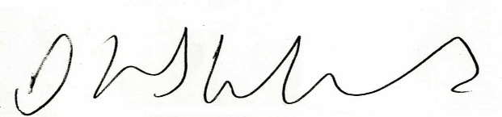

David Hinshelwood
Support Services Manager

