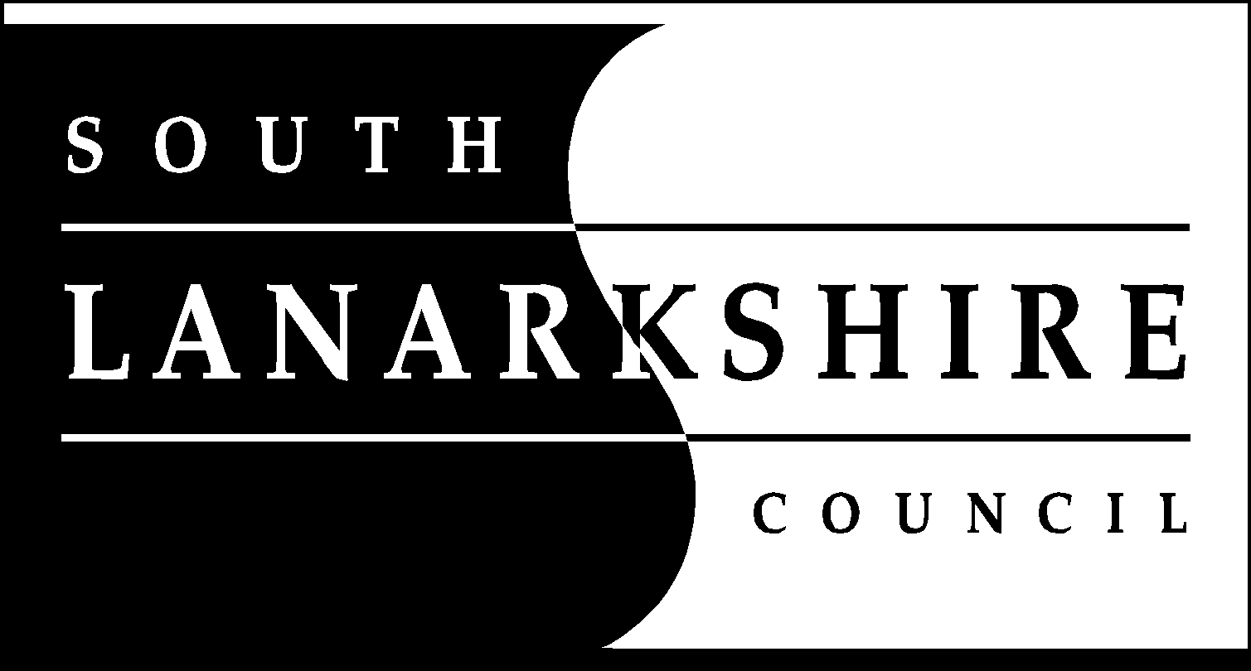
Education Resources
School holiday Dates Session 2021/2022
Break | Holiday dates
First Term | Teachers In-service | Thursday | 12 August 2021
 | In-service day | Friday | 13 August 2021
 | Pupils return | Monday | 16 August 2021
September Weekend | Close on  Re-open | Thursday  Tuesday | 23 September 2021  28 September 2021
October Break | Close on  Re-open | Friday  Monday | 8 October 2021  18 October 2021
 | In-service day | Monday | 15 November 2021
Christmas | Close on  Re-open | Wednesday  Wednesday | 22 December 2021  5 January 2022
Second Term
February break | Close on  Closed on | Friday  Monday and  Tuesday | 11 February 2022  14 February 2022  15 February 2022
 | In-service day | Wednesday | 16 February 2022
Spring break/Easter | Close on  Re-open | Friday  Tuesday | 1 April 2022  19 April 2022
Third Term
Local Holiday | Closed  Re-open | Monday  Tuesday | 2 May 2022  3 May 2022
 | In-service day | Thursday | 5 May 2022
Local Holiday | Close on  Re-open | Thursday  Tuesday | 26 May 2022  31 May 2022
Summer break | Close on | Friday | 24 June 2022
Proposed in-service  days | August dates to be confirmed

Notes
- Good Friday falls on Friday, 15 April 2022

- Lanark schools will close Thursday, 9 June 2022 and Friday, 10 June 2022

- Schools will close at 2.30pm on the last day of terms 1 and 2
(Wednesday, 22 December 2021 and Friday, 1 April 2022)

- Schools will close at 1pm on the last day of term 3 Friday, 24 June 2022)
*Two in-service days proposed for August 2022 to be confirmed.

