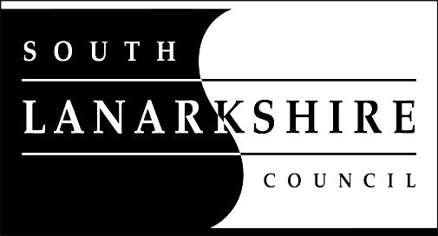

Education Resources

Privacy Notice
Introduction
In line with the European Union’s new General Data Protection Regulation (GDPR) which came into force on 25 May 2018 we have produced this Privacy Notice.

We care about the information we hold with regards to the education of children, young people and adults. We will keep this information safe and secure and will let you know more about the information we collect from you and how we use it.

Using your personal information
The Council has a legal obligation to deliver an effective education service to all children and young people in South Lanarkshire. In order to do this we need to collect personal information about children, young people and their families so that we can help them to learn and keep them safe.

Your personal information
We ask parents/carers during registration and enrolment to provide us with your child’s name, date of birth, gender, address, family contact details (phone/email). We will also ask you to update this information annually and to tell us when there are changes to your details

We also collect information provided about medical conditions, additional support needs, religion and ethnicity as well as information you may wish to provide about family circumstances.

We require this information to ensure that children and young people are educated appropriately, supported, and that we take account of their health and wellbeing.

We will use this information for the following purposes:
- for educating children and young people;
- for teaching, enrolment and assessment purposes and to monitor the educational progress of children and young people;
- to keep children and young people safe and provide guidance services in school;
- to identify where additional support is needed to help children and young people with their learning;
- to maintain records of attendance, absence and behaviour of children and young people (including exclusions);
- to support children and young people moving on each year from nursery to primary, primary to secondary and when they move or leave school;
- to create statistical reports.

We need this information so the Council can ensure it is delivering education appropriately to all learners.

We will share your information with:
- The Scottish Government and bodies such as Education Scotland, Scottish Qualifications Authority, Skills Development Scotland and other organisations that support children and young people’s learning;
- Other parts of the Council when required for services such as school meals, school transport, education benefits and with Social work in connection with any child protection concerns we become aware of;
- South Lanarkshire Leisure and Culture Limited, where children and young people are participating in sports and leisure activities;
- Other schools/local authorities – if a child moves or transfers to another school the Council has an obligation to pass on information with regards to pupil records to the new school/local authority.

Your rights
You have the right to ask us to:
- confirm that we are using personal information about you, detail what that information is, to whom we have disclosed it and request a copy of the information that we have about you (the right of access);
- correct any incorrect or misleading personal information that we have about you (the right to rectification);
- stop using any or all of your personal information (the right to object);
- to delete or destroy your personal information (the right to erasure); and
- stop using your personal information until we can look into correcting your personal information or our justification for using your personal information.

For more information on your rights and how to exercise them or for information about how we manage your personal information, you can get a copy of our full privacy notice from our website (www.southlanarkshire.gov.uk) or you can ask for a paper copy from the Data Protection Officer (details are below).
If you have any queries or are unhappy about the way that we use your personal information or have responded to you in relation to any of your rights, you can contact:
 | The Council’s Data Protection Officer | 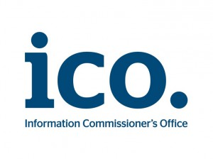 | The Information Commissioner
The Data Protection Officer,  Administrative and Legal Services,  Finance and Corporate Resources,  Floor 11,  Council Offices,  Almada Street,  Hamilton  ML3 0AA  Phone 0303 123 1015  Or by email to dp@southlanarkshire.gov.uk |  | You also have the right to complain to the Information Commissioner about the way we have handled your rights, to enquire about any exercise of those rights or to complain about the way that the Council has dealt with your rights (or any other aspect of data protection law). The Commissioner’s contact details are:  Information Commissioner's Office  Wycliffe House, Water Lane  Wilmslow, Cheshire  SK9 5AF  Phone 0303 123 1113 (local rate) or 01625 545 745 if you prefer to use a national rate number.  Fax 01625 524 510  Or online at: https://ico.org.uk/concerns/handling/

Version 1: May 2018

