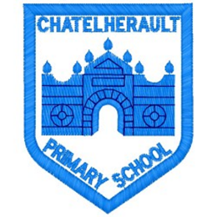
Chatelherault Primary School
Pupil Groups

Group: HGIOS
Date: October 2025

Points from previous meeting:

- Think about theme to explore this session based on the HGIOS book.
Main discussion points from today:

- We voted for the theme to focus on this term and the group felt that they wanted to begin with Relationships or HWB.
- HWB was in line with the Young Leaders Programme but to begin discussions, we looked at the features of effective practice for Relationships as the conversation linked to this theme.
- The group sorted features of effective practice into strengths and areas for development.
- Focus for discussion on why different statements were chosen.

Focus Article: Article 12

The right to an opinion and for these views and opinions to be taken seriously.
Action Points:

- Next meeting we will begin to look at HWB theme and think about how to gather evidence from the whole school.


Minute Taker: Mrs Dunbar

