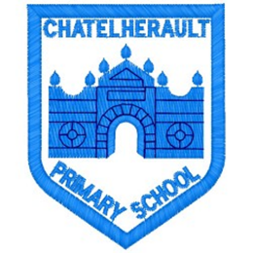
Chatelherault Primary School
Pupil Groups

Group: HGIOS
Date: September 2025

Points from previous meeting:

- N/A – First meeting
Main discussion points from today:

- Welcome to the group and introduction of our group members. The pupils shared why they had chosen the How Good Is OUR School group and some of the reasons were as follows :
- Want to make a change within the school
- Want to talk about what we are good at
- Want to work together with other pupils

- The group then looked at the HGIOS booklet and Mrs Dunbar explained the 5 themes. We talked about previous groups and last year was a focus on Relationships.

- Discussed possibility of Young Leaders Programme fro P5-7.

Focus Article: Article 12

The right to an opinion and for these views and opinions to be taken seriously.
Action Points:

- Think about theme to focus on based on evidence for our school.


Minute Taker: Mrs Dunbar

