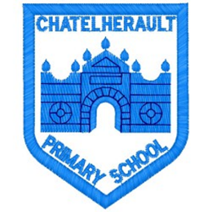
Chatelherault Primary School
Pupil Groups

Group: HGIOS
Date: January 2026

Points from previous meeting:

- Began looking at theme of Health and Wellbeing and quality indicators.
- Sorted in areas of strength and areas for improvement and discussed with pupil views.
Main discussion points from today:

- Looked at the 5 themes in HGIOS document and discussed Health and Wellbeing – this will be the theme for our Young Leaders of Learning peer visits.
- The group looked at the features of effective practise statements and sorted them into strengths and areas for development for our school.
- We spent lots of time discussing each point and sharing our views and why we felt it was a strength / area for development.

Focus Article: Article 12

The right to an opinion and for these views and opinions to be taken seriously.
Action Points:

- Begin thinking about the 5 QIs that we would like to showcase.
- Gather views from whole school relating to HWB.
- Start preparing for peer visits and think about what we would like to see from other schools.


Minute Taker: Mrs Dunbar

