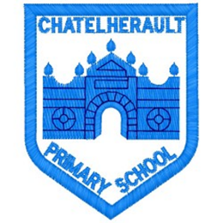
Chatelherault Primary School
Pupil Groups

Group: HGIOS
Date: February 2026

Points from previous meeting:

- Began looking at theme of Health and Wellbeing and quality indicators.
- Sorted in areas of strength and areas for improvement and discussed with pupil views.
Main discussion points from today:

- Spoke to pupils about upcoming visit for Young Leaders of Learning programme.
- Went over the paperwork that pupils will be expected to complete on the peer visit.
- Went over timetable sent by Auchinraith Primary and pupils discussed what they were looking forward to seeing – Meet the Mediators and the play zones.
- Investigation – gathered pupil views from Primary 3-7 by visiting each class to complete some survey questions related to HWB in our school.
- Choose 5 questions, based on whole school views and discussed how we would evidence these. Began compiling a list of evidence to showcase for questions.

Focus Article: Article 12

The right to an opinion and for these views and opinions to be taken seriously.
Action Points:

- Continue to build a bank of evidence to showcase for upcoming visit, relating to 5 questions.
- Go on peer visit to Auchinraith and Woodside.


Minute Taker: Mrs Dunbar

