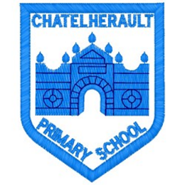
Chatelherault Primary School
Pupil Groups

Group: JRSO
Date: 29th October 2025
Minute Taker: A Duncan

Points from previous meeting:
- Importance of the completion of our WoW Schools Travel Tracker
- Pupils in the JRSO group to speak to their classes and teacher about the importance of recording this information each day and encouraging our classmates to travel to school by foot or bike/scooter
Main discussion points from today:

- JRSO pupils that attended the JRSO Community Event at Chatelherault Country park shared their learning from the event with the JRSO pupil voice group
- The focused learning was on road safety, the importance of a healthy lifestyle and protecting the environment in and around our school
Focus Article:

Including the article number and description

Article 13 - I have the right to find out and share information and learning
Action Points:

- Posters made by pupils to put up around the school to promote road safety around our school- specifically at drop off and pick up time
- Discussed what can we wear and where can we cross to ensure we can be seen and are safe
- Pupils in the JRSO group asked to continue to speak to their classes and teacher about the importance of recording how pupils travel to school each day and encourage our classmates to travel to school by foot or bike/scooter where possible




