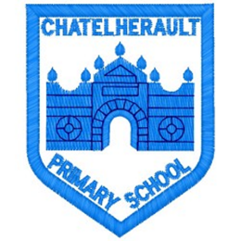
Chatelherault Primary School
Pupil Groups

Group: JRSO
Date: 27th January 2026
Minute Taker: A Duncan
Points from previous meeting:
- Posters made by pupils to put up around the school to promote no engine idling around our school- specifically at drop off and pick up times
- Discussed what we can do outside of school- encourage our parents/ carers to turn off their engines when stationary
- Pupils in the JRSO group asked to continue to speak to their classes and teacher about the importance of recording how pupils travel to school each day and encourage our classmates to travel to school by foot or bike/scooter where possible
Main discussion points from today:

- WOW - the walk to school challenge ‘Walk the Senses’ badge design competition 2026
- This year’s theme is Walk the Senses, which encourages pupils to take a moment to notice their surroundings as they walk or wheel to school.
- Competition runs until Tuesday 24 February and pupils could be in with the chance of creating one of the designs featured on the new badges for academic year 2026/27. The winning designers will also win up to £500 worth of FREE WOW resources for your school.
- The upcoming Scottish WOW Top Ten runs between 16 and 20 March 2026.
Focus Article:

Including the article number and description

Article 6 - I have the right to live and develop to my full potential
Action Points:

- Discussion around our 5 senses and what we could include on our entry form
- Distribution of the entry form and template
- Pupils made a start to their own entry forms and asked to discuss this with their teacher and class
- Email sent out to all teachers advising them of the competition and entry deadline
- Pupils in the JRSO group asked to continue to speak to their classes and teacher about the importance of recording how pupils travel to school each day and encourage our classmates to travel to school by foot or bike/scooter where possible




