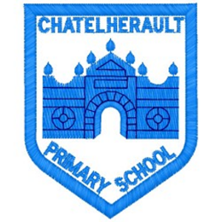
Chatelherault Primary School
Pupil Groups

Group: JRSO
Date: 8th September 2025
Minute Taker: A Duncan

Points from previous meeting:
N/A

Main discussion points from today:

- Welcome and introduction
- Our plans/ aims for the year - what do we want to improve? What is our job as part of the JRSO pupil voice group
Focus Article:

Including the article number and description

Article 15 - I have the right to meet with friends and join groups.

Action Points:

- Importance of the completion of our WoW Schools Travel Tracker
- Pupils in the JRSO group asked to continue to speak to their classes and teacher about the importance of recording how pupils travel to school each day and encourage our classmates to travel to school by foot or bike/scooter where possible




