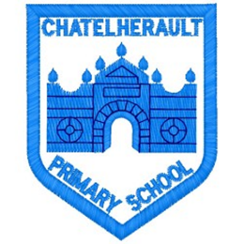**Chatelherault Primary School**

**Pupil Groups**

**Group: Rights Respecting**

**Date: 06.10.25**

|  |
| --- |
| **Points from previous meeting:**   * Miss Jamieson explained Ambassadors are important to the school’s reaccreditation and will meet more frequently to share ideas. * Complete Class Charter checks and give feedback. * Discussed ABCDE of Rights resource and requested access to support peers. |
| **Main discussion points from today:**  Rights Ambassadors have been meeting outside regular pupil group times to provide input on actions where our school has been successful against the UNCRC strands.  Focus of today’s meeting: Rights Scavenger Hunt / Together Time.   * Ambassadors supported the creation the Rights Scavenger Hunt worksheet. * They identified all areas in the school that represent rights and listed these locations in the answer key. * Ambassadors visited each location to ensure Rights display articles and Talking Tins were accessible. * Ambassadors trailed the scavenger hunt themselves to ensure it was clear and engaging. * Some Ambassadors recorded a video explaining how the scavenger hunt works, which will be played in classes before pupils take part. * Miss Jamieson shared the timetable with Ambassadors so they knew which class they would be leading the hunt in.   Together Time:   * Ambassadors were asked to share the new Right of the Month at assembly (Article 30). * Children should also be reminded about how to report any concerns about rights, which was included in the assembly script. |
| **Focus Article:**  Article 12 – Respect for the views of the child.  Article 13 – Freedom of expression  Article 30 – Minority culture, language and religion  Article 42 – knowledge of rights |
| **Action Points:**   * Rights Scavenger Hunt to take place the week beginning 20th October. * Scavenger Hunt materials to be emailed to staff. * Rights Ambassadors to speak at Together Time about the October Right of the Month. |



Minute Taker: *Miss Jamieson*