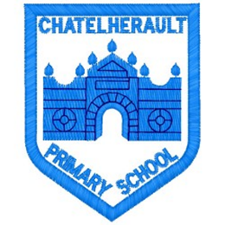**Chatelherault Primary School**

**Pupil Groups**

**Group: HGIOS**

**Date: 03.09.24**

|  |
| --- |
| Points from previous meeting:   * N/A as first meeting of the year. |
| Main discussion points from today:   * Welcomed our group members and took group photo. * Discussed what HGIOS group is and what we think our role is in the group. * Mrs Dunbar showed the 5 key themes that we will look at across the year and try to make a difference and positive change in. * We took a group vote to decide on the first theme to focus on and this was Theme 1 -Relationships. * We gathered opinions from the pupil group on where we think we are at with relationships across the school. Took at look at the quality indicators and what we should be working to achieve. |
| Focus Article: Article __12__  The right ti express views and have them taken seriously. |
| Action Points:   * Creating a whole school audit on where we are at with relationships. * Gathering results and creating action plan for the first term. * Think of ways to promote positive relationships with pupils and staff for next meeting. |



Minute Taker: