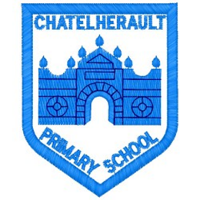
Chatelherault Primary School
Pupil Groups

Group: Rights Respecting Schools

Date: 4.12.23
Points from previous meeting:
- Welcome members and review the aims of the group
- Review Rights Hour discussions in classes
- OutRight campaign
Main discussion points from today:

- Introduce and welcome committee members
- Ask members to promote Right of the month for Dec – article 8 – right to an identity
- Discuss climate change, pupils to promote discussion in classes, as appropriate to age and understanding of children, use UNICEF powerpoint
- Discuss current COP summit, why are world leaders meeting, what do we hope will be achieved, try to raise profile in classes
- Discussed creating an outdoor emotions check in area, and creating a quiet zone within the playground, perhaps use benches and planters, where children can sit/gather

Focus Article:
ARTICLE - 29
Children have the right to an education which develops their personality, respect for others’ rights and the environment
ARTICLE 12
You have the right to give your opinion and for adults to take it seriously
Action Points:

- Watch ‘What is climate change’ Bing video and ask children to lead/ encourage class discussions – link to OutRight campaign
- Create quiet zone, check with P6&7 for volunteers who would be willing to join a rota

Minute Taker: J. McDonald

