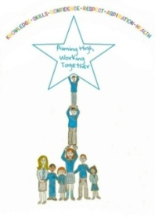

Chatelherault Primary
Newsletter
April 2023

Aiming high and working together we can achieve our potential in a happy, supportive and inclusive school.

Silver Reading School Award
Our school with the help of our amazing Literacy Pupil Group, supported by Mrs McCreadie and Mrs Lochhead has been awarded the Silver Reading Schools Award. Well done to all our children and staff who have been promoting reading and listening to stories across our school and nursery. The children have all been involved in selecting a wide range of new books for our fantastic, redeveloped library and it is lovely to see it in use across our school every minute of the day.

Break-in
It is with a heavy heart that I must report we had a school break-in just before the Spring Break. On this occasion there was no damage to the school when the police attended, they caught someone within the school building. Over recent months we have noticed some equipment in our playground being damaged and this included our new swing when it was being installed. If you see anyone in the school grounds out with school times, could you please contact the police.

Coronation
To celebrate the Coronation the children have decided on a One Planet Picnic and our Enterprise Committee are asking children to design a crown (in class). This will take place next week - Friday 5th May our Eco and Rights Respecting Groups are also focusing on sustainability and Global goals and are asking children to bring a homemade snack or a snack that has been produced locally and something comfy to sit on outside for our picnic.

Foodbank Donations
Thank you to the many parents and carers who donated Easter Eggs for our local Foodbank. The Enterprise Committee dropped these off at the foodbank before the Spring Break and we know they will have been enjoyed by all the children who received them.
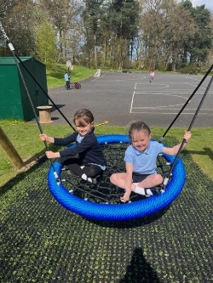
New Swing
We have added a new swing to our existing Trim Trail, and it has become an instant hit with all the children.

Our Primary Seven pupils and staff had an amazing time at Ardentinny. The weather was varied and included everything from snow, sun and rain. It was a fantastic experience where the children took part in rock hopping, canoeing, abseiling, gorge walking, search and rescue, orienteering, climbing, night hike and walking. We have already booked to go back next year and will be holding an information evening on Tuesday 23rd May at 6.00 pm.

Parking Safely
A parent has been in contact with the school to raise concerns about parking on the pavement outside of the school. Could I please remind all parents and carers that parking on the pavement is not safe for our children and you are putting them at risk by parking there.

Dates for Your Diary

DATE | TIME | EVENT/ACTIVITY
Fri 28th Apr |  | Literacy/ Learning Across the Curriculum home to parents
Fri 28th Apr | 9.30 am | Rm 18 Showcase of Learning – Parents invited
Mon 1st, Tues 2nd May |  | Bank Holiday, Inservice Day – School Closed
Mon 8th May |  | King’s Coronation – School Closed
Tues 16th May |  | Girls Football
Fri 19th May |  | Jotters home to Parents
Tue 23rd May | 2.00 pm  All Day  6.00 pm | Rm 3 Showcase of Learning – Parents invited  P7 Transition Visit to Hamilton Grammar  P6 – Ardentinny Parent Evening
Wed 24th May | 9.30am | Rm 8 Showcase of Learning – Parents invited  P7 Transition Visit to Hamilton Grammar
Thurs 25th May | 3.00 pm | School Closes for May Holiday Weekend
Tues 30th May | 9.00 am | School re-opens
Thurs 1st Jun |  | Nursery Trip to Safari Park
Tues 6th Jun | 9.30 am (Potted Sports)  1.30 pm (Traditional Sports) | Sports Day 1 – Weather Dependent
Thurs 8th Jun |  | Sports Day – Rearranged to this day if it cannot go ahead due to weather on Tues 6th Jun
Fri 9th Jun |  | Reports Due Out
Thurs 15th Jun | 11.00 | Class Moving on Day/ Meet your new teacher
Fri 16th Jun |  | Parent Council – Summer Fair
Mon 19th Jun | 9.30 am  11.00 am  2.00 pm | Celebrations of Achievement
Wed 21st Jun | 11.00 am  2.00 pm | P7 Leavers Assembly  P7 Supported Classes Leavers Assembly
Thurs 22nd Jun | 10.00 am | Nursery Celebration
Fri 23rd Jun | 10.00 am | End of Term Service
Tues 27th Jun | 1.00 pm | School closes for Summer Break

