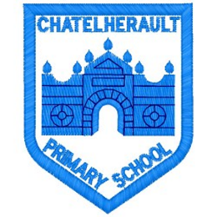
Chatelherault Primary School
Pupil Groups

Group: Rights Respecting Schools

Date: 4/9/23

Points from previous meeting:

What our Pupil Group did last year
Main discussion points from today:

- Introduce our new members and welcome to this pupil group
- What does the Rights Respecting group do – we spoke about how Rights language is used throughout the school and what we would like to work on this year
- Discussed class charters and what we should have on them – class charter audits will be carried out in the next two weeks
- This year’s OutRight campaign is about climate change, we’ll work on this campaign in school during the year
Focus Article:
Article 42
Everyone must know children’s rights

Including the Article number and the description
Action Points:

- Work in pairs to complete class audit for every class in the school and nursery.
- Talk to our classes about rights hour
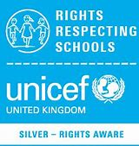
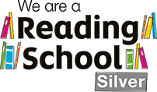
Minute Taker:

