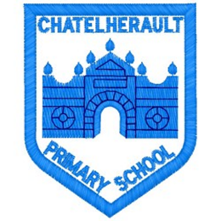
Chatelherault Primary School
Pupil Groups

Group: Literacy Ambassadors
Date: 28/09/22

Points from previous meeting:

This new literacy group which has representation form Primary 1 to Primary 7. Meetings will be held each month.

Main discussion points from today:

- Elaine from Hamilton Public Library met with the newly formed literacy group.
- We created mind maps about what we would like our new and improved school library to look like
- Created posters about what reading means to us and how it makes us feel.
- Mrs McCreadie arranged with Hamilton Public Library for each class to visit between now and Christmas.

Focus Article:

Including the Article number and the description

Article 12 – You have the right to give your opinion, and for adults to listen and take it seriously.
Action Points:

- Look at ordering some new furniture for the school library.
- Order some new contemporary children’s literature, pupils will be responsible for selecting the new titles.
- Three members of the literacy group will be the first group to visit the library.

Minute Taker: Mrs Lochhead

