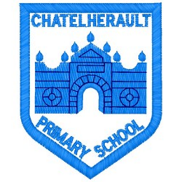
Chatelherault Primary School
Pupil Groups

Group: Literacy Ambassadors
Date: 22/2/23

Points from previous meeting:

The pupils discussed final plans for World Book Day which will be held next week on Thursday 2nd March. The new library displays are now completed and the tent has been put up in the library.
Main discussion points from today:

- The children created World Book Day posters to decorate and place around the school to raise the profile of World Book Day.
- The pupils re stocked and organised the outdoor library and then put up a new sign for the outdoor ‘Literacy Shed’.
- The pupils had a look through the application for the Reading Schools Silver Award and gave some suggestions about Book Buddies and getting the nursery involved.
- They all liked the idea of the Reading Heroes, which are parent/carers and friend of Chatelherault coming into school to read to classes.
- There have been two author live session one for the infants and one for the senior classes. Mrs Lochhead has emailed the link to the relevant teachers.
- The pupil group are pleased with their library and suggested that they would like some more ban bags, Mrs Lochhead will get these ordered.
- Each class now selects a pupil for the monthly Reading Award, which has been well received.

Focus Article:

Including the Article number and the description

Article 12 – You have the right to give your opinion, and for adults to listen and take it seriously.
Action Points:

- Get the office to re e-mail to give parent, carers and friend of the school one last chance to volunteer to be a reading hero during World Book Day.
- Order more nonfiction titles and get the pupil group to select these.

Minute Taker: Mrs Lochhead

