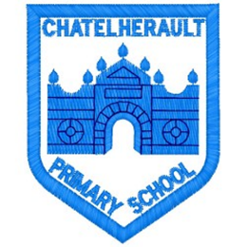
Chatelherault Primary School
Pupil Groups

Group: Literacy Ambassadors
Date: 27/4/23

Points from previous meeting:

The pupils discussed how World Book day went and all children enjoyed listening to stories read by the parents and grandparents of the school. We are grateful to everyone who gave up time to visit.
Main discussion points from today:

- We were delighted to receive our Reading School Silver Award. The pupils of the literacy group have worked particularly hard on promoting reading, making our library a cosy and inviting space and spreading their love of reading to others.
- We received our order of non-fiction books, we spent time labelling the new books. The members of the literacy group took a selection of the new non-fiction titles to their classes so they could view the new books.
- The pupils of the literacy group arranged a new rota for Book recommendations a assembly and passed this on to the classes.
- Mrs McCreadie will be sending out a new pupil reading survey for all the children to carry out. We are keen to get people views on reding.
- We still have a large number of old books, we would like the classes to wrap them up and create a ‘mystery book giveaway’, for pupils to take a book based on a short description and age range. They can keep this book and read for pleasure.

Focus Article:

Including the Article number and the description

Article 12 – You have the right to give your opinion, and for adults to listen and take it seriously.
Action Points:

- There are still a number of new books to label.
- Each class is timetabled to use the library once per week, we will look to increase that to two session per week.

Minute Taker: Mrs Lochhead

