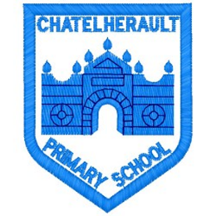
Chatelherault Primary School
Pupil Groups

Group: Eco Committee

Date: 27.4.23
Points from previous meeting
Most classes continuing with travel tracker

Main discussion points from today:

- Introduce 3rd action plan – Food in the Environment
- Choose the Sustainable Development Goal we will be working towards
- Visit from Fiona (Dinner Lady) – ask questions to find where food is sourced, packaging and what happens to waste food
- Discuss fruit and veg and where they come from
- Discuss food grown locally. Sustainable growth and discuss advantages of buying local food.
- Plan,’ One Planet Picnic’ and discuss ideas for the topic of Food and the Environment.
- Give each class a gift of seeds to grow for the ‘Chatelherault Salad’
Focus Article:

Including the Article number and the description
ARTICLE - 29
Children have the right to an education which develops their personality, respect for others’ rights and the environment
Action Points:
- Take time to review answers to questionnaire filled in with Fiona.
- One Planet Picnic – Eco members to talk to classes about local snack and benefits of choosing local foods, Isla suggested homemade healthy snack too
- Find out if classes have started to plant class vegetables for ‘ Chatelherault Salad’
- Look into clearing vegetable patches at the side of the trim trail
- Eco members were keen to have an eco-baking or cooking session with seasonal local produce to show all pupils.

