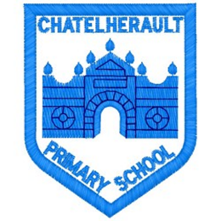
Chatelherault Primary School
Pupil Groups

Group: How Good Is OUR School

Date: 27.4.23
Points from previous meeting
Promoting discussion of Skills in class.
Collect posters that we have been working on, to be displayed in classes.
Look at How good is OUR school self evaluation document
Main discussion points from today:

- Introduce and welcome committee members
- Review action points that were created at the start of the school year and reflect on our progress
- Collect posters of core skills –to be displayed in classes to raise awareness and promote discussion
- Discussed ‘Our School and Community’ using ‘How good is OUR school’ self-evaluation document, this led to discussion about sustainability.
- Pupils could identify how sustainability is promoted through IDL topics, Animal Ambassador and Eco pupil groups
- We have recycling bags for paper in classes and food in the lunch hall, the group wondered if there could be plastic and metal recycling, this would be useful for children who have packed lunches
- We talked about children’s’ awareness of Global Goals and how we can promote them.

Focus Article:

Including the Article number and the description
ARTICLE - 29
Children have the right to an education which develops their personality, respect for others’ rights and the environment
Action Points:

- How Good Is Our School learning walk to be done, for all classes over the next 2 or 3 weeks
- Consider how we can promote Global Goals within the school

Minute Taker: J.McDonald

